Yes Pel.
Askuus vir die engels. Dog is makliker met al die termes.
Dankie vir dit. Skree maar as daar issues is, dan kyk ons as ons dit sommer saam kan uitsort.
Hier is my terugvoering:

- Go through all the Menu tabs.
Ensure that the links are removed from the tabs which should be clickable. Likewise with the dropdown menu’s
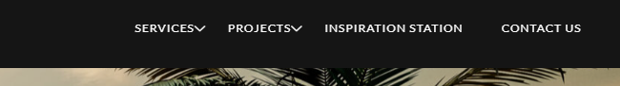

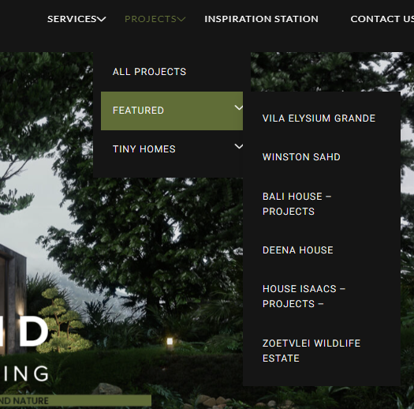

- I feel like the buttons should all read the same. (Padding sizes and text)
We can make the Text smaller as well.
Maybe like:
- New Build
- Amendments
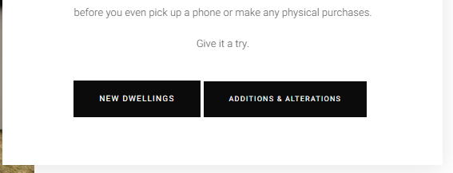
Here are the other buttons for reference. I feel we need to get some similaries between the padding and text sizes.
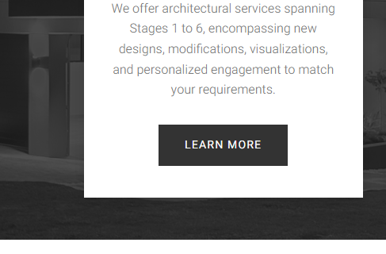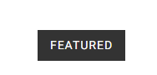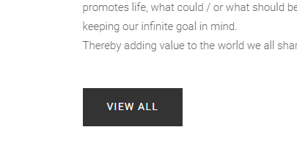

- We have noticed that one “All Projects” if you click on the image it opens up the image.
I feel like we should keep the clickable function (pointer) on the whole image like it currently is, but make sure when we click on the image it also goes to the project page and not open up the image.

Please add the clickable function (pointer) on the entire Home page “Feature” area. I have noticed that only the textarea is clickable.


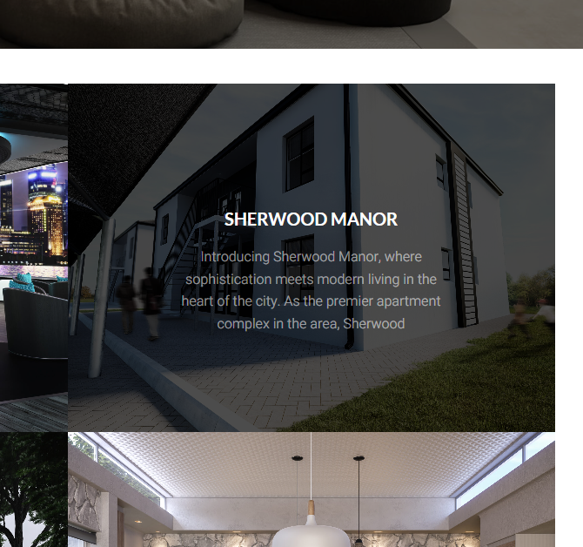

- On “All Projects” can we maybe remove the description on the highlighted area and only have the name? I think it is fine to have the descriptions on the “Home page” under “Feature” I don’t mind it there.

I just think if we go to “All projects”, we don’t need to see the extra info, it reads a bit much.

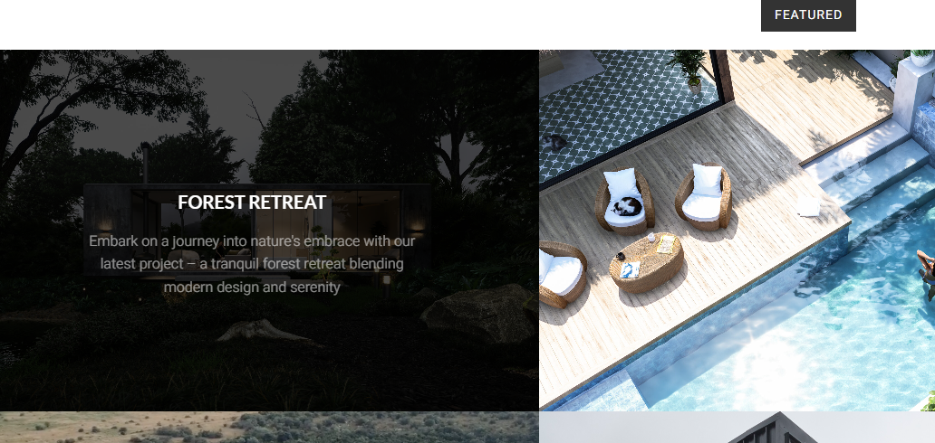

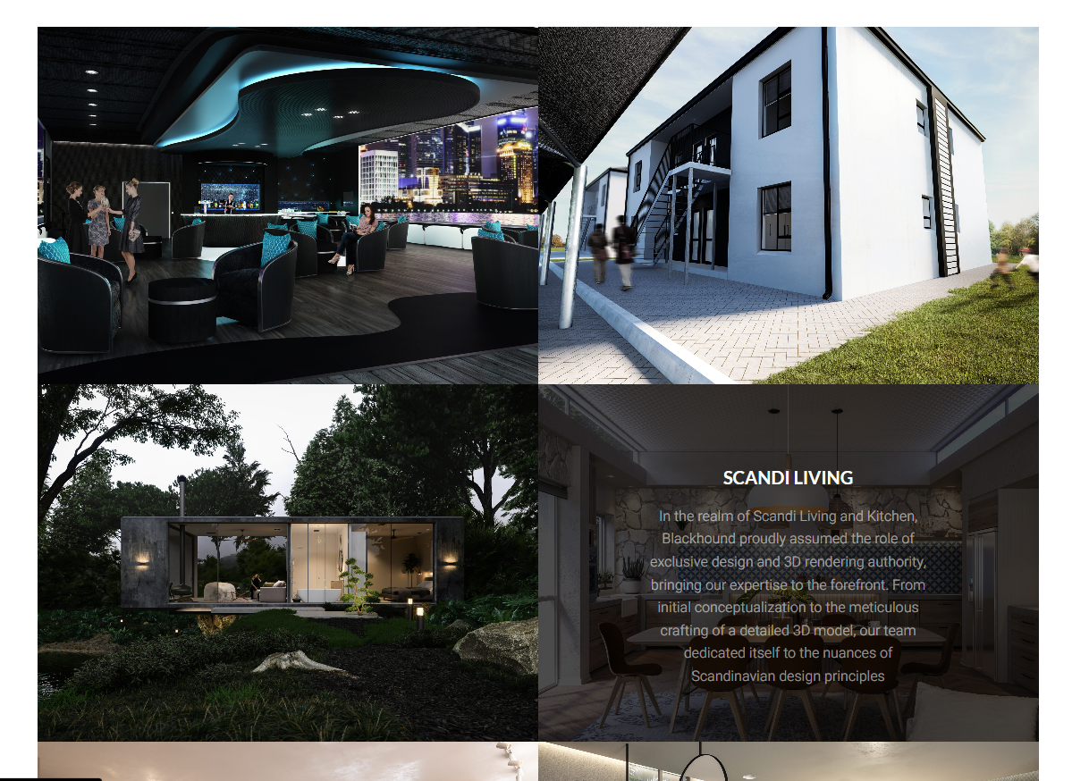
Remove the description and make the heading center of the image.

- Please change to 2024



- I feel like there is a disconnection between the banner heading and the text. I think we need to add some sort of subheading before we get the description.
Maybe something like:

Either justified centered or Left. Whatever works.
Please check. It says “premier”. I think primary sounds better.

WELCOME TO INSPIRATION STATION
Your primary source for ….

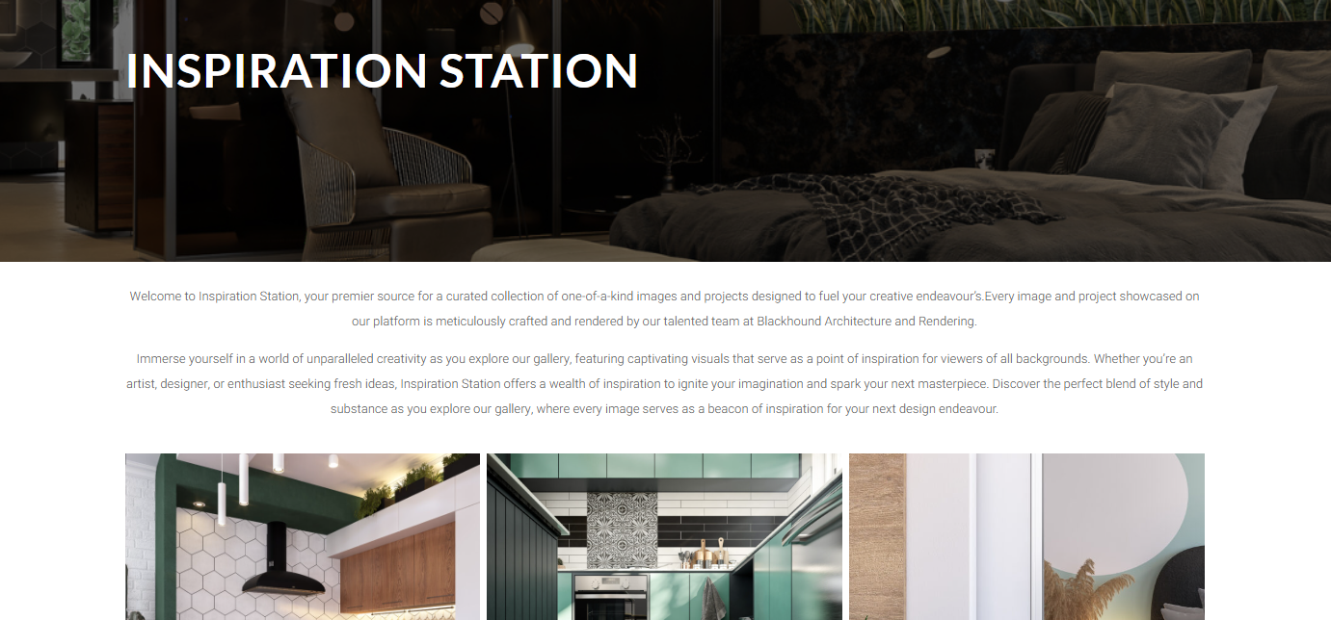
This is what I mean:
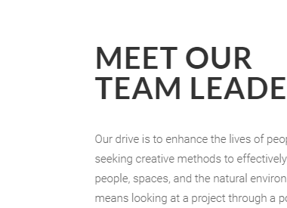

- On the Contact Us:
Please ensure that our contact details are hyperlinked like this.
<a href=’tel:…’ style=’text-decoration: none;’></a>
<a href=’mailto:…’ style=’text-decoration: none;’></a>
