Erf No.: 1609, SEDGEFIELD
Zoning: Single Residential Zone 1
Erf Area: 924.51 m²
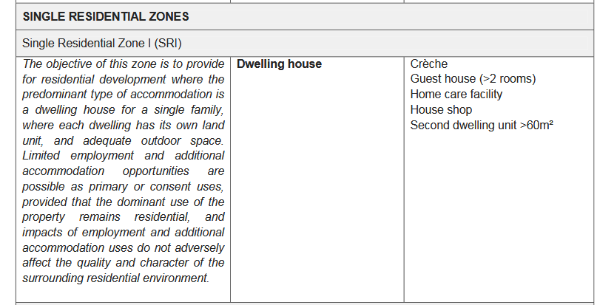

Site Access And Exits
the minimum width of a panhandle access may not be less than 4 metres wide and 3 metres wide in single residential zones

Height Restriction:
Dwelling houses may not exceed 8.5 metres above natural ground level directly below a given point of the building with a maximum of 2 storeys; provided that a departure from the 2 storey limit may be considered due to the slope of the site;
provided further that the 8.5 metres restriction is maintained and that the additional storey is added to the building on the lower side of the slope;

SINGLE RESIDENTIAL ZONE I
Primary Use:
Single Residential 1 properties may be used for the purpose of erecting one dwelling unit with associated out buildings. The individual development of each of the properties must contribute to the overall appearance as identified in the Design Parameters set out in par 4.3 below.

Consent Use:
Bed and Breakfast establishment with not have more than four bedrooms (eight beds) for the purpose of offering overnight accommodation.

Occupational Practice and Other Rights:
- Without prejudice to any powers of the Council under any other law, nothing in a Zoning Scheme contained shall be construed as prohibiting or restricting, or enabling the Council to prohibit or restrict, the following:

  - The letting, subject to the council’s regulations relating to Bed & Breakfast establishments, boarding houses and hostels, by any occupant of a dwelling unit or any part of such dwelling house;
  - The occasional utilization of a place of public worship, place of instruction, or institution as a hall for social functions; or
  - The utilization of a portion of a dwelling unit for purposes of occupational practice

- The following conditions shall apply where a portion of the dwelling unit is utilized for purposes of occupational practice:

  - Such a dwelling house, flat or residential building or any part thereof shall not be used for purposes of a shop, business premises, an industry or a noxious trade;
  - No goods for sale shall be publicly displayed;
  - No advertising sign shall be displayed other than an un-illuminated sign or notice not projecting over a street and not exceeding 2 000cm² in area and indicating only the name and profession or occupation of the occupant; and
  - No activities shall be carried on which are or are likely to be a source of disturbance or nuisance to occupants of other dwelling units or portions thereof.
Development Parameters:
- Coverage
Including garage and outbuildings, shall not exceed 35% of the area of the erf.

- Front building line
At least 5 metres.

- Rear building line
At least 1 metre.

- Side building line
At least 1,5 metres.

- Parking
- Parking shall be provided either on-site or off-site subject to agreement with surrounding land-owners according to Council’s requirements as they may be laid down from time to time.
- Parking shall be provided at the ratio of one bay for two beds in Bed & Breakfast establishments. These bays shall be provided either on or off site.

Additional Provisions:
- The parameters of the existing lawful development shall apply as land use restrictions where departures from those land use restrictions occur on land deemed to be zoned as Single Residential I, with effect from date of commencement of the By-law.

- A site development plan shall be approved by and filed with the local authority clearly indicating:
- The location of buildings on the erf;
- building design;
- building materials;
- services including design parameters and location of septic tank;
- roadways and parking where applicable;
- boundary walls and fences;
- landscaping;
- for all new buildings and additions and alterations to existing buildings.

- When new buildings are constructed only that land area required for the building footprint and plus a 3m clearance for construction should be cleared of indigenous vegetation.
- All residential sites shall be cleared by hand according to the approved site development plan. No site works should be embarked upon prior to approval of site development plan and building plans.
- The calculation of bedrooms for Bed & Breakfast establishments shall include all bedrooms on the property.
- A Homeowners Association must be established to which membership by the owners of all the properties is compulsory.

