


BLACKHOUND ENTERPRISES PTY LTD
T/A BLACKHOUND ARCHITECTURE & RENDERING

Hannes Gouws
hannes@blackhoundenterprises.com
072 799 9597

Unit 10 – The Network
19 Cactus Road
Fairview
Port Elizabeth (Gqeberha)
Eastern Cape
2075
The Network
19 Cactus Road
Fairview
Port Elizabeth (Gqeberha)
Eastern Cape
2075

Unit 10 – The Network
19 Cactus Road
Fairview
Port Elizabeth (Gqeberha)
Eastern Cape
2075

Client:
Kevin McLoughlin | Western Gruppe
084 573 5634
kevin@wgproperties.co.za
The Terraces|3d Modelling & Rendering – Fee Proposal REV00

Date: 20 JANUARY 2026
|PROJECT BRIEF:
3d model and provide high resolution renders of an apartment complex on ERF 903, Westering.

- 3d model 3x unique units and place in place on site:
  - Type A
  - Type B
  - Type C

- 3d model and landscape the development and environment.

- Provide the following rendering services:
  - Plan renders of each unique unit to be used for marketing.
  - Interior Renders of a typical unit.
  - Overview renders of the Development.
  - Animation production video to use for marketing.

- Prepare a marketing brochure.
    - A cover page.
    - The relevant site and location information with graphics.
(Site plan, written copy, unit prices.) – Supplied by the client.
    - Development plan.
    - 2x external renders per unit type.
    - 1x Floor plan render per unit type.
    - Interior renders of the spec unit.
    - Development specifications. – Supplied by the client.
    - Logos.

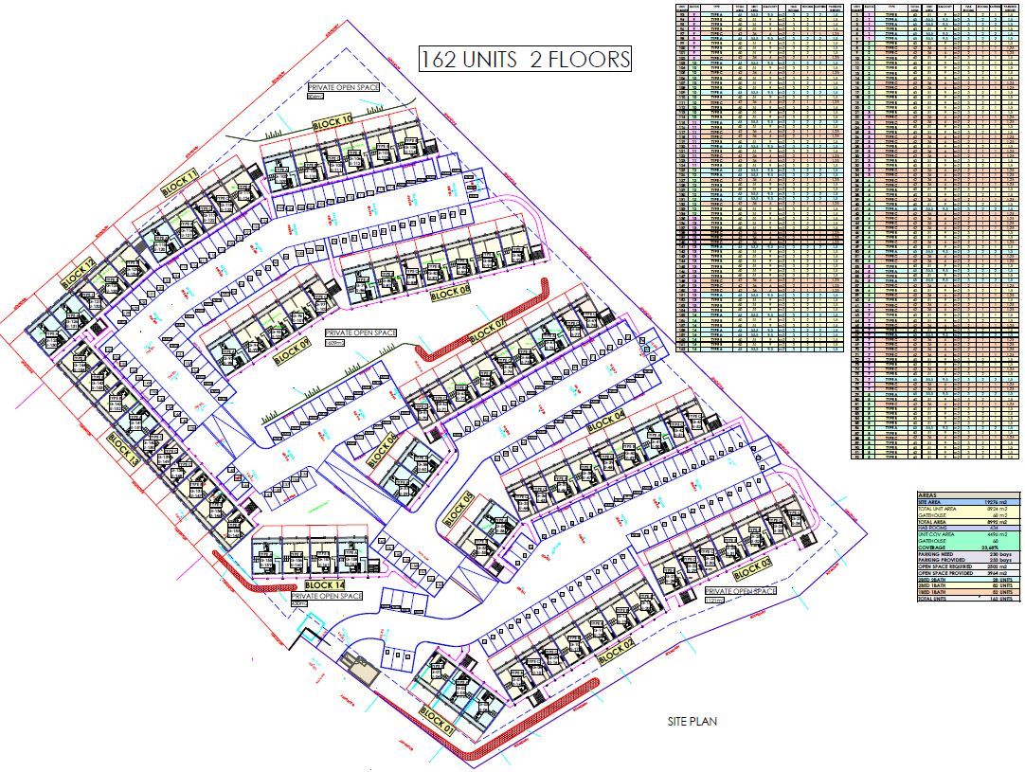
DEVELOPMENT LAYOUT:

|THE TERRACES: QUOTATION & DELIVERABLES
- PHASE ONE:

- 3d Modelling and Still Renders:
  - 3d modelling:
Blackhound will 3d model each unique unit and building.
We will do the necessary materials and textures / finishes to be able to render the project.
- No custom furniture to be 3d modelled or purchased.
- Should you require custom furniture and décor to match catalogues and specific brands, please refer to item 1.3 under Terms and Conditions.

  - Development 3d Modelling and general landscaping:
We will 3d model the development site and do the general landscaping to create a realistic environment to be showcased in the renders.

R16 920.00
- PHASE TWO:

- Still Image Rendering:

We will provide the following still image renders:
- Internal renders of a typical unit.
- Overall renders of the development.
- Furnished and finished floor plan renders of each unique unit.

R21 780.00

- This quote allows for a total of 2x Rounds of draft renders for you to approve the settings before we commence with the final renders.
Please refer to T’s & C’s.

- PHASE THREE:

- Animation Video Production:

1x animation production video for marketing the development and units.
- Animation productions consist of segments rendered of various scenes or spaces, capturing the details and movement through spaces. Focusing on selling the feeling of the environment and spaces.
These segments are then edited together in a post-production process with music and text animations to make up the final production presentation video.
The focused paths of the animation will be:
- the overview and features of the development.
- Moving through the spaces of a typical unit.

R23 885.00

- As discussed, once the still renders are approved and rendered will we proceed with creating the animation.

- PHASE FOUR:

- Marketing package:
Blackhound will put together a marketing brochure of the development to assist with the sales of the units.
All information that needs to be showcased must be supplied by the client.
R2 500.00

Fees Summery:
Phase 1: 3D MODELING: R 16 920.00

Phase 2: STILL IMAGE RENDERING: R 21 780.00
- ± 22x Renders
Phase 3: ANIMATION PRODUCTION: R 23 885.00
Phase 4: MARKETING PACKAGE: R 2 500.00

TOTAL QUOTE: (VAT not applicable) R 65 085.00

|PAYMENT TERMS:
- Deposit payable upon acceptance of quotation. (R 37 600.00)

- Balance of the fees payable upon receipt of animation production. (R 26 385.00)

|TERMS AND CONDITIONS:
Blackhound Enterprises PTY LTD will be employed for the 3d modelling and rendering of the proposed designs for ‘THE TERRACES’ apartment complex in Westering, Port Elizabeth, designed by RK Architects. Timeous work, communication and deliverables are expected.

- No Additional architectural or 3d rendering services have been included in this quotation.

- Should the client require architectural drawings, working drawings, design services and/or council submission services, a separate fee proposal will be prepared to accommodate the scope of works.

- Once the final draft renders have been approved by the client, please note that any design changes made to the 3D model could result in additional costs, which will be discussed and agreed upon before work commences.

  - SITE VISITS:
N/A.

  - ADDITIONAL RENDERS:
Should you request additional renders, the pricing will be as follows:

- Additional renders requested in a new space which has not been developed in the initial 3d modelling and rendering phase will be charged at R5 500.00 per additional render to allow for the time to develop the additional spaces and views.

- Additional renders requested in an already designed and developed space will be charged at a reduced rate of R2 000.00 per additional render.

  - CUSTOM FURNITURE:
Should you require us to 3d model furniture and décor items selected from catalogues or brands, a custom 3d modelling fee per 3d model will be applicable, depending on the complexity and scale of the items selected. A separate quote will be provided.

  - TERMINATION:
If the agreement between the parties is terminated by either party for reasons not caused by BLACKHOUND ENTERPRISES PTY LTD, the fee for the work in progress and the completed work will be due for payment.

  - SUSPENSION:
BLACKHOUND ENTERPRISES PTY LTD retains the right to suspend all service until the settlement of any outstanding account.

  - OTHER PROFESSIONALS:
BLACKHOUND ENTERPRISES PTY LTD is not responsible for the performance of other professionals or artists (such as Town Planners, Engineers, or any other designers and artists), nor for the quality of images, drawings and documents provided by them, tender prices, the actions of Homeowner Associations, Municipalities, or Municipal Services. We are also not responsible for the performance of the Contractor or any of their Sub-Contractors, Suppliers, or employees.

  - COPYRIGHT:
BLACKHOUND ENTERPRISES PTY LTD retains the ownership of copyright to all its intellectual property. No designs, drawings, renders or documents may be used and shared with other parties without our express permission. This includes our fee proposal and rates.

  - FEE OFFSET:
The Client is not entitled to ‘set-off’ or withhold payment for any alleged claim against either BLACKHOUND ENTERPRISES PTY LTD or any other party involved in the project. The claim is to be dealt with on its own merits.

  - FINAL INVOICE:
The final invoice will be due upon receipt of final renders.

  - VAT:
BLACKHOUND ENTERPRISES PTY LTD. Is not a VAT vendor. All architectural fees presented are exclusive of VAT until further notice.
|ACCEPTANCE:
The Terms and Conditions presented here may be modified or amended as necessary only by written instrument signed by both parties.
By submitting the non-refundable deposit payment or signing this document, you are agreeing to the terms and conditions detailed in this document.
This proposal is agreed upon in full, signed and dated.
By signing this document, I indicate that I understand, agree to, and accept the terms and conditions as contained herein, dated this 20 JANUARY 2026.

I, __________________________________________ hereby agree to the Terms and Conditions laid out in this document.

Email: hannes@blackhoundenterprises.com
Phone: 072 799 9597

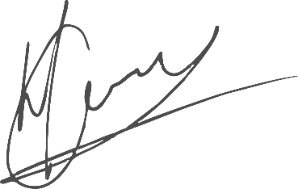

----------------------------------------------- -------------------------------------
Hannes Gouws KEVIN McLOUGHLIN
Director | PSAT 32449887 Date:

