


BLACKHOUND ENTERPRISES PTY LTD
T/A BLACKHOUND ARCHITECTURE & RENDERING

Dewald Potgieter
dewald@blackhoundenterprises.com
072 418 6867

Unit 10 – The Network
19 Cactus Road
Fairview
Port Elizabeth (Gqeberha)
Eastern Cape
2075

Unit 10 – The Network
19 Cactus Road
Fairview
Port Elizabeth (Gqeberha)
Eastern Cape
2075

Unit 10 – The Network
19 Cactus Road
Fairview
Port Elizabeth (Gqeberha)
Eastern Cape
2075

Client:
Desmond Thompson
072 073 9082
dezthompson@gmail.com Date: 20 January 2026
|SCOPE OF WORKS:
Measure and draw up existing house and submit plans to council on 7 Dresden St, Jeffreys Bay / Erf 5355, Jeffreys Bay.

Project Breakdown:
Deviations from the approved plans received from client:
- New roof at kitchen
- New roof at bedrooms
- New roof at front entrance
- New pool
Additional scope from client:
- New flatlet of 35 sqm
- Alterations to existing garage
- Alterations to existing bathroom

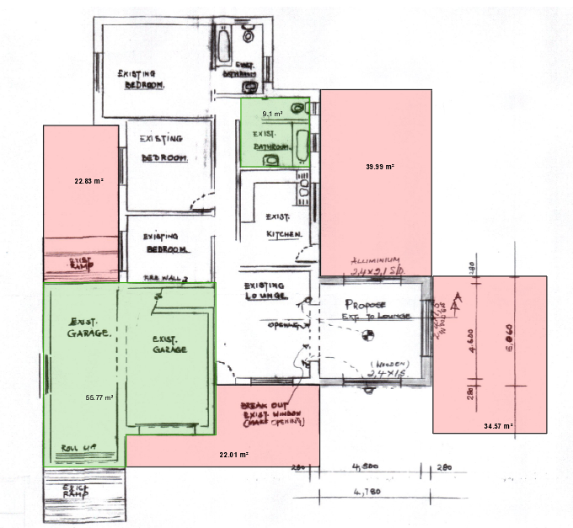

| MEASURE, DRAW & SUBMIT ONLY – QUOTE.
Professional Fees Calculation:
- Measure & draw existing R 14 200.00

- Design of Flatlet R 7 000.00

- Alteration to existing garage & bathroom R 3 250.00

- New roof at kitchen R 2 000.00

- New pool R 1 000.00

- New poly-carb sheeting area behind existing garage R 1 150.00

- New roof at entrance R 1 100.00

- Travel (Visit to site) R 975.00

- Admin (OVVIO Submission process) R 1 542.00

TOTAL QUOTE: R 32 217.00 (VAT not applicable)

KINDLY NOTE:
- Should our scope of work increase, our fees will be adjusted to accommodate the extra scope. This will be discussed before the work commences.
- This quote is only valid for 30 Days after the date of issue.
- Each invoice to be settled within 14 days after the date of issue.

Excluded from the fees:
- Submission fees (e.g. Council and municipal related fees/Estate/NHBRC)
- Hard copy prints (e.g. Council and municipal related)
- Other Professional consultancy fees that may be required (e.g. Structural Engineer, Quantity and Site Surveyors, Health & Safety, etc.)
- Execution of the works and testing of materials to ensure compliance with drawings and specifications remains the responsibility of the contractor.
- No application for an occupation certificate is not included.
|PAYMENT TERMS:
- Deposit payable at acceptance of quotation. (R 22 500.00)
- Fees payable at acceptance of master plan & commencement of
municipal plans (R 9 717.00)

|TERMS AND CONDITIONS:
Blackhound will be appointed to measure and draw up the existing house, compile the necessary municipal submission drawings, and submit the plans to the local authority for approval.
Technical submission drawings were not included in this quotation, as it isn’t a requirement for municipal submission.
Project management was not included in this quotation.

  - SITE VISITS:
If additional Site Visits are requested, a travel expense of R 1000.00 per Site Visit will be charged. This will be invoiced at the end of each month for the duration of the project or when Site visits are requested.

  - DEVIATIONS:
Any on-site deviations requiring updated plans will be billed at an hourly rate of R 650.00. A separate quotation for revising and, if necessary, resubmitting the drawings to council will be provided to the client for their approval.

  - Quality Control:
If any quality control checks are required, an expense of R1 850.00 per inspection will be charged. This will include the travel and report.

  - PRINTS:
Our fees are exclusive of any hard copy prints. If we must make hard copy prints for any reasons not attributed to BLACKHOUND ENTERPRISES PTY LTD, the client will be notified beforehand and will be invoiced separately or added to the client’s final invoice. Once the plans are approved by council, we will provide you with your stamped approved hard copy.
Revision drawings will be emailed to the site management team or the client where hard copy revision drawings will be the responsibility of the contractor / client / site manager.

  - TERMINATION:
If the agreement between the parties is terminated by either party for reasons not caused by BLACKHOUND ENTERPRISES PTY LTD, the fee for the work in progress and the completed work will be due for payment.

  - SUSPENSION:
BLACKHOUND ENTERPRISES PTY LTD retains the right to suspend all service until the settlement of any outstanding account.

  - OTHER PROFESSIONALS:
BLACKHOUND ENTERPRISES PTY LTD is not responsible for the performance of other professionals (such as Town Planners and Engineers), nor for the quality of drawings and documents provided by them, tender prices, the actions of Homeowner Associations, Municipalities, or Municipal Services. We are also not responsible for the performance of the Contractor or any of their Sub-Contractors, Suppliers, or employees.

  - COPYRIGHT:
BLACKHOUND ENTERPRISES PTY LTD retains the ownership of copyright to all of its intellectual property. No designs, drawings or documents may be used and shared with other parties without our express permission.

  - FEE OFFSET:
The Client is not entitled to ‘set-off’ or withhold payment for any alleged claim against either BLACKHOUND ENTERPRISES PTY LTD or any other party involved in the building contract. The claim is to be dealt with on its own merits.

  - FINAL INVOICE:
The final invoice will be due upon master plan approval & commencement of municipal drawings.

  - VAT:
BLACKHOUND ENTERPRISES PTY LTD. Is not a VAT vendor. All architectural fees presented are exclusive of VAT until further notice.
|ACCEPTANCE:
The Terms and Conditions presented here may be modified or amended as necessary only by written instrument signed by both parties.

By submitting the non-refundable deposit payment, you are agreeing to the terms and conditions detailed in this document. This proposal is agreed upon in full, signed and dated.

By signing this document, I indicate that I understand, agree to, and accept the terms and conditions as contained herein, dated 20 January 2026.

I, __________________________________________ hereby agree to the Terms and Conditions laid out in this document.

Email: dewald@blackhound.co.za
Phone: 072 418 6867

----------------------------------------------- -------------------------------------
Dewald Potgieter Desmond Thompson
Director | PAT 30442820 Date:

