


BLACKHOUND ENTERPRISES PTY LTD
T/A BLACKHOUND ARCHITECTURE & RENDERING

Dewald Potgieter
dewald@blackhound.co.za
072 418 6867

Unit 10 – The Network
19 Cactus Road
Fairview
Port Elizabeth (Gqeberha)
Eastern Cape
2075

Unit 10 – The Network
19 Cactus Road
Fairview
Port Elizabeth (Gqeberha)
Eastern Cape
2075

Unit 10 – The Network
19 Cactus Road
Fairview
Port Elizabeth (Gqeberha)
Eastern Cape
2075

Client:
Carmen Wilson
082 334 5875
carmenruthwilson@icloud.com
Date: 12 February 2025
|SCOPE OF WORKS:

Designing new kitchen layout for Carmen Wilson at 66 Ocean View Drive, Blue Horizon Bay, PE.

Project requirements:

- Design new Kitchen upstairs.
  - 2D floor plan
  - 3D (Visualization + Images)

Example of 3D image:

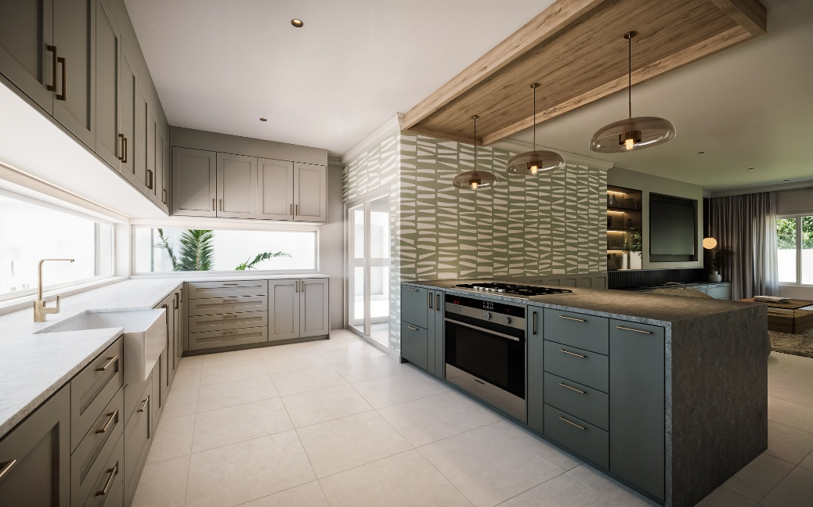

| DESIGNING NEW KITCHEN IN 2D & 3D - QUOTE.
Professional Fees Calculation:
- Design:
  - Floor planning (2D) R 3 124.00
  - 3D (Visualization + Images) R 12 496.00

- Admin R 1 562.00

TOTAL QUOTE: R 17 182.00 (VAT not applicable)

KINDLY NOTE:
- Should our scope of work increase, our fees will be adjusted to accommodate the extra scope. This will be discussed before the work commences.
- This quote is only valid for 30 Days after the date of issue.

|ACCEPTANCE:
By signing this document, I acknowledge that I have read, understood, and agree to the content within this proposal. This proposal is agreed upon in full, signed, and dated to confirm my acceptance.
Declaration:
I, __________________________________________, hereby agree to the content of this document.

Signature: _____________________________
Date: _____________________________

Quotation compiled by:



-----------------------------------------------
Dewald Potgieter
Director | PAT 30442820
Email: dewald@blackhound.co.za
Phone: 072 418 6867

Date: 12 February 2025.

