


BLACKHOUND ENTERPRISES PTY LTD
T/A BLACKHOUND ARCHITECTURE & RENDERING

Hannes Gouws
hannes@blackhoundenterprises.com
072 799 9597

Unit 10 – The Network
19 Cactus Road
Fairview
Port Elizabeth (Gqeberha)
Eastern Cape
2075

Unit 10 – The Network
19 Cactus Road
Fairview
Port Elizabeth (Gqeberha)
Eastern Cape
2075

Unit 10 – The Network
19 Cactus Road
Fairview
Port Elizabeth (Gqeberha)
Eastern Cape
2075

Client:
DURR AFRICA
Riaan Botha
041 101 4765
riaan.botha@durr.com
Date: 23 September 2024
|SCOPE OF WORKS:
Amend the provided drawings of a steel canopy at Volkswagen, Uithenhage to be sufficient for council approval and submit drawings and documentation to NMBM for the approval.
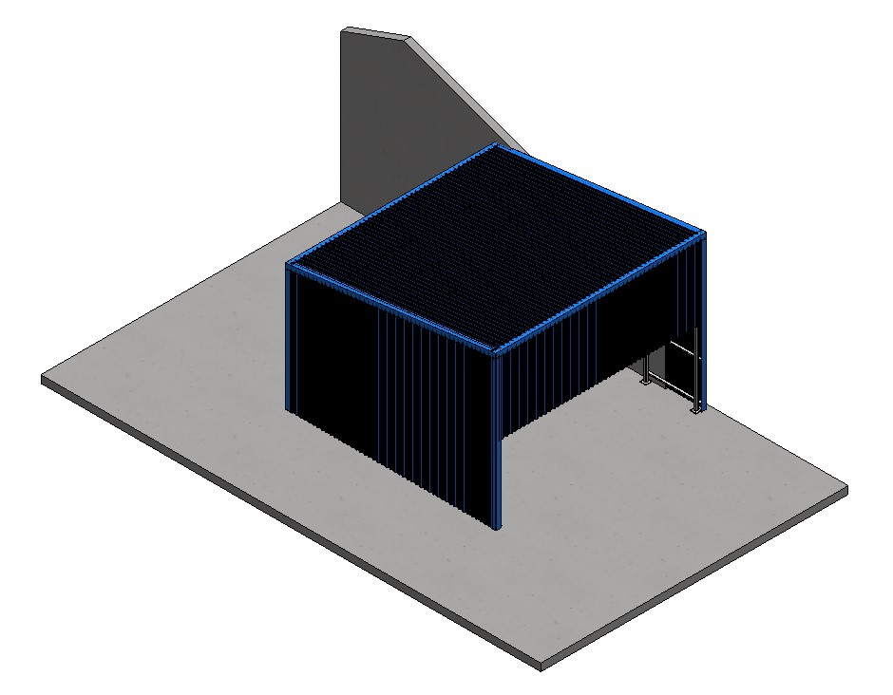

PROJECT SPECIFICATIONS:
- All existing drawings and proposed drawings will be provided by Dürr.
- No architectural design services will be required.

| VOLKSWAGEN CANOPY: QUOTE & DELIVERABLES.
Municipal Drawings and Documentation:
Professional Fees Calculation:
- Site Visit:
  - 1x Site Visit to take photos of the existing area prior to construction.
R 1 123.00

- Municipal Drawings and Documentation:
We will prepare the drawings provided on our architectural layouts with our title block and signatures

  - Municipal drawings; Site plan, Floor Plan, Section, Elevations.
  - Municipal Documentation and the council submission process.
R 11 696.00

SUB TOTAL:
- SITE VIST R 1 123.00

- MUNICIPAL DRAWINGS AND DOCUMENTATION: R 11 696.00

TOTAL QUOTE: R 12 819.00 (VAT not applicable)

KINDLY NOTE:
- Should our scope of work increase, our fees will be adjusted to accommodate the extra scope. This will be discussed before the work commences.
- This quote is only valid for 30 Days after the date of issue.
- Each invoice to be settled within 14 Calander days after the date of issue.

Excluded from the fees:
- Submission fees and hard copy prints, if required. (e.g. Council and municipal related fees/Estate/NHBRC)
- Other Professional consultancy fees that may be required (e.g. Structural Engineer, Quantity and Site Surveyors, Health & Safety, etc.)
- Execution of the works and testing of materials to ensure compliance with drawings and specifications remains the responsibility of the contractor.
- Printing of drawings for site.
|PAYMENT TERMS:
- 50% Deposit payable at acceptance of quotation. (R 6 409.00)
- Balance of fees payable at client approval of municipal drawings
prior to municipal submission. (R 6 409.00)
|TERMS AND CONDITIONS:
Blackhound will be employed to prepare the provided drawings of a proposed steel structure canopy, as emailed on 20.09.2024, to be sufficient as architectural drawings and to be submitted to NMBM for their approval. No architectural design or additional drawing services are included in this fee proposal.

  - SITE VISITS:
If additional Site Visits are requested, a travel expense of R1 123.00 per Site Visit will be charged. This will be invoiced at the end of each month for the duration of the project or when Site visits are requested.

  - PRINTS:
Our fees are exclusive of any hard copy prints. If we must make hard copy prints for any reasons not attributed to BLACKHOUND ENTERPRISES PTY LTD, the client will be notified beforehand and will be invoiced separately or added to the client’s final invoice. Once the plans are approved by council, we will provide you with your stamped approved hard copy.
Revision drawings will be emailed to the site management team or the client where hard copy revision drawings will be the responsibility of the contractor / client / site manager.
If we must make hard copy prints for site, it will be added to an invoice at:
R75 per A1 print
R105 per A0 print.

  - TERMINATION:
If the agreement between the parties is terminated by either party for reasons not caused by BLACKHOUND ENTERPRISES PTY LTD, the fee for the work in progress and the completed work will be due for payment.

  - DEVIATIONS:
Any deviations made on site that require updated drawings will be billed at an hourly rate of R 675.00. An additional quotation covering the cost of revising the drawings will be sent to the client.

  - SUSPENSION:
BLACKHOUND ENTERPRISES PTY LTD retains the right to suspend all service until the settlement of any outstanding account.

  - OTHER PROFESSIONALS:
BLACKHOUND ENTERPRISES PTY LTD is not responsible for the performance of other professionals (such as Town Planners and Engineers), nor for the quality of drawings and documents provided by them, tender prices, the actions of Homeowner Associations, Municipalities, or Municipal Services. We are also not responsible for the performance of the Contractor or any of their Sub-Contractors, Suppliers, or employees.

  - COPYRIGHT:
BLACKHOUND ENTERPRISES PTY LTD retains the ownership of copyright to all of its intellectual property. No designs, drawings or documents may be used and shared with other parties without our express permission.

  - FEE OFFSET:
The Client is not entitled to ‘set-off’ or withhold payment for any alleged claim against either BLACKHOUND ENTERPRISES PTY LTD or any other party involved in the building contract. The claim is to be dealt with on its own merits.

  - FINAL INVOICE:
The final invoice will be due upon submission to council. If you decide not to proceed with council submission, the final invoice remains payable after two weeks from the notification of completed work.

  - VAT:
BLACKHOUND ENTERPRISES PTY LTD. Is not a VAT vendor. All architectural fees presented are exclusive of VAT until further notice.

|ACCEPTANCE:
The Terms and Conditions presented here may be modified or amended as necessary only by written instrument signed by both parties.
By submitting the non-refundable deposit payment, you are agreeing to the terms and conditions detailed in this document. This proposal is agreed upon in full, signed and dated.
By signing this document, I indicate that I understand, agree to, and accept the terms and conditions as contained herein, dated 23 September 2024.

I, __________________________________________ hereby agree to the Terms and Conditions laid out in this document.

Email: hannes@blackhoundenterprises.com
Phone: 072 799 9597

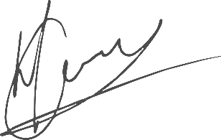

----------------------------------------------- -------------------------------------
Hannes Gouws RIAAN BOTHA / Authorised Representative
Director | PSAT 32449887 Date:

Blackhound Enterprises Banking Details:
Bank: NEDBANK
Account Type: Cheque Account
Account Number: 1212774191
Branch Code: 12681700 (Universal branch code)

