


BLACKHOUND ENTERPRISES PTY LTD
T/A BLACKHOUND ARCHITECTURE & RENDERING

Hannes Gouws
hannes@blackhoundenterprises.com
072 799 9597

Unit 10 – The Network
19 Cactus Road
Fairview
Port Elizabeth (Gqeberha)
Eastern Cape
2075

Unit 10 – The Network
19 Cactus Road
Fairview
Port Elizabeth (Gqeberha)
Eastern Cape
2075

Unit 10 – The Network
19 Cactus Road
Fairview
Port Elizabeth (Gqeberha)
Eastern Cape
2075

Client:
Rika Swart | SAMUS REST GUESTHOUSE
084 250 5485
marika@srvaley.co.za
Date: 10 JUNE 2024
|PROJECT BRIEF:
Measure the existing structure and do Municipal drawings and submit to council for approval for an existing guest house on Comando Kraal Estate, ERF ??, Addo, Eastern Cape.

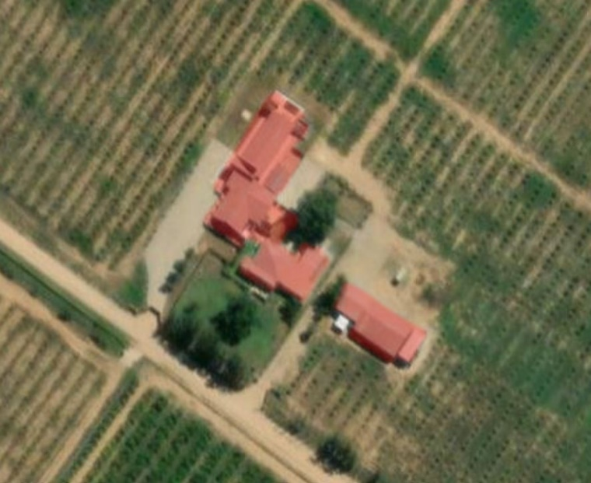

SCOPE OF WORKS:
  - Measure existing structures developed on erf: ± 2 058m².
Measured from NMBM GIS maps.

  - Prepare municipal drawings and submit to council for approval.
|SAMU REST: Quote & Deliverables
Measure, Municipal Drawings and Documentation:
Approximate Size of existing structures: ± 2 058.3m²

Professional Fees Calculation:
2.1) Phase 1: Measure and Redraw:
- Measure and redraw existing structures:
  - This includes measuring all existing structures built on site and redrawing the structure in electronic format.
R41 166.00 (± R20 per m²)
2.2) Phase 2: Municipal drawings, Documentation and Submission:
- Municipal drawings - Includes:
  - Here we will draw and detail the existing structures to comply with the national building regulations:
Site plan, Floor Plan, Section, Elevations, and basic Electrical layouts
  - Municipal Documentation and the council submission process.
  - Deemed-to-Satisfy Energy Efficiency and Fenestration calculations, as required by SANS10400.
  - Deemed-to-Satisfy fire plan.
R40 792.00
(± R20 per m²)
2.3) Site Visits:
  - We have allowed for 2 x Site visits in this fee proposal:
    - The first site visit will be to measure the existing structures.
    - The second site visit will be to submit the drawings to council in Kirkwood.

R2 035.00
KINDLY NOTE:
*Should our scope of work increase, our fees will be adjusted to accommodate the extra scope. This will be discussed before the work commences.
*This quote is only valid for 30 Days after the date of issue.

TOTAL QUOTE:
PHASE 1 & 2: R83 993.00 (VAT not applicable)

|PAYMENT TERMS:
- 70% Deposit payable at acceptance of quotation. (R 58 795.10)
- 30% Balance payable at Municipal Submission. (R 25 197.90)

Excluded from the fees:
- Submission fees and hard copy prints. (e.g. Council and municipal related fees/Estate/NHBRC)
- Other Professional consultancy fees that may be required (e.g. Structural Engineer, Quantity and Site Surveyors, Health & Safety, etc.)
- Execution of the works and testing of materials to ensure compliance with drawings and specifications remains the responsibility of the contractor.
- As-Built drawings, if any deviation occurred from the approved plans.
- Printing of drawings for site.
- Retrieval of Occupation Certificate.
- Contract and project management.

|TERMS AND CONDITIONS:
Blackhound will be employed for Phase 1 and Phase 2, as laid out in this document: to measure the existing structures built on the erf and to create municipal drawings and submit to submit the drawings and relative documentation to the local authority.
Furthermore, since Blackhound will not be appointed for additional architectural and professional services, it should be noted that the client will act as the intermediary between us and any contractor and sub-contractor. The client will also be responsible for obtaining all the certificates of compliance from contractors and their sub-contractors.

  - SITE VISITS:
If additional Site Visits are requested, a travel expense of R2 361.00 per Site Visit will be charged. This will be invoiced when Site visits are requested.
Travel Distance = 185km, round trip.

  - DETAILS AND TECHNICAL DRAWINGS:
This quotation is for measuring the existing structures and drawing the existing structures to municipal and National Building Regulation standards. Construction and technical detailing are not included in the current scope of work.

  - ON SITE DEVIATIONS:
We are not employed for contract and quality site management. For any deviations made on site that require an updated plan or a new submission to council, an hourly rate will be applied to update the drawings, a quotation will be sent to the client for approval prior to work. This quotation will be based on an hourly rate of R 650.00, which covers the cost of revising the drawings to be resubmitted to council for approval. Please note that the Hourly Rate is exclusive of Travel costs.

  - PRINTS:
Our fees are exclusive of any hard copy prints. If we must make hard copy prints for any reasons not attributed to BLACKHOUND ENTERPRISES PTY LTD, the client will be notified beforehand and will be invoiced separately or added to the client’s final invoice.
Revision drawings will be emailed to the site management team or the client where hard copy revision drawings will be the responsibility of the contractor / client / site manager.
If we must make hard copy prints for site, it will be added to an invoice at:
R55 per A1 print
R75 per A0 print.
Exclusive of any courier or delivery fees.

  - VAT:
BLACKHOUND ENTERPRISES PTY LTD. Is not a VAT vendor. All fees presented are exclusive of VAT until further notice.

  - FEE OFFSET:
The Client is not entitled to ‘set-off’ or withhold payment for any alleged claim against either BLACKHOUND ENTERPRISES PTY LTD or any other party involved in the building or design contract. The claim is to be dealt with on its own merits.

  - SUSPENSION:
BLACKHOUND ENTERPRISES PTY LTD retains the right to suspend all service until the settlement of any outstanding account.

  - TERMINATION:
In the event of the agreement between the parties being terminated by either party for reasons not attributable to BLACKHOUND ENTERPRISES PTY LTD, the fee for the work currently underway together with the completed work, would be payable.

  - OTHER PROFESSIONALS:
BLACKHOUND ENTERPRISES PTY LTD is not responsible for the performance of other professionals (Town Planners, Engineers, etc), drawings and documents provided by other professionals and suppliers, tender prices, the performance of Homeowner Associations, Municipalities or Municipal Services, the Contractor or any of his Sub-Contractors, Suppliers, or employees.

  - COPYRIGHT:
BLACKHOUND ENTERPRISES PTY LTD retains the ownership of copyright to all its intellectual property. No designs, drawings or documents may be used and shared with other parties without our express permission.

  - FINAL INVOICE:
The final invoice will be due upon submission to council. If the client decides not to proceed with council submission, the final invoice remains payable after two weeks from the notification of completed work.

|ACCEPTANCE:
The Terms and Conditions presented here may be modified or amended as necessary only by written instrument signed by both parties.
By submitting the non-refundable deposit payment and / or signing this document, you are agreeing to the terms and conditions detailed in this document. This proposal is agreed upon in full, signed and dated.
By signing this document, I indicate that I understand, agree to, and accept the terms and conditions as contained herein, dated this 10 JUNE 2024.

I, __________________________________________ hereby agree to the Terms and Conditions laid out in this document.

Email: hannes@blackhoundenterprises.com
Phone: 072 799 9597

----------------------------------------------- -------------------------------------
Hannes Gouws Client name:
Director | SACAP: PSAT 32449887 Date:

