


BLACKHOUND ENTERPRISES PTY LTD
T/A BLACKHOUND ARCHITECTURE & RENDERING

Hannes Gouws
hannes@blackhoundenterprises.com
072 799 9597

Unit 10 – The Network
19 Cactus Road
Fairview
Port Elizabeth (Gqeberha)
Eastern Cape
2075

Unit 10 – The Network
19 Cactus Road
Fairview
Port Elizabeth (Gqeberha)
Eastern Cape
2075

Unit 10 – The Network
19 Cactus Road
Fairview
Port Elizabeth (Gqeberha)
Eastern Cape
2075

Client:
TOBIAS LÖW
076 207 8167
t.loew@t-online.de

Date: 22 MARCH 2023
|SCOPE OF WORKS:
Design and do municipal drawings for additions and alterations to an existing house on ERF 686, 34 WARES ROAD, MILL PARK, PORT ELIZABETH, E.C.

Project Scope:
- Measure and draw the existing house.

- Design additions and alterations and 3d visualization.

- Develop the approved design drawings for municipal approval.

- BRIEF:

  - Amendments to:
    - Master bedroom, Dresser & En-suite.
    - Existing lobby.

  - Items to flag:
    - Scullery and Maids Bathroom is built over the building line.
      - This may result in altering the existing kitchen to accommodate the scullery and moving the existing Maids bathroom into the existing outbuilding.

|HOUSE LÖW FEE PROPOSAL.
Excluded from the fees:
- Submission fees and hard copy prints, if required. (e.g. Council and municipal related fees/Estate/NHBRC)
- Other Professional consultancy fees that may be required (e.g. Structural Engineer, Quantity and Site Surveyors, Health & Safety, etc.)
- Execution of the works and testing of materials to ensure compliance with drawings and specifications remains the responsibility of the contractor.
- Occupation and As-Built drawings, should the building not be built as per the approved plans.
- Printing of drawings for site.
Estimated Measurements:
Estimated Size of House (As previously approved): 360m²
Area of Erf (As per Title Deed): 892m²
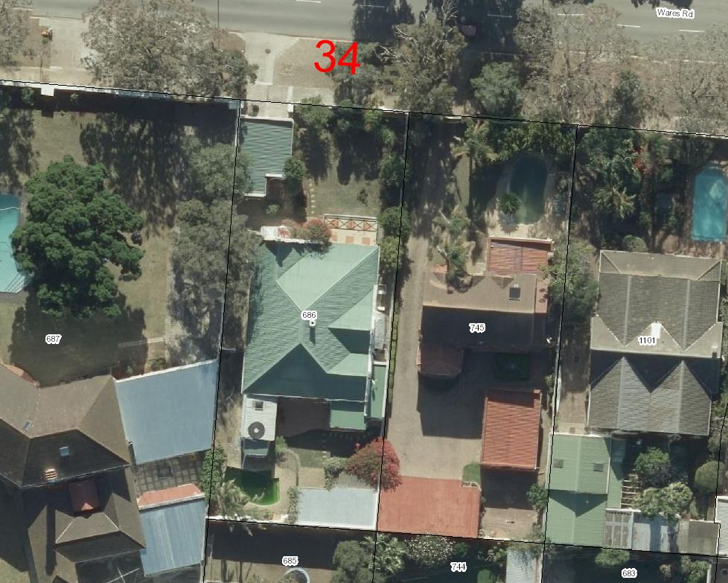

Affected spaces: (estimated measurements taken from the approved plans)
  - Master Bedroom, Dresser, En-suite bathroom, and existing lobby = ±47.7m²
- Estimated construction cost: ±R225 500.00
Architectural Fees Calculation:
Phase 1:
Measure and Redraw Existing:
This will include the first site visit to measure the existing building and gather the necessary municipal information to initiate the design.
We then redraw the existing house in 2d and 3d to start the design development.
- Measure, Redraw and 3d Model Existing Dwelling:
R17 708.00
Design process:
We will proceed with the design phase and liaise with you to achieve design approval.
Included in our fees for this phase is 3d modelling, to resolve design details and to give you a clear picture of what the design will look like before we proceed with the next phase.
- Design Proposed Additions and Alterations:
R5 376.00
Phase 2:
Municipal & Technical Drawings, Documentation and Submission:
- Floor Plans, Sections, Elevations, and basic Electrical layouts for municipal approval.
- Municipal Documentation and the council submission process.
- Deemed-to-Satisfy Energy Efficiency and Fenestration calculations, as required by SANS 10400.
  - Municipal Drawings and Submissions:
R9 814.40
Technical Detailing:
- Construction details.
- Windows and Door Schedules.
- Detailed electrical layouts, as per your required needs.
  - Construction and Technical Details:
R0.00

Phase 3:
Tender and Construction:
Should you require our assistance to manage the construction phase of this project, our fees will be:
R21 451.75
* This fee is based on the estimated construction cost for the project.
*Our final fee for phase 3 will be determined when a contractor with a BOQ or construction program is approved.
*This fee will be equally split over the construction period.

Architectural Fees:
PHASE 1: R23 084.00
PHASE 2: R9 814.40
(PHASE 3: R21 451.75)

TOTAL:
Phase 1 & 2: R32 898.40 (VAT not applicable)

KINDLY NOTE:
*Should our scope of work increase, our fees will be adjusted to accommodate the extra scope. This will be discussed before the work commences.
*This quote is only valid for 30 Days after the date of issue.
|PAYMENT TERMS FOR PHASE 1 & 2:
- 70% Deposit payable at inception. (R23 028.88)

- 30% Balance payable at Municipal Submission. (R9 869.52)

|ACCEPTANCE:
The Terms and Conditions presented here may be modified or amended as necessary only by written instrument signed by both parties.
By submitting the deposit payment, you are agreeing to the terms and conditions detailed in this document. This proposal is agreed upon in full, signed and dated.
By signing this document, I indicate that I understand, agree to, and accept the terms and conditions as contained herein, dated this 22 MARCH 2023.

I, __________________________________________ hereby agree to the Terms and Conditions laid out in this document.

Email: hannes@blackhoundenterprises.com
Phone: 072 799 9597

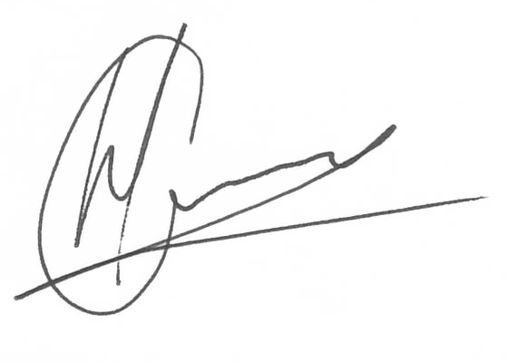

----------------------------------------------- -------------------------------------
Hannes Gouws Name:
Director | PSAT 32449887 Date:

|TERMS AND CONDITIONS:
Blackhound will be employed for Work stages 1 to 4.1, as part of PHASE 1 and 2, as laid out in this document: To design and create municipal drawings, assist with the municipal submission process until the design has been approved by the local authorities..
(Kindly see the end of the document for descriptions of the Architectural work stages.)
If Blackhound is not appointed for work PHASE 3 (Architectural Workstages 5 and 6), only PHASE 1 & 2: (Architectural Workstages 1 to 4.1) fees will be applicable and additional fees will be charged to provide a Form 4 and As-built drawings at the completion of the project, which is required to certify that the project has been completed in accordance with the National Building regulations and Standards Act. (As legally required and outlined in SANS 10400-A:2010)
  - SITE VISITS:
If Blackhound is employed for PHASES 1 - 3 (Architectural Work stages 1 to 6), fortnightly site visits will be included in the fees for PHASE 3.
If Blackhound is only employed for PHASES 1 & 2, and additional Site Visits are requested, a travel expense of R1150.00 per Site Visit will be charged. This will be invoiced at the end of each month for the duration of the project or when Site visits are requested.
  - DETAILS AND TECHNICAL DRAWINGS:
Technical drawings and detailing is removed for this fee proposal.
The municipal drawings will suffice to build from but will exclude construction and technical detailing which includes pricing details like, additional sections, window and door schedules, typical construction details, detailed lighting layouts and notes, which falls under stage 4.2 in the architectural work stages, and is not necessary for municipal approval, but is required for accurate pricing and construction detailing.
Please note: Should you then require technical detail drawings or any on site revision drawings, it will be charged at an hourly rate of R850 per hour.
  - PRINTS:
We will provide 1x set of hard copies of the municipal approved plans to the client.
Revision drawings will be emailed to the site management team or the client where hard copy revision drawings will be the responsibility of the contractor / client / site manager.
If we must make hard copy prints for site, it will be added to a monthly invoice at:
R95 per A1 print
R105 per A0 print.

  - EXTENDED CONSTRUCTION PERIOD:
Only applicable to PHASE 3: Should the construction period be extended, by no fault of BLACKHOUND, our fees will be amended by a daily rate to accommodate the extended construction period.

|ARCHITECTURAL WORK STAGES:
For information purposes only:
Stage 1: Inception
a) Receive, appraise and report on the client's requirements with regard to the client's brief;
b) Determine the site and rights and constraints;
c) Determine budgetary constraints; 0
d) Determine the need for consultants;
e) Determine indicative project timelines;
f) Determine methods of contracting; and
g) Whether other statutory authority applications are required or desirable.
Stage 2: Concept Design
- Prepare an initial design concept and advise on:
i the intended space provisions and planning relationships;
ii proposed materials and intended building services; and
iii the technical and functional characteristics of the design.
b) Check for conformity of the concept with the rights to the use of the land.
c) Consult with local and statutory authorities.
d) Review the anticipated costs of the project. e) Review the project programme.
Stage 3: Design Documentation
a) Develop all aspects of the design from concept to full development including, but not limited to, construction systems, materials, fittings, and finishes selections;
b) Review the programme and budget with the client, principal consultant or other consultants;
c) Coordinate other consultants’ designs into building design;
d) Prepare design development drawings including drafting technical details and material specifications;
e) Discuss and agree on the building plan application and approval requirements with the local authority;
Stage 4: Documentation and Procurement (municipal submission stage)
Stage 4.1:
a) Prepare documentation required for local authority building plan application submission;
b) Co-ordinate technical documentation with the consultants and complete primary co-ordination sufficient to support building plan submission;
c) Review the costing and programme with the consultants;
d) Obtain the client's authority, and submit documents for approval at the local authority.

Stage 4.2:
a) Prepare specifications for the works;
b) Complete technical documentation sufficient for tender;
c) Obtain offers for the execution of the works;
d) Evaluate offers, and recommend a successful tenderer for appointment;
e) Prepare the contract documentation and arrange the signing of the building contract by the client and the successful tenderer;
f) Complete all remaining technical and construction documentation and coordinate same with the consultants;
Stage 5: Construction
a) Administer the building contract;
b) Give possession of the site to the contractor;
c) Issue construction documentation;
d) Review sub-contractor designs, shop drawings and documentation for conformity of design intent;
e) Inspect the works for conformity with the contract documentation and acceptable quality in terms of industry standards;
f) Administer and perform the duties and obligations assigned to the principal agent in the building contract;
g) Manage the completion process of the project;
h) Assist the client to obtain the required documentation necessary for the client to obtain the occupation certificate.
Stage 6: Close out
a) Facilitate the project close-out including the collation of the necessary documentation to effect completion, handover and operational manual of the project.
b) When the contractor's obligations with respect to the building contract have been fulfilled, the architectural professional shall issue the certificates related to the contract completion.
c) Provide the client with construction record documentation and the relevant technical and contractual undertakings by the contractor and subcontractors.

