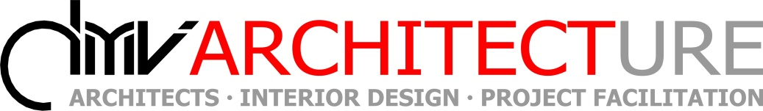
Unit 6, 1 Bridge Street
South End
Port Elizabeth
Tel: 041 581 1590
Cell: 083 295 3601
dal@dmvarchitecture.co.za

3 November 2017

Att : Building Inspector
C/O : Nelson Mandela Bay Municipality

FINAL COMPLETION – ERF

To whom it may concern:

This letter serves to confirm that final completion for the construction of the New Substation by Omega Building for has been reached on ERF. This has been completed to our satisfaction and is in accordance with the approved municipal plans.

Kind regards,

……………………………..
Dal Venables
MArch.
Reg. No. PrArch21014

