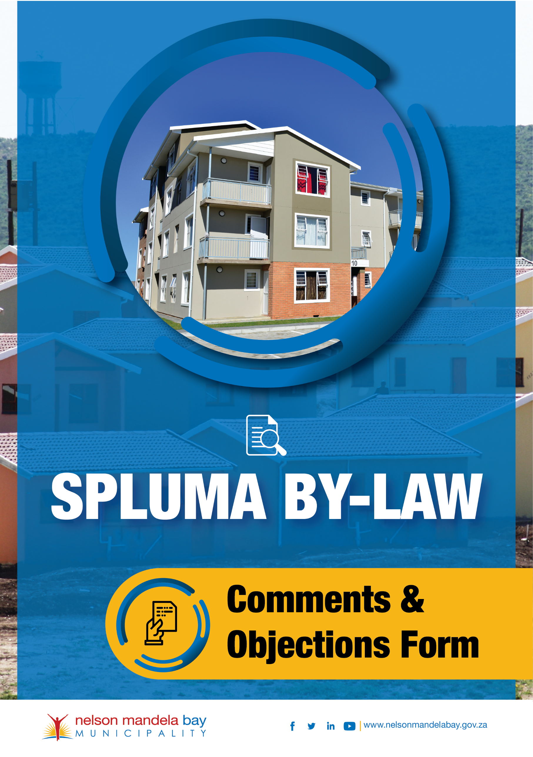
COMMENTS AND OBJECTIONS FORM

In terms of the provisions of the Nelson Mandela Bay Municipality Spatial Planning and Land Use Management By-Law, 2023
All complaints must be submitted in writing on the attached form and emailed to the below email address. Anonymous complaints will not be investigated. Further information may be requested in the form of a sworn affidavit in relation to the activities witnessed on site. This may lead to evidence being given in court.
PART A: COMMENTOR AND/OR OBJECTOR INFORMATION

First Name(s):

Surname:

Erf number:

Street address:

Email address:

Telephone number: |  |  | Cell phone number:

PART B: COMMENT AND OBJECTION

Nature of Application

Subject erf number:

Subject street address:

Interest in application:

Comment and/or objection:

(please attach additional pages, if needed)

PART C: DECLARATION

I, the undersigned, hereby declare that I am familiar with the contents of the provided information and other document(s) to the application presented on the subject listed in Parts A and B of this form

Name(s) and Surname:

Signature: |  | Date:

FOR OFFICIAL USE ONLY:

Date received:

Received by:

Email address deliverable to: | [please insert]

