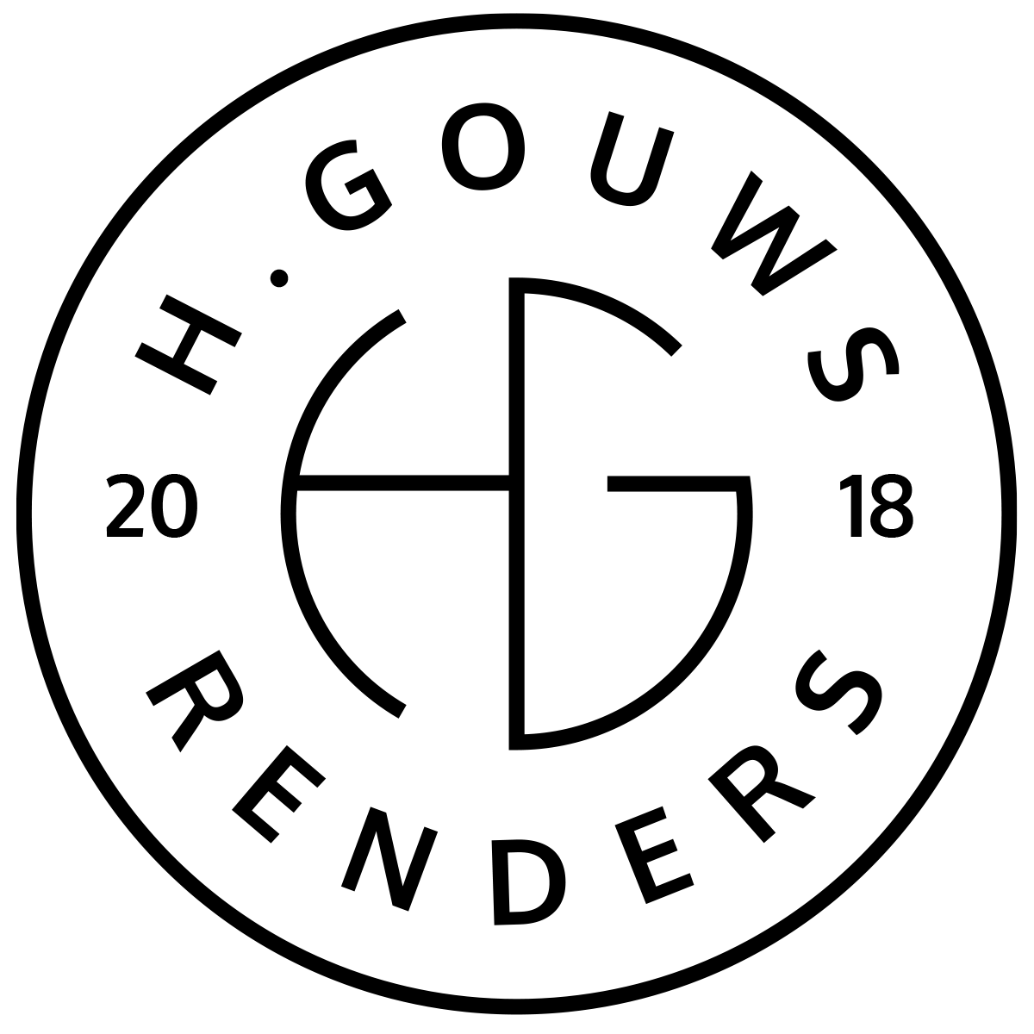H. Gouws Renders PTY LTD:
2020/784683/07

Unit 10 – The Network
19 Cactus Road
Fairview
Port Elizabeth (Gqeberha)
Eastern Cape
2075

Hannes Gouws
hgouws.renders@gmail.com
072 799 9597

Date: 01 JUNE 2022

POWER OF ATTORNEY.
To whom it may concern:
Permission is hereby given to Hannes Gouws from H. Gouws Renders to submit the Site Development Plan / Municipal Plans and relevant Documentation on behalf of the client to the relevant municipality.

ERF NO: …………………………………………………………………...

PHYSICAL ADDRESS: ……………………………………………………………………

CLIENT NAME: ……………………………………………………………………
[Please find attached a
Copy of the client’s ID
Document]

CONTACT NUMBER: ……………………………………………………………………

Thank you.
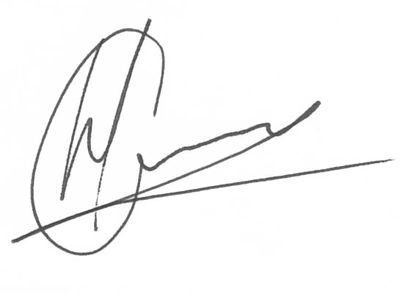Kind regards:

----------------------------------------------- --------------------------------
Hannes Gouws Client Signature: Daniel Dicks
Director ID: 7006015002082
H. Gouws Renders Date: 01 JUNE 2022

