
BLACKHOUND ENTERPRISES PTY LTD
T/A BLACKHOUND ARCHITECTURE & RENDERING

Hannes Gouws
hannes@blackhoundenterprises.com
072 799 9597

Unit 10 – The Network
19 Cactus Road
Fairview
Port Elizabeth (Gqeberha)
Eastern Cape
2075

Unit 10 – The Network
19 Cactus Road
Fairview
Port Elizabeth (Gqeberha)
Eastern Cape
2075

Unit 10 – The Network
19 Cactus Road
Fairview
Port Elizabeth (Gqeberha)
Eastern Cape
2075

Date: 01 JUNE 2022

POWER OF ATTORNEY.
To whom it may concern:
Permission is hereby given to Hannes Gouws from Blackhound Architecture & Rendering to submit the Site Development Plan / Municipal Plans and relevant Documentation on behalf of the client to the relevant municipality.

ERF NO: …………………………………………………………………...

PHYSICAL ADDRESS: ……………………………………………………………………

CLIENT NAME: ……………………………………………………………………
[Please find attached a
Copy of the client’s ID
Document]

CONTACT NUMBER: ……………………………………………………………………

Thank you.
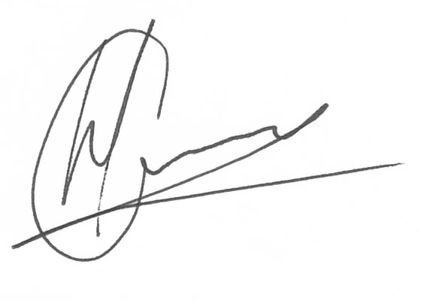Kind regards:

----------------------------------------------- --------------------------------
Hannes Gouws Client Signature:
Director ID No.:
Blackhound Architecture &
Rendering

