HR Offices - EXTERNAL - 2025/05/29
PAINT COLOURS:
- BRILLIANT WHITE (Fascia’s, barge boards, window cills, areas on walls.)
- SONG PORCELAN
- DARKEN PUDDLE
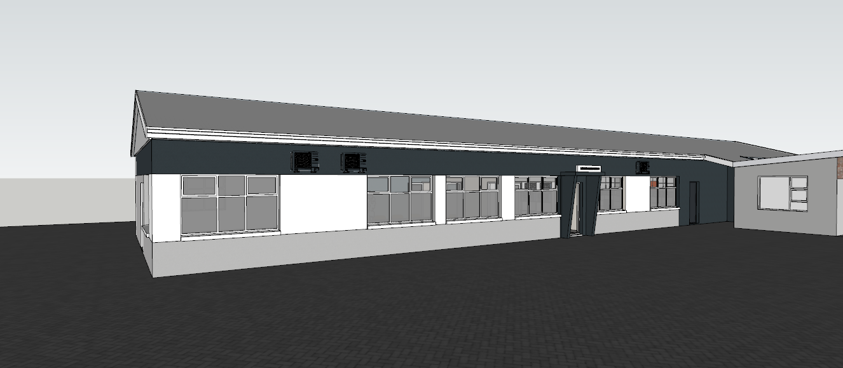
1
3
1
1
1
3
3
2
2
1
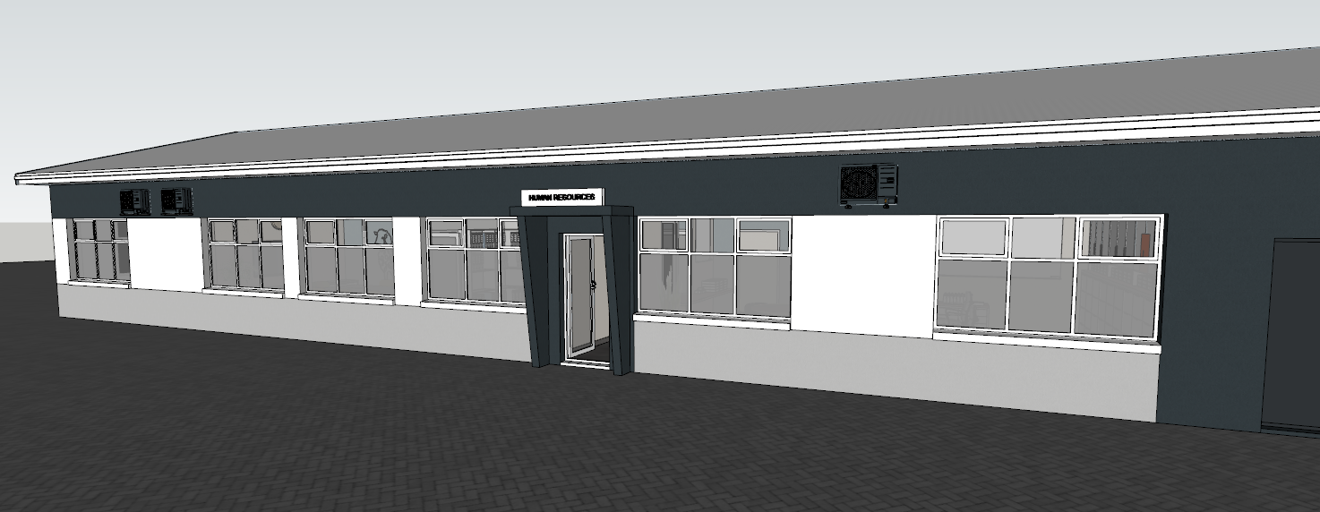
1
2
2
1
1
1
1
3
3
3
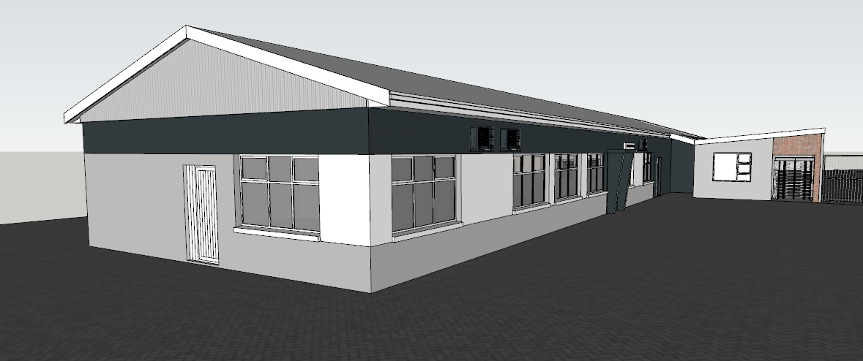
1
2
3
3
Existing sheeting
3
1
1
2
2

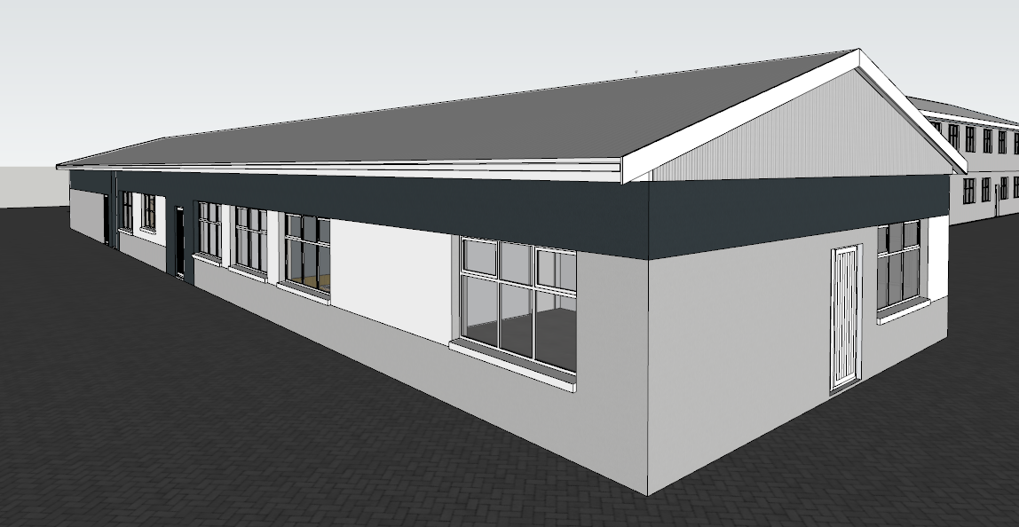
1
2
1
1
2
2
1
3
3
3
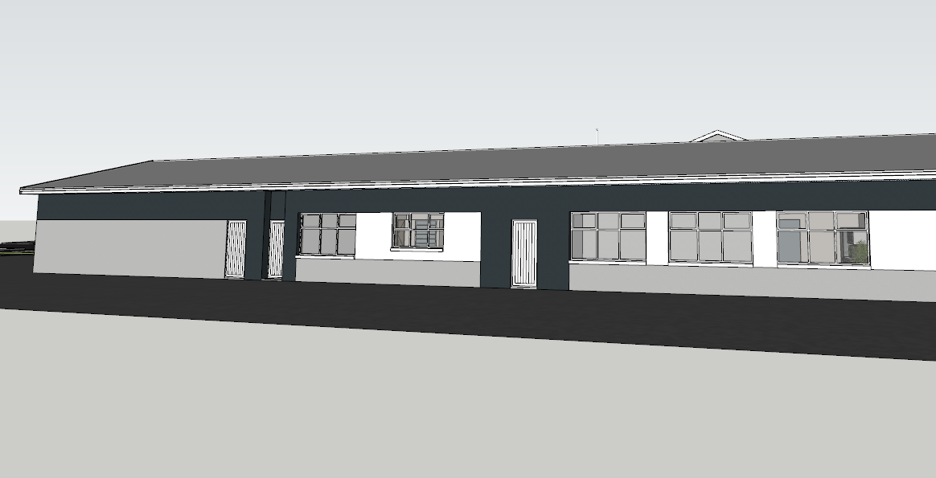
2
2
3
1
1
1
2
3

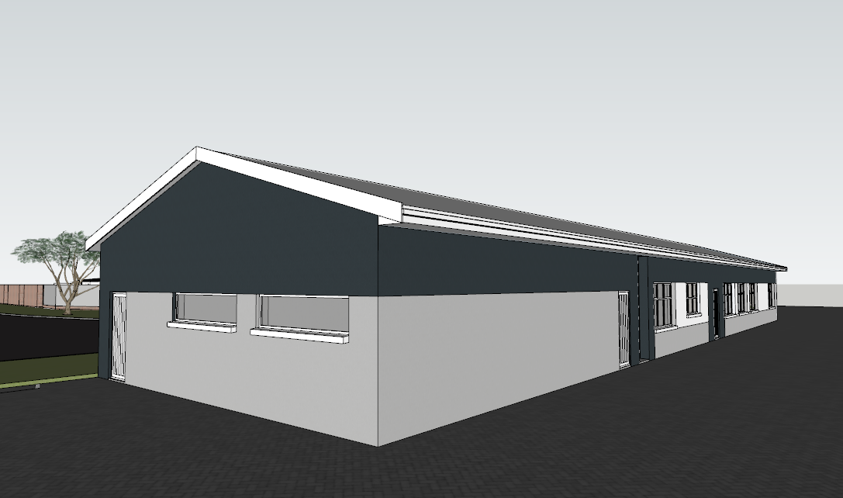
3
2
1
1
2
3
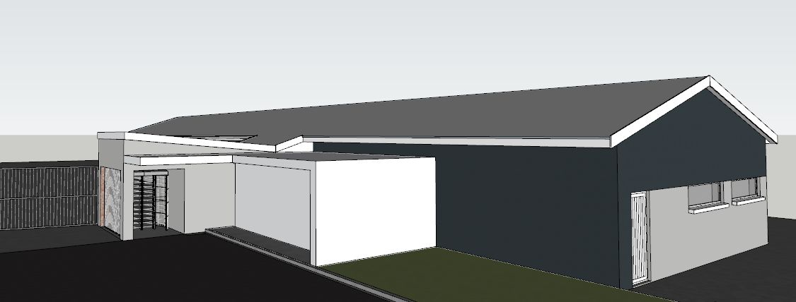
1
1
2
2
2
3
3

