2025 – 05 – 19
Updated Joinery, as per client.

PROJECT: G&I – Office Block

- Kitchenette area behind the Boardroom TV wall:
    - 4630 (L) x 550 (D) x 900 (H) – Height includes base height
    - 100mm (H) x 20mm (T) Eezi Qaurtz splash back – Magnolia
    - 20mm Thick Eezi Qaurtz countertop – Magnolia
    - Black grab handle – Length 200mm
    - 16mm Melamine framed with impact edging
    - Melamine to be Storm Grey
    - 100mm (H) Base to be plywood and covered with Super Black.
    - 4x drawers
    - 1 x single center shelf in the middle of the cupboards. (Spaces: Top & Bottom)
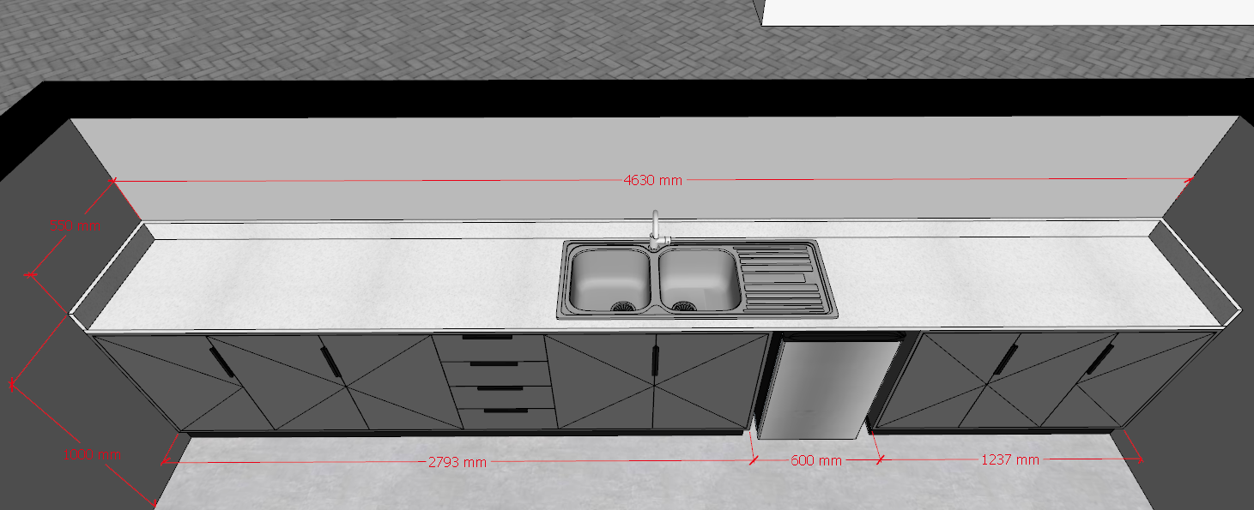

- Server area in kitchenette area behind boardroom TV wall:
    - 2065 (L) x 350 (D) x 900 (H) – Height includes base height
    - 100mm (H) x 20mm (T) Eezi Qaurtz splash back – Magnolia
    - 20mm Thick Eezi Qaurtz countertop – Magnolia
    - Black grab handle – Length 200mm
    - 16mm Melamine framed with impact edging - Dunblane
    - Melamine doors - Dunblane
    - 100mm (H) Base to be plywood and covered with Iceberg White.
    - 1 x single center shelf in the middle of the cupboards. (Spaces: Top & Bottom)
    - Floating shelf:
      - 3 x black L-brackets fixed to drywall.
      - 32mm (T) melamine with impact edging.
      - Colour to be Brookhill Fusion
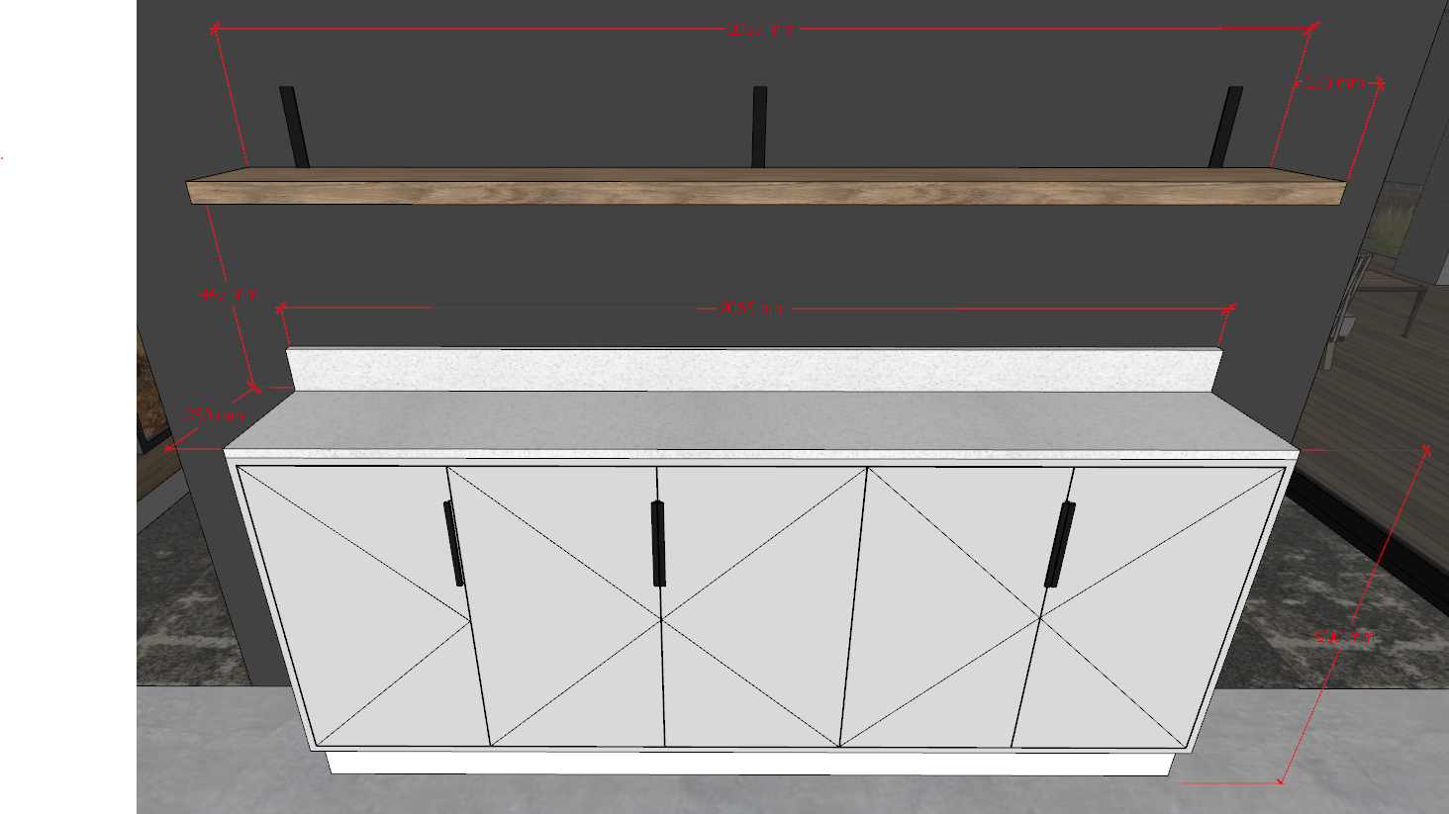

- Boardroom Table:
    - 4000 (L) x 1200 (D) x 770 (H) – Height includes base height
    - 50mm build up with 16mm Melamine and covered with Oak veneer to match wallpaper wall.
    - 20mm solid oak edging
    - 50mm x 70mm powder coated black steel base
    - Power docking allowance - PC of R 4000.00
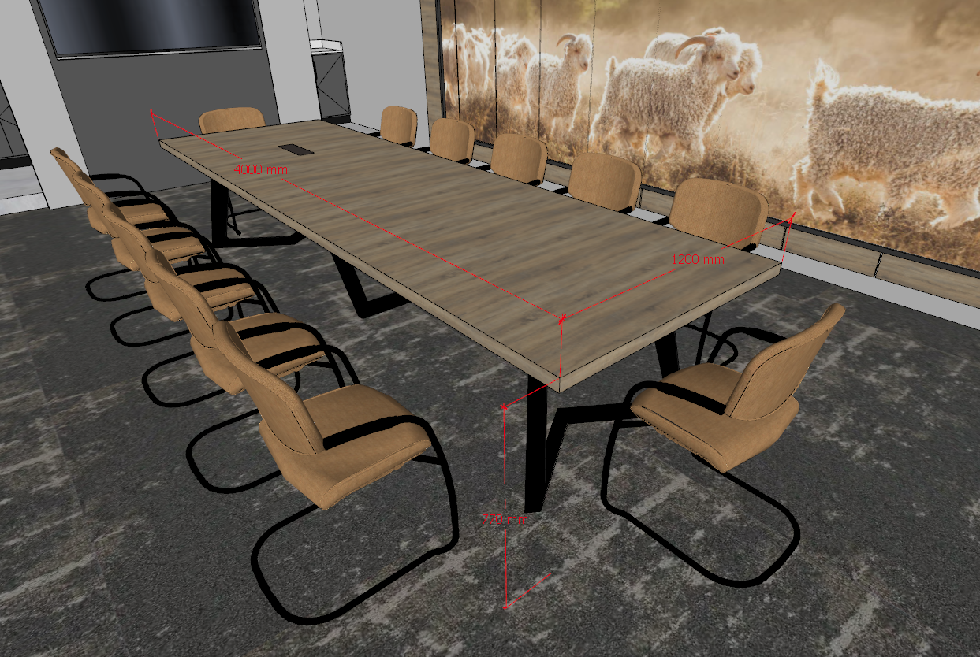

- 1 x Slatted Bench:
- Solid oak slats as per design
- Mild steel sub frame
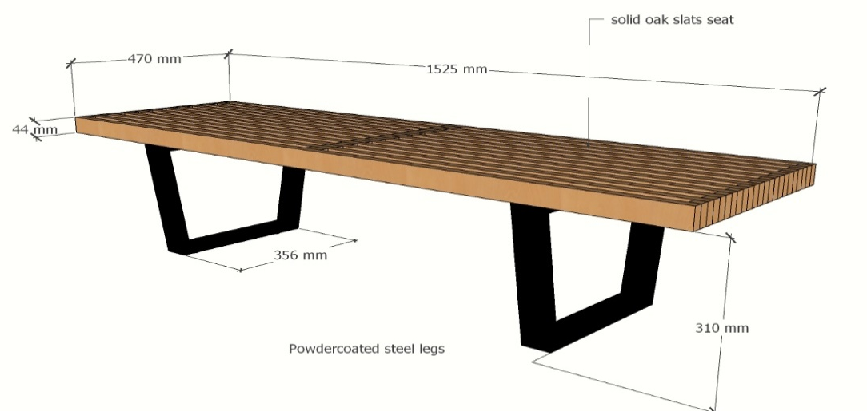

- Sanding down of wall panels in Boardroom + The frame and backing of the wallpaper:
    - Mural Frame: 5450 (L) x 1970 (H)
    - 16mm Backing for wallpaper
    - 32mm x 32mm MFD frame around backboard
    - 150mm (H) skimmed bulkhead to hide existing sprinkler system piping.
    - Painting and sanding of current wall panels (E.g. panel size - 600x 2320mm)
(Needs to match boardroom table, else we need to make the wall panels oak veneer. As per our discussion.)
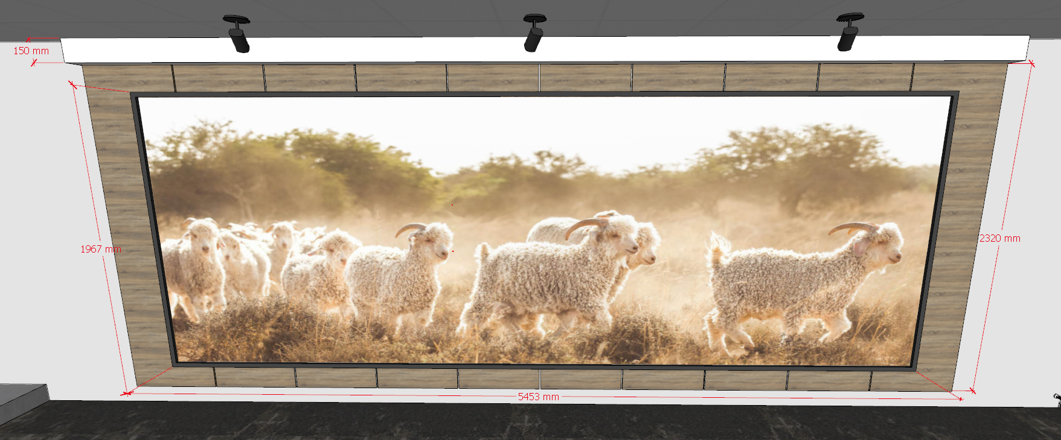
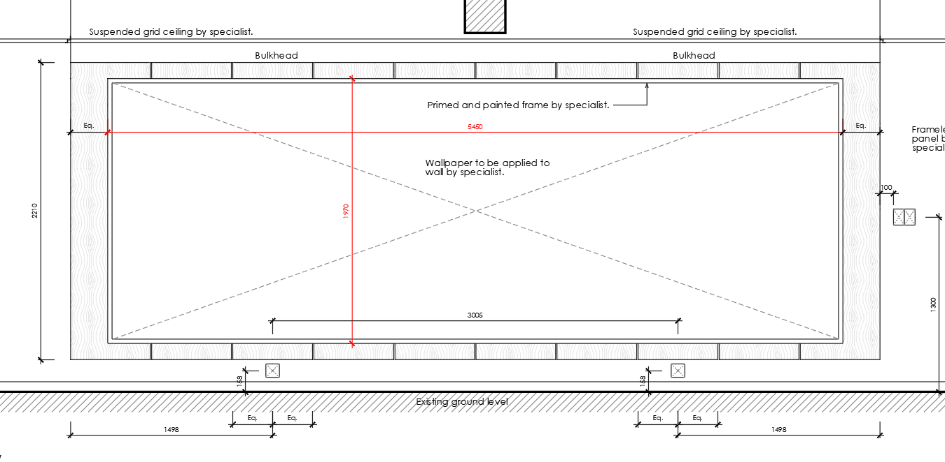
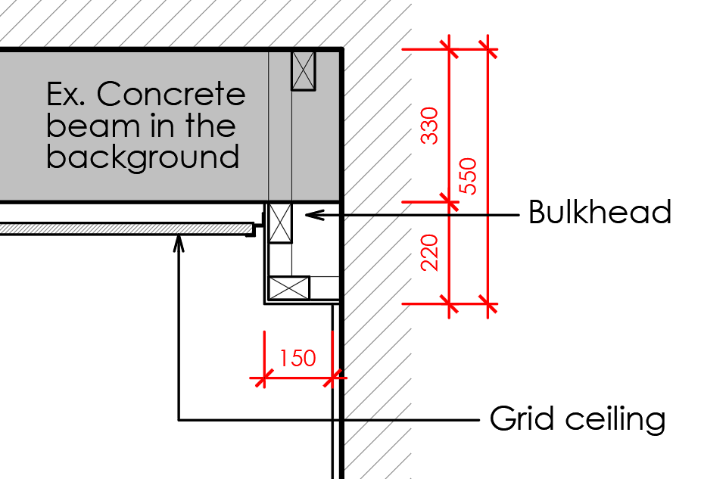
- Arch wall – Display area:
- 200mm high skimmed bulkhead
- Arch cover panel 18mm shutter-ply (2630mm (H) x 4151 mm (arched length))
- 150mm (H) shutter-ply base + Painted/Sprayed (Either or)

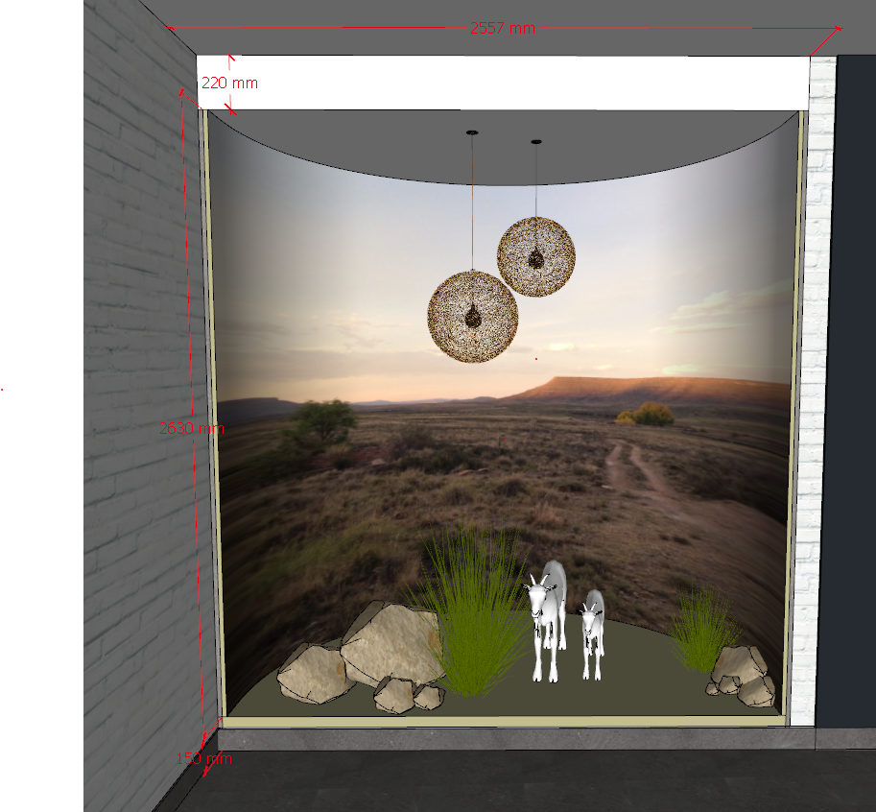

- Exhibition space (Display) – VOIDED
PC = R 8200
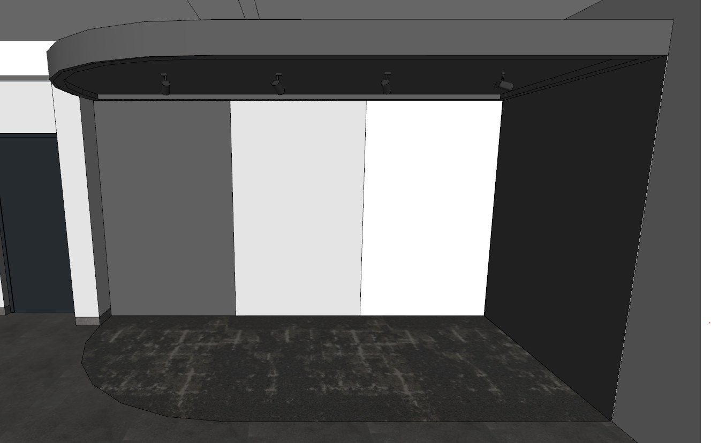

- Kitchenette on First Floor:
- Replace doors, draw fronts (Re-using existing carcasses only)
- Install new hinges and runners
- Install new base cladding
- Black grab handle – Length 200mm
- Remedial repair work to existing cabinets
- Install Eezi quarts 20mm top - Magnolia
- 4 x floating shelves:
      - 1380mm (L) x 300mm (D) x 32mm (H)
      - 32mm thick (16x2mm) melamine with matching impact edging.
      - Colour to be Brookhill Fusion
2025 – 05 -06
As per meeting on site with client. It was asked to use the existing carcass as a template to install a complete new kitchenette.
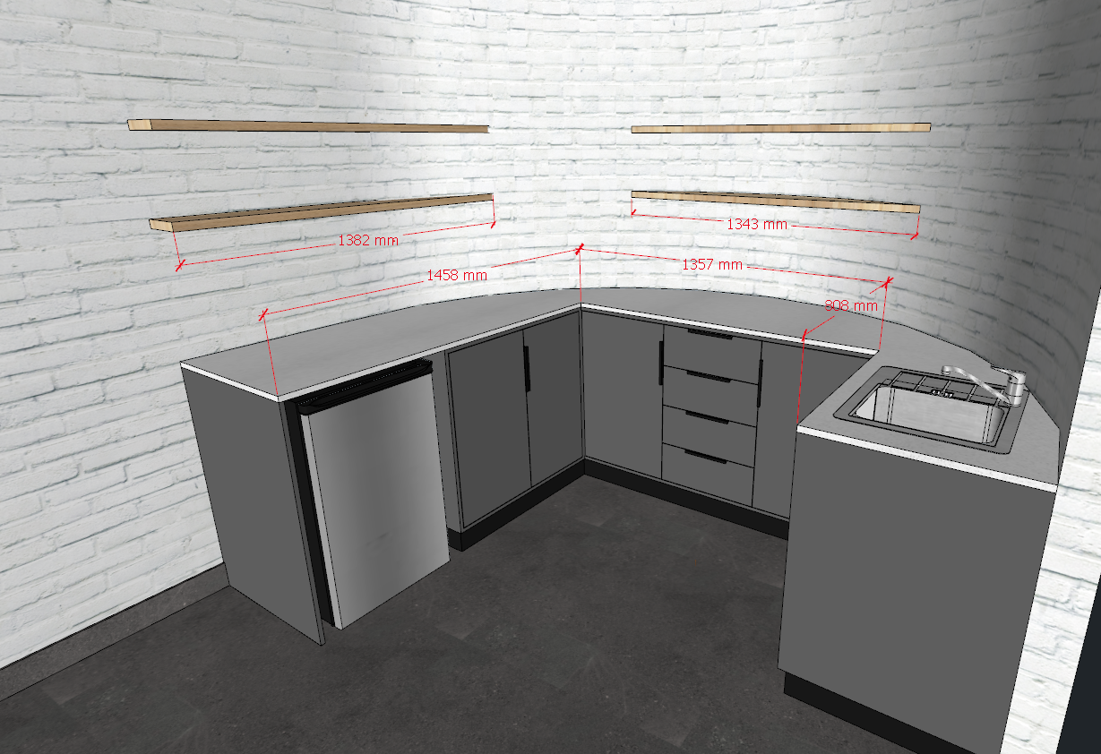

Please include: New framed area for wallpaper at bench
2140mm (w) x 1580mm (h) - To match boardroom frame style and colour.
