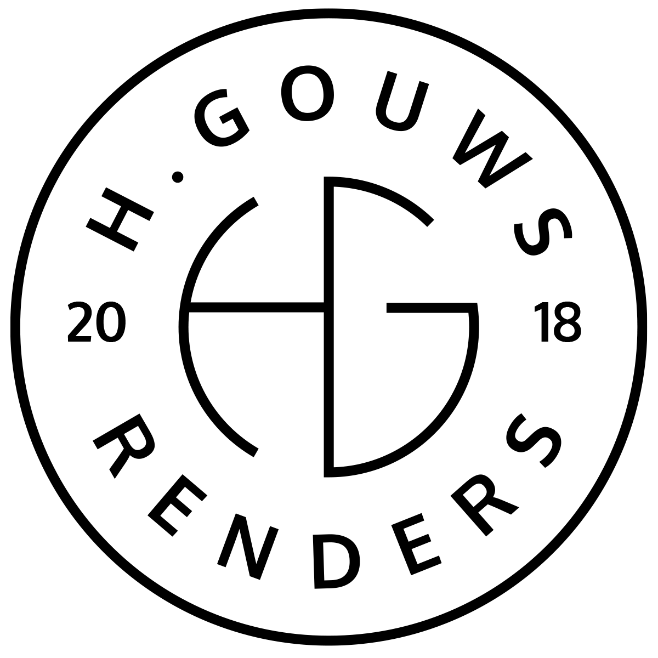H. Gouws Renders PTY LTD:
2020/784683/07
T/A: H. Gouws Renders and Designs

Unit 10 – The Network
19 Cactus Road
Fairview
Port Elizabeth (Gqeberha)
Eastern Cape
2075

Client:
LADYGROUP PTY LTD
VAT nr. 4 300 265 107
Reg nr. 2013/221295/07
5 Sunnybrae
Lovemore Heights Estate
Port Elizabeth (Gqeberha)
Eastern Cape
2075
INVOICE:
000402022OWEN
Date: 25 April 2022

Item: | Description: | Quantity: | Price: | Total:
-------------------------------------------------------------------------------------------------------
1 | Additions and alteration: Double Garage added to plans and submit.
| 7.0 hrs | R850.00 p/h | R5 950.00

-----------------------------------------------------------------------------------------------------------------------------------
TOTAL:
VAT Not Applicable R5 950.00 ex VAT

Banking details:
Nedbank
Account Number: 1212774191
Branch Code: 12681700
Cheque account

KINDLY USE THE INVOICE NUMBER AS YOUR PAYMENT REFERENCE

