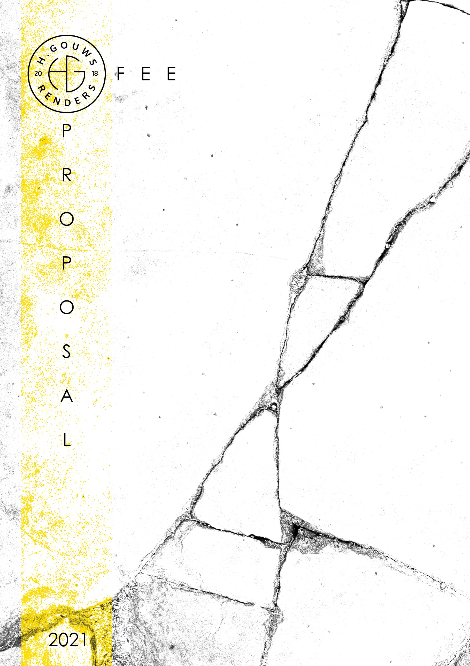

H. Gouws Renders PTY LTD:
2020/784683/07

1 Elsa Joubert street
Fairview
Port Elizabeth (Gqeberha)
Eastern Cape
2075

Client:
Neil Swire-Griffiths
Contact person:
CVL Projects
cvlprojectsoffice@gmail.com
Charl Van Loggenberg
064 236 3355
Date: 05 May 2021
|SCOPE OF WORKS:
Design and create Municipal drawings for a new Double Storey house in Plettenberg Bay, Western Cape, for Mr. & Mrs. Neil Swire-Griffiths.
Project Requirements:
- 4 Bedrooms
- Bathrooms (TBD) + Master En-suite
- Study
- Open plan Living, Kitchen and Dining with Scullery.
- Double Garage
|3D VISUALIZATIONS:
Included in my quote for the project is conceptual 3d’s, to assist in resolving the design, and details.
Should the client want to use my Photo Realistic rendering services for further visualization which can assist in selling of the property, kindly notify me of how many renders you want, then I can prepare a quote separately.

|PROJECT SPECIFICS:
H. Gouws Renders are employed for Work stages 1 to 4.2: to Design and create municipal drawings for a single storey dwelling, and to assist with the municipal submission process until the design has been approved by the local authorities.

SITE VISITS:
My overall quote will include 4 (two) quality check Site visits.
Extra Site visits will be quoted at R4500.00 per site visit. Calculated to cover the travel distance, as per the A.A. rates and time out of office.

DETAILS AND TECHNICAL DRAWINGS:
As agreed with Charl, the municipal drawings will be drawn to a level of detail to build from. I will be available on my cell or email should the builder/contractor require insight or spot details.

Please note I will require a site survey from a Professional surveyor to commence with the design.

PRINTS:
My quote will include 1 x set of the approved municipal drawings for site.
Revision drawings will be emailed to the site management team. Hard copy revision drawings will be the responsibility of the site manager.
If I have to make hard copy prints for site, it will be added to a monthly invoice of:
R60 per A1 print
R80 per A0 print.

|QUOTE:
Design and do Municipal Drawings and Documentation for a new dwelling:
Excluded from the fees:
- Submission fees and hard copy prints, if required. (e.g. Council and municipal related fees/Estate/NHBRC)
- Other Professional consultancy fees that may be required (e.g. Structural Engineer, Quantity and Site Surveyors, Health & Safety, etc.)
- Execution of the works and testing of materials to ensure compliance with drawings and specifications remains the responsibility of the contractor.
- Occupation and As-Built drawings, should the building not be built as per the approved plans.
- Printing of drawings for site.

                - R60 000.00 ex. VAT
Photo Realistic Renders: (To be discussed and quoted separately)
TOTAL QUOTE: _________________________________R60 000.00 ex VAT
50% Deposit payable at inception, with the balance payable at municipal submission.

|ACCEPTANCE:
The Terms and Conditions presented here may be modified or amended as necessary only by written instrument signed by both parties.

By submitting the deposit payment, you are agreeing to the terms and conditions detailed above. This proposal is agreed upon in full, signed and dated.

By signing this document, I indicate that I understand, agree to and accept the terms and conditions as contained herein, dated this 03 MAY 2021.

I, __________________________________________ hereby agree to the Terms and Conditions laid out in this document.

Date:
Signature / Digital Signature:
|ARCHITECTURAL WORK STAGES:
Stage 1: Inception
a) Receive, appraise and report on the client's requirements with regard to the client's brief;
b) Determine the site and rights and constraints;
c) Determine budgetary constraints;
d) Determine the need for consultants;
e) Determine indicative project timelines;
f) Determine methods of contracting; and
g) Whether other statutory authority applications are required or desirable.

Stage 2: Concept Design
- Prepare an initial design concept and advise on:
i the intended space provisions and planning relationships;
ii proposed materials and intended building services; and
iii the technical and functional characteristics of the design.
b) Check for conformity of the concept with the rights to the use of the land.
c) Consult with local and statutory authorities.
d) Review the anticipated costs of the project. e) Review the project programme.

Stage 3: Design Documentation
a) Develop all aspects of the design from concept to full development including, but not limited to, construction systems, materials, fittings, and finishes selections;
b) Review the programme and budget with the client, principal consultant or other consultants;
c) Coordinate other consultants’ designs into building design;
d) Prepare design development drawings including drafting technical details and material specifications;
e) Discuss and agree on the building plan application and approval requirements with the local authority;
Stage 4: Documentation and Procurement (municipal submission stage)
Stage 4.1:
a) Prepare documentation required for local authority building plan application submission;
b) Co-ordinate technical documentation with the consultants and complete primary co-ordination sufficient to support building plan submission;
c) Review the costing and programme with the consultants;
d) Obtain the client's authority, and submit documents for approval at the local authority.
Stage 4.2:
a) Prepare specifications for the works;
b) Complete technical documentation sufficient for tender;
c) Obtain offers for the execution of the works;
d) Evaluate offers, and recommend a successful tenderer for appointment;
e) Prepare the contract documentation and arrange the signing of the building contract by the client and the successful tenderer;
f) Complete all remaining technical and construction documentation and coordinate same with the consultants;

Stage 5: Construction
a) Administer the building contract;
b) Give possession of the site to the contractor;
c) Issue construction documentation;
d) Review sub-contractor designs, shop drawings and documentation for conformity of design intent;
e) Inspect the works for conformity with the contract documentation and acceptable quality in terms of industry standards;
f) Administer and perform the duties and obligations assigned to the principal agent in the building contract; g) Manage the completion process of the project;
h) Assist the client to obtain the required documentation necessary for the client to obtain the occupation certificate.

Stage 6: Close out
a) Facilitate the project close-out including the collation of the necessary documentation to effect completion, handover and operational manual of the project.
b) When the contractor's obligations with respect to the building contract have been fulfilled, the architectural professional shall issue the certificates related to the contract completion.
c) Provide the client with construction record documentation and the relevant technical and contractual undertakings by the contractor and subcontractors.

Email: hgouws.renders@gmail.com
Cell: 072 799 9597
Instagram: @hgouws.renders
Facebook: H. Gouws Renders (@hgouws.renders)

Thank you for the opportunity to quote on your project.

Keep well, and chat soon.
Thank you.

Kind Regards

Hannes Gouws
3d Artist | Professional Senior Architectural Technologist | PSAT 32449887

