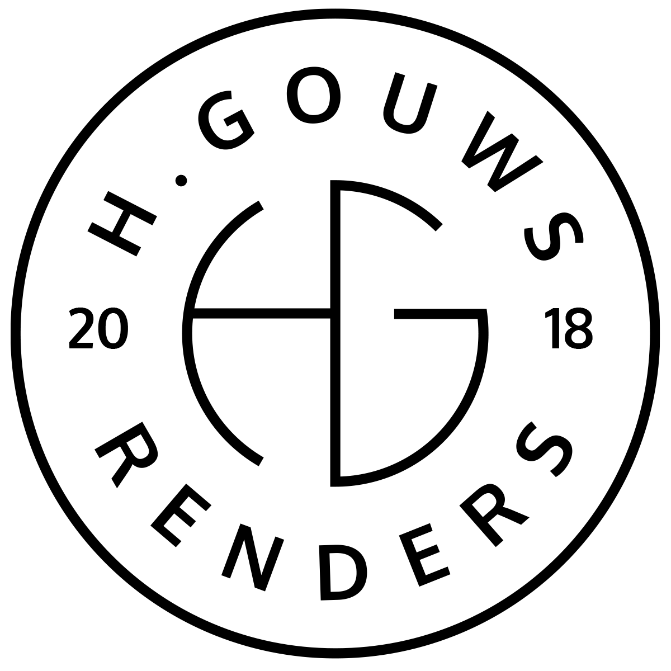H. Gouws Renders PTY LTD:
2020/784683/07

19 Cactus Road
Fairview
Port Elizabeth (Gqeberha)
Eastern Cape
2075

Client:
Dr. Johan Scherman
johan@healthgroup.co.za
082 588 6682
Zoetvlei
Paterson
Vat nr. 4630294058
INVOICE:
000352022ZOETVLEI
Date: 24 JANUARY 2022

Project Description:
-------------------------------------------------------------------------------------------------------
Zoetvlei Wildlife Estate Phase 2: Multifunctional Venue Design
Item: | Description: | Quantity: | Price: | Total:
-----------------------------------------------------------------------------------------------------------------------------------1 | Design Deposit | 0.5 | R70 200.00 | R35 100.00

-----------------------------------------------------------------------------------------------------------------------------------
TOTAL:
R35 100.00 ex VAT

Banking details:
Nedbank
Account Number: 1212774191
Branch Code: 12681700
Cheque account

KINDLY USE THE INVOICE NUMBER AS YOUR PAYMENT REFERENCE

