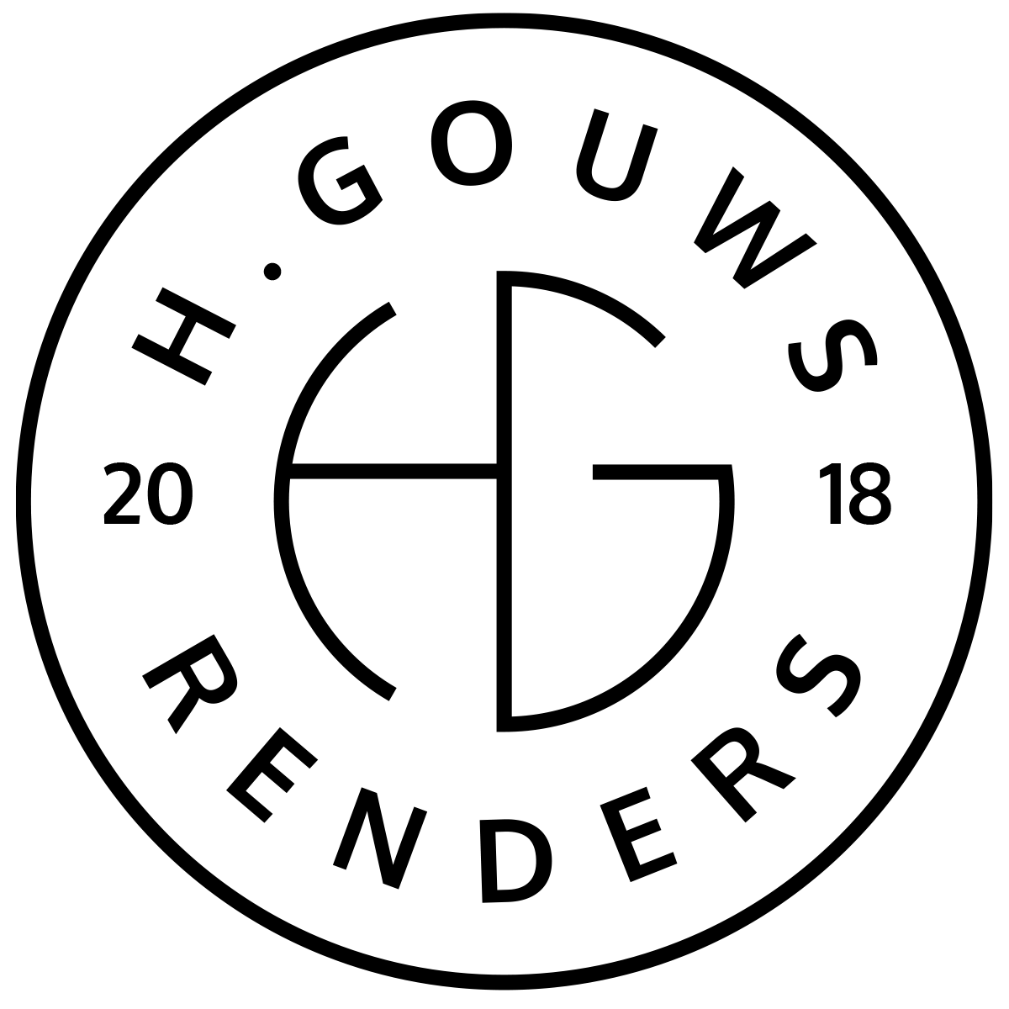H. Gouws Renders PTY LTD:
2020/784683/07
T/A: H. Gouws Renders and Designs

Unit 10 – The Network
19 Cactus Road
Fairview
Port Elizabeth (Gqeberha)
Eastern Cape
2075

Client:
Ms. Penelope Smith
Page Group
17 Vincent Road
Vincent
East London
5201
INVOICE:
000472022GUSSIES
Date: 25 April 2022

Item: | Description: | Quantity: | Price: | Total:
-------------------------------------------------------------------------------------------------------
1 | 3d Concept model and existing drawings:
| 12 hrs | R850.00 p/h | R10 200.00
2 | Gussie’s Boardwalk Mall – Tech Drawings for Body Corporate:
| 4 hrs | R950.00 p/h | R3 800.00
3 | Check Plans for Famous brands Boardwalk mall Submission:
| 1 hrs | R950.00 p/h | R950.00
4 | Meet at Humewood Penthouse to collect Famous brand plans:
| 44km | R4.50per km | R198.00
-----------------------------------------------------------------------------------------------------------------------------------
TOTAL:
VAT Not Applicable R15 148.00 ex VAT

Banking details:
Nedbank
Account Number: 1212774191
Branch Code: 12681700
Cheque account
KINDLY USE THE INVOICE NUMBER AS YOUR PAYMENT REFERENCE

