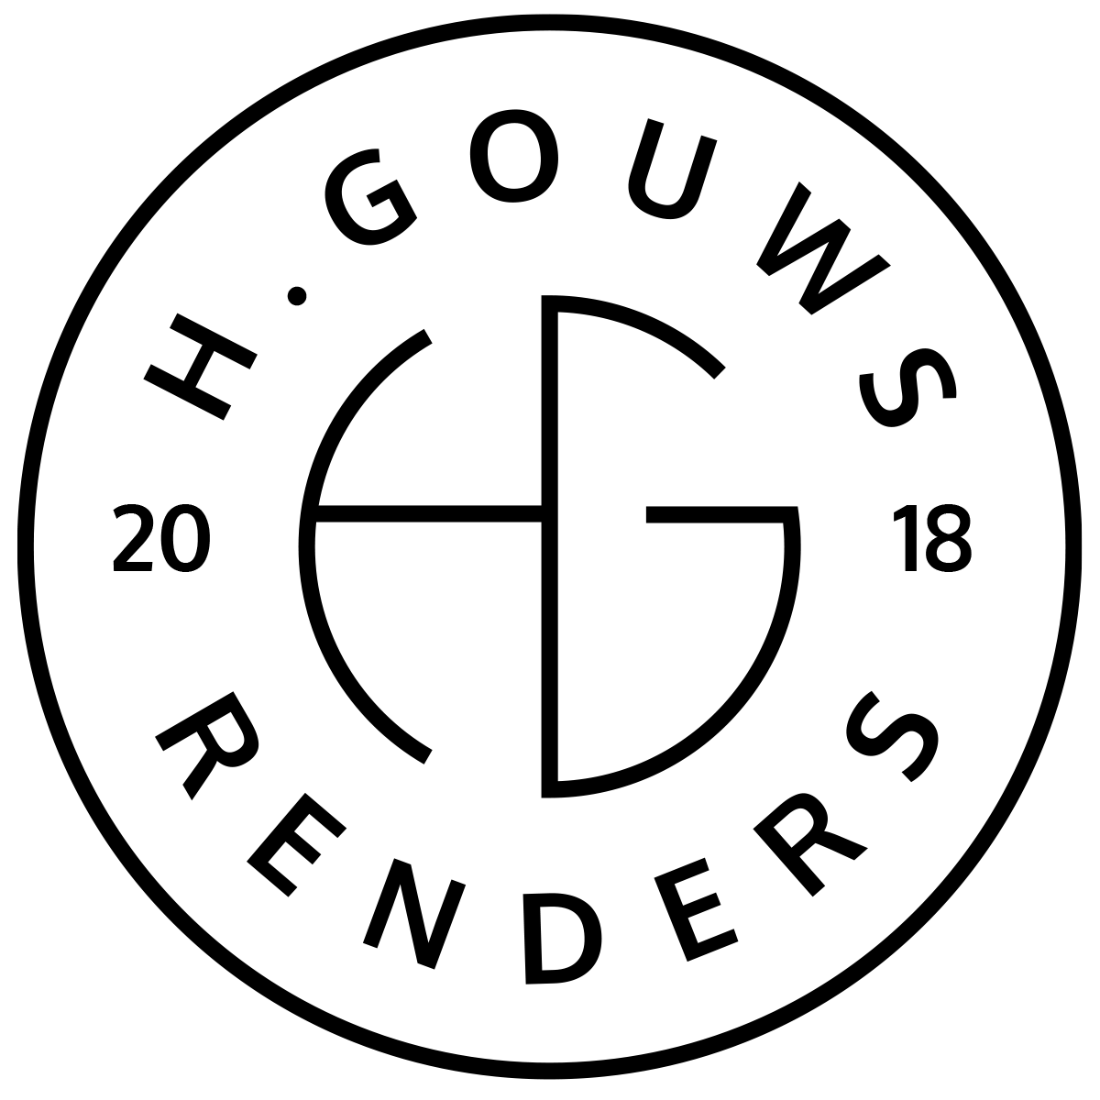H. Gouws Renders PTY LTD:
2020/784683/07

1 Elsa Joubert street
Fairview
Port Elizabeth (Gqeberha)
Eastern Cape
2075

Client:
Decobella

INVOICE:
000112021DECO

Date: 20 July 2021

Item: | Description: | Quantity: | Price: | Total:
-------------------------------------------------------------------------------------------------------
1 | Edit product images | 56 | R120.00 | R6 720.00

-----------------------------------------------------------------------------------------------------------------------------------
TOTAL:
R6 720.00 ex VAT

Banking details:
Nedbank
Account Number: 1212774191
Branch Code: 12681700
Cheque account

KINDLY USE THE INVOICE NUMBER AS YOUR PAYMENT REFERENCE

