


BLACKHOUND ENTERPRISES PTY LTD
T/A BLACKHOUND ARCHITECTURE & RENDERING

Hannes Gouws
hannes@blackhoundenterprises.com
072 799 9597

Unit 10 – The Network
19 Cactus Road
Fairview
Port Elizabeth (Gqeberha)
Eastern Cape
2075
The Network
19 Cactus Road
Fairview
Port Elizabeth (Gqeberha)
Eastern Cape
2075

Unit 10 – The Network
19 Cactus Road
Fairview
Port Elizabeth (Gqeberha)
Eastern Cape
2075

Client:
Danielle Finkelstein
076 867 4995
EMAIL: danielle@prismmedia.co.za
Victor Macey Chair|3d Modelling & Rendering – Fee Proposal REV01

Date: 10 MARCH 2026
|PROJECT BRIEF:
3d model the Victor Macey chair and provide the following rendering services:

- An assembly rendering showing the various elements of the chair.
  - Elements:
    - Main base element.
    - Gold inlay strip.
    - White seating inlay with fluted ribs.
    - Drainage holes with fixtures.
    - Logo inlays.
    - Gold name plaque.

- 360° rendering for website. & Colour Variations.

- Provide photo realistic renders of the chair in various scenes:
  - Client to specify scenes.
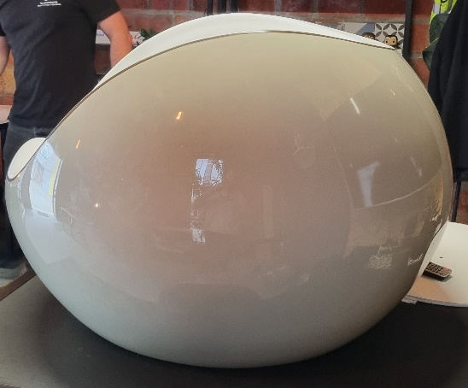
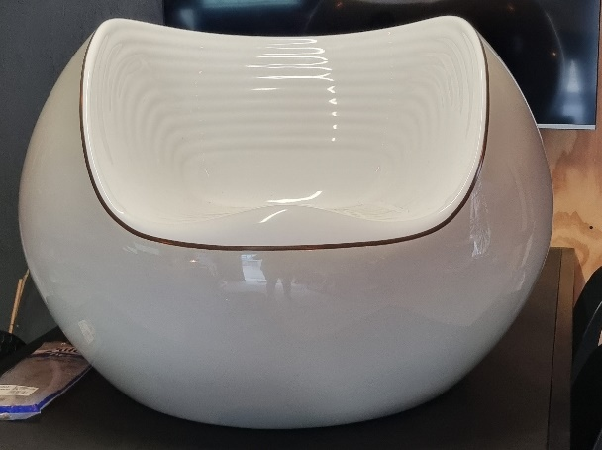
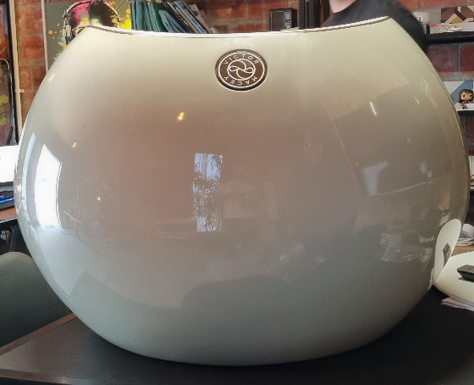

|VICTOR MACEY CHAIR: QUOTATION & DELIVERABLES
- PHASE ONE:

- 3d Modelling and Assembly Render:
  - 3d modelling:
Blackhound will 3d model the chair.
We will apply the necessary materials and textures to the product so that it can be rendered.

  - Assembly Rendering:
We will provide an assembly rendering where we pulled the chair apart indicating all the various elements that go into the chair, as discussed, with the relevant notations on the render.

PHASE ONE QUOTE : R15 000.00

- PHASE TWO:

- 360° Rendering for Website:

We will provide the necessary imagery for the web developers to do an interactive 360 rotation on the website.
- We will provide a base colour for the developer to use.
- Provide 4 additional colour variation 360° animation renderings with 3 accent colours per variation. (R 3 500 per variation.)

PHASE TWO QUOTE :
- Setup and first colour animation rendering = R6 000.00
- 3x Colour variations with 2x accents per variation = R10 500.00

- PHASE THREE:

- Provide photo realistic renders of the chair in various scenes:
- The client must provide reference images of scenes and spaces they would like to us to recreate and render
The fees shown below is for creating the scene and the first initial renders. Should you request additional renders within the same created scenes, the additional renders will be charged at a reduced rate of R2500 per additional render within the designed scenes.

PHASE THREE QUOTE:
- Small residential outdoor scenes = R8 500.00
- Large Landscaped outdoor scenes = R10 500.00

|PAYMENT TERMS:
- Payments prior to work commence.

- VAT Not Applicable

|TERMS AND CONDITIONS:
Blackhound Enterprises PTY LTD will be employed for the 3d modelling and rendering of the proposed Victor Macey chair for ‘Danielle Finkelstein’. Timeous work, communication and deliverables are expected.

- No Additional architectural or 3d rendering services have been included in this quotation.

- Should the client require any additional services, a separate fee proposal will be prepared to accommodate the scope of works.

- Once the final draft renders have been approved by the client, please note that any design changes made to the 3D model could result in additional costs, which will be discussed and agreed upon before work commences.

  - SITE VISITS:
N/A.

  - ADDITIONAL RENDERS:
Should you request additional renders, the pricing will be as follows:

- Additional renders requested in a new space which has not been developed in the initial 3d modelling and rendering phase will be charged at R6 500.00 per additional render to allow for the time to develop the additional spaces and views.

- Additional renders requested in an already designed and developed space will be charged at a reduced rate of R2 500.00 per additional render.

  - CUSTOM FURNITURE:
Should you require us to 3d model furniture and décor items selected from catalogues or brands, a custom 3d modelling fee per 3d model will be applicable, depending on the complexity and scale of the items selected. A separate quote will be provided.

  - TERMINATION:
If the agreement between the parties is terminated by either party for reasons not caused by BLACKHOUND ENTERPRISES PTY LTD, the fee for the work in progress and the completed work will be due for payment.

  - SUSPENSION:
BLACKHOUND ENTERPRISES PTY LTD retains the right to suspend all service until the settlement of any outstanding account.

  - OTHER PROFESSIONALS:
BLACKHOUND ENTERPRISES PTY LTD is not responsible for the performance of other professionals or artists (such as Town Planners, Engineers, or any other designers and artists), nor for the quality of images, drawings and documents provided by them, tender prices, the actions of Homeowner Associations, Municipalities, or Municipal Services. We are also not responsible for the performance of the Contractor or any of their Sub-Contractors, Suppliers, or employees.

  - COPYRIGHT:
BLACKHOUND ENTERPRISES PTY LTD retains the ownership of copyright to all its intellectual property. No designs, drawings, renders or documents may be used and shared with other parties without our express permission. This includes our fee proposal and rates.

  - FEE OFFSET:
The Client is not entitled to ‘set-off’ or withhold payment for any alleged claim against either BLACKHOUND ENTERPRISES PTY LTD or any other party involved in the project. The claim is to be dealt with on its own merits.

  - FINAL INVOICE:
The final invoice will be due upon receipt of final renders.

  - VAT:
BLACKHOUND ENTERPRISES PTY LTD. Is not a VAT vendor. All architectural fees presented are exclusive of VAT until further notice.
|ACCEPTANCE:
The Terms and Conditions presented here may be modified or amended as necessary only by written instrument signed by both parties.
By submitting the non-refundable deposit payment or signing this document, you are agreeing to the terms and conditions detailed in this document.
This proposal is agreed upon in full, signed and dated.
By signing this document, I indicate that I understand, agree to, and accept the terms and conditions as contained herein, dated this 10 MARCH 2026.
I, __________________________________________ hereby agree to the Terms and Conditions laid out in this document.

Email: hannes@blackhoundenterprises.com
Phone: 072 799 9597
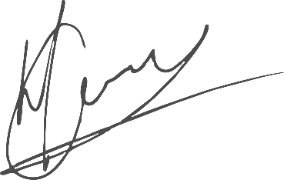

----------------------------------------------- -------------------------------------
Hannes Gouws Danielle Finkelstein
Director | SACAP: PSAT 32449887 Date:

