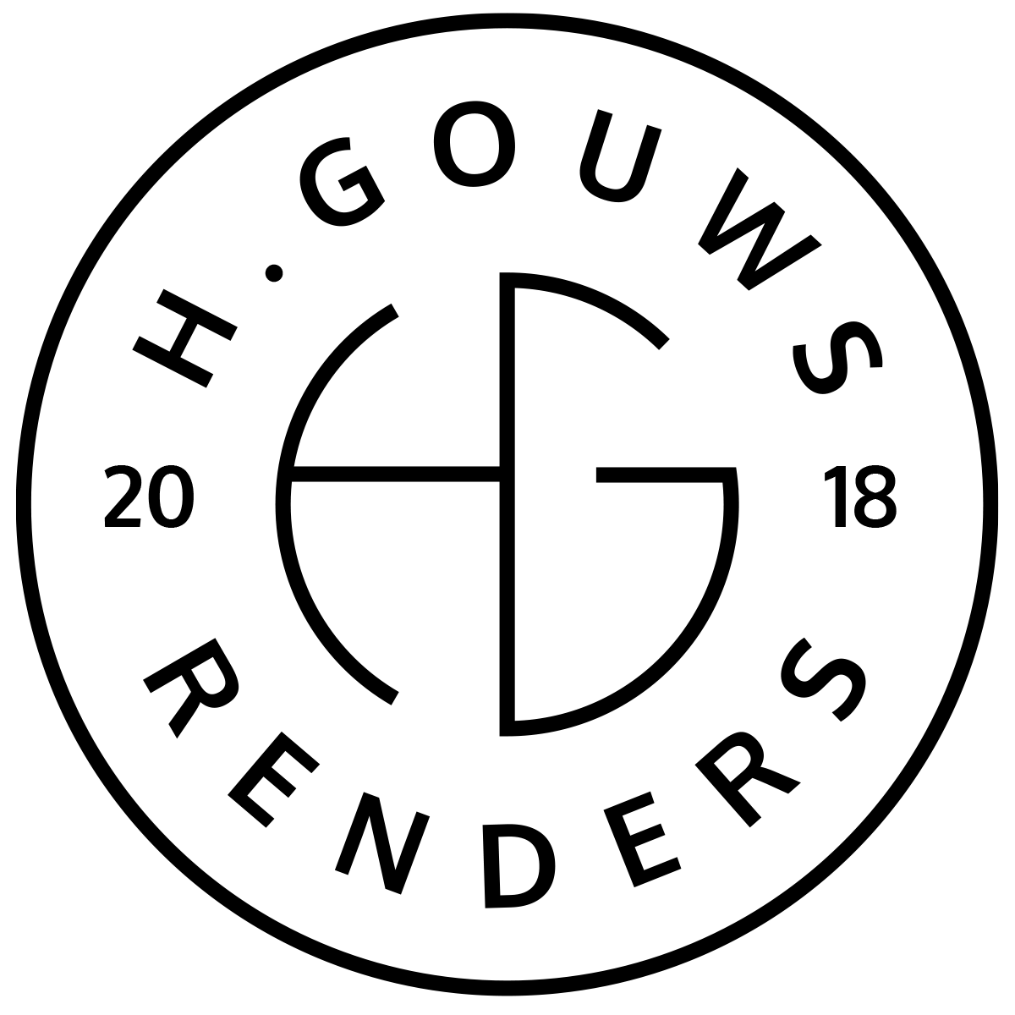H. Gouws Renders PTY LTD:
2020/784683/07

19 Cactus Road
Fairview
Port Elizabeth (Gqeberha)
Eastern Cape
2075

Client:
Nico and Cindy Venter
marketing@africanos.co.za
082 886 9513
8, Oranje Single
Kirkwood
6120
INVOICE:
000342022VENTER
Date: 24 JANUARY 2022

Item: | Description: | Quantity: | Price: | Total:
-------------------------------------------------------------------------------------------------------
House Venter (Kirkwood) Phase 1: Architectural Design
-----------------------------------------------------------------------------------------------------------------------------------1 | Design Balance Invoice | 0.5 | R100 619.37 | R50 309.68

-----------------------------------------------------------------------------------------------------------------------------------
TOTAL:
R50 309.68 ex VAT

Banking details:
Nedbank
Account Number: 1212774191
Branch Code: 12681700
Cheque account

KINDLY USE THE INVOICE NUMBER AS YOUR PAYMENT REFERENCE

