


BLACKHOUND ENTERPRISES PTY LTD
T/A BLACKHOUND ARCHITECTURE & RENDERING

Hannes Gouws
hannes@blackhoundenterprises.com
072 799 9597

Unit 10 – The Network
19 Cactus Road
Fairview
Port Elizabeth (Gqeberha)
Eastern Cape
2075

Unit 10 – The Network
19 Cactus Road
Fairview
Port Elizabeth (Gqeberha)
Eastern Cape
2075

Unit 10 – The Network
19 Cactus Road
Fairview
Port Elizabeth (Gqeberha)
Eastern Cape
2075

Client:
DECOBELLA
Stephan Morgan – 083 307 2133
stephan@decobella.co.za

Date: 13 FEBUARY 2023
|SCOPE OF WORKS:

Do photo-realistic renders of Decobella products in designed lifestyle scenes.

Project Requirements:
- New Projects:
  - Gemini Black (Single) + Garden white wall tiles.
  - Gemini Black (Multi) + Garden white tiles.
  - Gemini Black Ceramica Valsecchia + White subway tiles.
  - Gemini Blue (Single) + White Subway / Garden white tiles.
  - Gemini Sand (Single) + White Subway / Garden white tiles.

- Amendments to Alpine Design:

Information required for the project:
- Specifications:
  - Informal moodboards of each Decobella product and their desired setting.
  - Product samples to be sent to our studio.

- PROJECT ONE:

  - Gemini Black (Single) + Garden white wall tiles. = R9 765.00
  - Gemini Black (Multi) + Garden white tiles.

- PROJECT TWO:

Gemini Black Ceramica Valsecchia + White subway tiles. = R7 890.00

- PROJECT THREE:

Gemini Blue (Single) + White Subway / Garden white tiles. = R7 890.00

- PROJECT FOUR:

  - Gemini Sand (Single) + White Subway / Garden white tiles.
= R7 890.00

- Amendments to Alpine Designs:

  - Alpine Grey + Polaris: Exterior
= R1 342.00
  - Alpine Walnut: Interior
= R1 342.00

*This price includes 1x round of draft renders before final rendering.
*Generic furniture will be used to furnish the spaces to suit the style of the design.
*Additional custom furniture will be quoted at R1800 per piece and added to the final account.
*Additional renders will be charged at R1 875.00 per render.

SUB TOTAL:
5x PROJECTS: (excl. discount) R36 119.00
5% Discount: R1 805.95

TOTAL QUOTE
5x Projects: (incl. discount.) R34 313.05 (VAT not applicable)

KINDLY NOTE:
*Should our scope of work increase, our fees will be adjusted to accommodate the extra scope. This will be discussed before the work commences.
*This quote is only valid for 30 Days after the date of issue.
|PAYMENT TERMS:
- 70% (R24 019.16) as Deposit payable before work commence.

- Balance of (R10 293.89) payable on handover of Project 5 renders.

|ACCEPTANCE:
The Terms and Conditions presented here may be modified or amended as necessary only by written instrument signed by both parties.
By submitting the non-refundable deposit payment, you are agreeing to the terms and conditions detailed in this document and that this proposal is agreed upon in full.
By signing this document or by submitting the non-refundable deposit payment, I indicate that I understand, agree to, and accept the terms and conditions as contained herein, dated 13 FEBUARY 2023.

I, __________________________________________ hereby agree to the Terms and Conditions laid out in this document.

Email: hannes@blackhoundenterprises.com
Phone: 072 799 9597

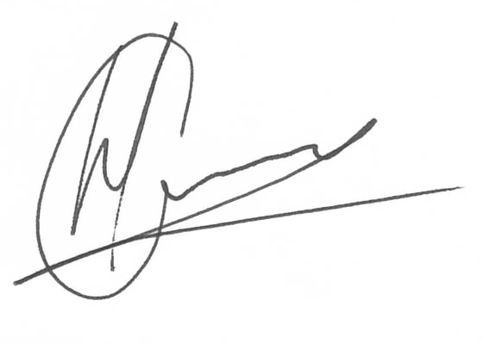

----------------------------------------------- -------------------------------------
Hannes Gouws Name:
Director | PSAT 32449887 Date:

