


BLACKHOUND ENTERPRISES PTY LTD
T/A BLACKHOUND ARCHITECTURE & RENDERING

Hannes Gouws
hannes@blackhoundenterprises.com
072 799 9597

Unit 10 – The Network
19 Cactus Road
Fairview
Port Elizabeth (Gqeberha)
Eastern Cape
2075

Unit 10 – The Network
19 Cactus Road
Fairview
Port Elizabeth (Gqeberha)
Eastern Cape
2075

Unit 10 – The Network
19 Cactus Road
Fairview
Port Elizabeth (Gqeberha)
Eastern Cape
2075

Client:
Leslie Jones Architecture
Contact Person: Peter Simmons – 076 196 8511
peter@sketchbox.co.za

Date: 22 NOVEMBER 2022
|SCOPE OF WORKS:

Produce photo realistic renderings for the interior commercial spaces at Pittsburgh Airport, U.S.A.

Project Requirements:
- Allowance to be made for 3d modelling and detailing:
  - Enhancing the perspective views,
  - Add people,
  - Shop frontage,
  - Central iconic unit,
  - Lounge seating,
  - Signage & wayfinding,
  - Ceiling and ambient lighting.

- Provide 6x Photo realistic renders:

  - 4x Airside
  - 2x Landside

- Allowance to be made for 1x round of draft renders and 2x rounds of production renders before commencement of the final renders.

|Pittsburgh Airport_U.S.A.
Information required for the project:
- Specifications:
  - Resolved 3d model of the building in Sketchup format or, if it is a Revit model, exported to:
    - A) .FBX
    - B) .3ds
  - Briefing document with finishes, details, décor, or any other specifications required.
  - Marked up sketches/drawings indicating where specific finishes, details or décor needs to be be.
  - Site / Environment images of the exterior if you want to see specific elements or context in the background.
  - Specific shopfront details.
Project Scope:

- RENDERING:
- 6 x Interior Commercial renders, fully populated, furnished and textured:

TOTAL QUOTE
R51 929.60 (VAT not applicable)

Terms and Conditions:

*This price includes 1x round of draft renders and 2x rounds of production renders and 1x round of final renders.

*Generic furniture will be used to furnish the spaces which best match the briefing document.

*Specific custom furniture will be quoted at R1800 per piece and discussed or added to the final account. (Depending on the total number of pieces)

*Request for re-rendering after the final renders will be charged at R4000 per re-render.

*The 3d files and assets used to create these renders will remain the property of Blackhound Enterprises.

*Should our scope of work increase, our fees will be adjusted to accommodate the extra scope. This will be discussed before the work commences.
*This quote is only valid for 30 Days after the date of issue.

|PAYMENT TERMS:
Option A: Full Phase 1 and Phase 2
- 70% no-refundable deposit payable at inception.

- Balance payable at final handover.

|ACCEPTANCE:
*The Terms and Conditions presented here may be modified or amended as necessary only by written instrument, signed / agreed upon by both parties.
*By submitting the deposit payment, you are agreeing to the terms and conditions detailed in this document and that this proposal is agreed upon in full, signed and dated.

By signing this document or making the deposit payment, I indicate that I understand, agree to, and accept the terms and conditions as contained herein, dated this
22 November 2022.

I, __________________________________________ hereby agree to the Terms and Conditions laid out in this document.

Email: hannes@blackhoundenterprises.com
Phone: 072 799 9597
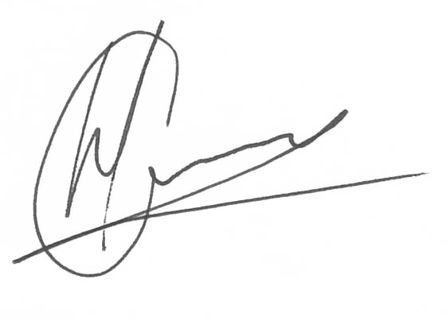

-----------------------------------------------
Hannes Gouws
Director | PSAT 32449887

