


BLACKHOUND ENTERPRISES PTY LTD
T/A BLACKHOUND ARCHITECTURE & RENDERING

Hannes Gouws
hannes@blackhoundenterprises.com
072 799 9597

Unit 10 – The Network
19 Cactus Road
Fairview
Port Elizabeth (Gqeberha)
Eastern Cape
2075

Unit 10 – The Network
19 Cactus Road
Fairview
Port Elizabeth (Gqeberha)
Eastern Cape
2075

Unit 10 – The Network
19 Cactus Road
Fairview
Port Elizabeth (Gqeberha)
Eastern Cape
2075

Client:
Carlien Jooste
072 408 1025
Carlien.jooste@gmail.com

Date: 26 AUGUST 2022
|SCOPE OF WORKS:

Interior Design, visualization and assist with interior procurement for a new dwelling on ERF 687, Unit 10, Kosmos ext. 7, Providence Village, Leloko Lifestyle Estate, Hartebeespoort.

Affected interior spaces:
- Ground Floor:
  - Entrance.
  - Dining space.
  - Kitchen.
  - Living space.
  - Bedroom 2.
  - Bedroom 3.
  - Master Bedroom.
  - Master en-suite.
  - Patio

|HOUSE JOOSTE QUOTE.
3d Model, Interior Design and assist with Procurement:
Excluded from the fees:
- Submission fees and hard copy prints, if required. (e.g. Council and municipal related fees/Estate/NHBRC)
- Other Professional consultancy fees that may be required (e.g. Structural Engineer, Quantity and Site Surveyors, Health & Safety, etc.)
- Execution of the works and testing of materials to ensure compliance with drawings and specifications remains the responsibility of the contractor.
- Occupation and As-Built drawings, should the building not be built as per the approved plans.
- Printing of drawings for site.
Estimated Interior Budget:
Size of House (Excluding Garage): 146.4m²
Entrance Porch: 6.6m²
Patio: 16.4m²
Professional Fees Calculation:
Phase 1: Redraw of existing plans and building of 3d Model:
  - We will redraw the existing PDF plans on CAD for us to start the design process.
  - Build the 3d model to resolve design details and to give you a clear picture of what the design will look like before we proceed with the next phase. *Please note that this is conceptual 3d visualization and not our photo-realistic rendering service.
  - Moodboards. @ R25 per m²
R12 813.80
Phase 2: Design:
  - 2d plans to indicate where changes are proposed with the existing.
  - All design work will be reflected on the 3d model, for your approval.
R10 736.00
Phase 3: Procurement:
  - To be confirmed upon completion of Phase 1 and 2.
  - This will be charged at a percentage of the selected and approved furniture.

Totals:
PHASE 1: R12 813.80
PHASE 2: R10 736.00
PHASE 3: To be discussed.

TOTAL QUOTE
Phase 1 and 2 R23 549.80 (VAT not applicable)

KINDLY NOTE:
*Should our scope of work increase, our fees will be adjusted to accommodate the extra scope. This will be discussed before the work commences.
*This quote is only valid for 30 Days after the date of issue.
|PAYMENT TERMS:
- 100% of (Phase 1) Deposit payable at inception.

- 50% of Phase 2 fees payable as deposit to commence with the design phase, with the balance payable at design approval.

- Phase 3 to be discussed.

|ACCEPTANCE:
The Terms and Conditions presented here may be modified or amended as necessary only by written instrument signed by both parties.
By submitting the deposit payment, you are agreeing to the terms and conditions detailed in this document. This proposal is agreed upon in full, signed and dated.
By signing this document, I indicate that I understand, agree to, and accept the terms and conditions as contained herein, dated this 26 AUGUST 2022.

I, __________________________________________ hereby agree to the Terms and Conditions laid out in this document.

Email: hannes@blackhoundenterprises.com
Phone: 072 799 9597

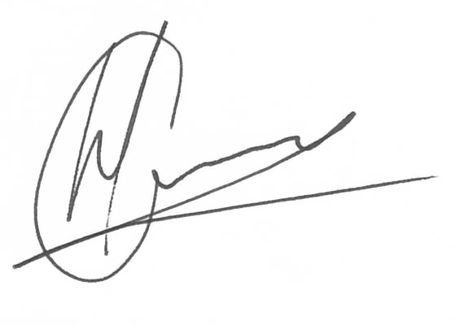

----------------------------------------------- -------------------------------------
Hannes Gouws Name:
Director | PSAT 32449887 Date:

|TERMS AND CONDITIONS:
Blackhound will be employed for Phase 1 to 3, as laid out in this agreement: to assist with the interior design and visualization, and to provide a procurement list of the selected and approve finishes and furniture at the end of the design phase to the client.
  - SITE VISITS:
Further to the fees, should Site Visits be requested, a Travel expense will be calculated per Site Visit. This will be invoiced at the end of each month for the duration of the project or when Site visits are requested.
  - DETAILS AND TECHNICAL DRAWINGS:
Should you require our assistance with working drawings / detail drawings, joinery details, etc. An hourly rate of R675 will be applicable.
  - PRINTS:
N/A
  - EXTENDED CONSTRUCTION PERIOD:
N/A

