Sign 1:
White matt plastic for external use. Letter depth to be 20mm from Evalast Cladding.
Height of the white letters is +- 340mm Width of the white letters +- 270mm
Sign 2:
Grey matt plastic (for external use). Letter depth to be 20mm from Evalast Cladding.

Bigger letters of Grey sign:
Height of the grey letters is +- 335mm Width of the grey letters is +- 175mm
Smaller letters of Grey sign:
Height of the grey letters is +- 260mm Width of the grey letters is +- 140mm

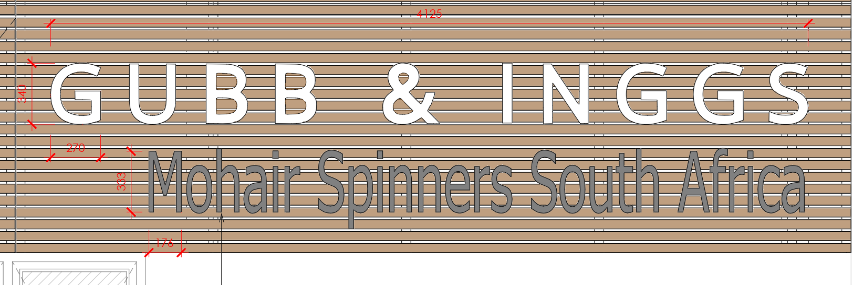
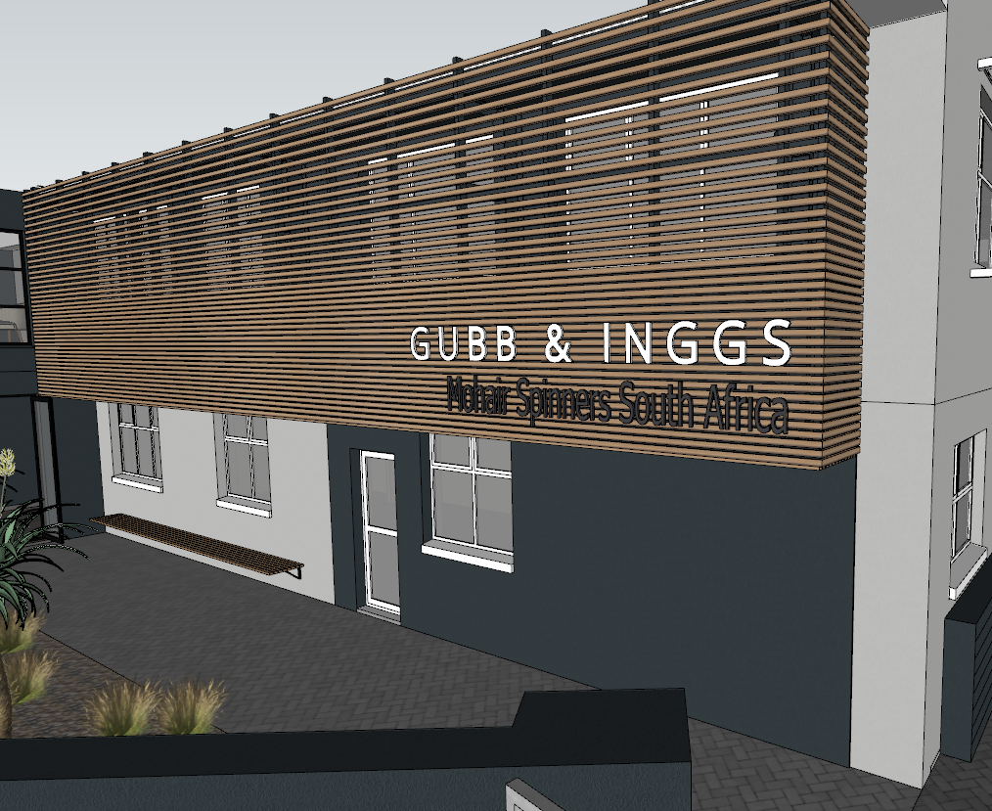
Sign 3:
3mm Brushed stainless steel letters with pins fixed 10mm off the wall.

Bigger letters:
+- 260mm (H) X 200mm (W)
Smaller letters:
+- 125mm (H) X 130mm (W)
The yellow areas to be powder coated. The straight line to be the only item not on pins off the wall. The yellow three arch lines should also be on pins off the wall.
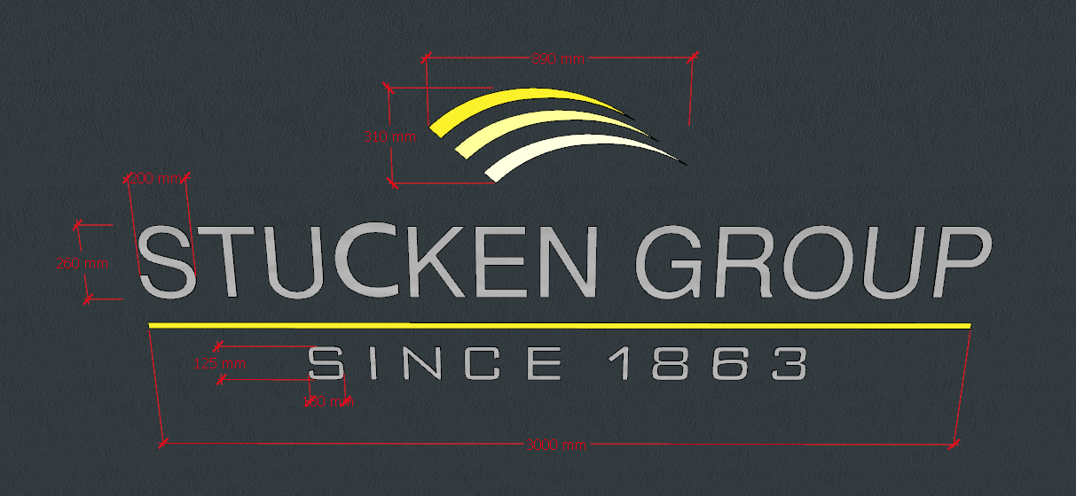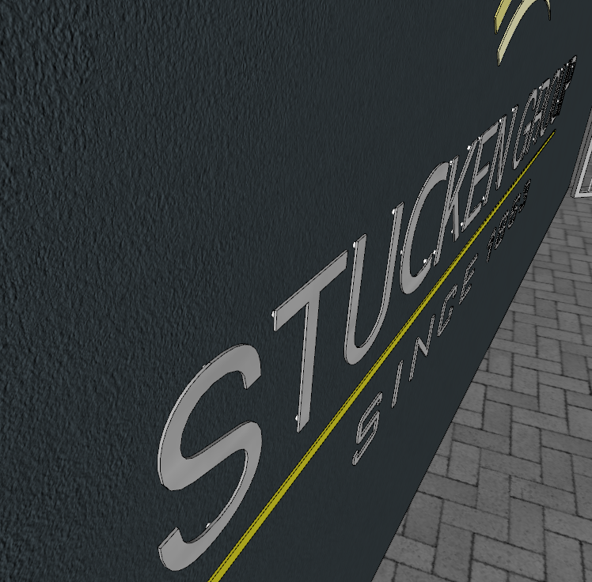
Sign 4:
85mm white box with grey vinyl stickers. No LED’s
255mm (H) x 1400mm (W)
Letter sizes: 80mm (H) x 60mm (W)

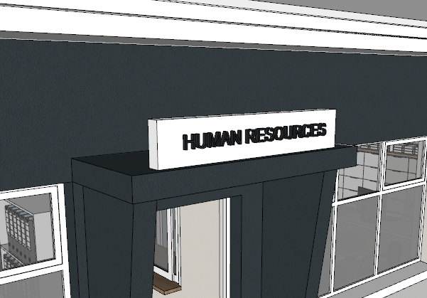
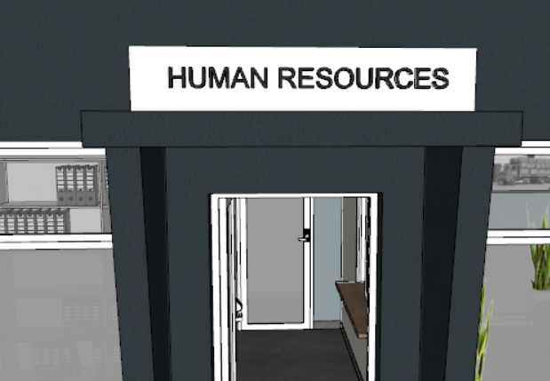

Sign 5:
We want to remove these signage stickers on this board. The whole thing is a sticker. We want to reprint this and reapply it to this existing board.
I will send you the dimensions tomorrow.
