Office Block - 2025/05/28
PAINT COLOURS:
- BRILLIANT WHITE (Arched feature wall, Fascia’s, barge boards, window cills.)
- SONG PORCELAN
- DARKEN PUDDLE
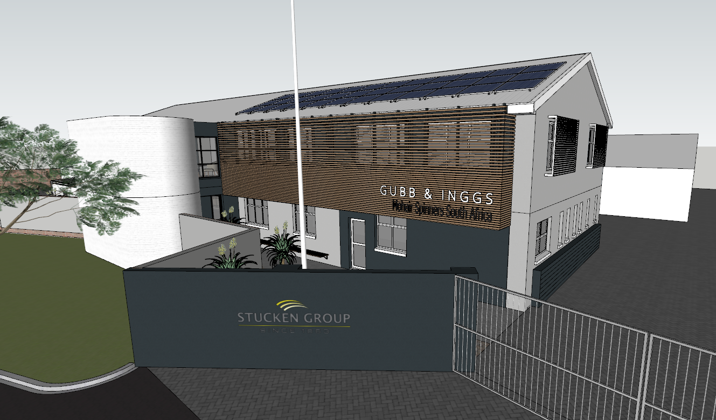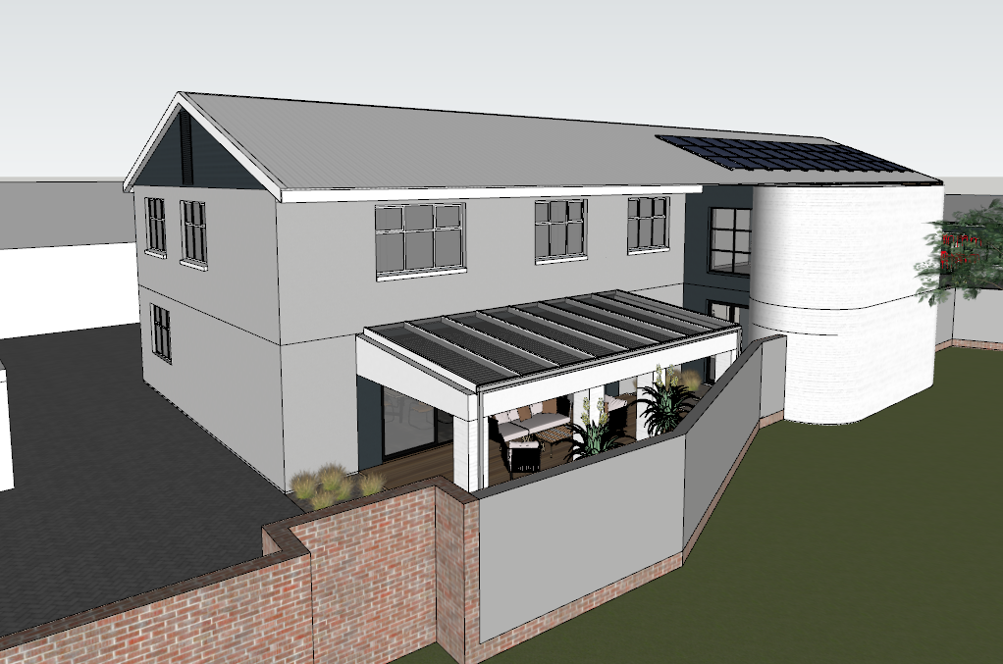
1
3
1
2
2
1
3
3
1
1
2
2
1
3
3
3
2
2
2
2
1
3
1
3

FOYER (Main Entrance):
- BRILLIANT WHITE (Arched feature wall, Soffit, Beams.)
- SONG PORCELAN
- DARKEN PUDDLE
- KITTEN WHITE
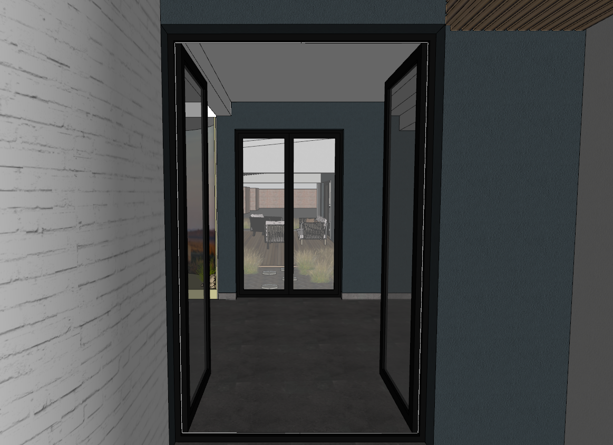
1
3
1
3
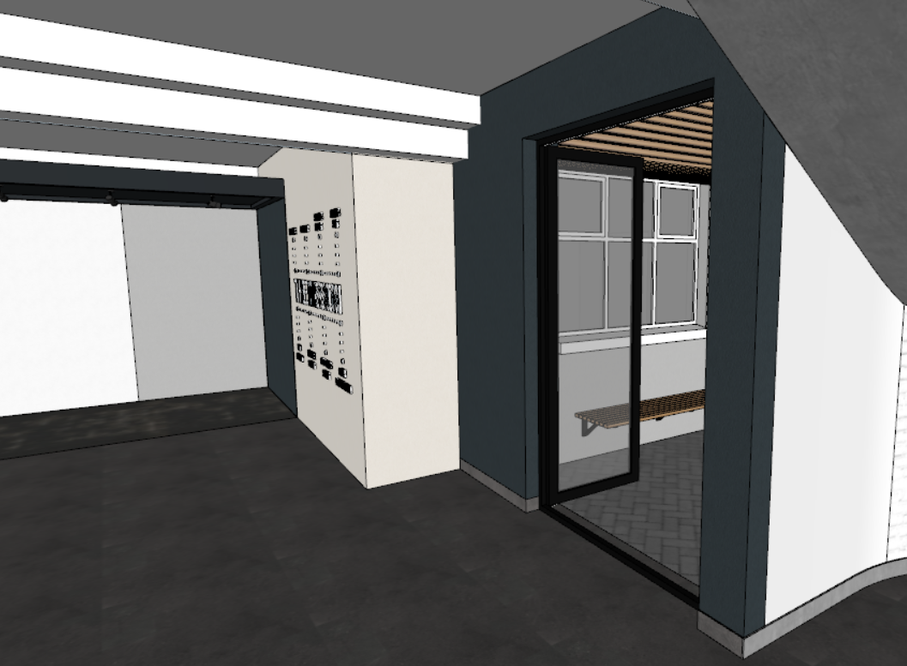
3
3
1
1
1
4
3

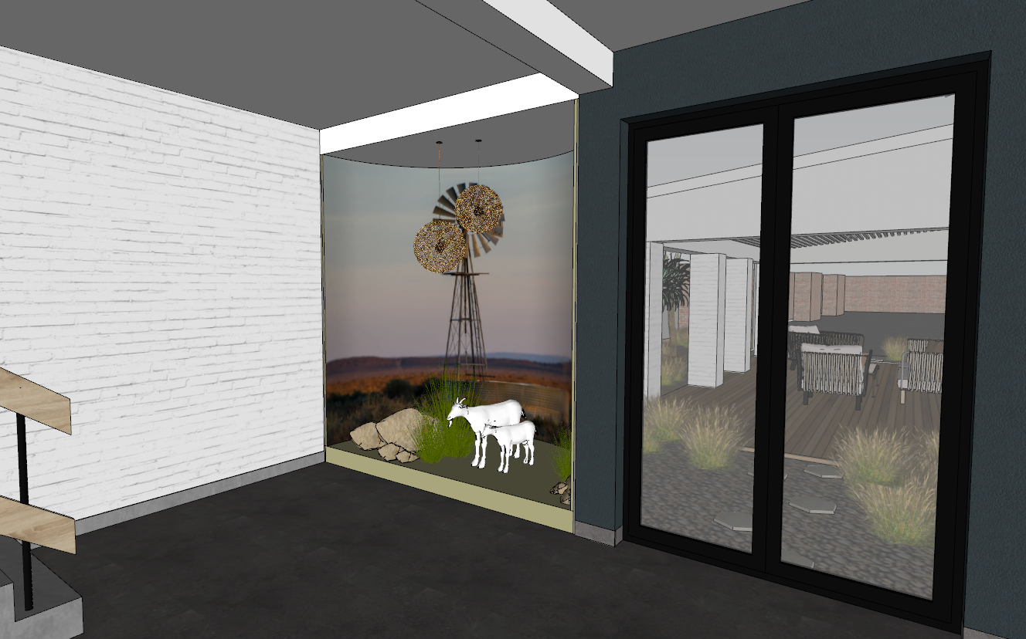
1
1
1
1
1
3
WALLART AREA:
- BRILLIANT WHITE (Soffit, beams, small- feature area.)
- SONG PORCELAN (Small- feature area)
- DARKEN PUDDLE
- KITTEN WHITE (General wall colour unless otherwise specified)
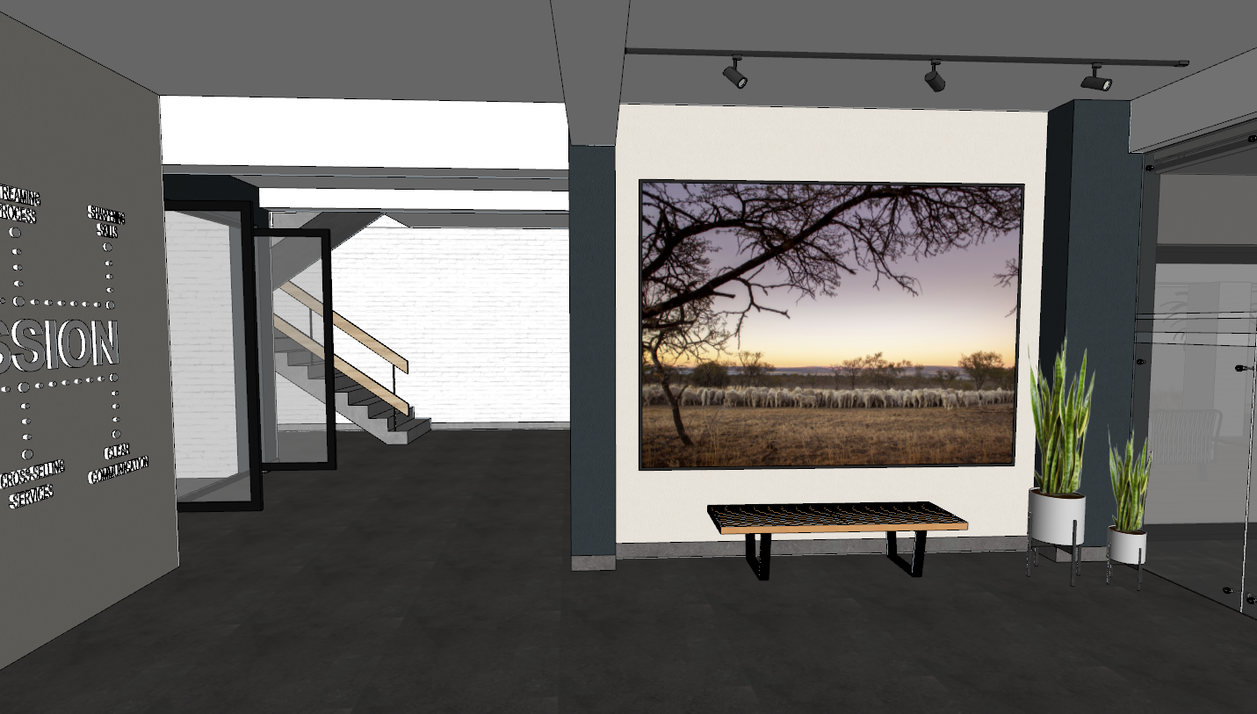
4
1
1
1
4
3
3
1
1
1
4
3

DISPLAY AREA:
- BRILLIANT WHITE (Soffit, beams, small- feature area.)
- SONG PORCELAN (Small- feature area)
- DARKEN PUDDLE
- KITTEN WHITE (General wall colour unless otherwise specified)
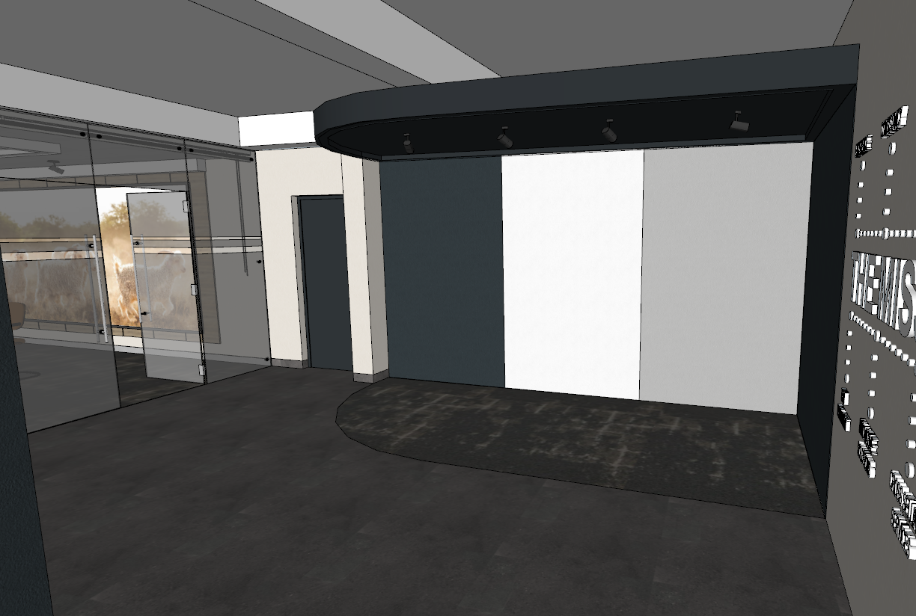
3
1
1
4
3
4
4
2
4
4
3
3
3
1
1
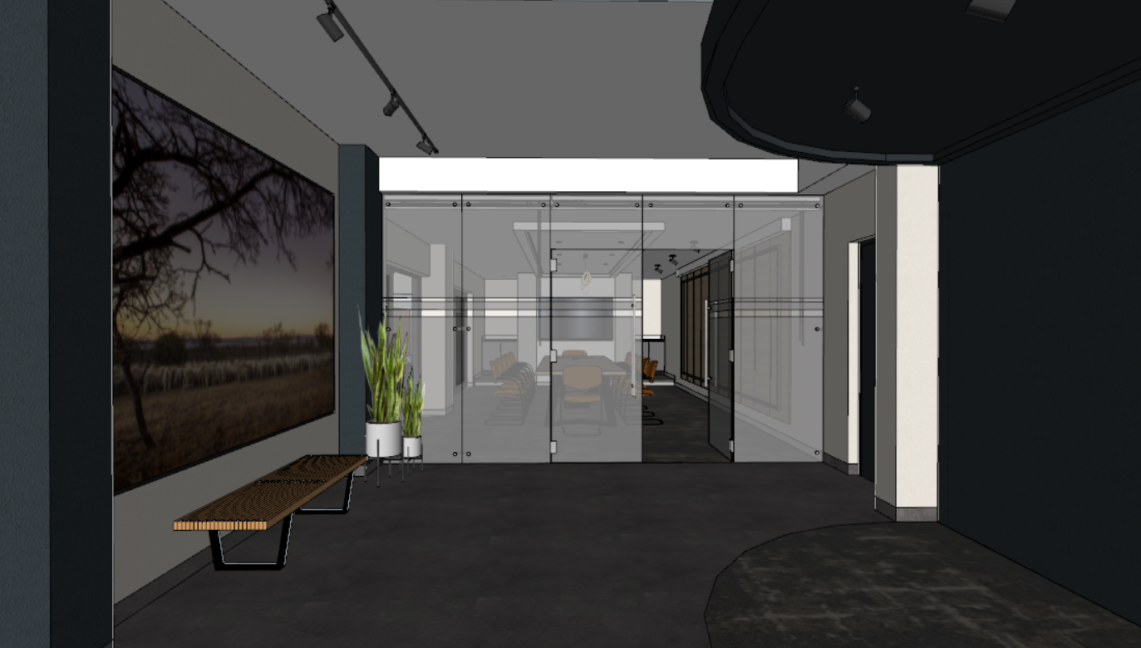
1
3
4
3
4
1
3
3
BOARDROOM:
- BRILLIANT WHITE (Bulkheads, small- feature area at TV)
- SONG PORCELAN (Small- feature area at TV)
- DARKEN PUDDLE
- KITTEN WHITE (General wall colour unless otherwise specified)
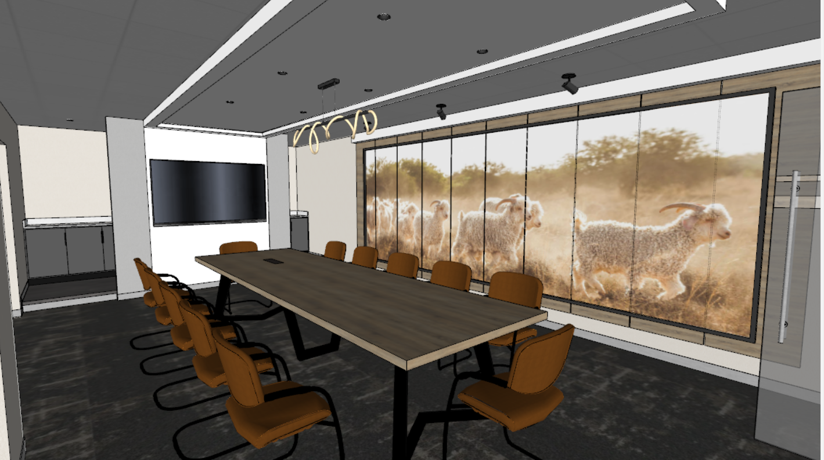
1
1
2
4
4
1
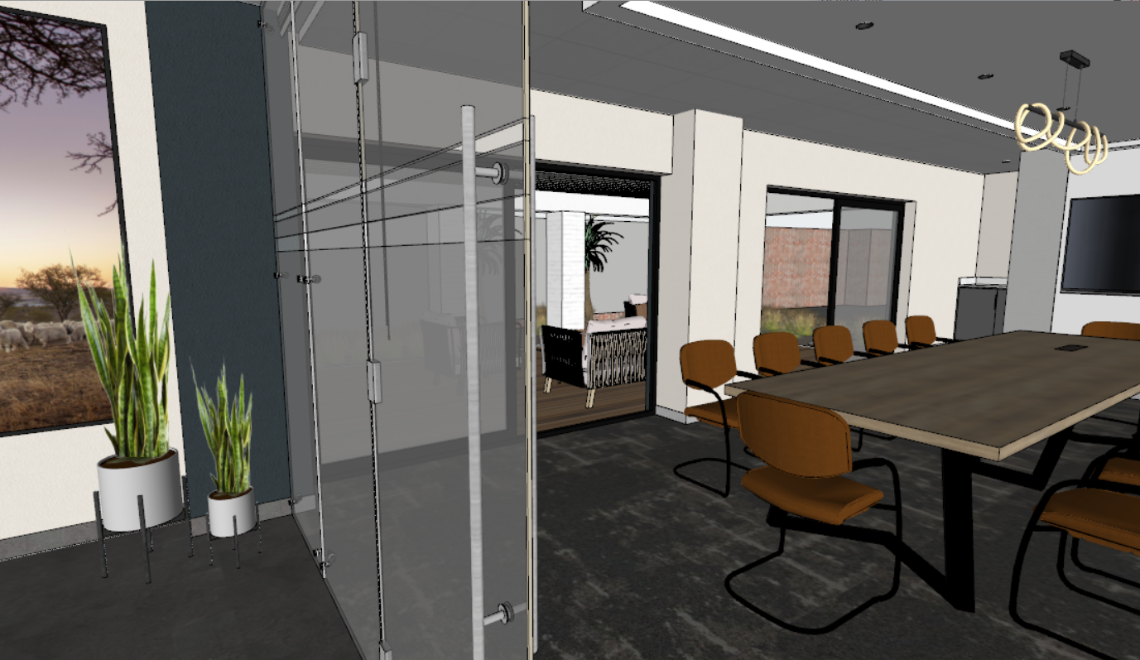
1
2
3
4
4
4
4
4

