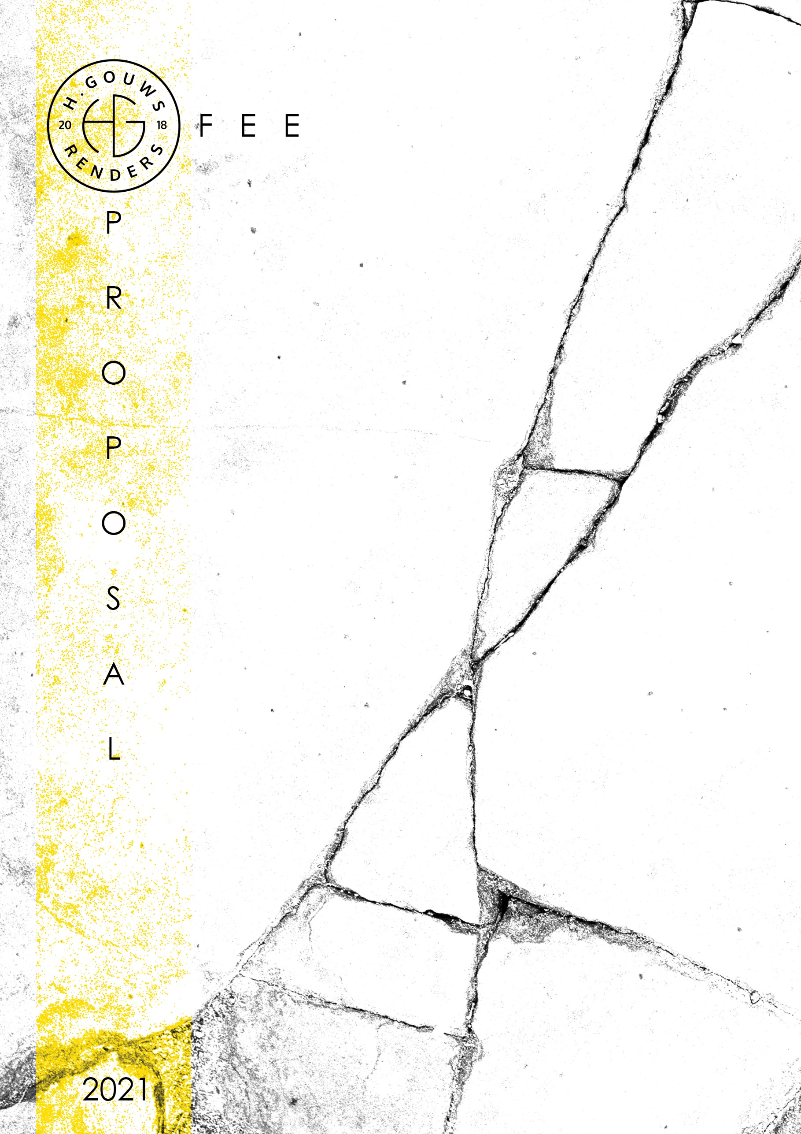

H. Gouws Renders PTY LTD:
2020/784683/07

1 Elsa Joubert street
Fairview
Port Elizabeth (Gqeberha)
Eastern Cape
2075

Client:
Eugene and Sanet Owen
Date: 26 July 2021
|SCOPE OF WORKS:
Measure, Design and create Municipal drawings for a +-347sqm residential additions and alterations in St. Francis Bay, Humansdorp. Eastern Cape, for Eugene and Sanet Owen.
Project Requirements:
- Measure and redraw the existing house and prepare a 3d model of the existing house, +- 347sqm as per the existing drawings.
  - 347sqm x R60 per sqm = R20 820.00

- Design internal alterations, prepare 3d concept drawings, and indicate the existing carport as the new Garage.
  - 16hrs x R700 p/h = R11 200.00

- Prepare municipal drawings and submit to council for approval.

|QUOTE:
Excluded from the fees:
- Submission fees (e.g. Council and municipal related fees/Estate/NHBRC)
- Other Professional consultancy fees that may be required (e.g. Structural Engineer, Quantity and Site Surveyors, Health & Safety, etc.)
- Execution of the works and testing of materials to ensure compliance with drawings and specifications remains the responsibility of the contractor.
- Occupation and As-Built drawings, should the building not be built as per the approved plans.
- Printing of plans, will be quoted and invoiced separately.
TOTAL QUOTE: ________________________________ R32 020.00
50% deposit payable at inception, with the balance payable at municipal submission.
|ACCEPTANCE:
The Terms and Conditions presented here may be modified or amended as necessary only by written instrument signed by both parties.

By submitting the deposit payment, you are agreeing to the terms and conditions detailed above. This proposal is agreed upon in full, signed and dated.

By signing this document, I indicate that I understand, agree to and accept the terms and conditions as contained herein, dated this 26 JULY 2021.

I, __________________________________________ hereby agree to the Terms and Conditions laid out in this document.
Date:
Signature / Digital Signature:

Email: hgouws.renders@gmail.com
Cell: 072 799 9597
Instagram: @hgouws.renders
Facebook: H. Gouws Renders (@hgouws.renders)

Thank you for the opportunity to quote on your project.

Keep well, and chat soon.
Thank you.

Kind Regards

Hannes Gouws
3d Artist | Professional Senior Architectural Technologist | PSAT 32449887

