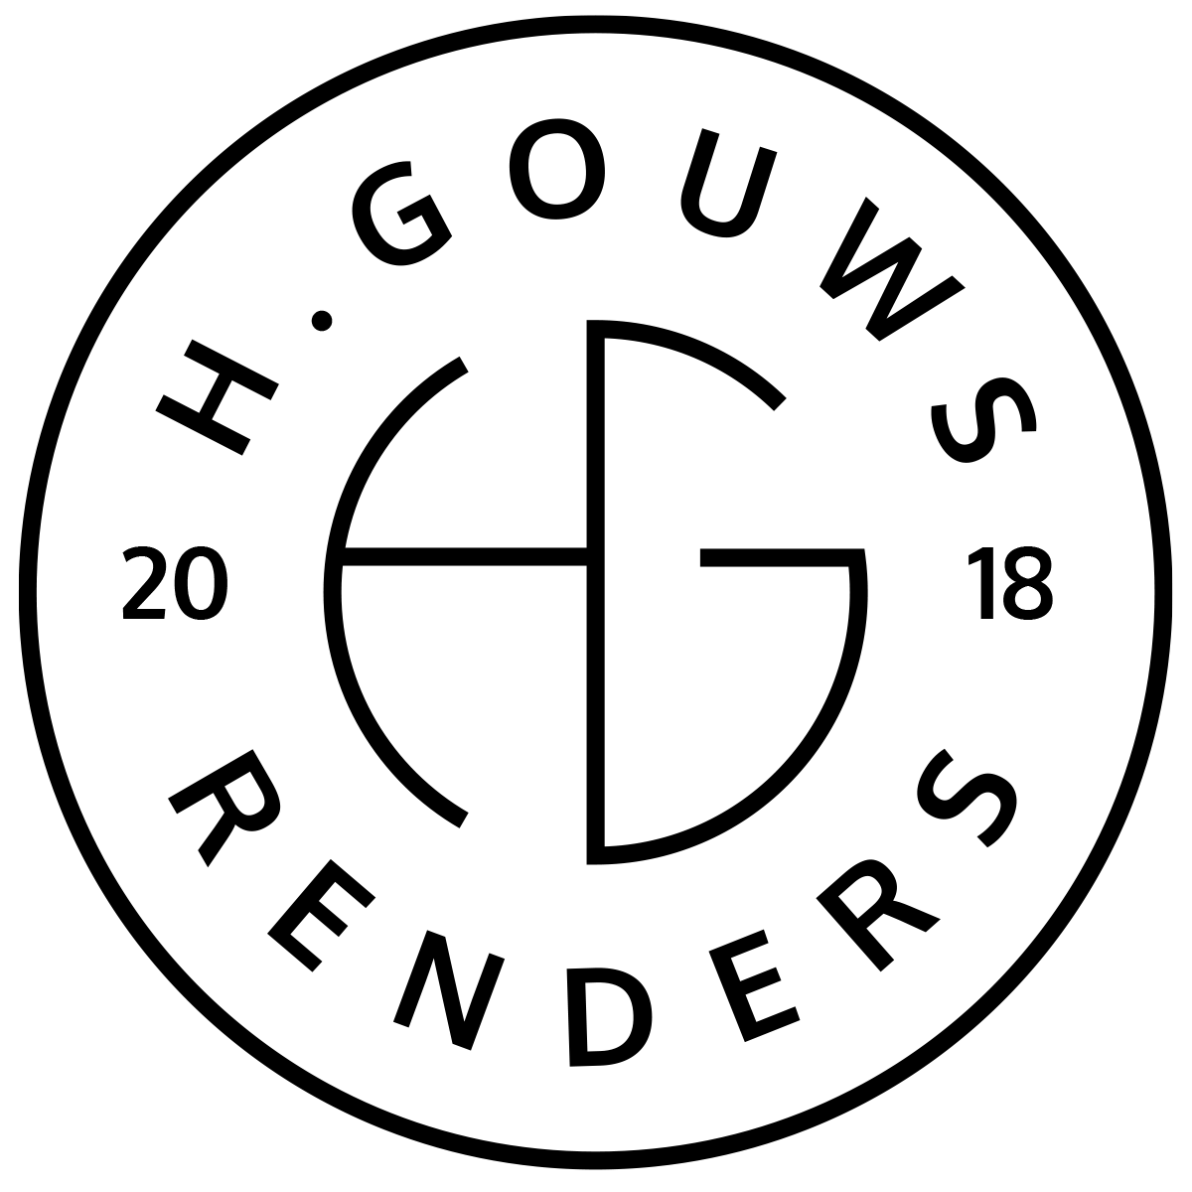H. Gouws Renders PTY LTD:
2020/784683/07

1 Elsa Joubert street
Fairview
Port Elizabeth (Gqeberha)
Eastern Cape
2075

Client:
LADYGROUP PTY LTD
VAT nr. 4 300 265 107
Reg nr. 2013/221295/07
5 Sunnybrae
Lovemore Heights Estate
Port Elizabeth (Gqeberha)
Eastern Cape
2075
INVOICE:
000222021OWEN

Date: 26 September 2021

Item: | Description: | Quantity: | Price: | Total:
-------------------------------------------------------------------------------------------------------
1 | Additions and alterations Final Invoice:
| 01 | R16 010.00 | R16 010.00

-----------------------------------------------------------------------------------------------------------------------------------
TOTAL:
R16 010.00 ex VAT

Banking details:
Nedbank
Account Number: 1212774191
Branch Code: 12681700
Cheque account

KINDLY USE THE INVOICE NUMBER AS YOUR PAYMENT REFERENCE

