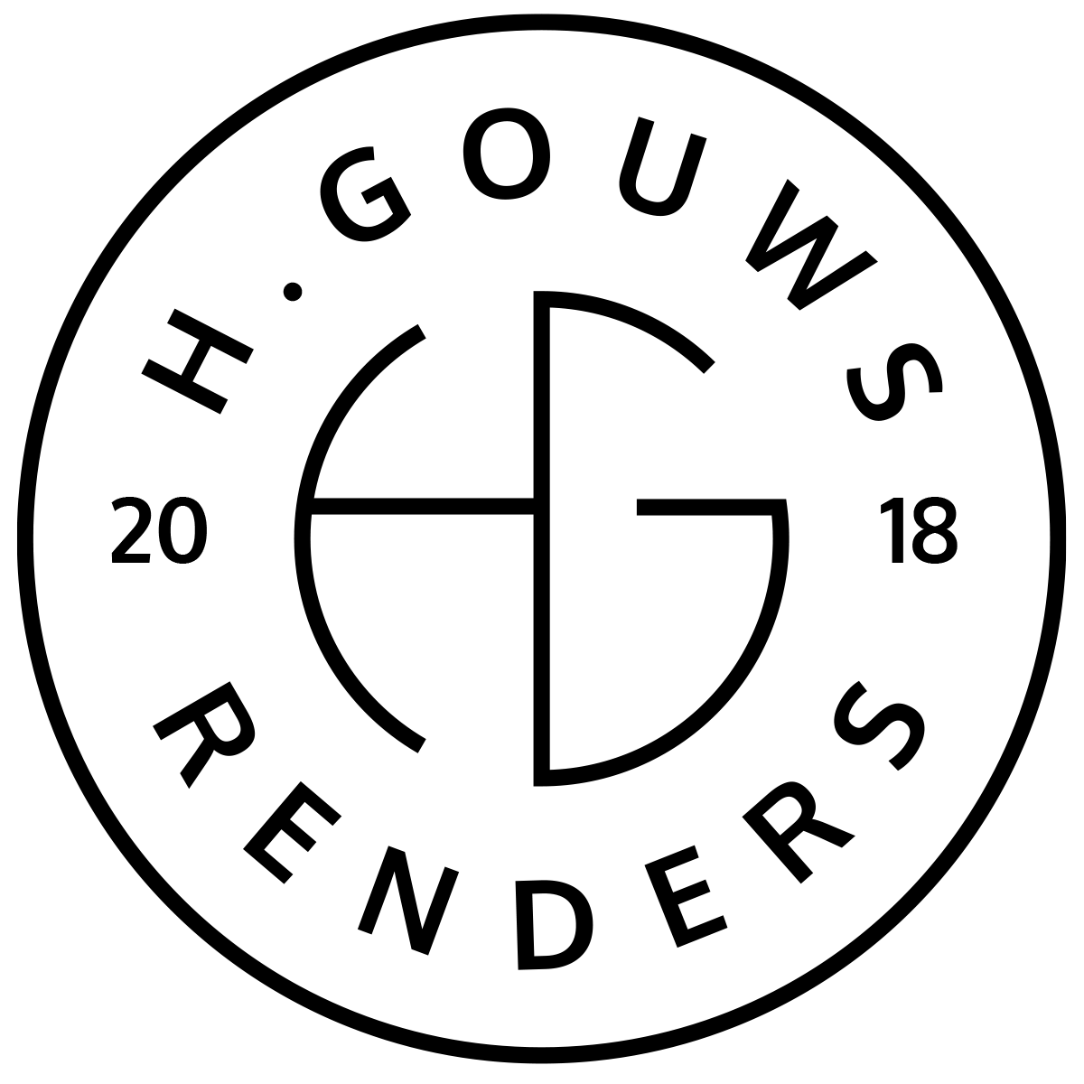H. Gouws Renders PTY LTD:
2020/784683/07
T/A: H. Gouws Renders and Designs

Unit 10 – The Network
19 Cactus Road
Fairview
Port Elizabeth (Gqeberha)
Eastern Cape
2075

Client:
Arcproject (PTY) Ltd
20 Nile Road
Perridgevale
Port Elizabeth
6000
VAT number: 4470292212
INVOICE:
000522022ARCPROJ

Date: 06 JUNE 2022

Item: | Description: | Quantity: | Price: | Total:
-------------------------------------------------------------------------------------------------------
01 | Seychelles Villa: Deposit Payment:
| 50% | R128 543.00 | R64 271.50

-----------------------------------------------------------------------------------------------------------------------------------
TOTAL:
VAT Not applicable R64 271.50 ex VAT

Banking details:
Nedbank
Account Number: 1212774191
Branch Code: 12681700
Cheque account
KINDLY USE THE INVOICE NUMBER AS YOUR PAYMENT REFERENCE

