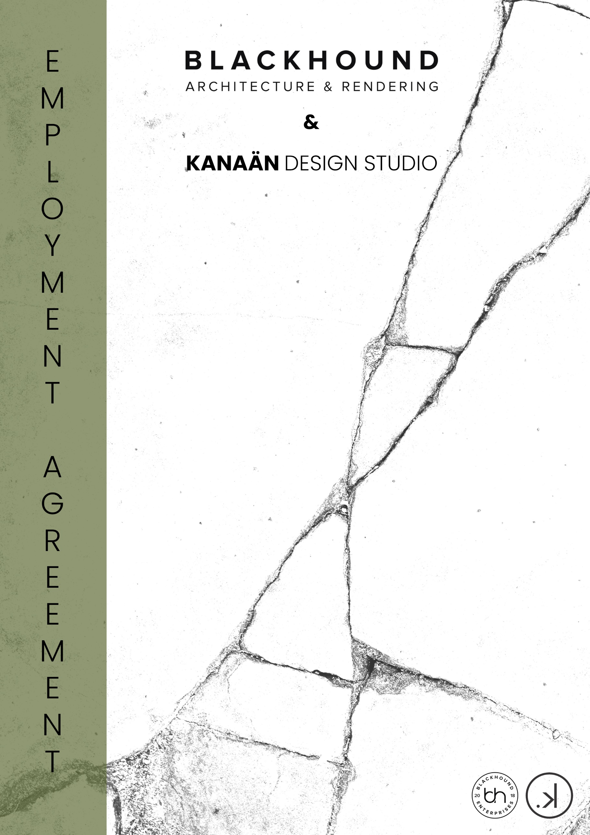

Employment Agreement for:


BLACKHOUND ENTERPRISES PTY LTD
T/A BLACKHOUND ARCHITECTURE & RENDERING

Hannes Gouws
hannes@blackhoundenterprises.com
072 799 9597

Dewald Potgieter
Dewald@blackhoundenterprises.com
072 418 6867

Unit 10 – The Network
19 Cactus Road
Fairview
Port Elizabeth (Gqeberha)
Eastern Cape
2075
The Network
19 Cactus Road
Fairview
Port Elizabeth (Gqeberha)
Eastern Cape
2075

Unit 10 – The Network
19 Cactus Road
Fairview
Port Elizabeth (Gqeberha)
Eastern Cape
2075

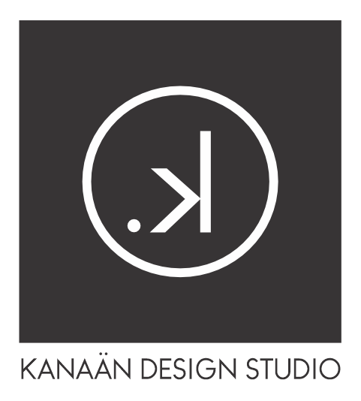

KANAAN DESIGN STUDIO PTY LTD

Seugnet Snyman
Hello@kanaandesignstudio.com
073 911 1781

17 Horton Street
South End
Port Elizabeth (Gqeberha)
Eastern Cape
6001
The Network
19 Cactus Road
Fairview
Port Elizabeth (Gqeberha)
Eastern Cape
2075

Unit 10 – The Network
19 Cactus Road
Fairview
Port Elizabeth (Gqeberha)
Eastern Cape
2075

EMPLOYMENT AGREEMENT
This Employment Agreement ("Agreement") is entered into by and between:
Employer:
Blackhound Architecture & Rendering (Pty) Ltd
Company Registration No: 2020/784683/07
Address: Unit 10 – The Network, 19 Cactus Road, Fairview, Port Elizabeth, 6075
(Hereinafter referred to as "Blackhound" where needed.)

Employer:
Kanaan Design Studio (Pty) Ltd
Company Registration No: 2018/619784/07
Address: Unit 10 – The Network, 19 Cactus Road, Fairview, Port Elizabeth, 6075
(Hereinafter referred to as "Blackhound" where needed.)

and
Employee:
Full Name: Bianca Van Vuuren
ID/Passport Number: ______________________________
Address: _________________________________________
(Hereinafter referred to as "the Employee")
- COMMENCEMENT:

  - The Employee’s employment shall commence on 7 January 2026.
  - This is a permanent position to be reviewed annually.
  - A probationary period of 3 months shall apply, during which either party may terminate this agreement with one week’s written notice.

- POSITION AND DUTIES:

  - The Employee is appointed as a Junior Interior Designer. She will be employed in a 50/50 capacity between Kanaan Design Studio and Blackhound Architecture & Rendering.

Her duties will be to support our design team throughout all project phases, from initial client briefing and concept development to materials sourcing, technical drawing compilation, client presentations, and on-site installations. This role is based in studio and reports directly to the relevant team leaders, it will also extend to the furniture/product design department.

Her key responsibilities will be but are not limited to:
- Assist with developing design concepts aligned to the studio’s aesthetic and client briefs.
- Prepare furniture layouts, spatial plans, and mood boards to support design development.
- Support the creation of drawing packs, including as-builts, electrical layouts, lighting plans, artwork layouts, and window treatments.
- Assist with analysing consultant layouts and helping identify potential design issues.
- Produce 3D views, renders, and visualisations for internal reviews and client presentations.
- Help compile detailed interior documentation: plans, elevations, joinery details, and finishes schedules.
- Research materials, finishes, furniture, and accessories, preparing specification sheets where required.
- Liaise with suppliers for samples, quotations, and lead times.
- Maintain organised project files, documentation, and adherence to studio standards.
- Participate in site visits to support the design team in inspections, measuring and progress reviews.
- Participate in visits to the local council to retrieve information as needed.
- Assist with processing and packaging orders.
- Assist with studio administration and management.
  - The Employee agrees to perform all duties faithfully, to the best of their ability, and in accordance with the standards of the Employer(s).

  - Blackhound Architecture and Rendering and Kanaan Design Studio will assist the employee to register to a governing body like the IID or SACAP if he/she chooses to register, but it will remain the employee’s responsibility to renew yearly registration and keep up with MTR’s where applicable to avoid de-registration.

- PLACE OF WORK:

  - The Employee will primarily work at Unit 10 – The Network, unless otherwise agreed.
  - Remote work arrangements may be made subject to prior approval and performance requirements.

- WORKING HOURS:

  - Standard working hours are from 08:00 AM to 16:00 PM, Monday to Friday.
  - Reasonable overtime may be required to meet project deadlines.
  - Any overtime must be authorized in advance and may be compensated as per company policy or by time off in lieu.

- REMUNERATION:

  - The Employee shall receive a Gross monthly salary of R11 000.00, payable on the 28th day of the month or before the last working day of each month.
After the probationary period the Gross salary will be adjusted to R12 000.00.
  - All statutory deductions (e.g., PAYE, UIF) shall be made in accordance with South African law.
  - Annual salary reviews may be conducted based on performance and company discretion.

- LEAVE:

  - The Employee is entitled to:
- Annual leave: 15 working days per year;
- Sick leave: As per Basic Conditions of Employment Act;
- Family responsibility leave and public holidays in accordance with the BCEA.
  - Leave requests must be submitted in writing and approved by management in advance.

- CONFIDENTIALITY:

  - The Employee agrees to maintain strict confidentiality regarding any company information, client data, project files, intellectual property, or trade secrets during and after the period of employment.
  - No hardcopy or electronic files are allowed to be copied or shared without authorization from the team leaders.

- OWNERSHIP OF WORK:

  - All work, including designs, visuals, renders, and intellectual property created during employment, shall remain the sole property of the Employer.

- TRAVEL:

  - The Employee may be required to travel as part of their duties, including but not limited to project sites, client meetings, municipal or council offices.
  - The Employee is expected to use their own private vehicle for such work-related travel, including daily travel to and from the Employer’s office, unless otherwise arranged.
  - The Employer shall reimburse the Employee for any project-related or client-related travel undertaken in their personal vehicle at the standard South African AA rate per kilometre, as applicable at the time of travel.
  - The Employee must submit a valid travel log and any necessary supporting documentation for reimbursement to be processed.

- PERFORMANCE AND CONDUCT:

  - The Employee is expected to maintain professional conduct, respect co-workers and clients, and contribute positively to the company culture.
  - Gross misconduct or breach of policy may result in disciplinary action, including dismissal.

- TERMINATION:

  - After the probation period, either party may terminate this agreement by giving:
- One month’s written notice.
  - The Employer may terminate employment summarily for just cause.

- COMPANY POLICIES:

  - The Employee agrees to abide by all company policies, procedures, and health and safety protocols, whether oral or written. These may be updated from time to time.

- ENTIRE AGREEMENT:

  - This Agreement constitutes the full understanding between both parties and supersedes all prior agreements, verbal or written. Any amendments must be in writing and signed by both parties.

- GOVERNING LAW:

  - This Agreement shall be governed by and construed in accordance with the laws of the Republic of South Africa.

SIGNED at _UNIT 10 – THE NETWORK__ on this 3rd day of December, 2025.
For the Employer: BLACKHOUND ARCHITECTURE AND RENDERING
Name: Hannes Gouws & Dewald Potgieter
Position: DIRECTORS

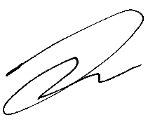
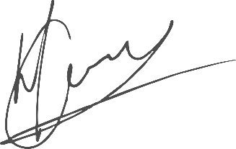

Signature: _______________________

For the Employer: KANAAN DESIGN STUDIO
Name: Seugnét Snyman
Position: DIRECTOR

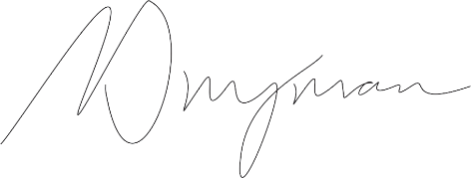
Signature: _______________________

For the Employee:
Name: BIANCA VAN VUUREN

Signature: _______________________

