
BLACKHOUND ENTERPRISES PTY LTD
T/A BLACKHOUND ARCHITECTURE & RENDERING

Hannes Gouws
hannes@blackhoundenterprises.com
072 799 9597

Unit 10 – The Network
19 Cactus Road
Fairview
Port Elizabeth (Gqeberha)
Eastern Cape
2075

Unit 10 – The Network
19 Cactus Road
Fairview
Port Elizabeth (Gqeberha)
Eastern Cape
2075

Unit 10 – The Network
19 Cactus Road
Fairview
Port Elizabeth (Gqeberha)
Eastern Cape
2075

30 January 2025

Subject: EMPLOYMENT CONFIRMATION LETTER FOR NOZUKO SMITH

To Whom It May Concern,

This letter serves to confirm that NOZUKO SMITH, ID number [8411230262082], is employed by Blackhound Architecture & Rendering in the capacity of a part time domestic worker. She has been working with us once a week since 2021 and continues to do so on a month-to-month basis.
NOZUKO SMITH is responsible for cleaning and maintaining our and she is remunerated in accordance with our agreed-upon terms, and her earnings of R700 are paid to her monthly.
Should you require any additional information, please do not hesitate to contact us at

Kind regards,

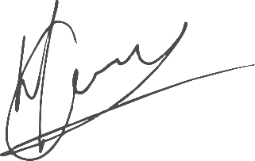

----------------------------------
Hannes Gouws
Professional Senior Architectural Technologist
SACAP: PSAT 32449887

