


BLACKHOUND ENTERPRISES PTY LTD
T/A BLACKHOUND ARCHITECTURE & RENDERING

Dewald Potgieter
dewald@blackhound.co.za
072 418 6867

Unit 10 – The Network
19 Cactus Road
Fairview
Port Elizabeth (Gqeberha)
Eastern Cape
2075
The Network
19 Cactus Road
Fairview
Port Elizabeth (Gqeberha)
Eastern Cape
2075

Unit 10 – The Network
19 Cactus Road
Fairview
Port Elizabeth (Gqeberha)
Eastern Cape
2075

Client(s):
Paul Du Preez
083 519 9465
paul@gamtoos.co.za
Date: 25 March 2026
|SCOPE OF WORKS:
New design layout, 3D visualisation for the existing lodge at Tuinskloof Lodge (Erf 90, Portion 3, Humansdorp)
- Project brief:
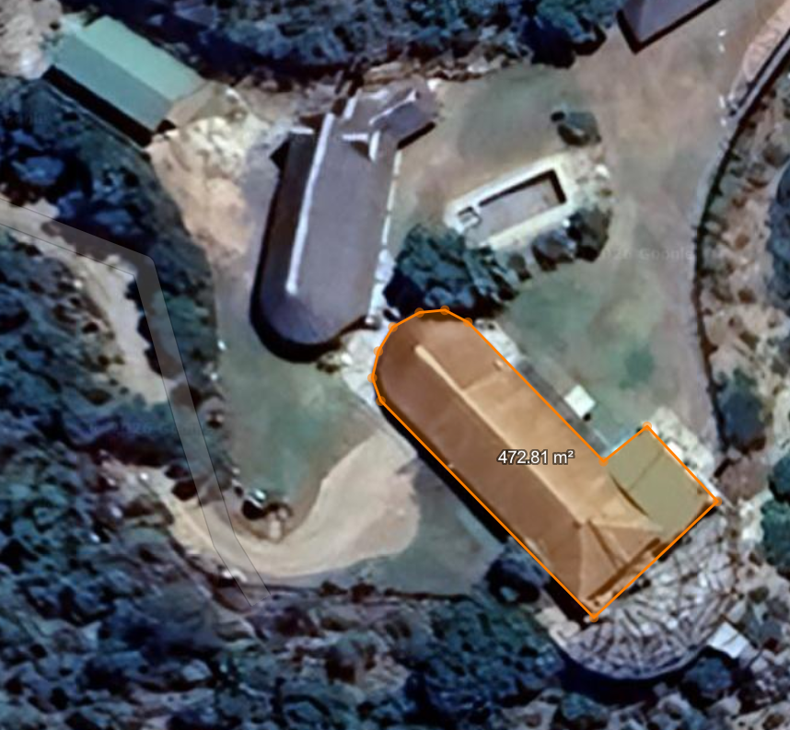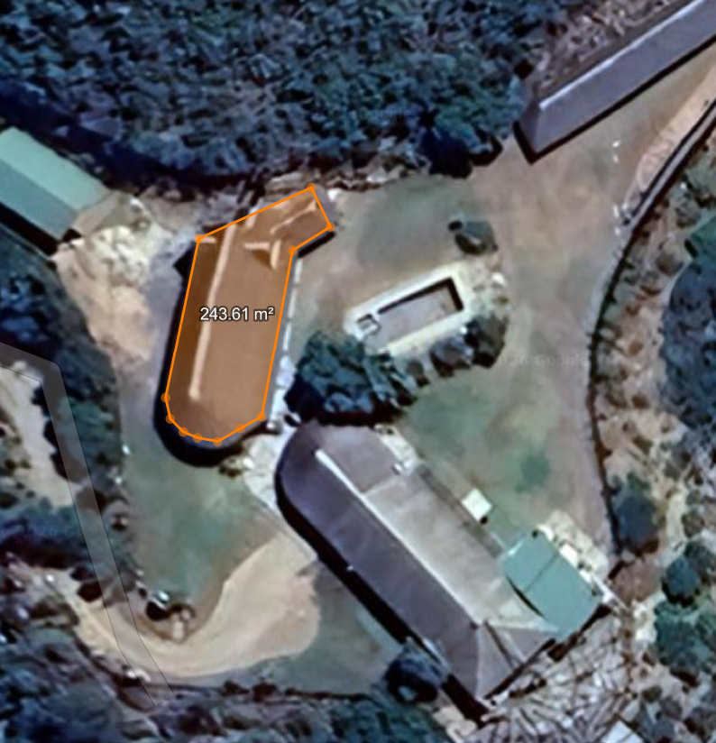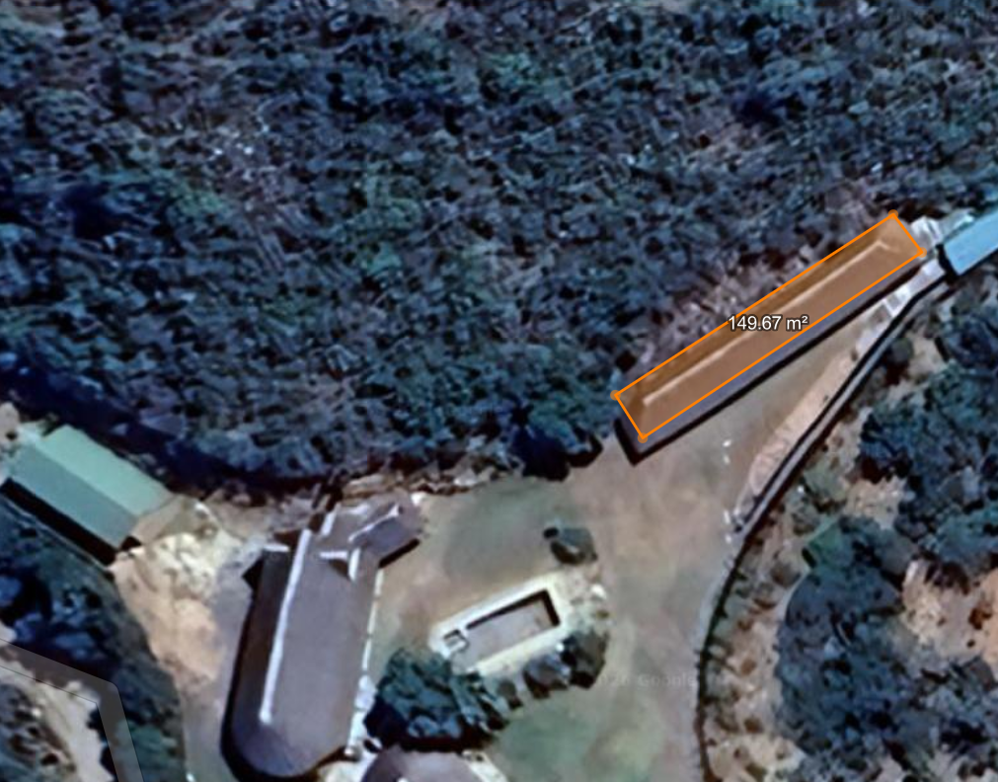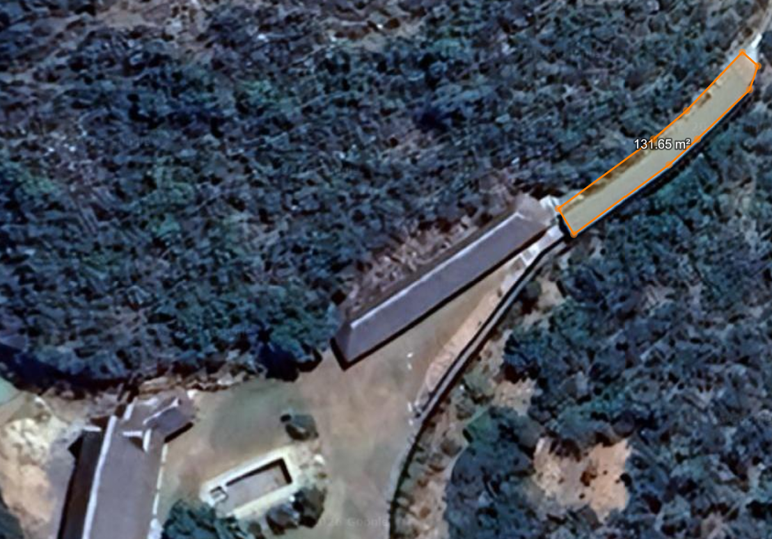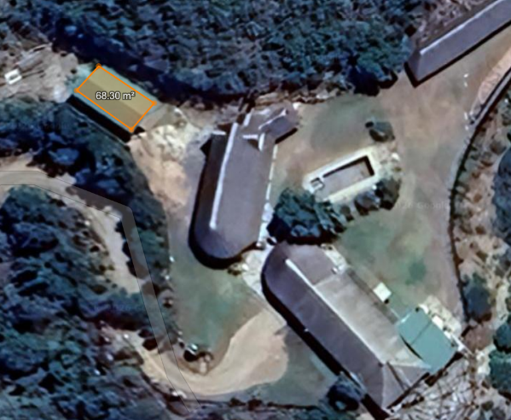

- Measure Existing & Draw
  - Old house footprint (+-473sqm)
  - Bar building + Toilets (+-244 sqm)
  - Single units (+-150 sqm)
  - Single units (+-132 sqm)
  - Laundry/Refuse (+-68 sqm)

- New design layout:
  - Old house footprint (+-473sqm)
  - Bar building + Toilets (+-244 sqm)
  - Single units (+-150 sqm)
  - Duplex units (+-264 sqm)
  - Laundry/Refuse (+-68 sqm)

- 3D visualization:
  - 3D visualization of the entire development.
  - Total Buildings: +-1067sqm

Initial(s): _________
| PROFESSIONAL FEES CALCULATION:

PHASE 1
- Measure & Draw - Old house footprint (+-473sqm) R 6 500.00
  - Measure existing building
  - Draw existing 2D layout

- Measure & Draw - Bar building + Toilets (+-244 sqm) R 3 575.00
  - Measure existing building
  - Draw existing 2D layout

- Measure & Draw - Single units (+-150 sqm) R 2 925.00
  - Measure existing building
  - Draw existing 2D layout

- Measure & Draw - Single units (+-132 sqm) R 2 080.00
  - Measure existing building
  - Draw existing 2D layout

- Measure & Draw - Laundry/Refuse (+-68 sqm) R 1 300.00
  - Measure existing building
  - Draw existing 2D layout

- Admin R 2 600.00
  - Travel, Meetings with client.

TOTAL FOR PHASE 1: (VAT not applicable) R 18 980.00

Initial(s): _________

PHASE 2

- Design - Old house footprint (+-473sqm) R 26 000.00
  - 2D design layout
  - 3D design visualization

- Design - Bar building + Toilets (+-244 sqm) R 5 200.00
  - 2D design layout
3D design visualization

- Design - Single units (+-150 sqm) R 4 875.00
  - 2D design layout
  - 3D design visualization

- Design - Duplex units (+-264 sqm) R 16 250.00
  - 2D design layout
  - 3D design visualization

- Design - Laundry/Refuse (+-68 sqm) R 3 250.00
  - 2D design layout
  - 3D design visualization

TOTAL FOR PHASE 2: (VAT not applicable) R 55 575.00

KINDLY NOTE:
*Should our scope of work increase, our fees will be adjusted to accommodate the extra scope.
This will be discussed before the work commences.
*This quote is only valid for 30 Days after the date of issue.

Excluded from the fees:
- Hard copy prints, if required.
- No Municipal drawings or submissions included.
- No other applications to the local authorities are included (e.g., Heritage applications, Occupation applications, etc.)
- No municipal or related fees are included (e.g. Council and municipal related fees/Levies/Estate/NHBRC)
- Other Professional consultancy fees that may be required (e.g. Structural Engineer, Quantity and Site Surveyors, Health & Safety, Professional Town planner, etc.)
- Execution of the works and testing of materials to ensure compliance with drawings and specifications remains the responsibility of the contractor.
- No interior design included, just a basic overall look and feel. If interior design is required, a separate quote will be sent to the client.

Initial(s): _________

|PAYMENT TERMS:
- Deposit payable upon acceptance of quotation. (R 18 980.00)
- Fees payable upon commencement of Phase 2. (R 50 000.00)
- Fees payable upon completion of Phase 2. (R 5 575.00)
|TERMS AND CONDITIONS:

BLACKHOUND (also known as BLACKHOUND ENTERPRISES (PTY) LTD) will be appointed to measure the existing buildings and develop new design layouts. Upon receiving client approval of the proposed layouts, BLACKHOUND will proceed with the full 3D visualisation of the entire development.

BLACKHOUND’s scope of work will be deemed complete once final design approval has been obtained.

  - SITE VISITS:
If additional Site Visits are requested, it be charged at R 2 600 per Site Visit.

  - DEVIATIONS:
Any on-site deviations requiring updated plans will be billed at an hourly rate of R 650.00. A separate quotation for revising will be provided to the client for their approval.

  - ADDITIONAL SERVICES:
Any additional services required by the client will be charged at an hourly rate of R 650.00. A separate quotation will be provided for the client’s approval.

  - PRINTS:
Our fees are exclusive of any hard copy prints. If we must make hard copy prints for any reasons not attributed to BLACKHOUND ENTERPRISES PTY LTD, the client will be notified beforehand and will be invoiced separately or added to the client’s final invoice.
Revision drawings will be emailed to the site management team or the client where hard copy revision drawings will be the responsibility of the contractor / client / site manager.

  - TERMINATION:
If the agreement between the parties is terminated by either party for reasons not caused by BLACKHOUND ENTERPRISES PTY LTD, the fee for the work in progress and the completed work will be due for payment.

  - SUSPENSION:
BLACKHOUND ENTERPRISES PTY LTD retains the right to suspend all service until the settlement of any outstanding account.

Initial(s): _________

  - OTHER PROFESSIONALS:
BLACKHOUND is not responsible for the performance of other professionals (such as Town Planners and Engineers), nor for the quality of drawings and documents provided by them, tender prices, the actions of Homeowner Associations, Municipalities, or Municipal Services. We are also not responsible for the performance of the Contractor or any of their Sub-Contractors, Suppliers, or employees.

  - COPYRIGHT:
All drawings, designs, documents and other intellectual property produced by BLACKHOUND remain the exclusive property of BLACKHOUND.

Upon full payment of all fees due, the client is granted the right to use the drawings and designs solely for the project and site for which they were prepared.

The drawings and designs may not be reproduced, amended, shared with third parties, or used for any other project or site without the prior written consent of BLACKHOUND, including submission by another professional or use of the design by others.

  - FEE OFFSET:
The Client is not entitled to ‘set-off’ or withhold payment for any alleged claim against either BLACKHOUND ENTERPRISES PTY LTD or any other party involved in the building contract. The claim is to be dealt with on its own merits.

  - VAT:
BLACKHOUND ENTERPRISES PTY LTD. Is not a VAT vendor. All architectural fees presented are exclusive of VAT until further notice. If the client requires a VAT number, we can make the necessary arrangements.

|ACCEPTANCE:
The Terms and Conditions presented here may be modified or amended as necessary only by written instrument signed by both parties.
By submitting the non-refundable deposit payment, you are agreeing to the terms and conditions detailed in this document. This proposal is agreed upon in full, signed and dated.
By signing this document, I indicate that I understand, agree to, and accept the terms and conditions as contained herein, dated 26 March 2026.

I, __________________________________________ hereby agree to the Terms and Conditions laid out in this document.


----------------------------------------------- -------------------------------------
Dewald Potgieter Client(s): Paul Du Preez
Director | PAT 30442820 Date:
Email: dewald@blackhound.co.za
Phone: 072 418 6867

