


BLACKHOUND ENTERPRISES PTY LTD
T/A BLACKHOUND ARCHITECTURE & RENDERING

Hannes Gouws
hannes@blackhoundenterprises.com
072 799 9597

Unit 10 – The Network
19 Cactus Road
Fairview
Port Elizabeth (Gqeberha)
Eastern Cape
2075
The Network
19 Cactus Road
Fairview
Port Elizabeth (Gqeberha)
Eastern Cape
2075

Unit 10 – The Network
19 Cactus Road
Fairview
Port Elizabeth (Gqeberha)
Eastern Cape
2075

Client:
Chamberlain + Associates | Fredrick Menyah-Artivor
+264 61 253 669
fredrick@caa.com.na
261 MICT|Animation Rendering – Fee Proposal REV00

Date: 13 AUGUST 2025
|PROJECT BRIEF:
Create 3x Animation fly-through videos moving around and through the indicated designated spaces of the MICT building, as provided on the reference videos on 13.08.2025.
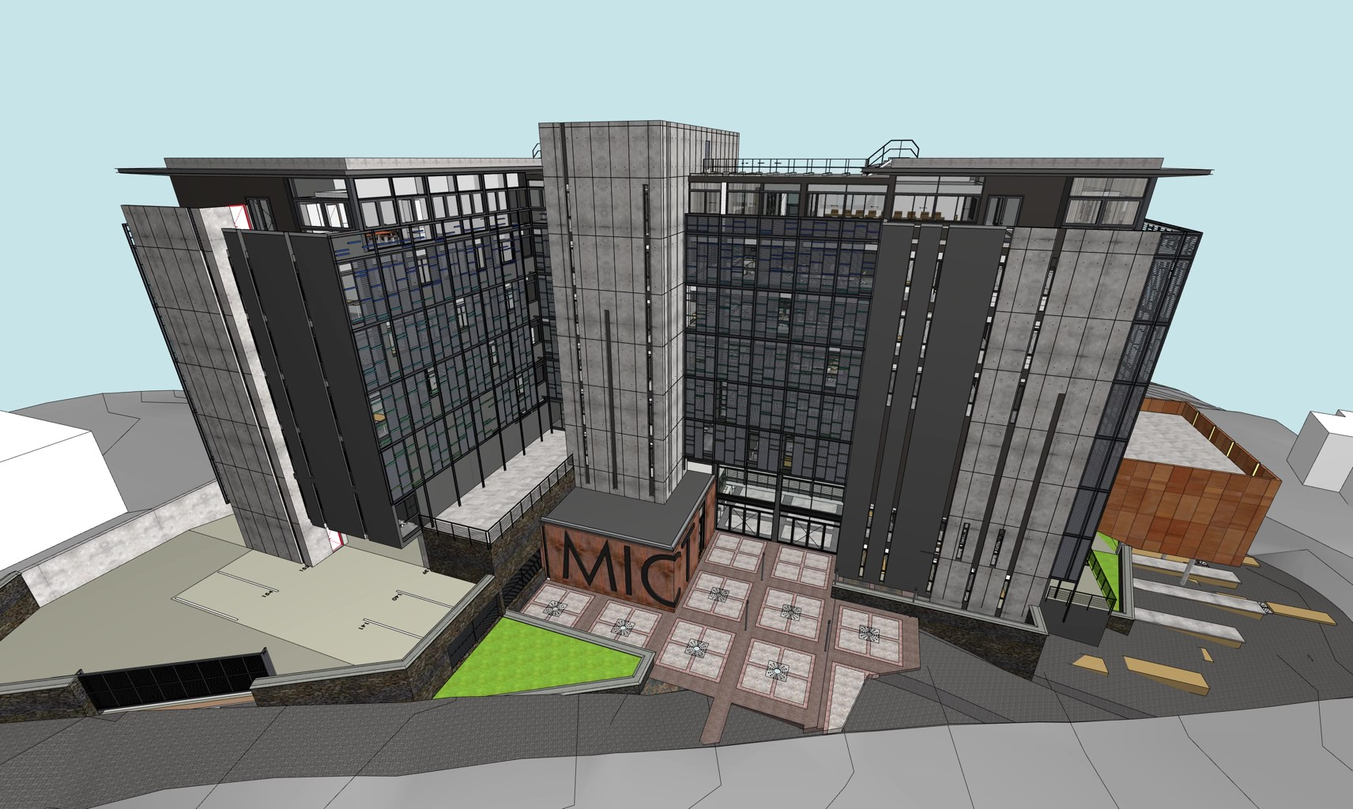

|MICT – Fly-Through: QUOTATION & DELIVERABLES
- PHASE ONE:

- 3d Modelling:
  - 3d modelling:
Blackhound will do the necessary 3d modelling to update the landscaping and context.
We will do the necessary lighting, environment, materials and textures adjustments and preparation to the 3d model to be able to render the project.

  - Context 3d Modelling:
Buildings in view and environment landscaping.

R 15 600.00

- PHASE TWO:

- Animation Video Production:

3x Animation Fly-through videos of ±1min each.
Blackhound will do the necessary 3d modelling to update the spaces and finishes for rendering.
CAA will provide a moodboard and references of the preferred furniture, finishes and décor, which we can use as reference to match similar from our library.
- No custom furniture to be 3d modelled or purchased.
- Should you require custom furniture and décor to match catalogues and specific brands, please refer to item 1.3 under Terms and Conditions.
- No design fees allowed.

The focused paths of the animations will be:
- Video 1:
Exterior drone fly around the building and into the main entrance and foyer, through the café and into and around the Auditorium.
- Video 2:
Starting from the Entrance / Reception lobby into and around the staircase and lift circulation space.
- Video 3:
Starting from the upper-level staircase landing moving to the reception desk and into and around the board room. From there moving down the passage into the designated offices and ending in the Bar / break room.

R 28 645.00

- As discussed, we will provide one round of draft fly-throughs for comments on the camera movement and overall approval before we proceed with creating the final high-res animation.

Fees Summery:
Phase 1: 3D MODELING: R 15 600.00
Phase 2: ANIMATION RENDERING: R 28 645.00

TOTAL QUOTE: (VAT not applicable) R 44 245.00

|PAYMENT TERMS:
- Deposit payable upon acceptance of quotation. (R 30 971.50)

- Balance of the fees payable upon receipt of animation production. (R 13 273.50)

|TERMS AND CONDITIONS:
Blackhound Enterprises PTY LTD will be employed for the rendering 3x Animation fly-through animations as laid out in this document, designed by Chamberlain + Associates. As discussed via email dated 12.08.2025, the first round of draft renders will be delivered by C.O.B. Monday, August 25th with the final renders delivered by C.O.B. on Monday, September 1st.

- No Additional architectural or 3d rendering services have been included in this quotation.

- Once the final draft renders have been approved by the client, please note that any design changes made to the 3D model could result in additional costs, which will be discussed and agreed upon before work commences.

  - SITE VISITS:
N/A.

  - ADDITIONAL RENDERS:
Should you request additional renders, the pricing will be as follows:

- Additional renders requested in a new space which has not been developed in the initial 3d modelling and rendering phase will be charged at R5 500.00 per additional render to allow for the time to develop the additional spaces and views.

- Additional still renders requested in an already designed and developed space will be charged at a reduced rate of R2 000.00 per additional render.

  - CUSTOM FURNITURE:
Should you require us to 3d model furniture and décor items selected from catalogues or brands, a custom 3d modelling fee per 3d model will be applicable, depending on the complexity and scale of the items selected. A separate quote will be provided.

  - TERMINATION:
If the agreement between the parties is terminated by either party for reasons not caused by BLACKHOUND ENTERPRISES PTY LTD, the fee for the work in progress and the completed work will be due for payment.

  - SUSPENSION:
BLACKHOUND ENTERPRISES PTY LTD retains the right to suspend all service until the settlement of any outstanding account.

  - OTHER PROFESSIONALS:
BLACKHOUND ENTERPRISES PTY LTD is not responsible for the performance of other professionals or artists (such as Town Planners, Engineers, or any other designers and artists), nor for the quality of images, drawings and documents provided by them, tender prices, the actions of Homeowner Associations, Municipalities, or Municipal Services. We are also not responsible for the performance of the Contractor or any of their Sub-Contractors, Suppliers, or employees.

  - COPYRIGHT:
BLACKHOUND ENTERPRISES PTY LTD retains the ownership of copyright to all its intellectual property. No designs, drawings, renders or documents may be used and shared with other parties without our express permission. This includes our fee proposal and rates.

  - FEE OFFSET:
The Client is not entitled to ‘set-off’ or withhold payment for any alleged claim against either BLACKHOUND ENTERPRISES PTY LTD or any other party involved in the project. The claim is to be dealt with on its own merits.

  - FINAL INVOICE:
The final invoice will be due upon receipt or notification of completion of final renders or animation.

  - VAT:
BLACKHOUND ENTERPRISES PTY LTD. Is not a VAT vendor. All architectural fees presented are exclusive of VAT until further notice.

|ACCEPTANCE:
The Terms and Conditions presented here may be modified or amended as necessary only by written instrument signed by both parties.
By submitting the non-refundable deposit payment or signing this document, you are agreeing to the terms and conditions detailed in this document.
This proposal is agreed upon in full, signed and dated.
By signing this document, I indicate that I understand, agree to, and accept the terms and conditions as contained herein, dated this 13 AUGUST 2025.

I, __________________________________________ hereby agree to the Terms and Conditions laid out in this document.

Email: hannes@blackhoundenterprises.com
Phone: 072 799 9597

----------------------------------------------- -------------------------------------
Hannes Gouws Chamberlain + Associates
Director | PSAT 32449887 Date:

