


BLACKHOUND ENTERPRISES PTY LTD
T/A BLACKHOUND ARCHITECTURE & RENDERING

Hannes Gouws
hannes@blackhoundenterprises.com
072 799 9597

Unit 10 – The Network
19 Cactus Road
Fairview
Port Elizabeth (Gqeberha)
Eastern Cape
2075
The Network
19 Cactus Road
Fairview
Port Elizabeth (Gqeberha)
Eastern Cape
2075

Unit 10 – The Network
19 Cactus Road
Fairview
Port Elizabeth (Gqeberha)
Eastern Cape
2075

Client:
Cameron Harvey | Paul Schmidt
Cameron Harvey | 071 645 3843
cameron@dslinvestments.co.za
Moffit Office Park|Rendering – Fee Proposal REV00

Date: 26 JUNE 2025
|PROJECT BRIEF:
Visualise the main façade and allocated greening spaces of the Moffit Office Park by providing 7x photo realistic renders of these spaces and 1x animation video production moving through the spaces, as discussed in our meeting on 24.06.2025.
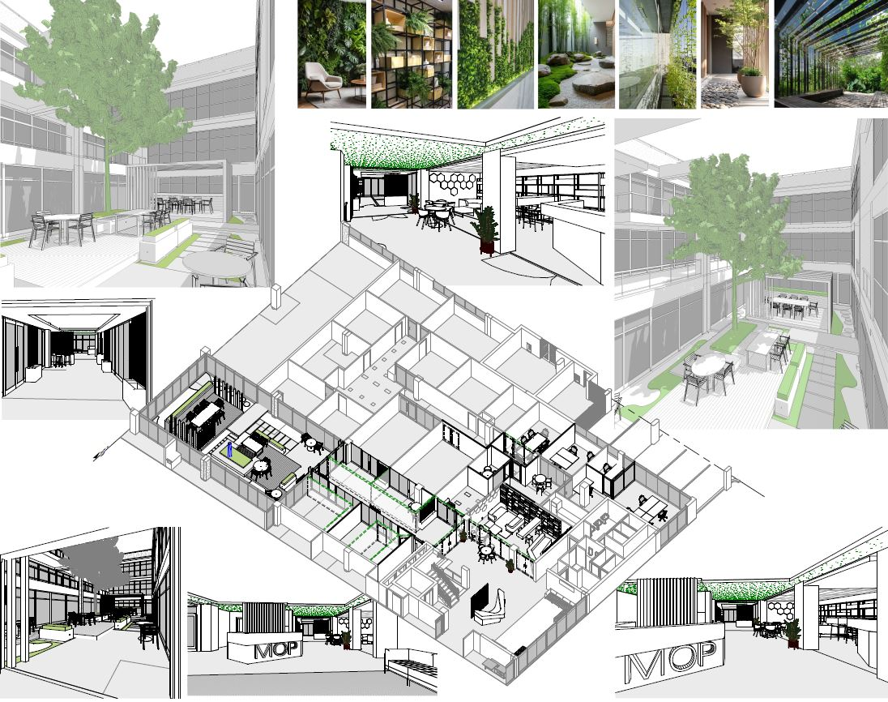

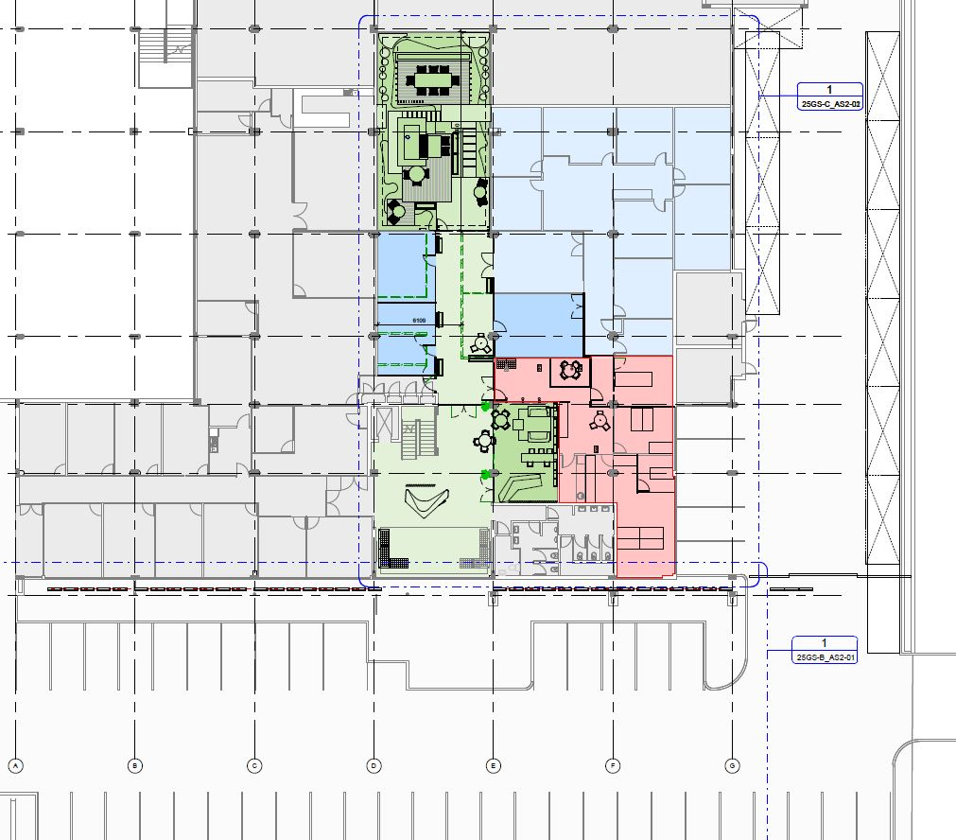
VIEW SUGGESTIONS:

Exterior: 3x Renders: RED
- Perspective view of the Moffit Façade.
- Front Facing Façade render of the Moffit Façade.
- Perspective view of the North Facade.

Interior: 4x Renders: BLUE
- Entrance Foyer
- Coffee Shop
- Atrium A
- Atrium B

|MOFFIT OFFICE PARK: QUOTATION & DELIVERABLES
- PHASE ONE:

- 3d Modelling and Still Renders:
  - 3d modelling:
Blackhound will do the necessary 3d modelling to update the spaces for rendering.
We will do the necessary lighting, environment, materials and textures adjustments and preparation to the 3d model to be able to render the project.
- No custom furniture to be 3d modelled or purchased.
- Should you require custom furniture and décor to match catalogues and specific brands, please refer to item 1.3 under Terms and Conditions.

  - Context 3d Modelling:
Buildings in view and environment landscaping.

R7 200.00
- PHASE TWO:

- Still Image Rendering:

We will provide a total of 7x Renders of the following spaces:

      - Perspective view of the Moffit Façade = 1x Render.
      - Front Facing Façade render of the Moffit Façade = 1x Renders.
      - Perspective view of the North Facade = 1x Render.
      - Entrance Foyer = 1x Render
      - Coffee Shop = 1x Render
      - Atrium = 2x Renders

R31 089.00

- This quote and discussed timeline allows for a total of 2x Rounds of draft renders for you to approve the design and settings before we commence with the final renders.
Please refer to T’s & C’s.

- PHASE THREE:

- Animation Video Production:

1x animation production video. Animation productions consist of segments rendered of various scenes or spaces, capturing the details and movement through spaces. These segments are then edited together in a post-production process with music and text animations to make up the final production presentation video.

The focused paths of the animation will be:
- the Main façade and entrance to the building.
- The coffee shop.
- The experience and movement through the Atrium space.

R21 286.00

- As discussed, once the still renders are approved and rendered will we proceed with creating the animation.
Fees Summery:
Phase 1: 3D MODELING: R 7 200.00

Phase 2: STILL IMAGE RENDERING: R 31 089.00
- 7x Photo Realistic Renders @ ± R 4 441.22per render
Phase 3: ANIMATION PRODUCTION: R 21 286.00

TOTAL QUOTE: (VAT not applicable) R 59 575.00

|PAYMENT TERMS:
- Deposit payable upon acceptance of quotation. (R 38 289.00)

- Balance of the fees payable upon receipt of animation production. (R 21 286.00)

|TERMS AND CONDITIONS:
Blackhound Enterprises PTY LTD will be employed for the rendering of the proposed designs of Moffit Office Park, designed by BouNou. There are no strict deadlines discussed, but timeous work and deliverables are expected as good measure.

- No Additional architectural or 3d rendering services have been included in this quotation.

- Should the client require architectural drawings, working drawings, design services and/or council submission services, a separate fee proposal will be prepared to accommodate the scope of works.

- Once the final draft renders have been approved by the client, please note that any design changes made to the 3D model could result in additional costs, which will be discussed and agreed upon before work commences.

  - SITE VISITS:
N/A.

  - ADDITIONAL RENDERS:
Should you request additional renders, the pricing will be as follows:

- Additional renders requested in a new space which has not been developed in the initial 3d modelling and rendering phase will be charged at R5 500.00 per additional render to allow for the time to develop the additional spaces and views.

- Additional renders requested in an already designed and developed space will be charged at a reduced rate of R2 000.00 per additional render.

  - CUSTOM FURNITURE:
Should you require us to 3d model furniture and décor items selected from catalogues or brands, a custom 3d modelling fee per 3d model will be applicable, depending on the complexity and scale of the items selected. A separate quote will be provided.

  - TERMINATION:
If the agreement between the parties is terminated by either party for reasons not caused by BLACKHOUND ENTERPRISES PTY LTD, the fee for the work in progress and the completed work will be due for payment.

  - SUSPENSION:
BLACKHOUND ENTERPRISES PTY LTD retains the right to suspend all service until the settlement of any outstanding account.

  - OTHER PROFESSIONALS:
BLACKHOUND ENTERPRISES PTY LTD is not responsible for the performance of other professionals or artists (such as Town Planners, Engineers, or any other designers and artists), nor for the quality of images, drawings and documents provided by them, tender prices, the actions of Homeowner Associations, Municipalities, or Municipal Services. We are also not responsible for the performance of the Contractor or any of their Sub-Contractors, Suppliers, or employees.

  - COPYRIGHT:
BLACKHOUND ENTERPRISES PTY LTD retains the ownership of copyright to all its intellectual property. No designs, drawings, renders or documents may be used and shared with other parties without our express permission. This includes our fee proposal and rates.

  - FEE OFFSET:
The Client is not entitled to ‘set-off’ or withhold payment for any alleged claim against either BLACKHOUND ENTERPRISES PTY LTD or any other party involved in the project. The claim is to be dealt with on its own merits.

  - FINAL INVOICE:
The final invoice will be due upon receipt of final renders.

  - VAT:
BLACKHOUND ENTERPRISES PTY LTD. Is not a VAT vendor. All architectural fees presented are exclusive of VAT until further notice.

|ACCEPTANCE:
The Terms and Conditions presented here may be modified or amended as necessary only by written instrument signed by both parties.
By submitting the non-refundable deposit payment or signing this document, you are agreeing to the terms and conditions detailed in this document.
This proposal is agreed upon in full, signed and dated.
By signing this document, I indicate that I understand, agree to, and accept the terms and conditions as contained herein, dated this 26 JUNE 2025.

I, __________________________________________ hereby agree to the Terms and Conditions laid out in this document.

Email: hannes@blackhoundenterprises.com
Phone: 072 799 9597

----------------------------------------------- -------------------------------------
Hannes Gouws Cameron Harvey
Director | PSAT 32449887 Date:

