


BLACKHOUND ENTERPRISES PTY LTD
T/A BLACKHOUND ARCHITECTURE & RENDERING

Hannes Gouws
hannes@blackhoundenterprises.com
072 799 9597

Unit 10 – The Network
19 Cactus Road
Fairview
Port Elizabeth (Gqeberha)
Eastern Cape
2075

Unit 10 – The Network
19 Cactus Road
Fairview
Port Elizabeth (Gqeberha)
Eastern Cape
2075

Unit 10 – The Network
19 Cactus Road
Fairview
Port Elizabeth (Gqeberha)
Eastern Cape
2075

Client:
Johan Britz
069 586 4262
Johanbritz8@gmail.com
Date: 04 APRIL 2024
|PROJECT BRIEF:

Measure and redraw the existing house on ERF 322, Sea Vista, St. Francis Bay, Eastern Cape.
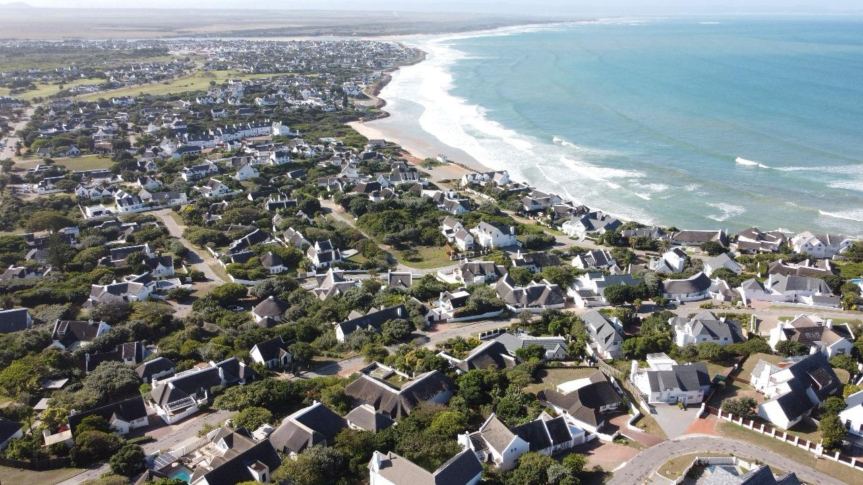

SCOPE OF WORKS:
  - Measure Existing House and Redraw:
Existing Structures: ± 634m² measured from GIS and Existing images.

  - No Design services have been allowed in this fee proposal.

  - No Municipal drawings have been allowed in this fee proposal.

|HOUSE 5 LOVEMORE CR. SEA VISTA:
Quote & Deliverables
Design, Municipal Drawings, Technical Drawings and Documentation:
Approximate Size of House: 634m²

Professional Fees Calculation:
2.1) Phase 1: Measure and Redraw:
- Measure and redraw existing structures:
  - This includes measuring all existing structures built on site and redrawing the structure in electronic format.
R31,700.00

2.3) Site Visits:
  - We have allowed for 1 x Site visits in this fee proposal.
(1x Site visit will be used with Phase 1: To measure the existing structures.)
R1 100.00

KINDLY NOTE:
*Should our scope of work increase, our fees will be adjusted to accommodate the extra scope. This will be discussed before the work commences.
*This quote is only valid for 30 Days after the date of issue.

TOTAL QUOTE: R32 800. 00 (VAT not applicable)

|PAYMENT TERMS:
- 70% Deposit payable at acceptance of quotation. (R 61 089.28)
- 30% Balance payable at handover of existing drawings. (R 26 181.12)

*See the T’s & C’s below.
Excluded from the fees:
- Submission fees and hard copy prints. (e.g. Council and municipal related fees/Estate/NHBRC)
- Other Professional consultancy fees that may be required (e.g. Structural Engineer, Quantity and Site Surveyors, Health & Safety, etc.)
- Execution of the works and testing of materials to ensure compliance with drawings and specifications remains the responsibility of the contractor.
- As-Built drawings, if any deviations occurred from the approved plans.
- Printing of drawings for site.
- Retrieval of Occupation Certificate.
- Contract and project management.

|TERMS AND CONDITIONS:

BLACKHOUND ENTERPRISES PTY LTD will be employed ONLY to measure and redraw the existing structure built on site. Should you require architectural design or municipal drawings services, a separate fee proposal will be prepared for your approval.

No occupation application process was included in this quotation. Should the client require this service a separate quote can be provided.

  - SITE VISITS:
If additional Site Visits are requested, a travel expense of R1 100.00 per Site Visit will be charged. This will be invoiced at the end of each month for the duration of the project or when Site visits are requested.

  - PRINTS:
This quotation excludes any hard copy prints. If BLACKHOUND ENTERPRISES PTY LTD must make hard copy prints for any reasons, the client will be notified beforehand and will be invoiced separately or added to the client’s final invoice. Once the plans are approved by council, BLACKHOUND ENTERPRISES PTY LTD will provide the client with their stamped approved hard copy.
Revision drawings will be emailed to the site management team or the client where hard copy revision drawings will be the responsibility of the contractor / client / site manager.
If BLACKHOUND ENTERPRISES PTY LTD must make hard copy prints for site, it will be added to a separate invoice at:
R55 per A1 print
R75 per A0 print.

  - TERMINATION:
If the agreement between the parties is terminated by either party for reasons not caused by BLACKHOUND ENTERPRISES PTY LTD, the fee for the work in progress and the completed work will be due for payment.

  - DEVIATIONS:
Any deviations made on site that require an updated plan will be billed at an hourly rate of R 650.00. An additional quotation for the cost of revising the drawings will be sent to the client before making the changes.

  - SUSPENSION:
BLACKHOUND ENTERPRISES PTY LTD retains the right to suspend all services until the settlement of any outstanding accounts.

  - OTHER PROFESSIONALS:
BLACKHOUND ENTERPRISES PTY LTD will not be held responsible for the performance of other professionals (such as Town Planners and Engineers), nor for the quality of drawings and documents provided by them, tender prices, the actions of Homeowner Associations, Municipalities, or Municipal Services. BLACKHOUND ENTERPRISES PTY LTD are also not responsible for the performance of the Contractor or any of their Sub-Contractors, Suppliers, or employees.

  - COPYRIGHT:
BLACKHOUND ENTERPRISES PTY LTD retains the ownership of copyright to all their intellectual property. No designs, drawings or documents may be used and shared with other parties without our express permission.

  - VAT:
BLACKHOUND ENTERPRISES PTY LTD. Is not a VAT vendor. All architectural fees presented are exclusive of VAT until further notice.

  - PAYMENTS:
The client is not entitled to ‘set-off’ or withhold any payments to BLACKHOUND ENTERPRISES PTY LTD for any alleged claims against other parties involved in the project. Each claim should be addressed on its own merits.

Each invoice to be settled within 7 Calendar days after the date of issue.

*Design completion will be deemed achieved should the client fail to notify BLACKHOUND ENTERPRISES PTY LTD of any possible changes within 14 Calendar days after the initial design was presented to the client.

*Balance payable at commencement of Municipal drawings as set out in the payment terms, means the balance of the architectural fees will become payable upon notification of commencement of municipal drawings. (Stage 4.1)

|ACCEPTANCE:
The Terms and Conditions presented here may be modified or amended as necessary only by written instrument signed by both parties.
By submitting the non-refundable deposit payment and / or signing this document, you are agreeing to the terms and conditions detailed in this document. This proposal is agreed upon in full, signed and dated.
By signing this document, I indicate that I understand, agree to, and accept the terms and conditions as contained herein, dated this 04 APRIL 2025.

I, __________________________________________ hereby agree to the Terms and Conditions laid out in this document.

Email: hannes@blackhoundenterprises.com
Phone: 072 799 9597

----------------------------------------------- -------------------------------------
Hannes Gouws Client name:
Director | SACAP: PSAT 32449887 Date:

