


BLACKHOUND ENTERPRISES PTY LTD
T/A BLACKHOUND ARCHITECTURE & RENDERING

Hannes Gouws
hannes@blackhoundenterprises.com
072 799 9597

Unit 10 – The Network
19 Cactus Road
Fairview
Port Elizabeth (Gqeberha)
Eastern Cape
2075

Unit 10 – The Network
19 Cactus Road
Fairview
Port Elizabeth (Gqeberha)
Eastern Cape
2075

Unit 10 – The Network
19 Cactus Road
Fairview
Port Elizabeth (Gqeberha)
Eastern Cape
2075

Client:
Danielle & Rikus Robbertze
072 170 7417
danielle.robbertze10@gmail.com
Date: 02 October 2024
|SCOPE OF WORKS:
Design Additions and Alterations to an existing house in Bridal Glen townhouse complex, ERF 166, Montmedy Road, Lorraine, Port Elizabeth.
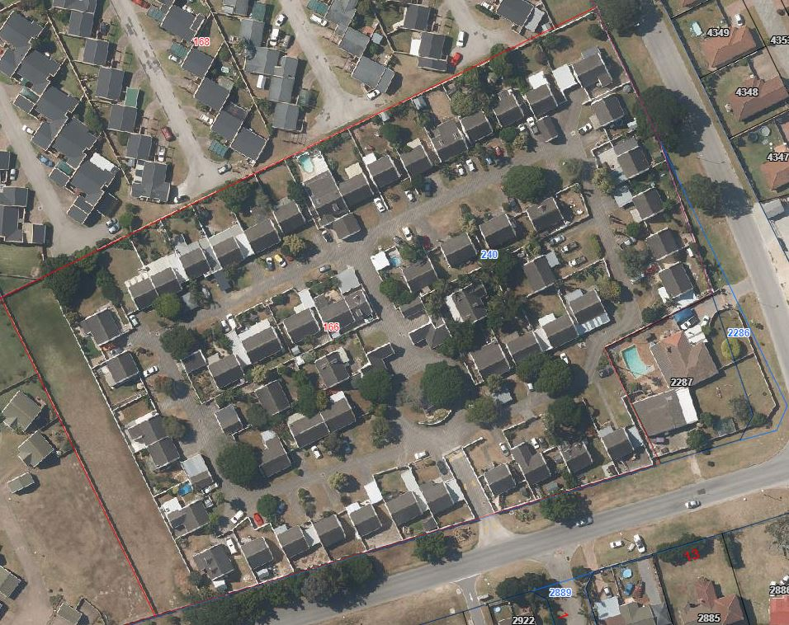

PROJECT REQUIREMENTS:
Affected areas:
- Dining area.
- Living room.
- Introduce a Braai.

- Original Approved Drawings:
It was determined that the original drawings are not available at NMBM.
Therefore, we will measure and draw the house as existing to correspond with what is built on site and according to the latest approved plans.

- HOA: Bellbouy
Hayden Cockroft – 041 374 444

- Interior Design: Not included.

| HOUSE ROBBERTZE: QUOTE & DELIVERABLES.
Design, Municipal Drawings, Technical Drawings and Documentation:
Approximate Size of Existing House and structures: ± 160m² (Double storey measured from NMBM GIS Mapping).
Professional Fees Calculation:
- Phase 1: Measure Existing and Design (incl. 3D visualization):
  - Measure and Redraw:
  - This includes measuring all existing structures built on site and redrawing the structure in electronic format. (2d and 3d)
R 12 800.00
  - Design: Architectural Workstage 1 – 3 (Refer to the Architectural work stages at the end of this document, as per the Architectural Professional: Act 44 of 2000)

  - We will proceed with the design phase and liaise with you to achieve design approval.
  - Included in our design phase is conceptual 3D modelling, to resolve design details, basic finishes and to give you a clear picture of what the design will look like before we proceed to the next phase.
  - Liaising with a contractor to give us an estimate construction price based on your approved design
R 10 752.00

- Phase 2: Municipal Drawings, Documentation and Submission:
5.1. Stage 4.1 – Municipal drawings include:

  - Municipal drawings; Site plan, Floor Plan, Section, Elevations, and basic Electrical layouts
  - Municipal Documentation and the council submission process.
  - Deemed-to-Satisfy Energy Efficiency and Fenestration calculations, as required by SANS10400.
  - Liaising with a contractor to give us an updated accurate construction price based on the approved design
R14 264.00

  - Stage 4.2 - Construction / Technical Drawings:

  - Detailed Electrical layouts, Window and Door schedules.
  - Details: Threshold details, finish transition details, staircase drawings, balustrade details,
Roof details, specifications.
  - Window and Door schedules.
R5 376.00

SUB TOTAL:
- Phase 1:
  - Measure Existing and Redraw R 12 800.00
  - Design (affected Area) R 10 752.00

- Phase 2:
  - Municipal Drawings (Stage 4.1) R 14 264.00
  - Construction / Technical drawings (Stage 4.2) R 5 376.00

TOTAL QUOTE: R 43 192.00 (VAT not applicable)

Project Management
This service is not included in this fee proposal. Should you require this services, a separate fee proposal will be issued where Management will be @ 5% of the project cost spread over the duration of the project and claimed at the end of each month.

With Project Management each month will include:
- 2 x Travel.
- Contract and site management.
- Quality control checking.
- Fortnightly minuted meetings with the client and contractor on-site.
- Evaluation of payment claims and approval thereof. (as per JBCC)

KINDLY NOTE:
- Should our scope of work increase, our fees will be adjusted to accommodate the extra scope. This will be discussed before the work commences.
- This quote is only valid for 30 Days after the date of issue.
- Each invoice to be settled within 14 Calander days after the date of issue.

Excluded from the fees:
- Submission fees and hard copy prints, if required. (e.g. Council and municipal related fees/Estate/NHBRC)
- Other Professional consultancy fees that may be required (e.g. Structural Engineer, Quantity and Site Surveyors, Health & Safety, etc.)
- Execution of the works and testing of materials to ensure compliance with drawings and specifications remains the responsibility of the contractor.
- Printing of drawings for site.
|PAYMENT TERMS:
- Deposit payable at acceptance of quotation. (R 30 234.40)
- Fees payable at start of municipal drawings. (R 12 957.60)
|TERMS AND CONDITIONS:
Blackhound will be employed for the design of the additions and alterations to the affected areas as laid out in the Project Requirements on page 2. A design and conceptual 3D of the design will be created, focusing on the above-mentioned areas. Thereafter, we will provide an estimated construction cost for this design. Once the design has received approval from the client, we will proceed with the municipal drawings and prepare the necessary documentation sufficient for municipal submission to achieve municipal approval.
We have allowed for Construction / Technical Drawings (partial Stage 4.2) in this fee proposal. Please note that should you choose to remove this service from the fee proposal and later request our assistance on the items that is covered under this section, an hourly rate of R850 per hour will be applicable to do the additional work.
(Kindly see the end of the document for descriptions of the Architectural work stages.)
Project Management is not included.

  - SITE VISITS:
If additional Site Visits are requested, a travel expense of R850.00 per Site Visit will be charged. This will be invoiced at the end of each month for the duration of the project or when Site visits are requested.

  - PRINTS:
Our fees are exclusive of any hard copy prints. If we must make hard copy prints for any reasons not attributed to BLACKHOUND ENTERPRISES PTY LTD, the client will be notified beforehand and will be invoiced separately or added to the client’s final invoice. Once the plans are approved by council, we will provide you with your stamped approved hard copy.
Revision drawings will be emailed to the site management team or the client where hard copy revision drawings will be the responsibility of the contractor / client / site manager.
If we must make hard copy prints for site, it will be added to an invoice at:
R85 per A1 print
R105 per A0 print.

  - TERMINATION:
If the agreement between the parties is terminated by either party for reasons not caused by BLACKHOUND ENTERPRISES PTY LTD, the fee for the work in progress and the completed work will be due for payment.

  - DEVIATIONS:
Any deviations made on site that require an updated plan will be billed at an hourly rate of R 650.00. An additional quotation covering the cost of revising the drawings will be sent to the client.

  - SUSPENSION:
BLACKHOUND ENTERPRISES PTY LTD retains the right to suspend all service until the settlement of any outstanding account.

  - OTHER PROFESSIONALS:
BLACKHOUND ENTERPRISES PTY LTD is not responsible for the performance of other professionals (such as Town Planners and Engineers), nor for the quality of drawings and documents provided by them, tender prices, the actions of Homeowner Associations, Municipalities, or Municipal Services. We are also not responsible for the performance of the Contractor or any of their Sub-Contractors, Suppliers, or employees.

  - COPYRIGHT:
BLACKHOUND ENTERPRISES PTY LTD retains the ownership of copyright to all of its intellectual property. No designs, drawings or documents may be used and shared with other parties without our express permission.

  - FEE OFFSET:
The Client is not entitled to ‘set-off’ or withhold payment for any alleged claim against either BLACKHOUND ENTERPRISES PTY LTD or any other party involved in the building contract. The claim is to be dealt with on its own merits.

  - FINAL INVOICE:
The final invoice will be due upon submission to council. If you decide not to proceed with council submission, the final invoice remains payable after two weeks from the notification of completed work.

  - VAT:
BLACKHOUND ENTERPRISES PTY LTD. Is not a VAT vendor. All architectural fees presented are exclusive of VAT until further notice.
|ACCEPTANCE:
The Terms and Conditions presented here may be modified or amended as necessary only by written instrument signed by both parties.
By submitting the non-refundable deposit payment, you are agreeing to the terms and conditions detailed in this document. This proposal is agreed upon in full, signed and dated.
By signing this document, I indicate that I understand, agree to, and accept the terms and conditions as contained herein, dated 02 October 2024.

I, __________________________________________ hereby agree to the Terms and Conditions laid out in this document.

Email: hannes@blackhoundenterprises.com
Phone: 072 799 9597

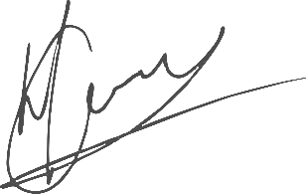

----------------------------------------------- -------------------------------------
Hannes Gouws Danielle Robbertze
Director | PSAT 32449887 Date:

|ARCHITECTURAL WORK STAGES:
As per the Architectural Professional: Act 44 of 2000
For information purposes only:
Stage 1: Inception
  - Receive, appraise and report on the client's requirements with regard to the client's brief;
  - Determine the site and rights and constraints;
  - Determine budgetary constraints; 0
  - Determine the need for consultants;
  - Determine indicative project timelines;
  - Determine methods of contracting; and
  - Whether other statutory authority applications are required or desirable.
Stage 2: Concept Design
- Prepare an initial design concept and advise on:
          - the intended space provisions and planning relationships;
          - proposed materials and intended building services; and
          - the technical and functional characteristics of the design.
- Check for conformity of the concept with the rights to the use of the land.
- Consult with local and statutory authorities.
- Review the anticipated costs of the project. e) Review the project programme.
Stage 3: Design Documentation
- Develop all aspects of the design from concept to full development including, but not limited to, construction systems, materials, fittings, and finishes selections;
- Review the programme and budget with the client, principal consultant or other consultants;
- Coordinate other consultants’ designs into building design;
- Prepare design development drawings including drafting technical details and material specifications;
- Discuss and agree on the building plan application and approval requirements with the local authority;

Stage 4: Documentation and Procurement
Stage 4.1: (Municipal Submission stage)
- Prepare documentation required for local authority building plan application submission;
- Co-ordinate technical documentation with the consultants and complete primary co-ordination sufficient to support building plan submission;
- Review the costing and programme with the consultants;
- Obtain the client's authority, and submit documents for approval at the local authority.

Stage 4.2: (Construction / Tender stage)
- Prepare specifications for the works;
- Complete technical documentation sufficient for tender;
- Obtain offers for the execution of the works;
- Evaluate offers, and recommend a successful tenderer for appointment;
- Prepare the contract documentation and arrange the signing of the building contract by the client and the successful tenderer;
- Complete all remaining technical and construction documentation and coordinate same with the consultants;
Stage 5: Construction
- Administer the building contract;
- Give possession of the site to the contractor;
- Issue construction documentation;
- Review sub-contractor designs, shop drawings and documentation for conformity of design intent;
- Inspect the works for conformity with the contract documentation and acceptable quality in terms of industry standards;
- Administer and perform the duties and obligations assigned to the principal agent in the building contract;
- Manage the completion process of the project;
- Assist the client to obtain the required documentation necessary for the client to obtain the occupation certificate.
Stage 6: Close out
- Facilitate the project close-out including the collation of the necessary documentation to effect completion, handover and operational manual of the project.
- When the contractor's obligations with respect to the building contract have been fulfilled, the architectural professional shall issue the certificates related to the contract completion.
- Provide the client with construction record documentation and the relevant technical and contractual undertakings by the contractor and subcontractors.

