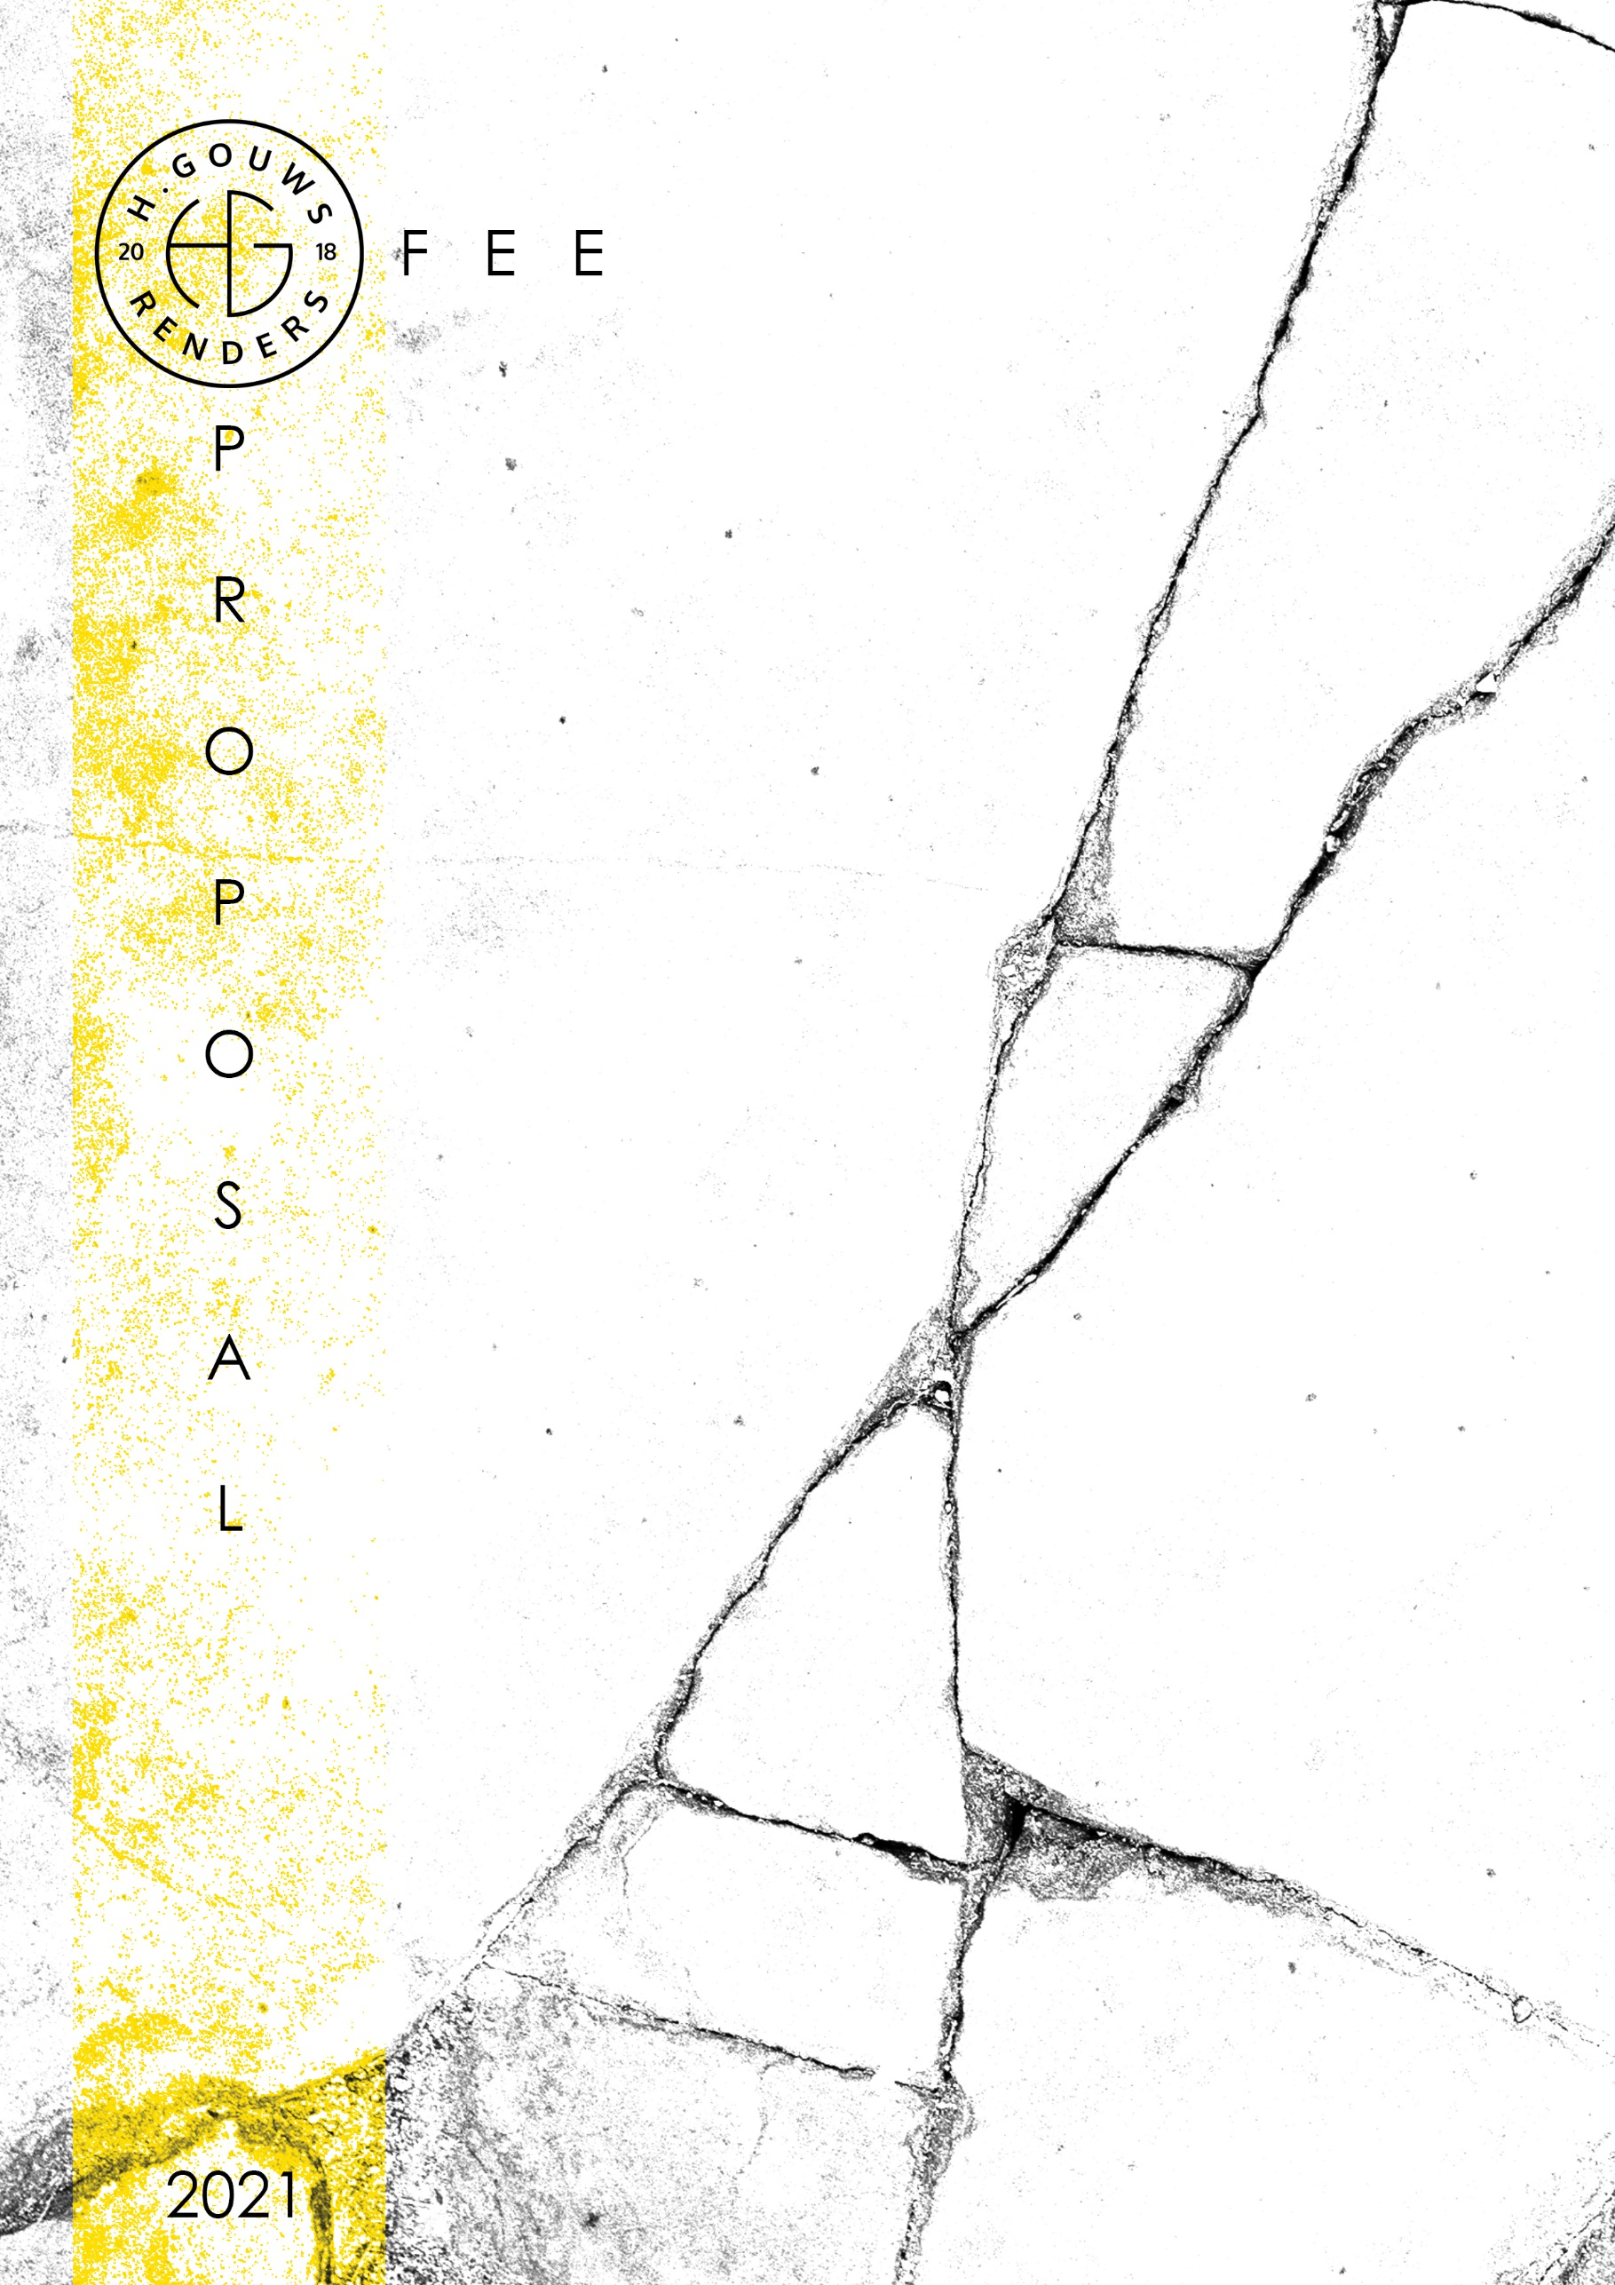

H. Gouws Renders PTY LTD:
2020/784683/07

1 Elsa Joubert street
Fairview
Port Elizabeth (Gqeberha)
Eastern Cape
2075

Client:
Nico and Cindy Venter
marketing@africanos.co.za
082 886 9513

Date: 20 August 2021
|SCOPE OF WORKS:
Phase 1:
Design and create Municipal drawings for Additions and Alterations to a ± existing single storey house on ERF 1634, 8 Oranje Street, Kirkwood, Eastern Cape, for Nico and Cindy Venter.

Duties:
- Design the new entrance and double volume space.
- Design a proposed first floor layout.
- General space planning throughout the house.
- Create municipal drawings to be used for construction.
Project and spaces Requirements:
- 7 x Bedrooms, all bedrooms to have full en-suite bathrooms.
  - Master suite must have a coffee station with a big walk in dresser and full en-suite bathroom.
- 1 x Full guest bathroom.
- Open plan Living, Dining and Kitchen with Scullery.
- Designed feature staircase.
- Entertainment Area.
  - The braai/entertainment area must be linked to the pool and front yard patio.
- Office/study space.
- PJ Lounge
- Playroom/Games room – Ground floor and First floor.
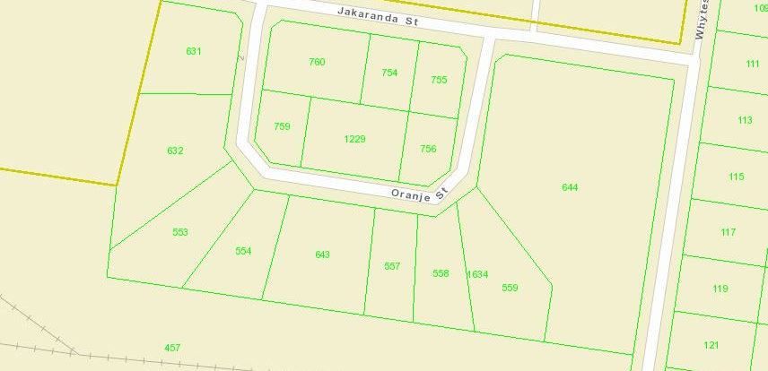
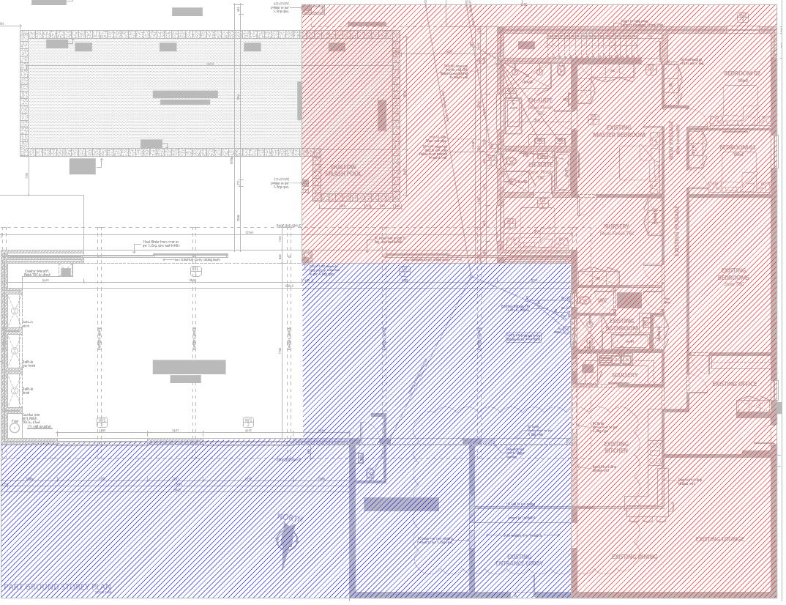

Blue = Ground floor design additions and alterations. Measured on the PDF’s = ± 270m ²
Red = First floor design additions and alterations. Measured on the PDF’s = 378 m ²
|3D VISUALIZATIONS:
Included in my quote for Phase 1 is conceptual 3d’s, to assist in resolving the design, and details.
The Phase 2 quote will include photo realistic rendering and interior visualizations.
|PROJECT SPECIFICS:
PHASE 1: H. Gouws Renders are employed for Work stages 1 to 4.1: to Design and create municipal drawings for a double storey dwelling, and to assist with the municipal submission process until the design has been approved by the local authorities.

SITE VISITS:
My overall quote will include 4 (Four) quality check Site visits. 1 (One) Site visit after the initial 4 site visits will not be charged, this was covered as part of the Design initiation fee that was paid on the 18th of August.
Extra Site visits will be quoted at R3500.00 per site visit. Calculated to cover the travel distance, as per the A.A. rates and time out of office.

DETAILS AND TECHNICAL DRAWINGS:
The municipal drawings will be drawn to a level of detail to build from. I will be available on my cell or email should the builder/contractor require insight on details.
Should you require spot details and Construction details, it will be quoted at an hourly rate, to be discussed and approved before the work commences.

PRINTS:
My quote will include 1 x set of the approved municipal drawings for site.
Revision drawings will be emailed to the site management team or the client. Hard copy revision drawings will be the responsibility of the site manager.
If I have to make hard copy prints for site, it will be added to a monthly invoice of:
R60 per A1 print
R80 per A0 print.
|QUOTE:
Phase 1: Architecture
Design and do Municipal Drawings and Documentation for Additions and Alterations:
Excluded from the fees:
- Submission fees and hard copy prints, if required. (e.g. Council and municipal related fees/Estate/NHBRC)
- Other Professional consultancy fees that may be required (e.g. Structural Engineer, Quantity and Site Surveyors, Health & Safety, etc.)
- Execution of the works and testing of materials to ensure compliance with drawings and specifications remains the responsibility of the contractor.
- Occupation and As-Built drawings, should the building not be built as per the approved plans.
- Printing of drawings for site.
Professional fees calculation: (Standard cost-based fee As per SACAP Government Gazette 2020)
*Total design area affected = 648m²
*Average price per m² for high end finishes and specification houses are ± R16 000 per m²

Value of Works (Build cost): R3 000 per m² x 648m² (affected area) = R 1 944 000.00

Project Cost | R1 944 000.00
Professional Fees: (ex. VAT)
Primary Fee | R128 099.67
Secondary fee | R186 335.85
 | R314 435.52
Additions and alterations Extra| N.A. | 0
Stages 1 - 6 | R314 435.52

Work Stages |  | % of Fee | Fee ex VAT | % Discount | Final Fees ex VAT
Design | Stages 1 - 3 | 40% | R125 774.21 | 20% | R100 619.37
Municipal Submission | Stage 4.1 | 20% | R62 887.10 | 0% | R62 887.10
Tender | Stage 4.2 | 10% | 0 | 0% | R0.00
Construction | Stages 5 - 6 | 30% | 0 | 0% | R0.00
Total ex. Discount |  |  | R188 661.31
Total incl. Discount |  |  |  | Ex. VAT | R163 506.47

LESS: R 5138.00 Paid on the 18th of August 2021
TOTAL QUOTE (Phase 1):________________________R158 368.47 ex VAT
*Please note, should the scope of work increase, our professional fees will be adjusted to accommodate the extra scope. This will be discussed before the work commences.
|PAYMENT TERMS:

- 50% Design Deposit payable at inception, with the balance payable at design approval.
- 50% Of the Municipal drawings fees will be payable to commence with the drawings, with the balance payable 30 days after that or at municipal submission, whichever comes first.

INVOICE 1: INVOICE 2: INVOICE 3:
50% Design Deposit Balance of the design fees 30 Days after the Municipal
With the 50% of the Municipal Drawing fees, or at municipal
Drawings fees. submissions.

|SCOPE OF WORKS:
Phase 2: Interior Design and Visualization
Create photo realistic Interior renders with custom furniture and specialist finishes.

1 x Exterior renders for the Pool patio

GROUND FLOOR:
- Entrance Foyer: 1 x render
- Kitchen: 2 x render
- Scullery: 1 x render
- Dining: 1 x render
- Living space: 1 x render
- Entertainment area: 1 x render
- Play room: 1 x render
- Bedroom 1:
  - With En-suite and Play Station room: 3 x renders
- Bedroom 2:
  - With En-suite and walk in dresser: 3 x renders.
- Guest Suite:
  - With En-suite, walk-in-dresser and coffee station: 3 x renders.
- Office/Study space: 1 x render.
- Guest Bathroom: 1 x render.

FIRST FLOOR:
- Bedroom 3:
  - With En-suite: 2 x renders.
- Bedroom 4:
  - With En-suite: 2 x renders.
- Bedroom 5:
  - With En-suite: 2 x renders.
- Bedroom 6: Master Suite:
  - Bedroom Overall: 1 x render.
  - Coffee station: 1 x render.
  - Walk-in-dresser: 1 x render.
  - En-suite bathroom: 1 x render.
- Play room/Games Room: 1 x render.
|Request for Information:
Information required for the project:
- Client to provide images of finishes they prefer.
- Client to provide images/links to furniture they would want to use.
|QUOTE:
Phase 2: Interior Design and Visualization
- 31 x Renders in total.
- If additional renders are requested within a designed space, a fee of R3000 per extra render will be charged.
- All the rooms and secondary spaces will be fully furnished with custom furniture and finishes, as per the client. Please note: We are not employed to source the furniture, should you require our assistance in sourcing furniture, it will be charged at an hourly rate discussed before we proceed.
- Post production changes to the renders, like wall colour amendments, can be made relatively fast to final renders at no charge.
- I will also not charge for re-renders should you want to add or remove furniture.
- This fee includes 1 (One) site visit for the initiation of Stage 1.
Fee Breakdown:
Interior Design, Stage 1:

- Mood Boards for all the interior spaces: Here we work with you and place everything you select for a room/space on a designed moodboard and plan layout, to see and get a feel for how the selected colours and furniture work together in the space. =R 43 000.00
Interior Design, Stage 2:
- Interior Design and Visualization: This is where we use the approved styles and moodboards and start designing, modelling and visualizing your rooms and spaces.
This includes:
  - 31 x Renders of the rooms and spaces with custom furniture
  - Joinery details and sizes for the specialists to work from: =R 257 000.00
TOTAL QUOTE (Phase 2) _________R 300 000.00 ex VAT

|PAYMENT TERMS:
I am happy to discuss a payment plan with you. As a general these are my usual payment terms:
- 50% Deposit payable at inception, with the balance payable at Final handover.

- We can break the total fee into 4 x instalments of R 75 000.00. With the first instalment to be paid at inception of Phase 2 and the following instalments to be paid at the end of each month for the duration of the project, with the final payment due at final handover.
|ACCEPTANCE:
The Terms and Conditions presented here may be modified or amended as necessary only by written instrument signed by both parties.

By submitting the deposit payment, you are agreeing to the terms and conditions detailed above. This proposal is agreed upon in full, signed and dated.

By signing this document, I indicate that I understand, agree to and accept the terms and conditions as contained herein, dated this 20 August 2021.

I, __________________________________________ hereby agree to the Terms and Conditions laid out in this document.

Date:
Signature / Digital Signature:

|ARCHITECTURAL WORK STAGES:
Stage 1: Inception
a) Receive, appraise and report on the client's requirements with regard to the client's brief;
b) Determine the site and rights and constraints;
c) Determine budgetary constraints;
d) Determine the need for consultants;
e) Determine indicative project timelines;
f) Determine methods of contracting; and
g) Whether other statutory authority applications are required or desirable.

Stage 2: Concept Design
- Prepare an initial design concept and advise on:
i the intended space provisions and planning relationships;
ii proposed materials and intended building services; and
iii the technical and functional characteristics of the design.
b) Check for conformity of the concept with the rights to the use of the land.
c) Consult with local and statutory authorities.
d) Review the anticipated costs of the project. e) Review the project programme.

Stage 3: Design Documentation
a) Develop all aspects of the design from concept to full development including, but not limited to, construction systems, materials, fittings, and finishes selections;
b) Review the programme and budget with the client, principal consultant or other consultants;
c) Coordinate other consultants’ designs into building design;
d) Prepare design development drawings including drafting technical details and material specifications;
e) Discuss and agree on the building plan application and approval requirements with the local authority;
Stage 4: Documentation and Procurement (municipal submission stage)
Stage 4.1:
a) Prepare documentation required for local authority building plan application submission;
b) Co-ordinate technical documentation with the consultants and complete primary co-ordination sufficient to support building plan submission;
c) Review the costing and programme with the consultants;
d) Obtain the client's authority, and submit documents for approval at the local authority.
Stage 4.2:
a) Prepare specifications for the works;
b) Complete technical documentation sufficient for tender;
c) Obtain offers for the execution of the works;
d) Evaluate offers, and recommend a successful tenderer for appointment;
e) Prepare the contract documentation and arrange the signing of the building contract by the client and the successful tenderer;
f) Complete all remaining technical and construction documentation and coordinate same with the consultants;

Stage 5: Construction
a) Administer the building contract;
b) Give possession of the site to the contractor;
c) Issue construction documentation;
d) Review sub-contractor designs, shop drawings and documentation for conformity of design intent;
e) Inspect the works for conformity with the contract documentation and acceptable quality in terms of industry standards;
f) Administer and perform the duties and obligations assigned to the principal agent in the building contract; g) Manage the completion process of the project;
h) Assist the client to obtain the required documentation necessary for the client to obtain the occupation certificate.

Stage 6: Close out
a) Facilitate the project close-out including the collation of the necessary documentation to effect completion, handover and operational manual of the project.
b) When the contractor's obligations with respect to the building contract have been fulfilled, the architectural professional shall issue the certificates related to the contract completion.
c) Provide the client with construction record documentation and the relevant technical and contractual undertakings by the contractor and subcontractors.

Email: hgouws.renders@gmail.com
Cell: 072 799 9597
Instagram: @hgouws.renders
Facebook: H. Gouws Renders (@hgouws.renders)

Thank you for the opportunity to quote on your project.

Keep well, and chat soon.
Thank you.

Kind Regards

Hannes Gouws
3d Artist | Professional Senior Architectural Technologist | PSAT 32449887

