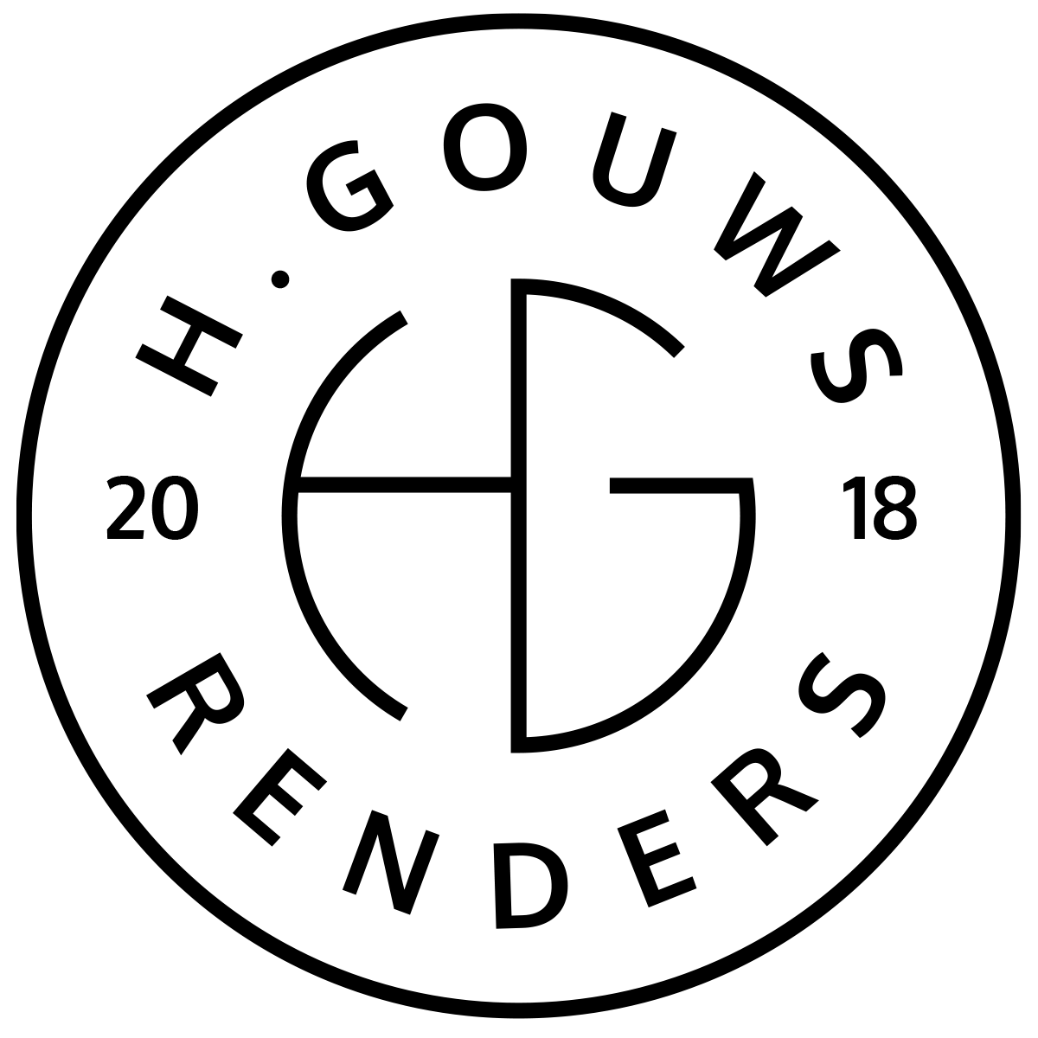H. Gouws Renders PTY LTD:
2020/784683/07

1 Elsa Joubert street
Fairview
Port Elizabeth (Gqeberha)
Eastern Cape
2075

Client:
Nico and Cindy Venter
marketing@africanos.co.za
082 886 9513
8, Oranje Single
Kirkwood
6120
INVOICE:
000152021VENTER
Date: 17 AUGUST 2021

Item: | Description: | Quantity: | Price: | Total:
-------------------------------------------------------------------------------------------------------
1 | House Venter (Kirkwood) Design initiation and planning meeting. | 01 | R5138.00 | R5138.00

-----------------------------------------------------------------------------------------------------------------------------------
TOTAL:
R5 138.00 ex VAT

Banking details:
Nedbank
Account Number: 1212774191
Branch Code: 12681700
Cheque account

KINDLY USE THE INVOICE NUMBER AS YOUR PAYMENT REFERENCE

