


BLACKHOUND ENTERPRISES PTY LTD
T/A BLACKHOUND ARCHITECTURE & RENDERING

Hannes Gouws
hannes@blackhoundenterprises.com
072 799 9597

Unit 10 – The Network
19 Cactus Road
Fairview
Port Elizabeth (Gqeberha)
Eastern Cape
2075

Unit 10 – The Network
19 Cactus Road
Fairview
Port Elizabeth (Gqeberha)
Eastern Cape
2075

Unit 10 – The Network
19 Cactus Road
Fairview
Port Elizabeth (Gqeberha)
Eastern Cape
2075

Client:
Pierre & Catherine Van As
+44 7731 987204 | +44 7960 845682
Pierre.vanas@yahoo.com
Date: 07 FEBRUARY 2024
|PROJECT BRIEF:

Design, do Municipal drawings & Construction drawings, and submit to council for approval for a new family home on ERF 10222, Plettenberg Bay, Knysna, Western Cape.
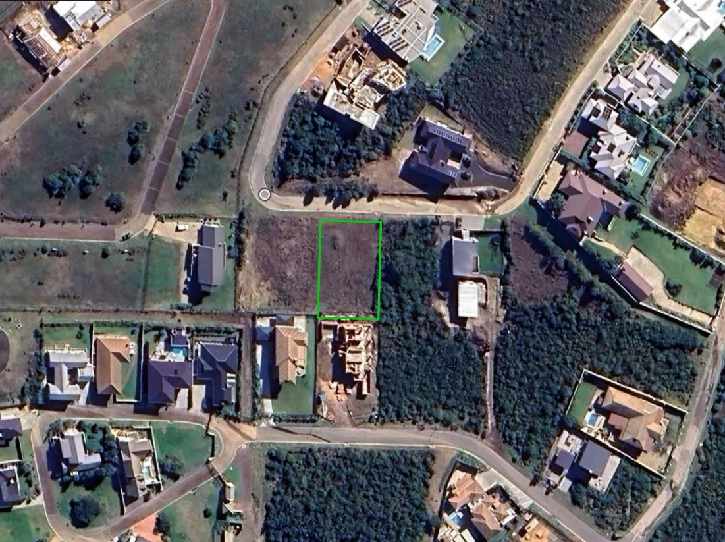

SCOPE OF WORKS:
  - ) House size: ± 250 – 300m².
  - ) General Notes and Requirements:
    - Aesthetic requirements:
      - Contemporary Colonial, Modern Barn, Modern Industrial.
      - Emphasis to be placed on Volume for the spaces:
Vaulted ceilings / Exposed rafters.
    - Emphasis must be on maximizing the view towards the South and Southeast parts of the site, while also keeping in mind the prevailing southeasterly driven wind.
    - Preferably a single storey house with a possible mezzanine study / office.
(This is open to creative design and site requirements.)
  - ) Spatial Requirements:
    - Double Garage
    - Open plan living, kitchen and Dining. With a serving hatch link between the kitchen and outdoor entertainment space.
    - Separate Scullery and Laundry linking to kitchen and service courtyard.
    - 2x Bedrooms
      - Possible en-suite bathrooms to bedrooms, if not, a full shared bathroom.
    - Master bedroom with dresser and en-suite bathroom.
    - Guest Loo
    - Separate detached AirBnB room with a kitchenette and full bathroom.
  - ) Extras included in the overall design:
    - Firepit.
    - Decked patio with pergola for outdoor entertainment.
    - Pool.

  - Prepare municipal drawings and submit to council for approval.

  - Prepare construction drawings.

|HOUSE VAN AS: Quote & Deliverables
Design, Municipal Drawings, Technical Drawings and Documentation:
Approximate Size of House: 250m² - 300m²

Professional Fees Calculation:
2.1) Phase 1: Design (incl. 3D) + Interior visualizations:
- Design: Architectural Workstage 1 – 3 (Refer to the Architectural work stages at the end of this document, as per the Architectural Professional: Act 44 of 2000)

  - This includes the first site visit to walk the site and gather the necessary information to initiate the design.
  - We will then proceed with the design phase and liaise with you to achieve design approval.
  - Included in our design phase is 3D modelling, to resolve design details and to give you a clear picture of what the design will look like before we proceed to the next phase.
R53 760.00
- Design: Interior Visualization:

  - In this stage we furnish and apply finishes to the interior of the house to indicate how the spaces will live.
  - This will be based on your reference images and styles you like, to give you a better look into our design intent and how we envision the spaces and house living.

*Please note: Should you decide to exclude this phase from our service, our architectural 3d modelling included in our design phase is only applicable to the architectural design and 3d modelling of the house, not the interior design or interior visualization.
R8 100.00
2.2) Phase 2: Municipal drawings, Technical Drawings, Documentation and Submission:
- Stage 4.1 – Municipal drawings - Includes:

  - Municipal drawings; Site plan, Floor Plan, Section, Elevations, and basic Electrical layouts
  - Municipal Documentation and the council submission process.
  - Deemed-to-Satisfy Energy Efficiency and Fenestration calculations, as required by SANS10400.

R43 814.40
- Stage 4.2 - Construction / Technical Drawings:

  - Detailed Electrical layouts, Window and Door schedules.
  - Details: Threshold details, finish transition details, staircase drawings, balustrade details,
Roof details, specifications.
R16 128.00
2.3) Site Visits:
  - We have allowed for 3 x Site visits in this fee proposal, to be used at your discretion.
  - Recommended Site Visit intervals:
    - Checking on building set-out and floor level, before construction starts.
    - Before casting of ground floor slab.
    - At roof level.
R7 590.00
KINDLY NOTE:
*Should our scope of work increase, our fees will be adjusted to accommodate the extra scope. This will be discussed before the work commences.
*This quote is only valid for 30 Days after the date of issue.

TOTAL QUOTE:
PHASE 1 & 2: R129 392.40 (VAT not applicable)

|PAYMENT TERMS:
- 70% Deposit payable at acceptance of quotation. (R 90 574.68)
- 30% Balance payable at Municipal Submission. (R 38 817.72)

Excluded from the fees:
- Submission fees and hard copy prints. (e.g. Council and municipal related fees/Estate/NHBRC)
- Other Professional consultancy fees that may be required (e.g. Structural Engineer, Quantity and Site Surveyors, Health & Safety, etc.)
- Execution of the works and testing of materials to ensure compliance with drawings and specifications remains the responsibility of the contractor.
- As-Built drawings, if any deviation occurred from the approved plans.
- Printing of drawings for site.
- Retrieval of Occupation Certificate.
- Contract and project management.

|TERMS AND CONDITIONS:
Blackhound will be employed for Work stages 1 to 4.1 and partial 4.2: to Design and create municipal drawings. The Municipal drawings will then be submitted to council for approval by the local authorities and to create construction and technical drawings to assist with pricing and construction process.
(Kindly see the end of the document for descriptions of the Architectural work stages.)
No other Additional services have been included in this quotation. Should you require our assistance to cover the occupation process, which is required to certify that the project has been completed in accordance with the National Building regulations and Standards Act. (As legally required and outlined in SANS 10400-A:2010), a separate quotation will be prepared to cover our time for this process.
Furthermore, since Blackhound will not be appointed for the full work stage 4.2, work stages 5, and 6, it should be noted that the client will act as the intermediary between us and any contractor and sub contract. The client will also be responsible for obtaining all the certificates of compliance from the contractor and their sub-contractors.
(E.g., Electrical COC, Plumbing COC, Beacon Certificate, Roof Certificate, Engineers Form4, etc.)

This Quotation is only for Architectural work stage’s 1, 2, 3, 4.1 and partial 4.2; and Excludes parts of work stages 4.2, 5 & 6.
(Kindly see the descriptions of Architectural work stages at the end of the document.)
Should you require our assistance with these additional work stages we will provide you with an emended fee proposal.

  - SITE VISITS:
If additional Site Visits are requested, a travel expense of R3200.00 per Site Visit will be charged. This will be invoiced when Site visits are requested.
Travel Distance = 460km, round trip.
  - DETAILS AND TECHNICAL DRAWINGS:
The quotation will be for municipal drawings and construction and technical detailing of the current scope of work.
  - ON SITE DEVIATIONS:
We will not be employed for contract and quality site management, which falls under Work stage 5 and 6. For any deviations made on site that require an updated plan to be submitted to the council, an additional quotation will be sent to the client. This quotation will be based on an hourly rate of R 650.00, which covers the cost of revising the drawings to be resubmitted to council for approval.

  - PRINTS:
Our fees are exclusive of any hard copy prints. If we must make hard copy prints for any reasons not attributed to BLACKHOUND ENTERPRISES PTY LTD, the client will be notified beforehand and will be invoiced separately or added to the client’s final invoice.
Revision drawings will be emailed to the site management team or the client where hard copy revision drawings will be the responsibility of the contractor / client / site manager.
If we must make hard copy prints for site, it will be added to an invoice at:
R55 per A1 print
R75 per A0 print.
Exclusive of any courier or delivery fees.
  - VAT:
BLACKHOUND ENTERPRISES PTY LTD. Is not a VAT vendor. All fees presented are exclusive of VAT until further notice.
  - FEE OFFSET:
The Client is not entitled to ‘set-off’ or withhold payment for any alleged claim against either BLACKHOUND ENTERPRISES PTY LTD or any other party involved in the building or design contract. The claim is to be dealt with on its own merits.

  - SUSPENSION:
BLACKHOUND ENTERPRISES PTY LTD retains the right to suspend all service until the settlement of any outstanding account.

  - TERMINATION:
In the event of the agreement between the parties being terminated by either party for reasons not attributable to BLACKHOUND ENTERPRISES PTY LTD, the fee for the work currently underway together with the completed work, would be payable.

  - OTHER PROFESSIONALS:
BLACKHOUND ENTERPRISES PTY LTD is not responsible for the performance of other professionals (Town Planners, Engineers, etc), drawings and documents provided by other professionals and suppliers, tender prices, the performance of Homeowner Associations, Municipalities or Municipal Services, the Contractor or any of his Sub-Contractors, Suppliers, or employees.

  - COPYRIGHT:
BLACKHOUND ENTERPRISES PTY LTD retains the ownership of copyright to all its intellectual property. No designs, drawings or documents may be used and shared with other parties without our express permission.

  - FINAL INVOICE:
The final invoice will be due upon submission to council. If the client decides not to proceed with council submission, the final invoice remains payable after two weeks from the notification of completed work.

|ACCEPTANCE:
The Terms and Conditions presented here may be modified or amended as necessary only by written instrument signed by both parties.
By submitting the non-refundable deposit payment and / or signing this document, you are agreeing to the terms and conditions detailed in this document. This proposal is agreed upon in full, signed and dated.
By signing this document, I indicate that I understand, agree to, and accept the terms and conditions as contained herein, dated this 07 FEBRUARY 2024.

I, __________________________________________ hereby agree to the Terms and Conditions laid out in this document.

Email: hannes@blackhoundenterprises.com
Phone: 072 799 9597

----------------------------------------------- -------------------------------------
Hannes Gouws Client name:
Director | SACAP: PSAT 32449887 Date:

(Kindly see the descriptions of Architectural work stages at the end of the document.)

|ARCHITECTURAL WORK STAGES:
Stage 1: Inception
a) Receive, appraise and report on the client's requirements with regard to the client's brief;
b) Determine the site and rights and constraints;
c) Determine budgetary constraints;
d) Determine the need for consultants;
e) Determine indicative project timelines;
f) Determine methods of contracting; and
g) Whether other statutory authority applications are required or desirable.

Stage 2: Concept Design
- Prepare an initial design concept and advise on:
i) the intended space provisions and planning relationships;
ii) proposed materials and intended building services; and
iii) the technical and functional characteristics of the design.
b) Check for conformity of the concept with the rights to the use of the land.
c) Consult with local and statutory authorities.
d) Review the anticipated costs of the project. e) Review the project programme.

Stage 3: Design Documentation
a) Develop all aspects of the design from concept to full development including, but not limited to, construction systems, materials, fittings, and finishes selections;
b) Review the programme and budget with the client, principal consultant or other consultants;
c) Coordinate other consultants’ designs into building design;
d) Prepare design development drawings including drafting technical details and material specifications;
e) Discuss and agree on the building plan application and approval requirements with the local authority;
Stage 4: Documentation and Procurement (municipal submission stage)
Stage 4.1:
a) Prepare documentation required for local authority building plan application submission;
b) Co-ordinate technical documentation with the consultants and complete primary co-ordination sufficient to support building plan submission;
c) Review the costing and programme with the consultants;
d) Obtain the client's authority, and submit documents for approval at the local authority.

Stage 4.2:
a) Prepare specifications for the works;
b) Complete technical documentation sufficient for tender;
c) Obtain offers for the execution of the works;
d) Evaluate offers, and recommend a successful tenderer for appointment;
e) Prepare the contract documentation and arrange the signing of the building contract by the client and the successful tenderer;
f) Complete all remaining technical and construction documentation and coordinate same with the consultants;
Stage 5: Construction
a) Administer the building contract;
b) Give possession of the site to the contractor;
c) Issue construction documentation;
d) Review sub-contractor designs, shop drawings and documentation for conformity of design intent;
e) Inspect the works for conformity with the contract documentation and acceptable quality in terms of industry standards;
f) Administer and perform the duties and obligations assigned to the principal agent in the building contract;
g) Manage the completion process of the project;
h) Assist the client to obtain the required documentation necessary for the client to obtain the occupation certificate.
Stage 6: Close out
a) Facilitate the project close-out including the collation of the necessary documentation to effect completion, handover and operational manual of the project.
b) When the contractor's obligations with respect to the building contract have been fulfilled, the architectural professional shall issue the certificates related to the contract completion.
c) Provide the client with construction record documentation and the relevant technical and contractual undertakings by the contractor and subcontractors.

