


BLACKHOUND ENTERPRISES PTY LTD
T/A BLACKHOUND ARCHITECTURE & RENDERING

Hannes Gouws
hannes@blackhoundenterprises.com
072 799 9597

Unit 10 – The Network
19 Cactus Road
Fairview
Port Elizabeth (Gqeberha)
Eastern Cape
2075

Unit 10 – The Network
19 Cactus Road
Fairview
Port Elizabeth (Gqeberha)
Eastern Cape
2075

Unit 10 – The Network
19 Cactus Road
Fairview
Port Elizabeth (Gqeberha)
Eastern Cape
2075

Client:
Glynis Hogben
074 164 0840
glynishogben@yahoo.co.uk
Date: 09 October 2023
|SCOPE OF WORKS:

Design and do Municipal drawings of proposed Additions and Alteration on ERF 25, Portion 150, Chelsea, Theesecombe, Port Elizabeth.
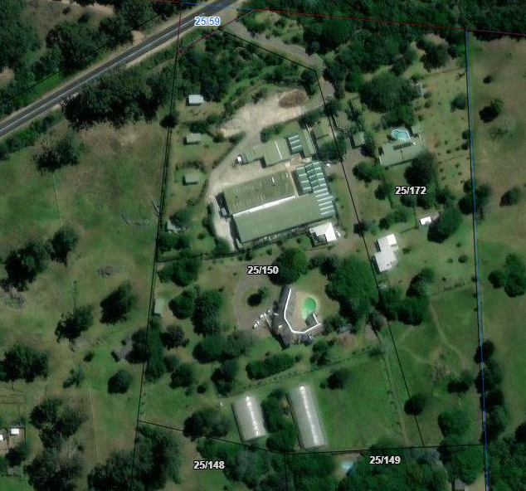

- Measure and draw the existing house in 3d.

- Propose a new roof.

- Design and visualize the proposed additions and alterations:
  - ) Phase 1: Public Spaces. (As provided by the client.)
    - Exit points on Southern and Western sides of the house - patios to be added to both exit points with a built-in braai to the Western side.
    - Laundry with linen cupboard- important to be a good size as it will hold guesthouse linen and supplies too. Also needed for ironing. Broom cupboard.
    - Scullery - ideally combined with a working space for processing produce from the farm and a larder for excess bottling, preserving, dehydrating, etc.
    - Workspace - Place to keep and work with seeds / seed storage / small gadgets for gardening and sewing station to always keep machine on standby.
    - Tool Storage - drill, screws, tape measure, hammer, etc
    - Storage Requirements – Suitcases, kit bags, Sports equipment, rollerblades, motorbike helmets, umbrellas
    - Gym for family to use.
    - Playroom to hold ping pong table, dart board, pool table, tv (gaming station?)
    - Indoor braai
    - Fireplace
    - new office space / library space.
    - General Storage.
    - Morning breakfast garden.

  - ) Phase 2: Private Spaces: (To be quoted separately)
- Study
- Bedroom 1
- Bedroom 2
- Master Bedroom, En-suite and Dresser.
- General Bathroom
- Guest Bedroom and En-suite – 1st Floor
- Guest Bedroom – 1st Floor

- Prepare municipal drawings and submit to council for approval.

- Prepare construction drawings.

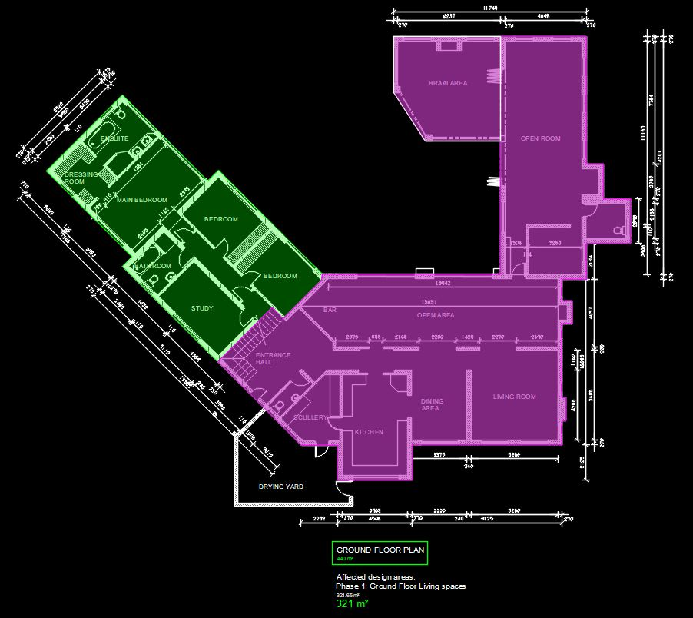
|HOUSE HOGBEN QUOTE.

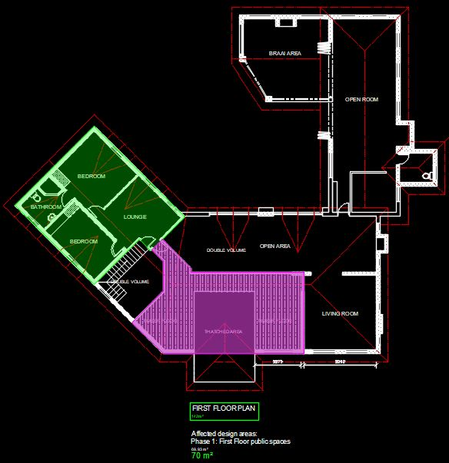

Design, Municipal Drawings and Documentation:
(Measurements taken from CDS Architectural Services’ pdf plans)
Existing house: 582m² (Full house, including covered Braai area)
- Ground Floor: 440m²
- First Floor: 142m²
Affected Design area:
- Phase 1: Public Spaces: 391m² (Ground- and First Floor)
- Phase 2: Private Spaces: 191m² (Ground- and First Floor)(Not for this fee proposal)

Professional Fees Calculation:
Phase 1: Living Spaces
1) Spot Measurements and Redraw the existing house in 3d: Medium complexity house.

  - Existing House: 582m² @ R30 per m²
This is a reduced price to allow for spot-measurements and height measurements on site, as we will be working with the existing drawings provided.
R14 550.00
2) Design (incl. 3D) + Interior Design:
- Stage 1 – 3 (Refer to the Architectural work stages at the end of this document, as per the Architectural Professional: Act 44 of 2000)

  - This includes the first site visit to walk the site and gather the necessary information to initiate the design.
  - We will then proceed with the design phase and liaise with you to achieve design approval.
  - Included in our design phase is 3D modelling, to resolve design details and to give you a clear picture of what the design will look like before we proceed on to the next phase.
R53 760.00
- Phase 1 – Interior Design: Concept and Planning

  - Design research and presentation of space-specific mood boards to establish a design language.
  - Basic Footprint of interior layout
  - Presentation on finishes, furniture, and décor.
  - Create optimized space plan & layout. (Ergonomically suitable.)
  - Design features and details presented.
  - Tactile sample board to showcase.
R11 730.00

3) Municipal drawings, Technical Drawings, Documentation and Submission:
- Stage 4.1 – Municipal drawings - Includes:

  - Municipal drawings; Site plan, Floor Plan, Section, Elevations, and basic Electrical layouts
  - Municipal Documentation and the council submission process.
  - Deemed-to-Satisfy Energy Efficiency and Fenestration calculations, as required by SANS10400.
R43 008.00
- Construction / Technical Drawings - Includes:

  - Demolition plan, detailed Electrical layouts, Window and Door schedules.
  - Details: Threshold details, finish transition details, staircase drawings, balustrade details,
Roof details, specifications.
R26 880.00
KINDLY NOTE:
*Should our scope of work increase, our fees will be adjusted to accommodate the extra scope. This will be discussed before the work commences.
*This quote is only valid for 30 Days after the date of issue.

TOTAL QUOTE:
PHASE 1: R149 928.00 (VAT not applicable

|PAYMENT TERMS:
- 60% Deposit payable at acceptance of quotation. (R 89 956.80)
- 20& Interim payment at design approval or
1 month after deposit payment. (R 29 985.60)
- 20% Balance payable at Municipal Submission. (R 29 985.60)

Excluded from the fees:
- Submission fees and hard copy prints. (e.g. Council and municipal related fees/Estate/NHBRC)
- Other Professional consultancy fees that may be required (e.g. Structural Engineer, Quantity and Site Surveyors, Health & Safety, etc.)
- Execution of the works and testing of materials to ensure compliance with drawings and specifications remains the responsibility of the contractor.
- As-Built drawings, if any deviation occurred from the approved plans.
- Printing of drawings for site.
- Retrieval of Occupation Certificate.

|TERMS AND CONDITIONS:
Blackhound will be employed for Work stages 1 to 4.1 and partial 4.2: to Design and create municipal drawings. The Municipal drawings will then be submitted to council for approval by the local authorities and to create construction and technical drawings to assist with the tender and construction process.
(Kindly see the end of the document for descriptions of the Architectural work stages.)
No other Additional services have been included in this quotation. Should you require our assistance to cover the occupation process, which is required to certify that the project has been completed in accordance with the National Building regulations and Standards Act. (As legally required and outlined in SANS 10400-A:2010), a separate quotation will be prepared to cover our time for this process.
Furthermore, since Blackhound will not be appointed for the full work stage 4.2 and work stages 5, and 6, it should be noted that the client will act as the intermediary between us and the contractor. The client will also be responsible for obtaining all the certificates of compliance from the contractor and their sub-contractors.
(E.g., Electrical COC, Plumbing COC, Beacon Certificate, Roof Certificate, Engineers Form4, etc.)

This Quotation is only for Architectural work stage’s 1, 2, 3, 4.1 and partial 4.2; and Excludes parts of work stages 4.2, 5 & 6.
(Kindly see the descriptions of Architectural work stages at the end of the document.)
Should you require our assistance with these additional work stages we will provide you with an emended fee proposal.

  - SITE VISITS:
If additional Site Visits are requested, a travel expense of R850.00 per Site Visit will be charged. This will be invoiced when Site visits are requested.

  - DETAILS AND TECHNICAL DRAWINGS:
The quotation will be for municipal drawings and construction and technical detailing of the current scope of work.
  - ON SITE DEVIATIONS:
We will not be employed for contract and quality site management, which falls under Work stage 5 and 6. For any deviations made on site that require an updated plan to be submitted to the council, an additional quotation will be sent to the client. This quotation will be based on an hourly rate of R 650.00, which covers the cost of revising the drawings and resubmitting the drawings to council for approval.

  - PRINTS:
Our fees are exclusive of any hard copy prints. If we must make hard copy prints for any reasons not attributed to BLACKHOUND ENTERPRISES PTY LTD, the client will be notified beforehand and will be invoiced separately or added to the client’s final invoice. Once the plans are approved by council, we will hand over the stamped hard copy set of approved plans to you.
Revision drawings will be emailed to the site management team or the client where hard copy revision drawings will be the responsibility of the contractor / client / site manager.
If we must make hard copy prints for site, it will be added to an invoice at:
R95 per A1 print
R105 per A0 print.

BLACKHOUND ENTERPRISES PTY LTD. Is not a VAT vendor. All architectural fees presented are exclusive of VAT until further notice.

The Client is not entitled to ‘set-off’ or withhold payment for any alleged claim against either BLACKHOUND ENTERPRISES PTY LTD or any other party involved in the building contract. The claim is to be dealt with on its own merits.

BLACKHOUND ENTERPRISES PTY LTD retains the right to suspend all service until the settlement of any outstanding account.

In the event of the agreement between the parties being terminated by either party for reasons not attributable to BLACKHOUND ENTERPRISES PTY LTD, the fee for the work currently underway together with the completed work, would be payable.

BLACKHOUND ENTERPRISES PTY LTD is not responsible for the performance of other professionals (Town Planners, Engineers, etc), drawings and documents provided by other professionals and suppliers, tender prices, the performance of Homeowner Associations, Municipalities or Municipal Services, the Contractor or any of his Sub-Contractors, Suppliers or employees.

BLACKHOUND ENTERPRISES PTY LTD retains the ownership of copyright to all of its intellectual property. No designs, drawings or documents may be used and shared with other parties without our express permission.

|ACCEPTANCE:
The Terms and Conditions presented here may be modified or amended as necessary only by written instrument signed by both parties.
By submitting the non-refundable deposit payment and / or signing this document, you are agreeing to the terms and conditions detailed in this document. This proposal is agreed upon in full, signed and dated.
By signing this document, I indicate that I understand, agree to, and accept the terms and conditions as contained herein, dated this 09 OCTOBER 2023.

I, __________________________________________ hereby agree to the Terms and Conditions laid out in this document.

Email: hannes@blackhoundenterprises.com
Phone: 072 799 9597

----------------------------------------------- -------------------------------------
Hannes Gouws Client name:
Director | SACAP: PSAT 32449887 Date:

(Kindly see the descriptions of Architectural work stages at the end of the document.)

|ARCHITECTURAL WORK STAGES:
Stage 1: Inception
a) Receive, appraise and report on the client's requirements with regard to the client's brief;
b) Determine the site and rights and constraints;
c) Determine budgetary constraints; 0
d) Determine the need for consultants;
e) Determine indicative project timelines;
f) Determine methods of contracting; and
g) Whether other statutory authority applications are required or desirable.

Stage 2: Concept Design
- Prepare an initial design concept and advise on:
i) the intended space provisions and planning relationships;
ii) proposed materials and intended building services; and
iii) the technical and functional characteristics of the design.
b) Check for conformity of the concept with the rights to the use of the land.
c) Consult with local and statutory authorities.
d) Review the anticipated costs of the project. e) Review the project programme.

Stage 3: Design Documentation
a) Develop all aspects of the design from concept to full development including, but not limited to, construction systems, materials, fittings, and finishes selections;
b) Review the programme and budget with the client, principal consultant or other consultants;
c) Coordinate other consultants’ designs into building design;
d) Prepare design development drawings including drafting technical details and material specifications;
e) Discuss and agree on the building plan application and approval requirements with the local authority;
Stage 4: Documentation and Procurement (municipal submission stage)
Stage 4.1:
a) Prepare documentation required for local authority building plan application submission;
b) Co-ordinate technical documentation with the consultants and complete primary co-ordination sufficient to support building plan submission;
c) Review the costing and programme with the consultants;
d) Obtain the client's authority, and submit documents for approval at the local authority.

Stage 4.2:
a) Prepare specifications for the works;
b) Complete technical documentation sufficient for tender;
c) Obtain offers for the execution of the works;
d) Evaluate offers, and recommend a successful tenderer for appointment;
e) Prepare the contract documentation and arrange the signing of the building contract by the client and the successful tenderer;
f) Complete all remaining technical and construction documentation and coordinate same with the consultants;
Stage 5: Construction
a) Administer the building contract;
b) Give possession of the site to the contractor;
c) Issue construction documentation;
d) Review sub-contractor designs, shop drawings and documentation for conformity of design intent;
e) Inspect the works for conformity with the contract documentation and acceptable quality in terms of industry standards;
f) Administer and perform the duties and obligations assigned to the principal agent in the building contract;
g) Manage the completion process of the project;
h) Assist the client to obtain the required documentation necessary for the client to obtain the occupation certificate.
Stage 6: Close out
a) Facilitate the project close-out including the collation of the necessary documentation to effect completion, handover and operational manual of the project.
b) When the contractor's obligations with respect to the building contract have been fulfilled, the architectural professional shall issue the certificates related to the contract completion.
c) Provide the client with construction record documentation and the relevant technical and contractual undertakings by the contractor and subcontractors.

