


BLACKHOUND ENTERPRISES PTY LTD
T/A BLACKHOUND ARCHITECTURE & RENDERING

Hannes Gouws
hannes@blackhoundenterprises.com
072 799 9597

Unit 10 – The Network
19 Cactus Road
Fairview
Port Elizabeth (Gqeberha)
Eastern Cape
2075

Unit 10 – The Network
19 Cactus Road
Fairview
Port Elizabeth (Gqeberha)
Eastern Cape
2075

Unit 10 – The Network
19 Cactus Road
Fairview
Port Elizabeth (Gqeberha)
Eastern Cape
2075

Client:
Paul Du Preez
083 519 9465
paul@gamtoos.co.za

Date: 10 FEBRUARY 2023
|SCOPE OF WORKS:

Provide photo-realistic renderings for the interior design, provided by Blackbird Concepts.

Project Requirements:
- Interior Design – Provided by Blackbird Concepts.

- Spaces to be Rendered:

  - Entrance
  - Entertainment
  - Patio
  - Pool Patio
  - Bar
  - Living room
  - Kitchen
  - Dining space

|HOUSE DU PREEZ_GAMTOOS, EASTERN CAPE
Information required for the project:
- Specifications: Will be provided by Blackbird Concepts
  - Finishes, Furniture selection and Outdoor furniture and placement, and any other specific detail elements. (Feature lighting, décor elements, etc.)
  - Marked up sketches/drawings.
Project Scope:
- RENDERING:
Still Images to be rendered:
- Entrance: x1 Renders

- Entertainment: x1 Renders

- Patio (pool area): x1 Render

- Bar and Dining: x1 Render

- Living Room: x2 Render

- Kitchen: x1 Render

Total Still image Renders:
- 7x Renders (@ R3 834.28 per image at discounted rate.)

*This price includes 1x round of draft renders before final rendering.
*Additional custom furniture will be quoted at R1800 per piece and added to the final account.
*Changes to the design after final renders, resulting in re-rendering, will be charged at R3000 per re-render.

TOTAL QUOTE
- Still Image Rendering: R26 839.96 (VAT not applicable)

KINDLY NOTE:
*Should our scope of work increase, our fees will be adjusted to accommodate the extra scope. This will be discussed before the work commences.
*This quote is only valid for 30 Days after the date of issue.
|PAYMENT TERMS:
- 70% (R18 787.97) as Deposit payable to start the project.

- The balance (R8 051.99) will be payable at final handover.
|ACCEPTANCE:
The Terms and Conditions presented here may be modified or amended as necessary only by written instrument signed by both parties.
By submitting the non-refundable deposit payment, you are agreeing to the terms and conditions detailed in this document and that this proposal is agreed upon in full, signed and dated.
By signing this document, or by submitting the non-refundable deposit payment I indicate that I understand, agree to, and accept the terms and conditions as contained herein, dated this 10 FEBRUARY 2023.

I, __________________________________________ hereby agree to the Terms and Conditions laid out in this document.

Email: hannes@blackhoundenterprises.com
Phone: 072 799 9597
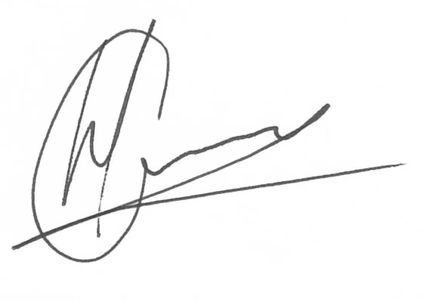

----------------------------------------------- -------------------------------------
Hannes Gouws Name:
Director | PSAT 32449887 Date:

