


BLACKHOUND ENTERPRISES PTY LTD
T/A BLACKHOUND ARCHITECTURE & RENDERING

Hannes Gouws
hannes@blackhoundenterprises.com
072 799 9597

Unit 10 – The Network
19 Cactus Road
Fairview
Port Elizabeth (Gqeberha)
Eastern Cape
2075

Unit 10 – The Network
19 Cactus Road
Fairview
Port Elizabeth (Gqeberha)
Eastern Cape
2075

Unit 10 – The Network
19 Cactus Road
Fairview
Port Elizabeth (Gqeberha)
Eastern Cape
2075

Client:
Konrad Buchner
073 631 3891
Konrad.buchner@pwc.com

Date: 02 AUGUST 2022
|SCOPE OF WORKS:

Design and do municipal drawings for additions and alterations to an existing house on ERF 567, 39 Hayden Avenue, Framesby, Port Elizabeth, E.C.

Project Scope:
- Measure affected existing spaces and draw in CAD.
  - Items not indicated on existing plans received:
    - Pool.
    - Tool shed incorrectly indicated on existing plan.
- Propose alterations to the existing master bedroom and en-suite.
- Proposed Double garage additions and alterations.
- Propose additional pool entertainment area with braai.

|HOUSE BUCHNER FEE PROPOSAL.
Design and Municipal drawings and Documentation:
Excluded from our fees:
- Submission fees and hard copy prints, if required. (e.g. Council and municipal related fees/Estate/NHBRC)
- Other Professional consultancy fees that may be required (e.g. Structural Engineer, Quantity and Site Surveyors, Health & Safety, etc.)
- Execution of the works and testing of materials to ensure compliance with drawings and specifications remains the responsibility of the contractor.
- Occupation and As-Built drawings, should the building not be built as per the approved plans.
- Printing of drawings for construction.
Estimated Measurements:
Estimated Additions (Measured from PDF Plans):
- Double Garage = 48m²
- Pool Entertainment Area= 38m²
- Master Bedroom Suite = 21m²
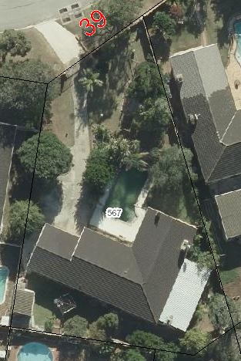
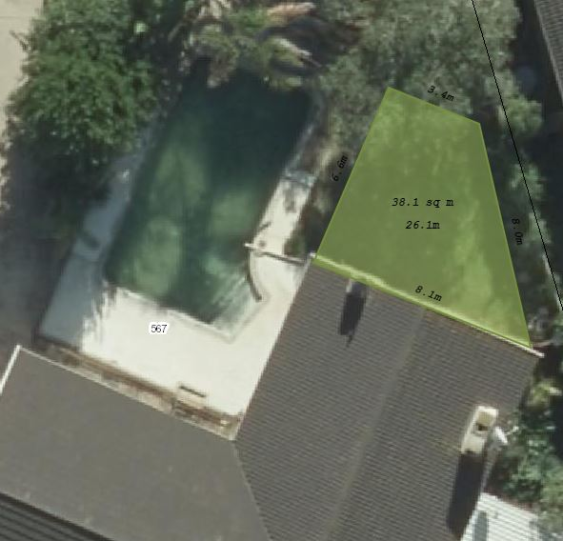

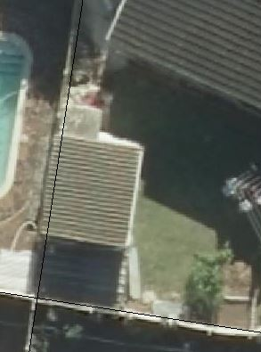
Missing on drawings

Incorrectly indicated on drawings.

Cost Calculation:
- Estimated Additions construction cost: ±R681 000.00
- Estimated Internal Alterations construction cost: ±R42 000.00
Architectural Fees Calculation: (for full scope of works)
Phase 1: Design:
- Stage 1 – 3 (Refer to the Architectural work stages at the end of this document, as per the Architectural Professional: Act 44 of 2000)

  - This will include a site visit to measure existing and gather the necessary municipal information to initiate the design.
  - We will then proceed with the design phase and liaise with you to achieve design approval.
  - Included in Stages 1 - 3 is 3d modelling, to resolve design details and to give you a clear picture of what the design will look like before we proceed with the next phase.
  - This price also includes redrawing the existing house in DWG to do the necessary architectural layouts.
R22 801.00
Phase 2: Municipal & Technical Drawings, Documentation and Submission:
- Stage 4.1 – 4.2
Stage 4.1 Includes:
  - Municipal drawings; Floor Plans, Sections, Elevations, and basic Electrical layouts
  - Municipal Documentation and the council submission process.
  - Deemed-to-Satisfy Energy Efficiency and Fenestration calculations, as required by SANS 10400.
- Municipal Drawings and Submissions:
R19 890.00
Stage 4.2: NOT APPLICABLE.
  - Construction details.
  - Windows and Door Schedules.
  - Detailed electrical layouts, as per your required needs.
- Construction and Technical Details:
R0
Phase 3: Construction:
- Stages 5 and 6
Should you require our assistance to manage the construction phase of this project, a separate fee proposal, based on the final design and professional calculated project cost will be provided for your approval.

Architectural Fees
PHASE 1: STAGE 1 – 3: R22 801.00
PHASE 2: STAGE 4.1: R19 890.00

TOTAL: R42 691.00 (VAT not applicable)

KINDLY NOTE:
*Should our scope of work increase, our fees will be adjusted to accommodate the extra scope. This will be discussed before the work commences.
*This quote is only valid for 30 Days after the date of issue.
|PAYMENT TERMS:
- 100% of the Design (Phase 1) Deposit payable at inception. (Work Stages 1-3)

- 100% of Phase 2 fees payable at Municipal Submission.

OR

- Should we continue with the full scope of architectural work, the total amount of Phase 1 and Phase 2 can be split into 3x instalments, invoiced over the period of 3x months.

|ACCEPTANCE:
The Terms and Conditions presented here may be modified or amended as necessary only by written instrument signed by both parties.
By submitting the deposit payment, you are agreeing to the terms and conditions detailed in this document. This proposal is agreed upon in full, signed and dated.
By signing this document, I indicate that I understand, agree to, and accept the terms and conditions as contained herein, dated this 02 AUGUST 2022.

I, __________________________________________ hereby agree to the Terms and Conditions laid out in this document.

Email: hannes@blackhoundenterprises.com
Phone: 072 799 9597

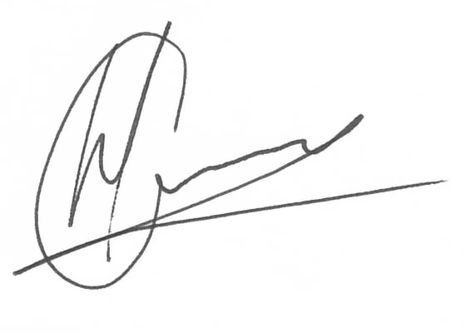

----------------------------------------------- -------------------------------------
Hannes Gouws Name:
Director | PSAT 32449887 Date:

|TERMS AND CONDITIONS:
Blackhound will be employed for Work stages 1 to 4.1: to Design and create municipal drawings, assist with the municipal submission process until the design has been approved by the local authorities, as laid out in the Professional Fees Calculation on page 3.
(Kindly see the end of the document for descriptions of the Architectural work stages.)
If Blackhound is not appointed for work stages 5 and 6, only Work stages 1 – 4.1 fees will be applicable and additional fees will be charged to provide a Form 4 at the completion of the project, which is required to certify that the project has been completed in accordance with the National Building regulations and Standards Act. (As legally required and outlined in SANS 10400-A:2010)
  - SITE VISITS:
If Blackhound is employed for Work stages 1 to 6, fortnightly site visits will be included in the Construction fee proposal. (Please see the work stages breakdown at the end of this document)
Further to the fees, should additional Site Visits be requested, a Travel expense of R850.00 per Site Visit will be charged. This will be invoiced at the end of each month for the duration of the project or when Site visits are requested.
  - DETAILS AND TECHNICAL DRAWINGS:
If Blackhound is not appointed for Stage 4.2:
The municipal drawings will be drawn to build from under stage 4.1, but will exclude construction drawings and pricing details like, staircase sections, window and door schedules, typical details, etc. which falls under stage 4.2, and is not necessary for municipal approval, but may be required for accurate pricing and construction detailing.
Please note: Should you then require technical detail drawings or any on site revision drawings, it will be charged at an hourly rate of R850 per hour.
  - PRINTS:
We will only provide 1x set of hard copies of the municipal approved plans, should you require it.
Revision drawings will be emailed to the site management team where hard copy revision drawings will be the responsibility of the contractor / site manager.
If we must make hard copy prints for site, it will be added to a monthly invoice at:
R95 per A1 print
R105 per A0 print.
If Blackhound is employed for Work stages 5 and 6, Disbursements will be calculated in the Construction Fee Proposal.
  - EXTENDED CONSTRUCTION PERIOD:
Only applicable if Blackhound is employed for Work stages 5 and 6. This will then be noted in the Construction Fee Proposal document.

|ARCHITECTURAL WORK STAGES:
Stage 1: Inception
a) Receive, appraise and report on the client's requirements with regard to the client's brief;
b) Determine the site and rights and constraints;
c) Determine budgetary constraints; 0
d) Determine the need for consultants;
e) Determine indicative project timelines;
f) Determine methods of contracting; and
g) Whether other statutory authority applications are required or desirable.
Stage 2: Concept Design
- Prepare an initial design concept and advise on:
i the intended space provisions and planning relationships;
ii proposed materials and intended building services; and
iii the technical and functional characteristics of the design.
b) Check for conformity of the concept with the rights to the use of the land.
c) Consult with local and statutory authorities.
d) Review the anticipated costs of the project. e) Review the project programme.
Stage 3: Design Documentation
a) Develop all aspects of the design from concept to full development including, but not limited to, construction systems, materials, fittings, and finishes selections;
b) Review the programme and budget with the client, principal consultant or other consultants;
c) Coordinate other consultants’ designs into building design;
d) Prepare design development drawings including drafting technical details and material specifications;
e) Discuss and agree on the building plan application and approval requirements with the local authority;
Stage 4: Documentation and Procurement (municipal submission stage)
Stage 4.1:
a) Prepare documentation required for local authority building plan application submission;
b) Co-ordinate technical documentation with the consultants and complete primary co-ordination sufficient to support building plan submission;
c) Review the costing and programme with the consultants;
d) Obtain the client's authority, and submit documents for approval at the local authority.

Stage 4.2:
a) Prepare specifications for the works;
b) Complete technical documentation sufficient for tender;
c) Obtain offers for the execution of the works;
d) Evaluate offers, and recommend a successful tenderer for appointment;
e) Prepare the contract documentation and arrange the signing of the building contract by the client and the successful tenderer;
f) Complete all remaining technical and construction documentation and coordinate same with the consultants;
Stage 5: Construction
a) Administer the building contract;
b) Give possession of the site to the contractor;
c) Issue construction documentation;
d) Review sub-contractor designs, shop drawings and documentation for conformity of design intent;
e) Inspect the works for conformity with the contract documentation and acceptable quality in terms of industry standards;
f) Administer and perform the duties and obligations assigned to the principal agent in the building contract;
g) Manage the completion process of the project;
h) Assist the client to obtain the required documentation necessary for the client to obtain the occupation certificate.
Stage 6: Close out
a) Facilitate the project close-out including the collation of the necessary documentation to effect completion, handover and operational manual of the project.
b) When the contractor's obligations with respect to the building contract have been fulfilled, the architectural professional shall issue the certificates related to the contract completion.
c) Provide the client with construction record documentation and the relevant technical and contractual undertakings by the contractor and subcontractors.

