


BLACKHOUND ENTERPRISES PTY LTD
T/A BLACKHOUND ARCHITECTURE & RENDERING

Hannes Gouws
hannes@blackhoundenterprises.com
072 799 9597

Unit 10 – The Network
19 Cactus Road
Fairview
Port Elizabeth (Gqeberha)
Eastern Cape
2075

Unit 10 – The Network
19 Cactus Road
Fairview
Port Elizabeth (Gqeberha)
Eastern Cape
2075

Unit 10 – The Network
19 Cactus Road
Fairview
Port Elizabeth (Gqeberha)
Eastern Cape
2075

Client:
BAUART DEVELOPMENTS
Stiaan Herbst – 082 786 5862
stiaan@bauart.co.za

Date: 04 OCTOBER 2022
|SCOPE OF WORKS:

Visualization and Rendering for a new house on ERF 1435, Plot 118, Breakwater Bay, George, Western Cape.

Project Requirements:
- Provide 3d modelling from 2d Plans.

- Provide High resolution renders:

  - Kitchen (to include Entrance)
  - Dining and Lounge
  - Media Lounge
  - Master Bedroom, Dresser, and En-suite
  - Bedroom 1 or 2 and En-suite
  - Study
  - Gym
  - Garden Court

- Provide an Animation video of selected spaces:
  - Kitchen & Entrance
  - Dining Lounge
  - Study
  - Gym
  - Master Bed
  - Garden Court

|HOUSE HERBST_BREAKWATER BAY, GEORGE
Information required for the project:
- Specifications:
  - Finishes, Furniture selection and Outdoor furniture and placement, and any other specific detail elements. (Feature lighting, décor elements, etc.)
  - Marked up sketches/drawings of the landscaping around the pool.
  - Site and Environment images.
Project Scope:
- PHASE 1: 3D MODELLING VISUALIZATION:

3d Modelling from 2d Plans:

- Open areas = 312m² (@ R18 per m²)
= R5 616.00
- Total Dwelling = 454m² (@R47 per m²)
= R21 338.00

- PHASE 2: RENDERING:
Stage 1: Still Images:
- Kitchen: x2 Renders
(Including Entrance and finishes to kitchen Garden visible through kitchen windows)

- Dining and Lounge: x2 Renders

- Media Lounge: x1 Render

- Master Bedroom, Dresser and En-suite: x3 Render

- Bedroom 1 or 2 and En-suite: x2 Render

- Study: x1 Render

- Gym: x1 Render

- Garden Court: x2 Render

Total Still image Renders:
- 14x Renders (@ R4 787.6 per image)
R67 027.20
*This price includes 1x round of draft renders before final rendering and 7x Custom furniture pieces. Generic furniture will be used to furnish the spaces to suit the style of the design.
*Additional custom furniture will be quoted at R1600 per piece and added to the final account.
*Changes to the design after final renders, resulting in re-rendering, will be charged at R3000 per re-render.

Stage 2: Animation Rendering:
- Kitchen and Entrance
- Dining and Lounge
- Study
- Gym
- Master Bedroom, Dresser and En-suite
- Garden Court

*Total Animation length estimated to be 1min. to 1:10sec

Estimated animation rendering Cost:
- 6x videos: = R50 700.00

*PLEASE NOTE: Animations are rendered by an external render farm and the rendering price for animation rendering are an estimated price provided by the render farm, should the scope of work be increased or reduced the rendering prices will also be adjusted to accommodate render times.

Animation editing:
- 6x videos editing and compiled in a ± 1min to 1:10sec presentation: = R5 400.00

TOTALS:
PHASE 1: 3D Modelling R26 954.00
PHASE 2: Rendering
- STAGE 1: 14x Still Images R67 027.20
- STAGE 2: 1x Animation Video R56 740.00

TOTAL QUOTE
OPTION A: FULL PHASE 1 & 2 R150 721.2 (VAT not applicable)
OPTION B: PHASE 1 & PHASE 2 (Stage 1 Only) R93 981.2 (VAT not applicable)

KINDLY NOTE:
*Should our scope of work increase, our fees will be adjusted to accommodate the extra scope. This will be discussed before the work commences.
*This quote is only valid for 30 Days after the date of issue.

|PAYMENT TERMS:
Option A: Full Phase 1 and Phase 2
- 50% of Phase 1 + Phase 2: Stage 1 as Deposit payable at inception.

- Balance of Phase 1 + Phase 2: Stage 1 payable at final handover.

- 100% Animation fees payable before we can commence with animation rendering. (Render farms are paid upfront for you to use their rendering nodes.)

Option B: Phase 1 and Phase 2: Stage one Only
- 50% of Phase 1 + Phase 2: Stage 1 as Deposit payable at inception.

- Balance of Phase 1 + Phase 2: Stage 1 payable at final handover.
|ACCEPTANCE:
The Terms and Conditions presented here may be modified or amended as necessary only by written instrument signed by both parties.
By submitting the deposit payment, you are agreeing to the terms and conditions detailed in this document. This proposal is agreed upon in full, signed and dated.
By signing this document, I indicate that I understand, agree to, and accept the terms and conditions as contained herein, dated this 4 OCTOBER 2022.

I, __________________________________________ hereby agree to the Terms and Conditions laid out in this document.

Email: hannes@blackhoundenterprises.com
Phone: 072 799 9597

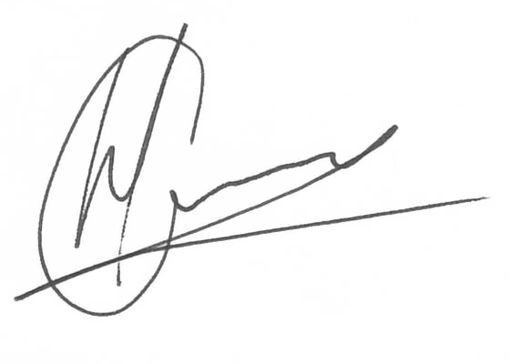

----------------------------------------------- -------------------------------------
Hannes Gouws Name:
Director | PSAT 32449887 Date:

