


BLACKHOUND ENTERPRISES PTY LTD
T/A BLACKHOUND ARCHITECTURE & RENDERING

Hannes Gouws
hannes@blackhoundenterprises.com
072 799 9597

Unit 10 – The Network
19 Cactus Road
Fairview
Port Elizabeth (Gqeberha)
Eastern Cape
2075

Unit 10 – The Network
19 Cactus Road
Fairview
Port Elizabeth (Gqeberha)
Eastern Cape
2075

Unit 10 – The Network
19 Cactus Road
Fairview
Port Elizabeth (Gqeberha)
Eastern Cape
2075

Client:
Banthatile Rwasoka
063 790 4793
Banthatile.rwasoka@gmail.com

Date: 10 NOVEMBER 2022
|SCOPE OF WORKS:

Design a new restaurant and lounge on homelands of Limpopo

Project Requirements:
- Ground Floor:
  - Total covered area = 450m² (30m x 15m)
  - Kitchen
  - Storeroom
  - General ablutions
  - V.I.P. ablutions
  - V.I.P. Lounge
  - Cigar Lounge
  - General lounge
  - DJ Booth
  - Waiting area and Reception
  - Open Deck area
Request for Information:
- Interior Design plans, specifications and finishes will be supplied by Banthatile Rwasoka.

|HOUSE SEKHUKHUNI, LIMPOPO.
Design, and Technical Drawings:
Excluded from the fees:
- Submission fees and hard copy prints, if required. (e.g. Council and municipal related fees/Estate/NHBRC)
- Other Professional consultancy fees that may be required (e.g. Structural Engineer, Quantity and Site Surveyors, Health & Safety, etc.)
- Execution of the works and testing of materials to ensure compliance with drawings and specifications remains the responsibility of the contractor.
- Occupation and As-Built drawings, should the building not be built as per the approved plans.
- Printing of drawings for site.
Area:
Total Covered Area: 450m²
Total Estimated decking area: ± 220m²
Professional Fees Calculation:
Phase 1: Design:
  - After acceptance of the fee proposal, we will proceed with the design phase and liaise with you to achieve design approval.
  - Included in our design phase is 3d modelling, to resolve design details and to give you a clear picture of what the design will look like before we proceed with the next phase.
  - Please keep in mind that this is only conceptual 3d visualization and not rendering. Please refer to Phase 3 for the rendering proposal.

R69 829.31

Phase 2: Technical Drawings:
Includes:
  - Technical drawings; Floor Plans, Sections, Elevations, and basic Electrical layouts
  - All drawings will be done to comply with NBR of S.A. and SANS 10400 regulations.
  - Deemed-to-Satisfy Energy Efficiency and Fenestration calculations, as required by SANS 10400.
R59 462.89

Construction Drawings and Details - NOT ALLOWED
  - Construction details.
  - Windows and Door Schedules.
  - Detailed electrical layouts, as per your required needs.
  - Water reticulation layouts.

Phase 3: Rendering:
- Kitchen: x1 Renders

- Storeroom: x1 Renders

- General Ablution: x1 Render

- VIP Lounge: x1 Render

- VIP Ablutions: x1 Render

- Cigar Lounge: x1 Render

- General Lounge and DJ booth: x1 Render

- Reception and Waiting area: x1 Render

- Exterior Deck area: x1 Render

Total Still image Renders:

- 9x Renders (@ ±R4 778.4 per image) R43 005.60

*This price includes 1x round of draft renders before final rendering and 4x Custom furniture pieces.
Generic furniture will be used to furnish the spaces to suit the style of the design.
*Additional custom furniture will be quoted at R1600 per piece and added to the final account.
*Changes to the design after final renders, resulting in re-rendering, will be charged at R3000 per re-render.

Totals:
PHASE 1: (Architectural and Interior Design) R69 829.31
PHASE 2: (Technical Drawings) R59 462.89
PHASE 3: Rendering: R43 005.60

TOTAL QUOTE
PHASE 1 & 2 R129 292.20 (VAT not applicable)
PHASE 3 (Optional) R43 005.60 (VAT not applicable)

TERMS AND CONDITIONS:
*Should our scope of work increase, our fees will be adjusted to accommodate the extra scope. This will be discussed before the work commences.
*This quote is only valid for 30 Days after the date of issue.
*Should you accept the total quote (Option A below) and make the deposit payment for Phase 1,2 & 3 a 5% discount will apply to the total quote.
*Should additional drawings or services be required an hourly fee will be applicable, this will be discussed and agreed prior to the works.

|PAYMENT TERMS:
Option A: Phase 1,2 & 3 : Less 5% Discount (R172 297.80 – R8 614.89)
- 70% , non-refundable deposit payable at inception.
(R114 578.03)

- Balance of the fees payable at technical drawings handover.
(R49 104.88)

Option B: Phase 1,2 & 3 Instalments.
The total amount for phase 1,2 & 3 can be split in 3 instalments of R57 432.6.
- First Instalment: As a non-refundable deposit at inception.

- Second Instalment: At design approval, before we commence with the technical drawings.

- Third Instalment: At technical drawings handover.

Option C: Phase 1 & 2 ONLY (R129 292.2)
- 70% , non-refundable deposit payable at inception.
(R90 504.54)

- Balance of the fees payable at technical drawings handover.
(R38 787.66)

|ACCEPTANCE:
The Terms and Conditions presented here may be modified or amended as necessary only by written instrument signed by both parties.
By submitting the deposit payment, you are agreeing to the terms and conditions detailed in this document. This proposal is agreed upon in full, signed and dated.
By signing this document, I indicate that I understand, agree to, and accept the terms and conditions as contained herein, dated this 10 NOVEMBER 2022.

I, __________________________________________ hereby agree to the Terms and Conditions laid out in this document.

Email: hannes@blackhoundenterprises.com
Phone: 072 799 9597

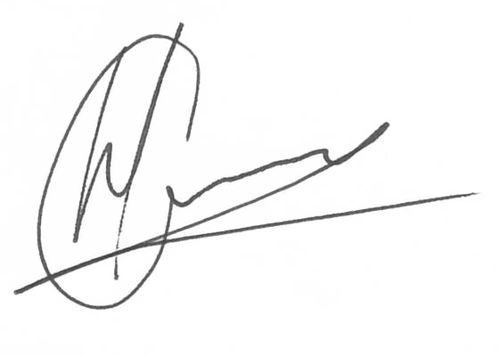

----------------------------------------------- -------------------------------------
Hannes Gouws Name:
Director | PSAT 32449887 Date:

