HINTERVELD - 2025/05/05
PAINT COLOURS:
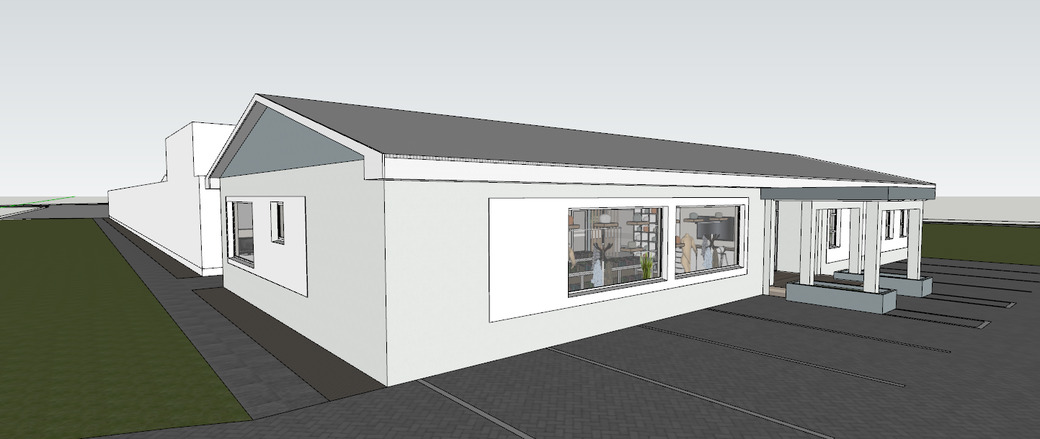
2
3
1
3
3
1
1
- SPA BLUE (Top half of gable and feature colours at Main entrance)
- CHELSEA FOG (Main external colour)
- BRILLIANT WHITE (Window bands, eaves, fascia’s, barge boards.
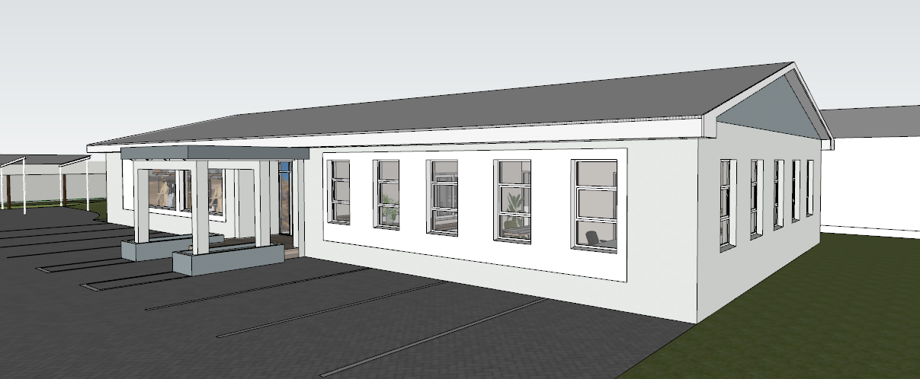
3
3
2
2
1
1
1
- SPA BLUE (Top half of gable and feature colours at Main entrance)
- CHELSEA FOG (Main external colour)
- BRILLIANT WHITE (Window bands, eaves, fascia’s, barge boards.)

RECEPTION:
- SPA BLUE (Feature colour in passage on both sides of the wall.)
- BRILLIANT WHITE (Ceilings, Cornices, Door frames, Skirtings)
- DARKEN PUDDLE (Feature wall to be a specialist screeded finish. I will get back to you on this one.)
- KITTEN WHITE (General internal wall colour)
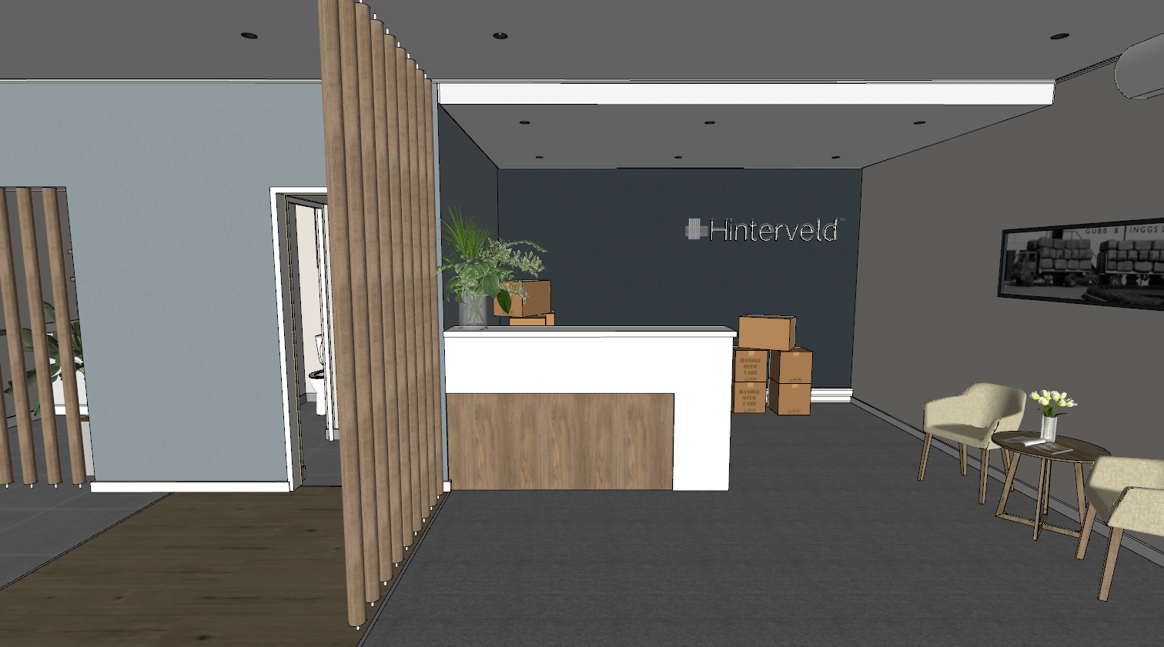
3
2
2
2
2
4
1

PASSAGE 1:
- KITTEN WHITE (General internal wall colour)
- BRILLIANT WHITE (Ceilings, Cornices, Door frames, Skirtings)
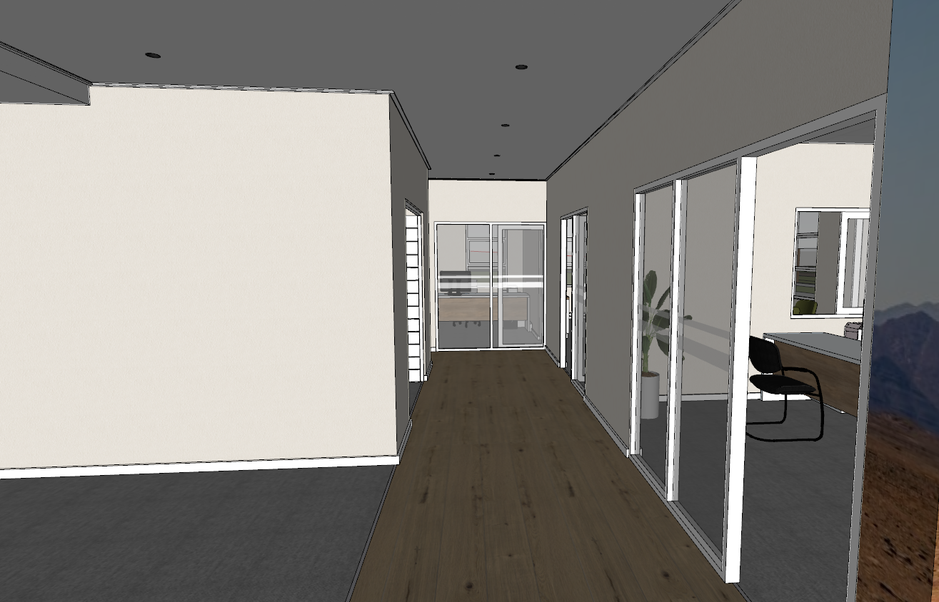
1
2
2
1
1
1
1
OFFICE 1:
All internal walls to be Kitten white.
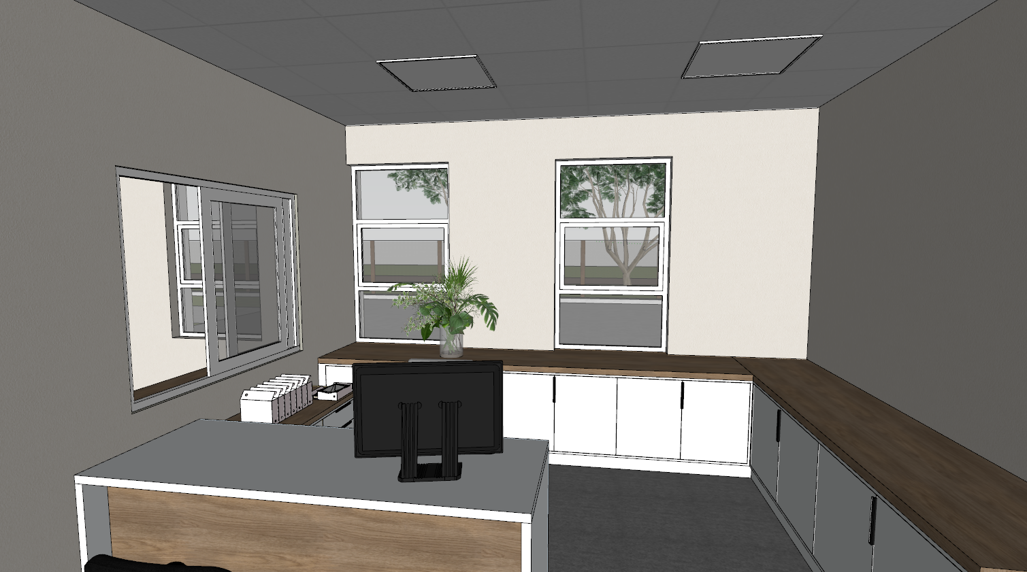

Daniels Office:
All internal walls to be Kitten White
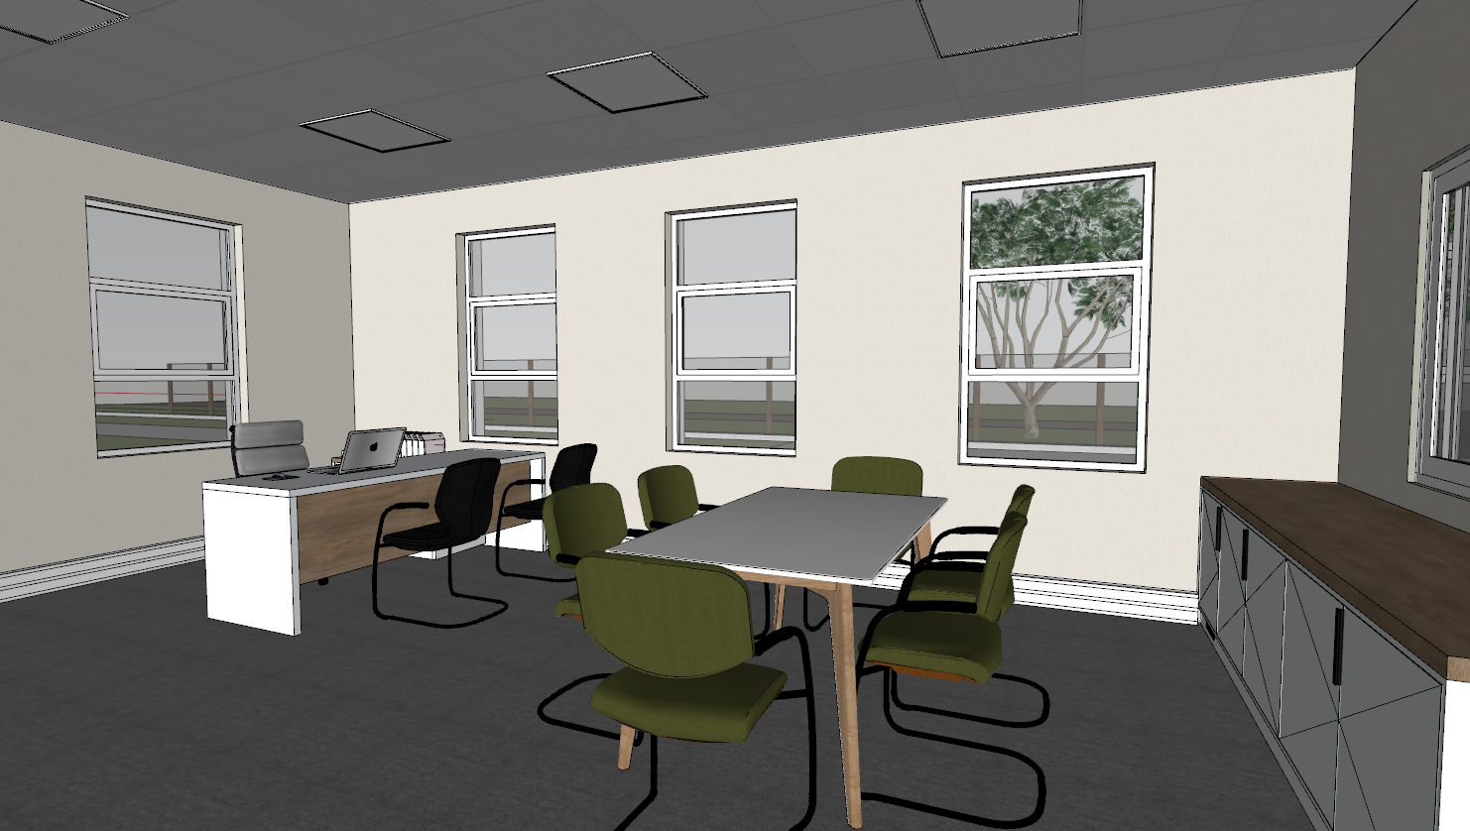

OFFICE 2:
All internal walls to be Kitten white.
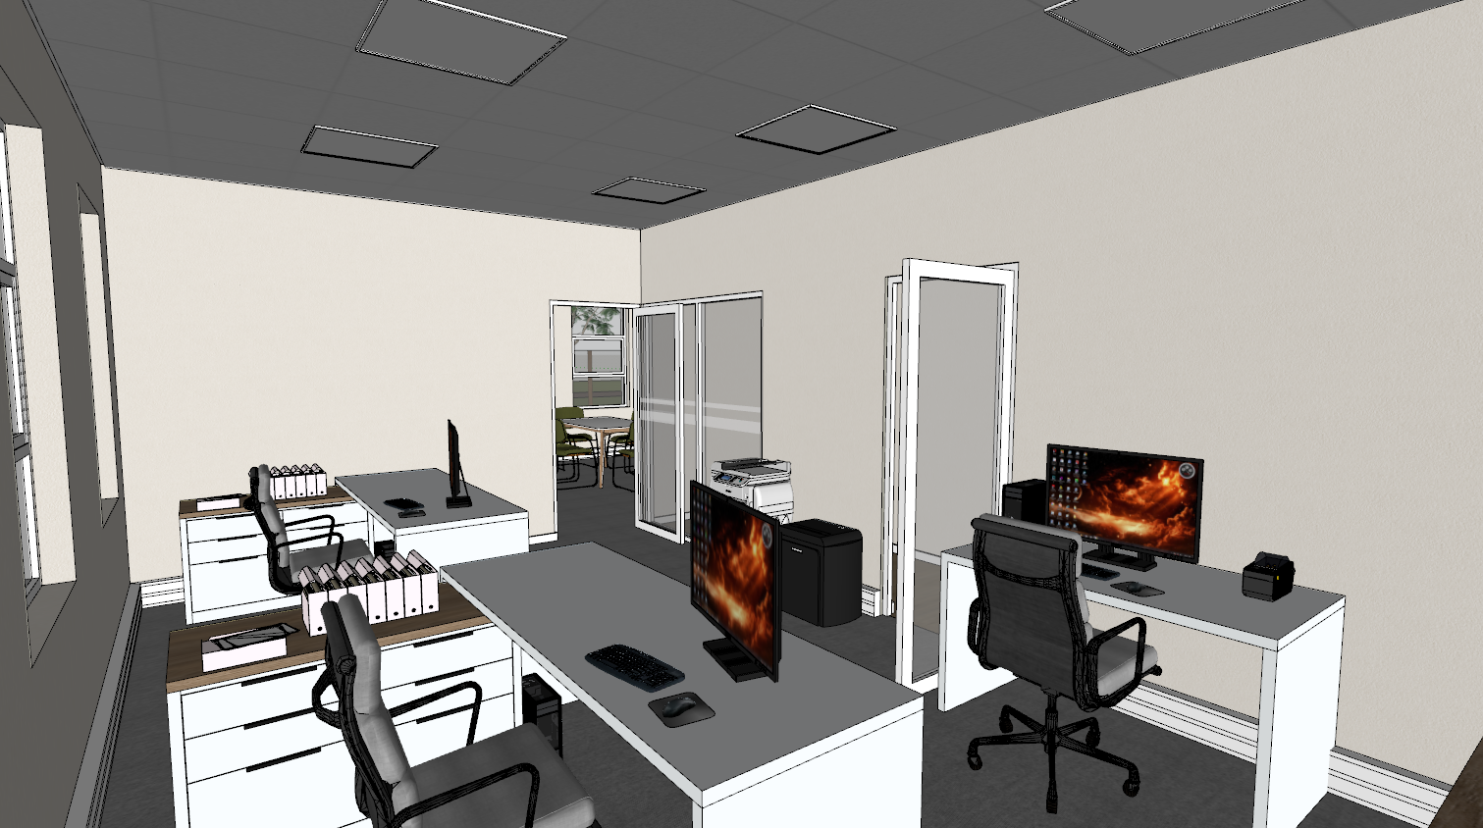

SERVER ROOM:
All internal walls to be Kitten white.
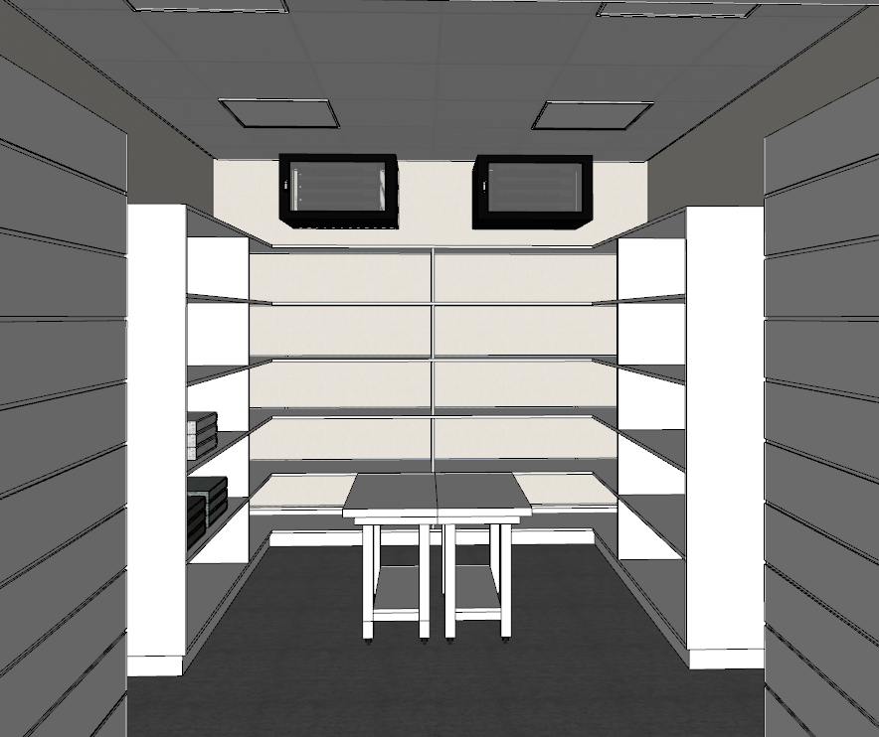

PASSAGE 1:
- BRILLIANT WHITE (Ceilings, Cornices, Doors & Door frames, Skirtings)
- KITTEN WHITE (General internal wall colour)
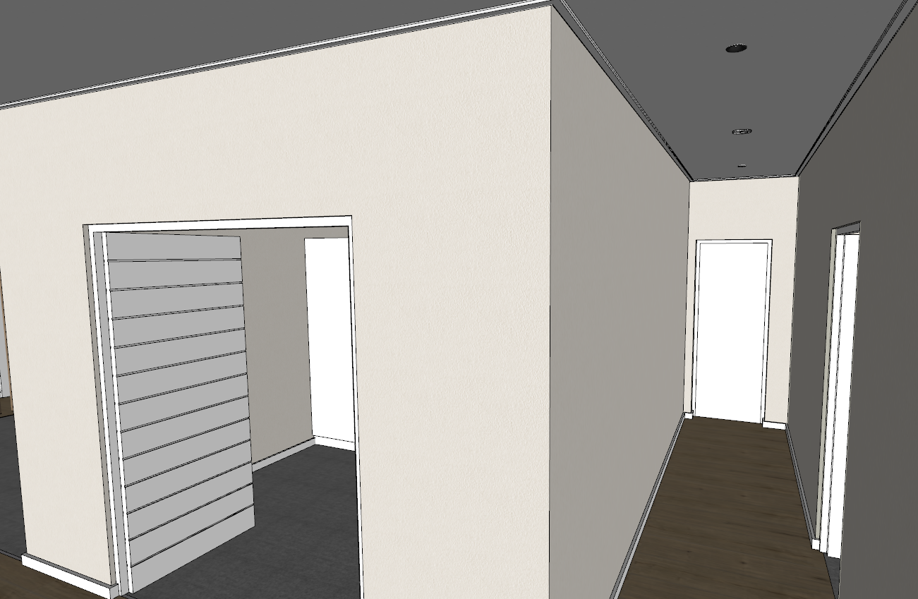
1
1
1
1
1
2
2
2
2

SHOW ROOM:
- BRILLIANT WHITE (Ceilings, Cornices, Doors & Door frames, Skirtings)
- KITTEN WHITE (General internal wall colour)
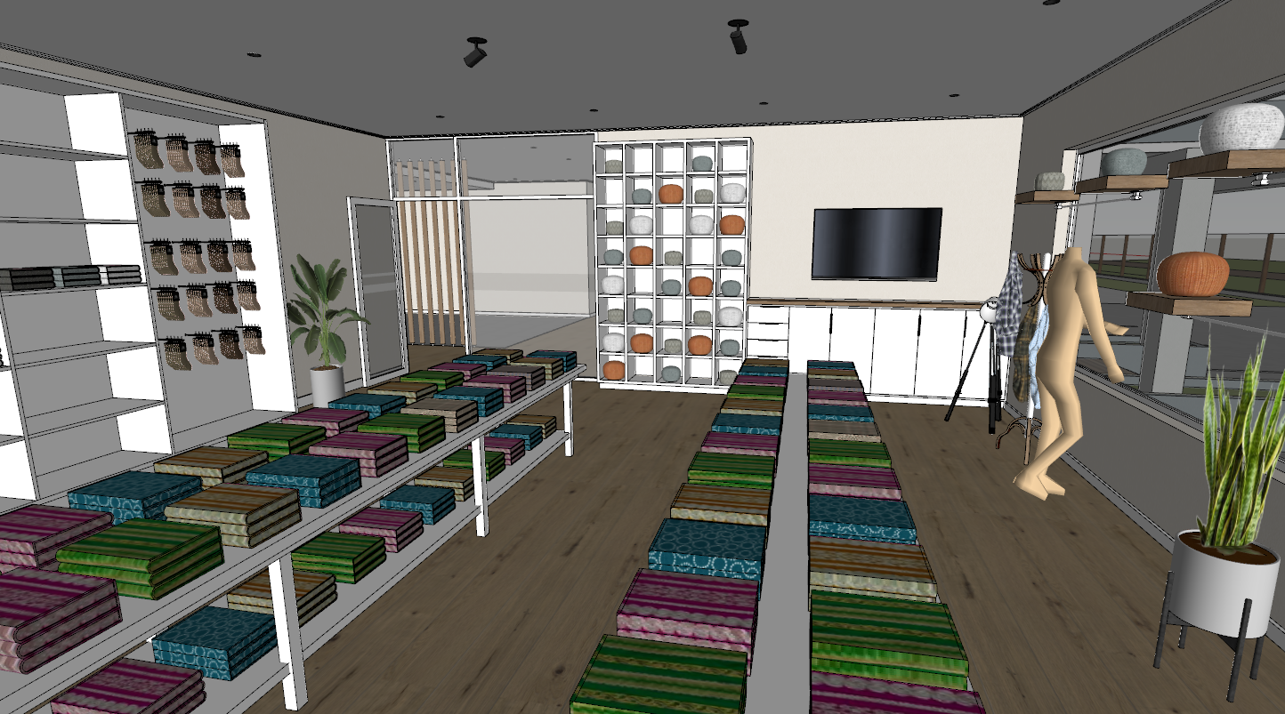
2
2
2
1

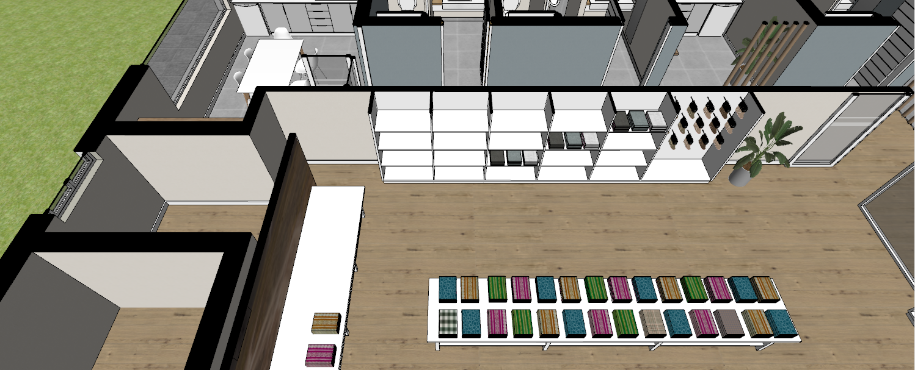
2
2
2
2

COFFEE NOOK:
- SPA BLUE (Feature colour in passage on both sides of the wall.)
- BRILLIANT WHITE (Ceilings, Cornices, Doors & Door frames, Skirtings)
- KITTEN WHITE (General internal wall colour)
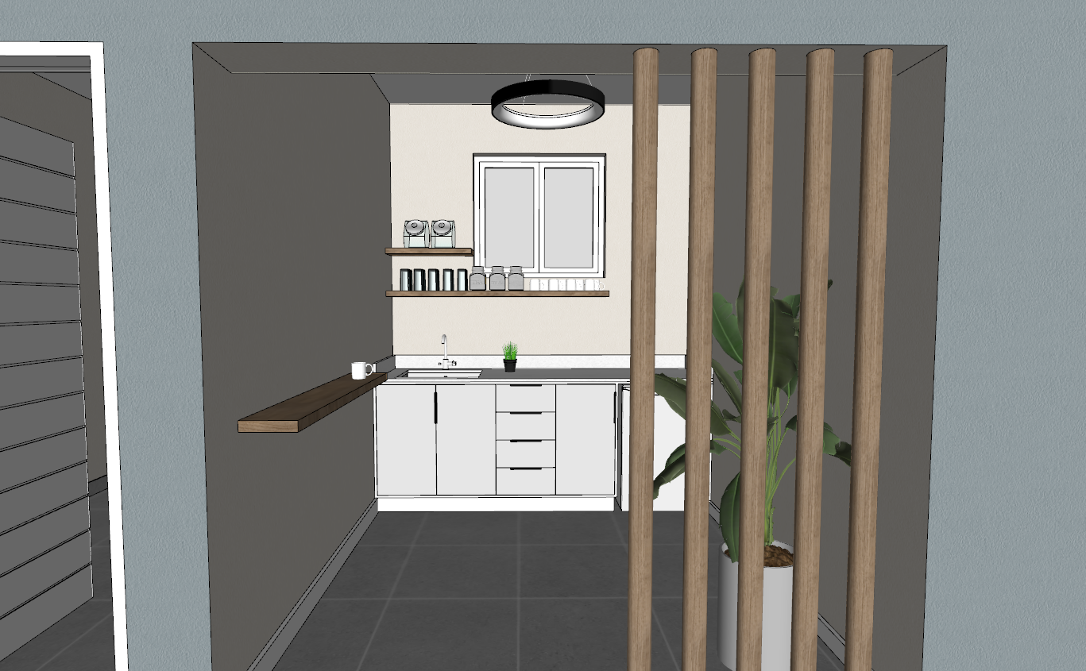
2
2
2
2
1
1
1
3
3
3
3
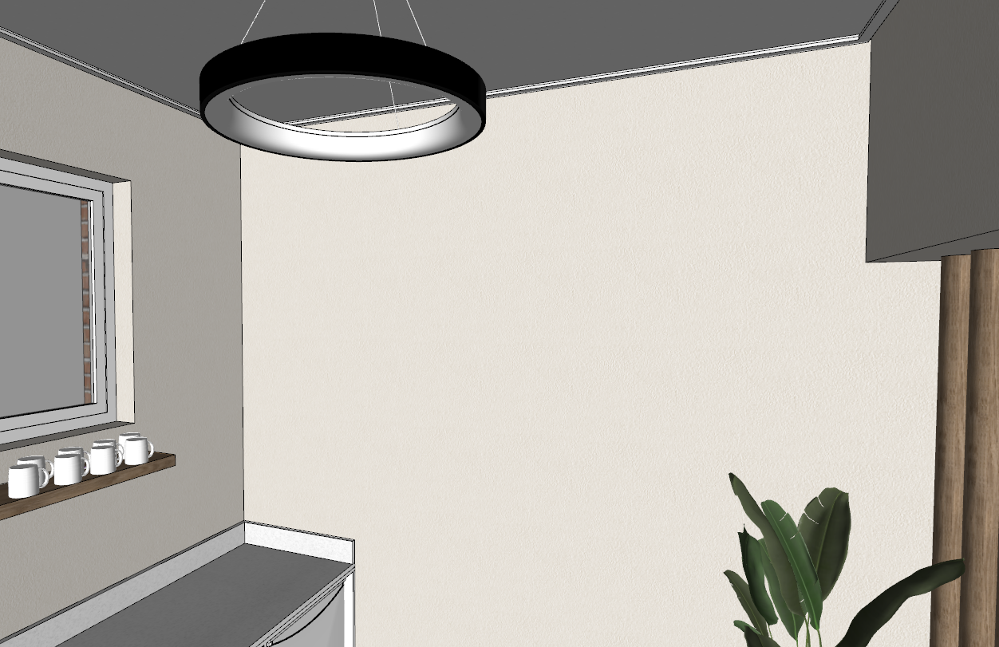
3
2
3
3
3

STAFF MALE & FEMALE RESTROOMS:
- SPA BLUE (Feature colour in passage on both sides of the wall.)
- BRILLIANT WHITE (Doors, Door frames & Skirtings)
- KITTEN WHITE (General internal wall colour)
3
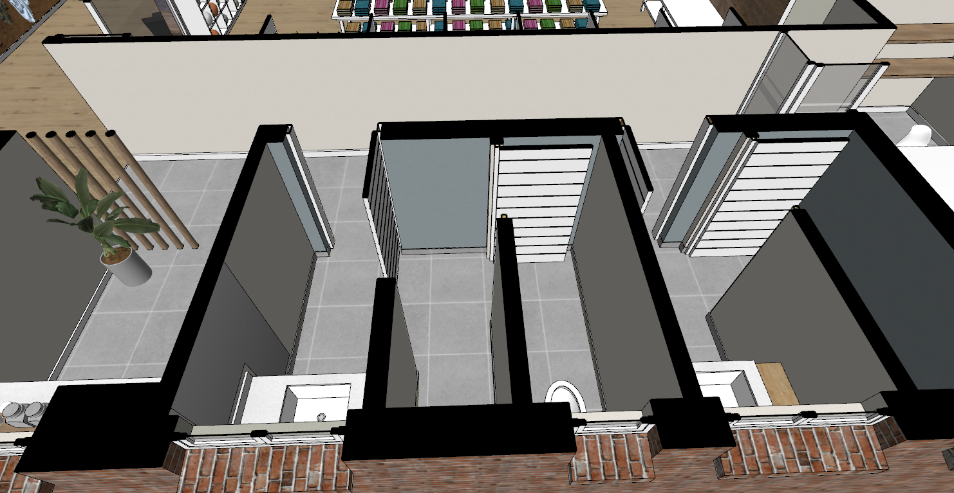
3
3
2
2
2
1
3
3
3
3
1
1
3

CANTEEN:
- SPA BLUE (Feature colour in passage on both sides of the wall.)
- BRILLIANT WHITE (Doors, Door frames & Skirtings)
- KITTEN WHITE (General internal wall colour)
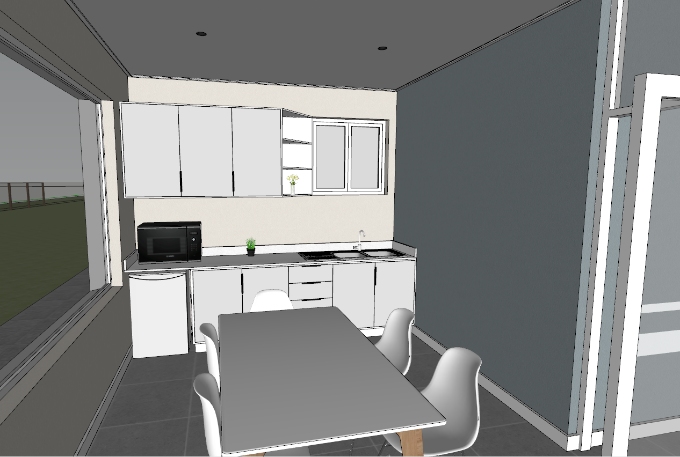
1
2
2
3
3
2
1
3
VISITORS RESTROOM:
- SPA BLUE (Feature colour in passage on both sides of the wall.)
- BRILLIANT WHITE (Doors, Door frames & Skirtings)
- KITTEN WHITE (General internal wall colour)
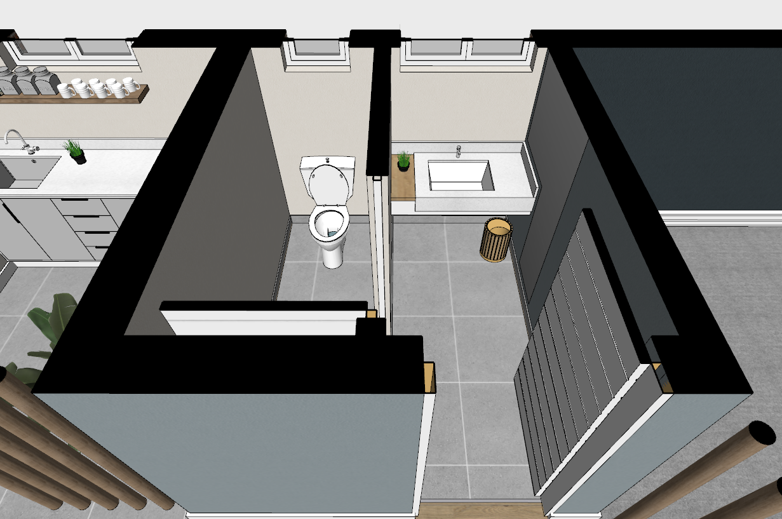
3
3
3
3
2
1
1
1

GENERAL COMMENTS:
All restrooms to be a 100mm high tiled skirting with L-trim on the top.

Where the urinal has been mounted. The wall tile/skirting will be 150mm above the top side of the push plate. (As per the image below)
