HR Offices - INTERNAL - 2025/05/29
PAINT COLOURS:
FOYER:
- BRILLIANT WHITE (Fascia’s, barge boards, window cills, areas on walls.)
- SPA BLUE
- KITTEN WHITE (General internal wall colour)
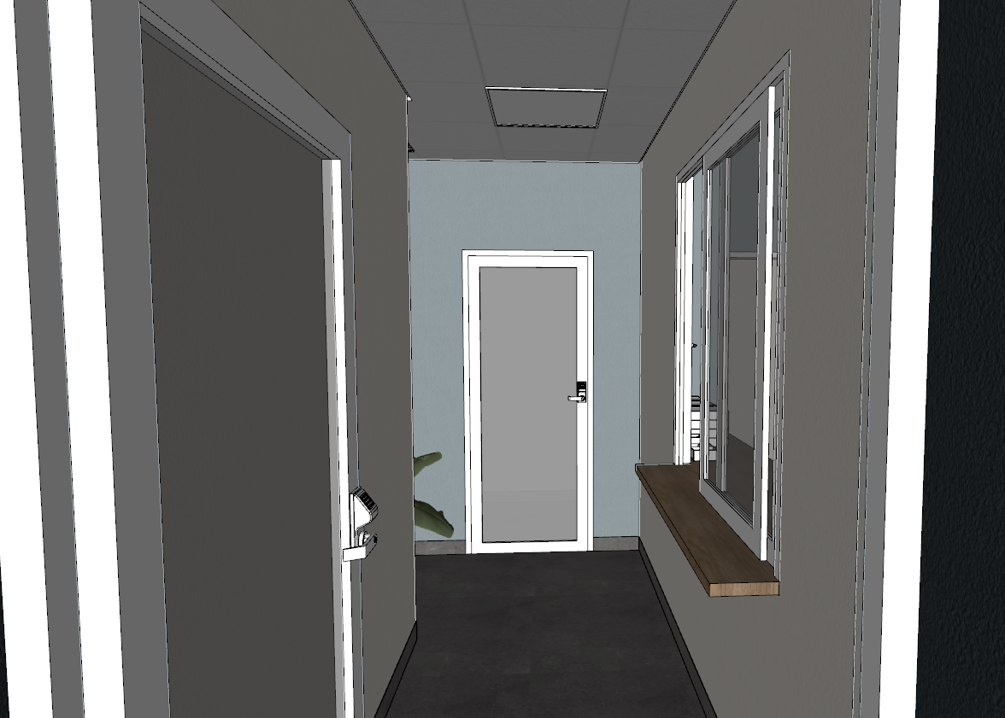
3
3
2

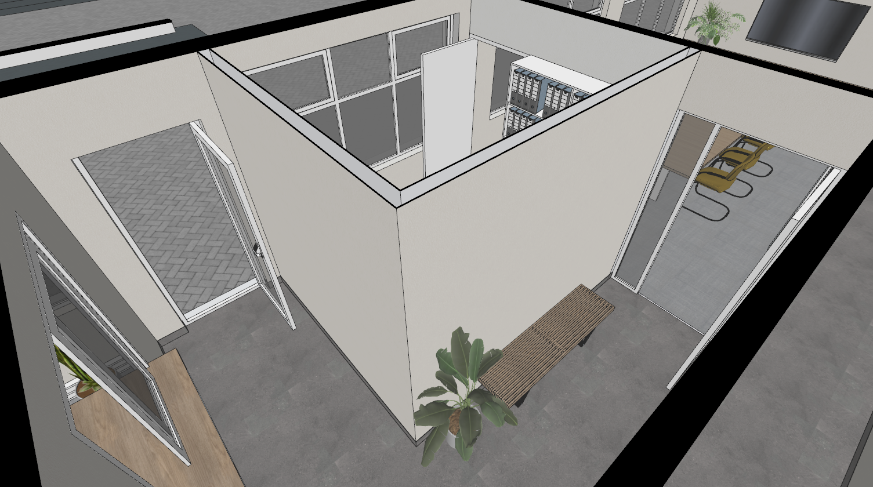
3
3
3
3
3
3
3
3
BOARDROOM:
- BRILLIANT WHITE
- SPA BLUE
- KITTEN WHITE (General internal wall colour)
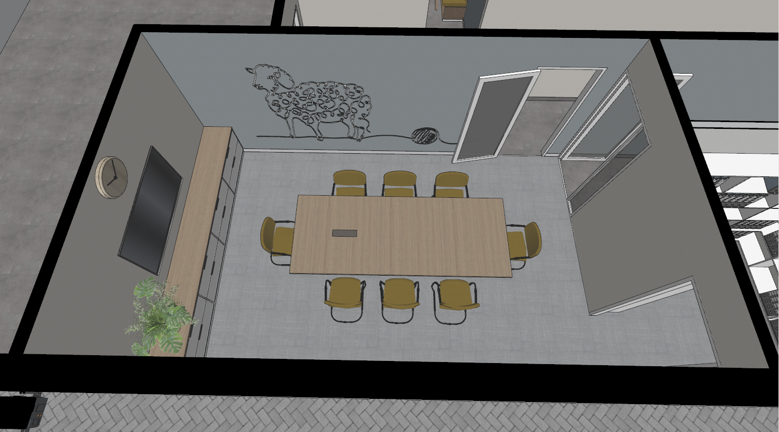
3
3
3
2
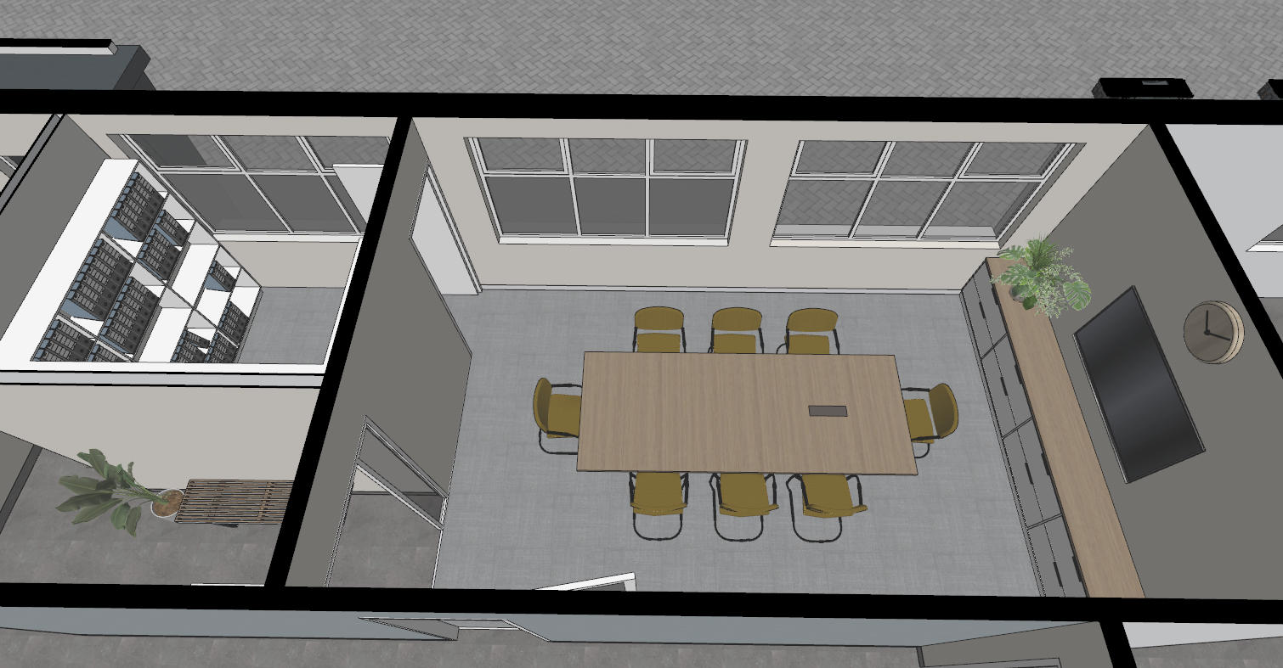
3
3
3
3
3
3
3

PASSAGE:
- BRILLIANT WHITE
- SPA BLUE
- KITTEN WHITE (General internal wall colour)
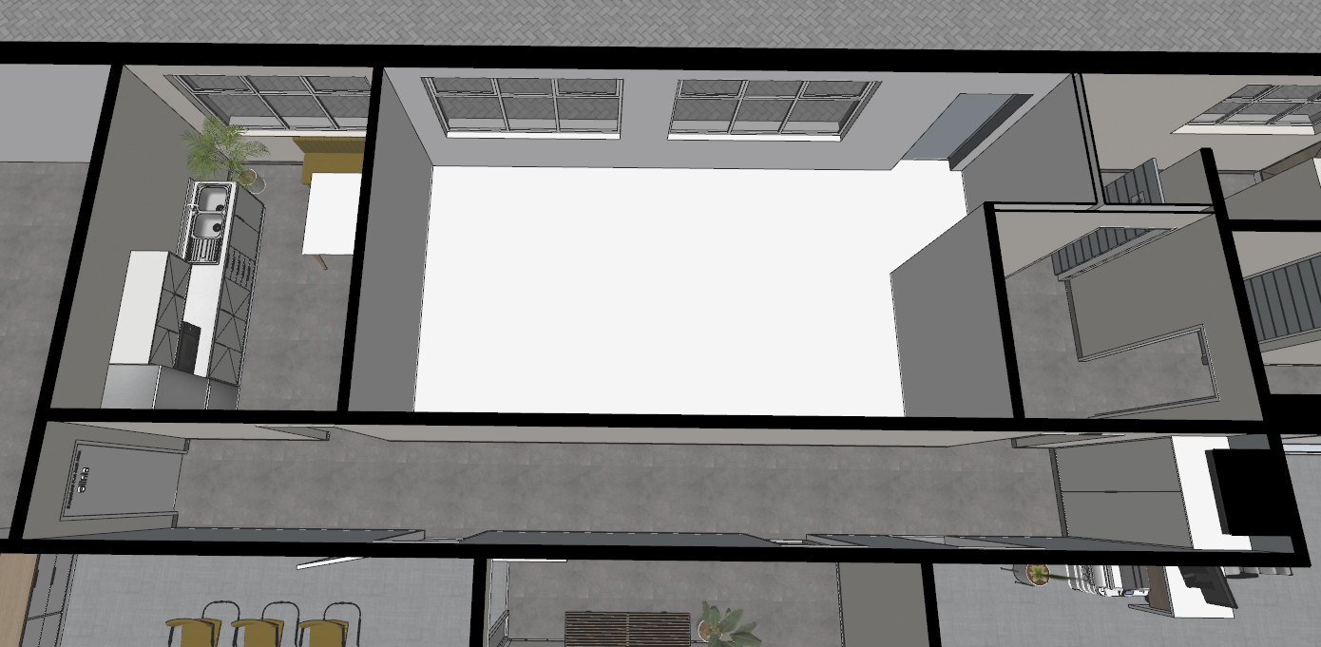
3
3
3
3
3
3
3
3
2
2
2
2
KITCHEN:
- BRILLIANT WHITE
- SPA BLUE
- KITTEN WHITE (General internal wall colour)
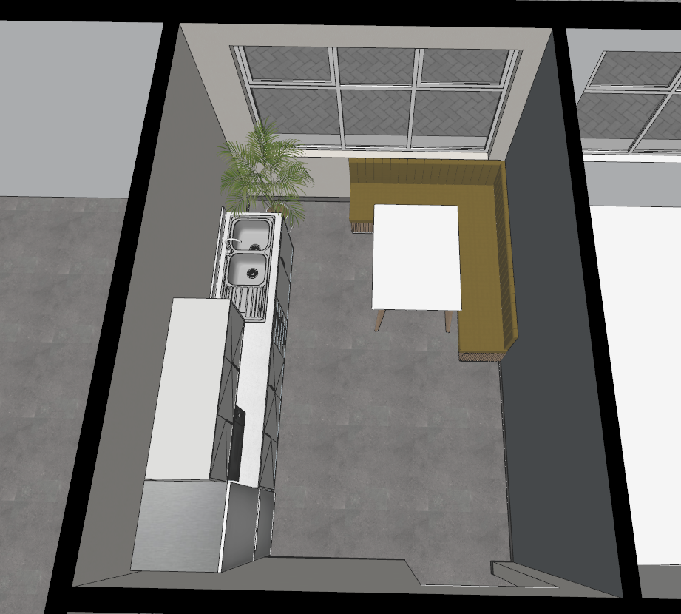
3
3
3
2
COMMON SPACE + FEMALE / MALE RESTROOM:
- All walls to be KITTEN WHITE
- All timber door frames to be painted BRILLIANT WHITE
- All timber doors to be painted SPA BLUE
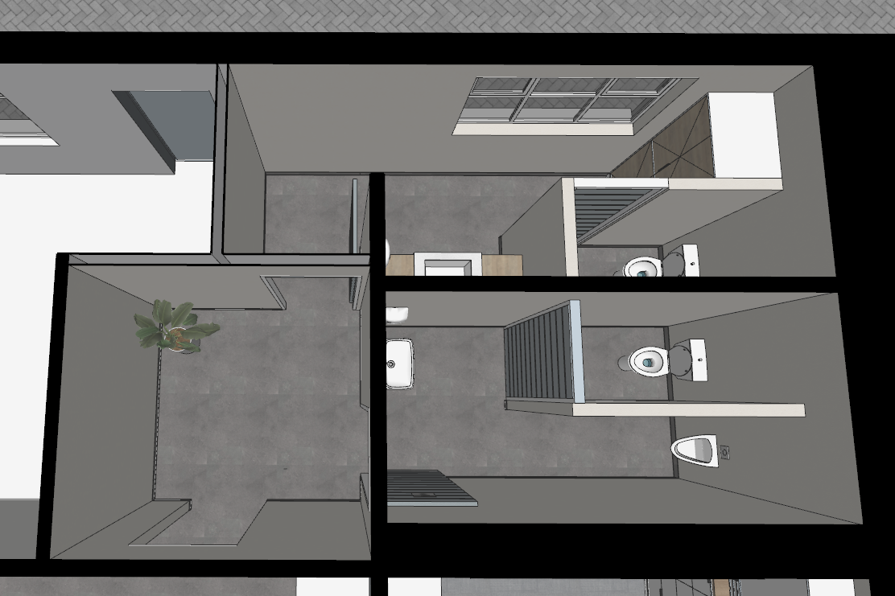
OPEN PLAN OFFICES:
- BRILLIANT WHITE
- SPA BLUE
- KITTEN WHITE (General internal wall colour)
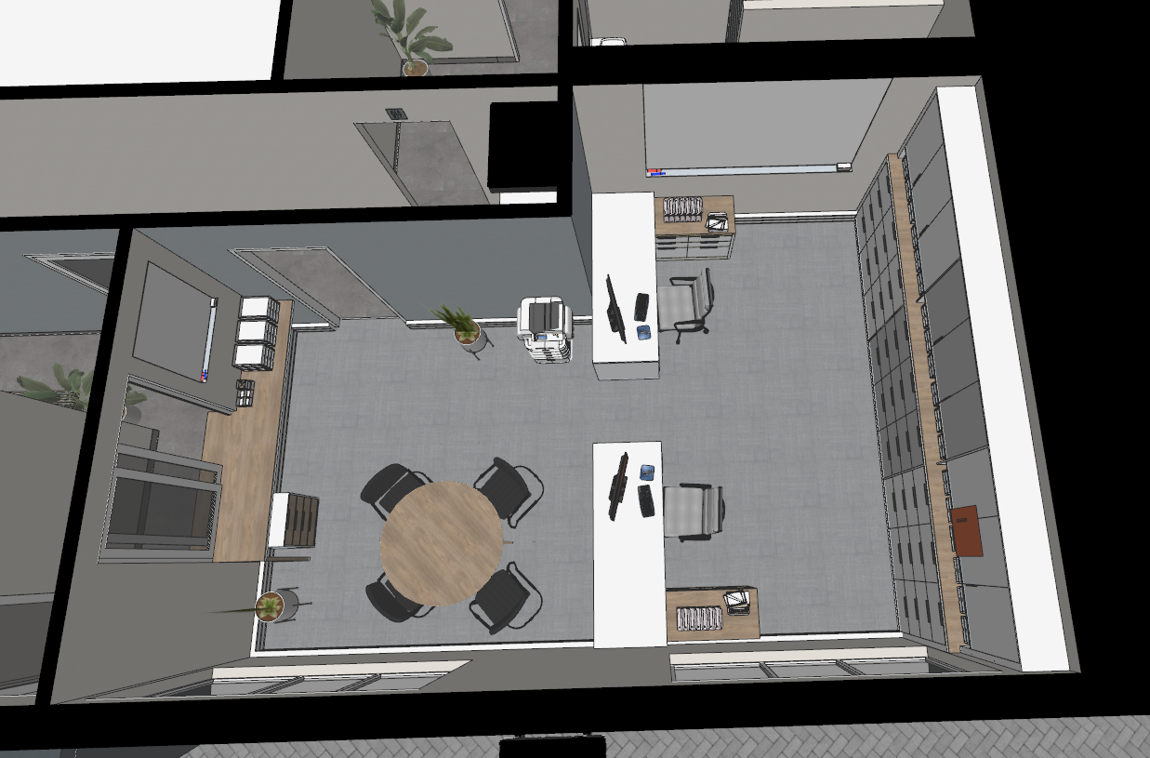
3
3
3
2
3
3
3
3
2
3

