Date: 11/05/2024
Quote estimate Number: 6899

Gubb & Ings
Uitenhage
Email: dewald@blackhoundenterprises.com
C/O Dewald Potgieter
Cell:072 418 6867
__________________________________________________________________________________

Dear Dewald

Further to our discussions, please see below estimate and scope of works:
This estimate is subject to design and selection of materials.

Description of materials

Joinery: Demand range Melamine – Mid range
- Manufacture and install as per design: Final measurements to be confirmed.
- Provision for melamine built in cabinets
- Description of materials
  - White melamine interiors
  - Doors and seen sides
    - Dunblane melamine
    - Iceberg white melamine
    - Sahara timber melamine
  - Soft closing runners and hinges
  - 3,2 Masonite backing.
- Eazi quartz 20mm counter tops
- All plumbing and electrical excluded

Scope of works

- Kitchen -PC
  - 2700 x 900 floor units
    - 2750 x 600 Ezi quartz counter
    - 1500 wall units +glass doors
  - 2700 Corner bench breakfast nook
    - Upholstery excluded
  - 1500 x 1000 -table
R 33 540.00 ex vat

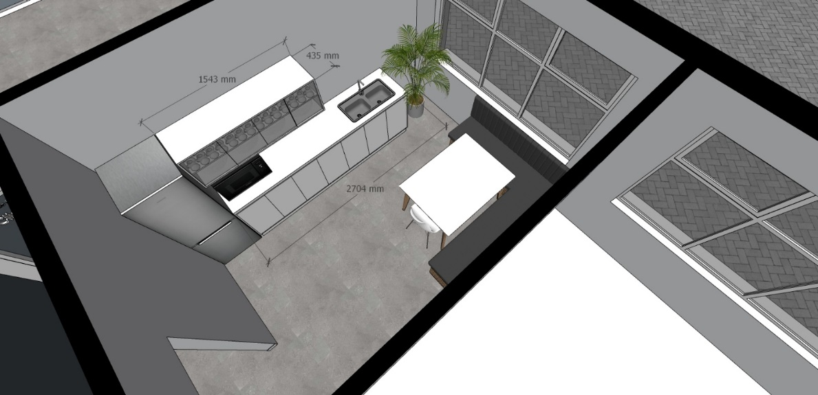

- Slatted bench
  - Solid oak slats as per design
  - Mild steel sub frame R 12 500.00 ex vat

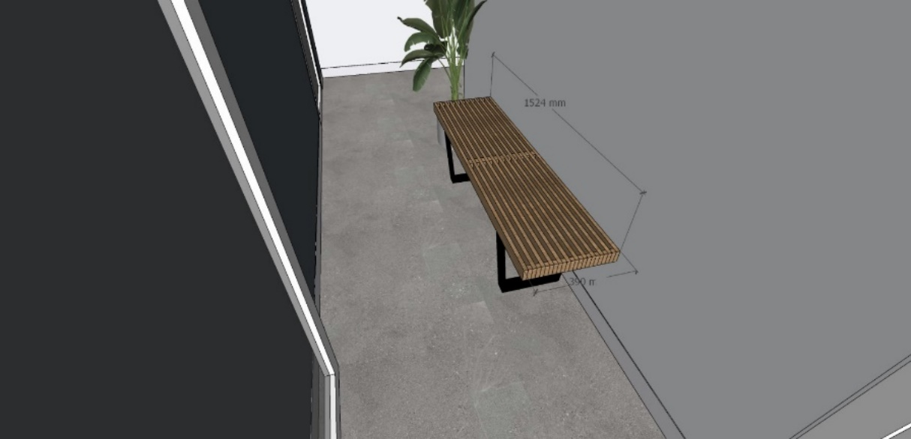

- Boardroom
  - Filing units
    - 3660 x 400 x 745
  - Boardroom table
    - 3050 x 1200 Sahara + Ergo edging
    - 1 x power dock
R 42 650.00 ex vat

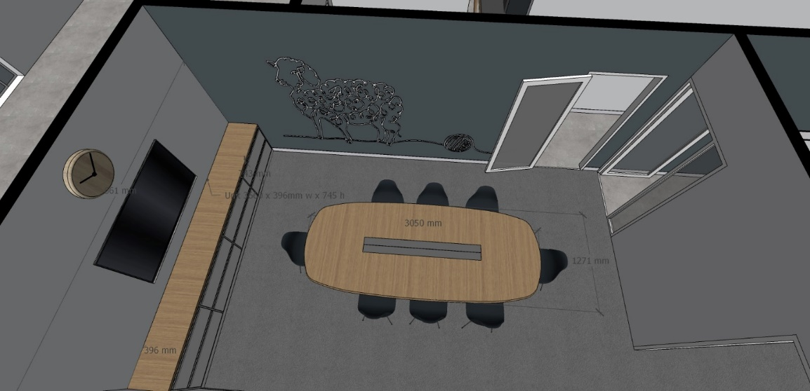

- Filing room
  - 30 x 30 square tubing framework
    - Painted black
    - 8 x 2400 x 350 frames
    - Pine glulam shelving 19mm
R 32 850.00 ex vat

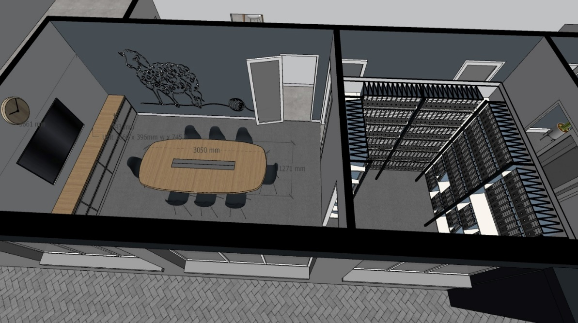

- Vanity -PC
  - 2200 x 500
    - Floating Ezi quarts counter
    - Pc – Frame joinery beneath counter
    - Design to be confirmed
R 10 500.00 ex vat

- Tall built in units
  - 2200 x 1200
  - 2200 x 800
    - White interior
    - Grey Mel exterior
    - Interior design to be confirmed
R 8 650.00 ex vat

- Open plan HR office
  - Reception desk
  - 2700 x 600 desk + down stand +extension
    - 600 x 3/draw caster unit
    - White interior
    - Grey Mel and Shahara exterior melamine
    - Interior design to be confirmed
R 14 850.00.00 ex vat
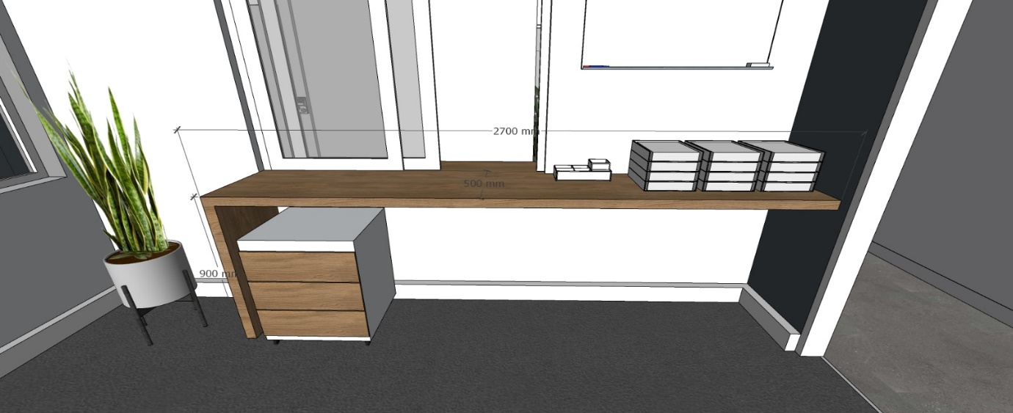

  - Occasional table x1
    - 1200 dimeter
    - Pedestal (off the shelf)
R 4 500.00 ex vat

  - L-Shaped desks x2 -PC
    - 2000 x 750
      - Legs and modesty panel
    - 2x800 x 600 3/draw unit
R 28 800.00 ex vat

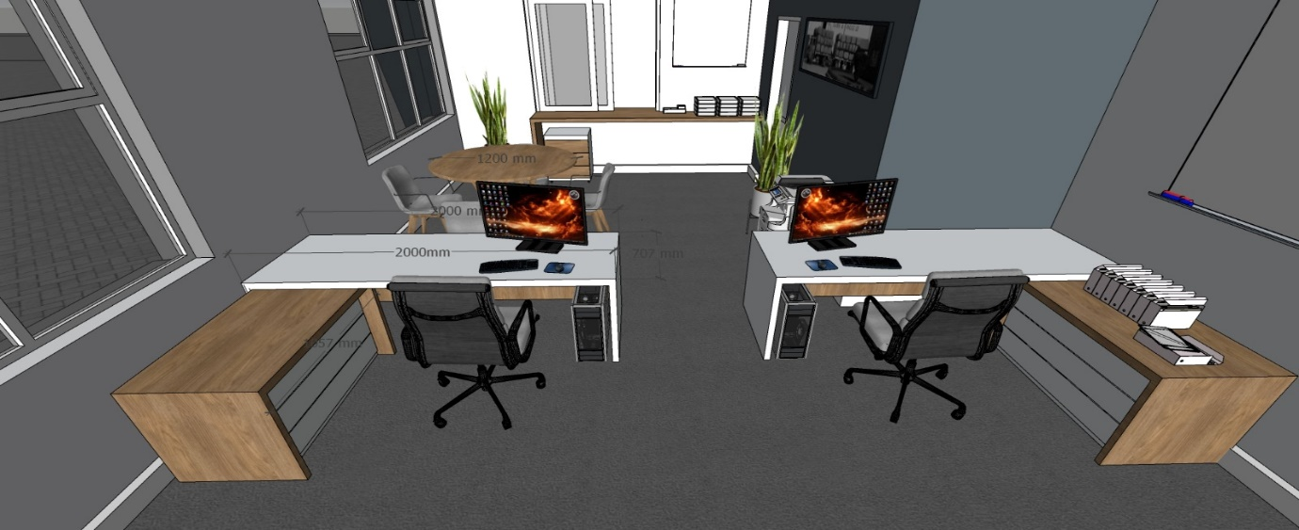

  - Filing units and draws
    - 4880 x 3000X 450M
      - 4 x 1200 x 1350 4 /draw (arch-lever)
      - 4 X 1200 x 1200 wall units
      - 4 x 1200 x 700 timber in full units
R 32 600.00 ex vat
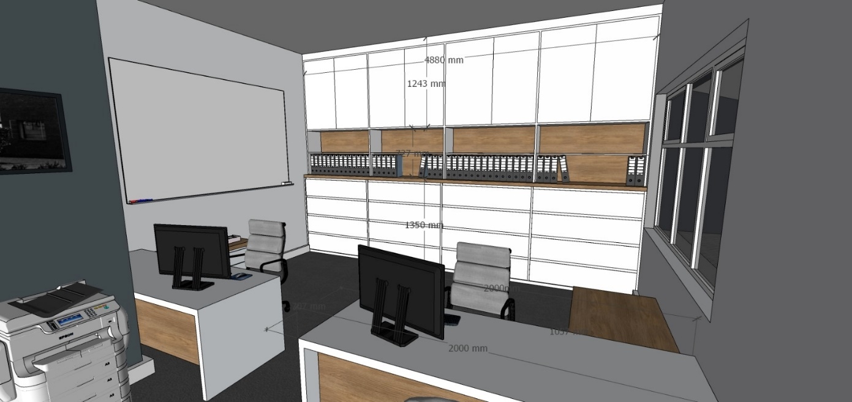

Costing:
- Kitchen R 33 540.00
- Slatted bench R 12 500.00
- Board room R 46 250.00
- Filing room R 32 850.00
- Vanity PC R 10 500.00
- Tall storage built-in units R 8 650.00
- Reception desk R 14 850.00
- Occasional table R 4 500.00
- L-shaped desks R 28 800.00
- Filing units wi5th arch-lever draws R 32 600.00

Total excluding vat R225 040.00

__________________________________________________________________________________
Terms and Conditions
- Quotations are valid for 7 days.
- All quotes are subject to final measurements.
- This quote is for cut, supply, and specified assembly.
- This quote DOES NOT include Any plumbing, sinks, electrical or lighting installations.
- All materials are payable upfront.
- A 70% deposit is payable upfront, thereafter a progress payment, and balance to be paid on completion.
- Interest will be charged on outstanding balances after 7 working days at 10%.
- No work will commence unless deposit is paid, and quote is signed and agreed upon.
- All materials remain the property of Design Line until all monies are paid in full.
- Any work that has not been quoted for but requested by the client will be charged for.
- Errors and Omissions exempted.
- Penalties for delays in works will be levied at 8% of the total quoted amount and per calendar day from the end of the agreed upon completion date.
- Penalties for delays in works are applicable to both parties. (All prices excluding VAT)
- DESIGNS: In accordance with South Africa’s Copyright Act, 98 of 1978, Design Line & Co will retain the limited rights to completed artistic works. (Graphic designs, drawings, diagrams, photographs, graphic recommendations of colour and material usage.)
- PC amounts refer to provisional costing amounts that are subject to change.
- Price increases in material may affect quotes if materials are not locally available and may incur additional transport costs.
- New timelines will be created for any additional works and will not form part of allocated time for accepted quote.
- Design Line cannot be held responsible for material that is not available in Port Elizabeth, as we rely on outsource companies for material.

Client Signature: Date:

Commencement Date:

Completion Date:

Witness Signature:

Banking Details
E Harmse
ABSA
Newton Park
Account Number: 4054098750

