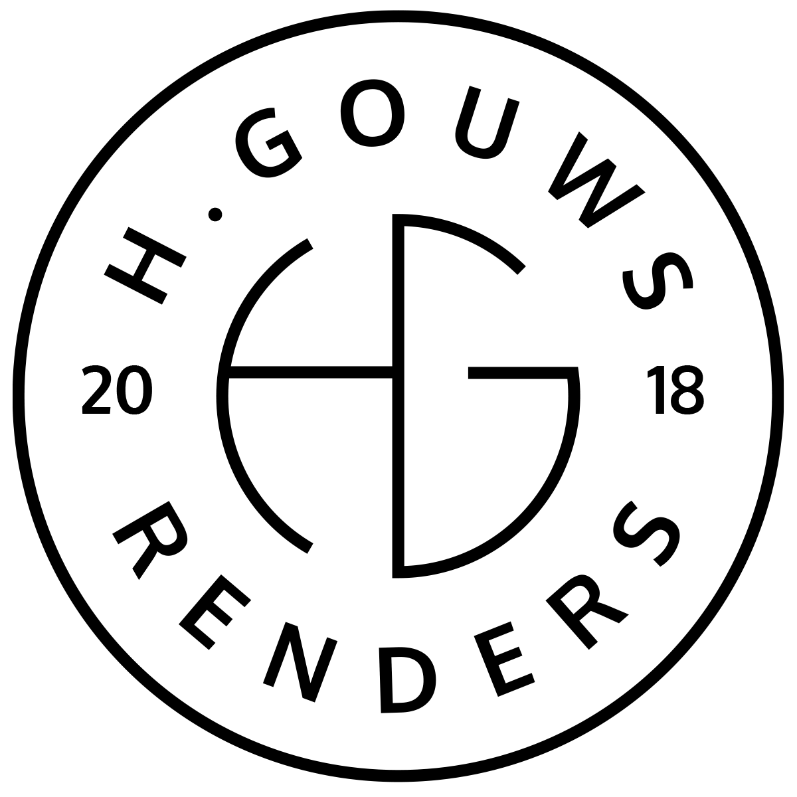H. Gouws Renders PTY LTD:
2020/784683/07

1 Elsa Joubert street
Fairview
Port Elizabeth (Gqeberha)
Eastern Cape
2075

Client:
BASEMARK INVESTMENTS (Pty) Ltd
11 Meyer Street
Claremont
Cape Town
7708
INVOICE:
000292021ISAACS

Date: 28 October 2021

Item: | Description: | Quantity: | Price: | Total:
-------------------------------------------------------------------------------------------------------
1 | House Swire-Griffiths: Final Drawings Invoice. | 0.5 | R60 000.00 | R30 000.00
1 | House Swire-Griffiths: BARC drawings print_ 06-08-2021. | 1.0 | R284.00 | R284.00

-----------------------------------------------------------------------------------------------------------------------------------
TOTAL:
R30 284.00 ex VAT

Banking details:
Nedbank
Account Number: 1212774191
Branch Code: 12681700
Cheque account

KINDLY USE THE INVOICE NUMBER AS YOUR PAYMENT REFERENCE

