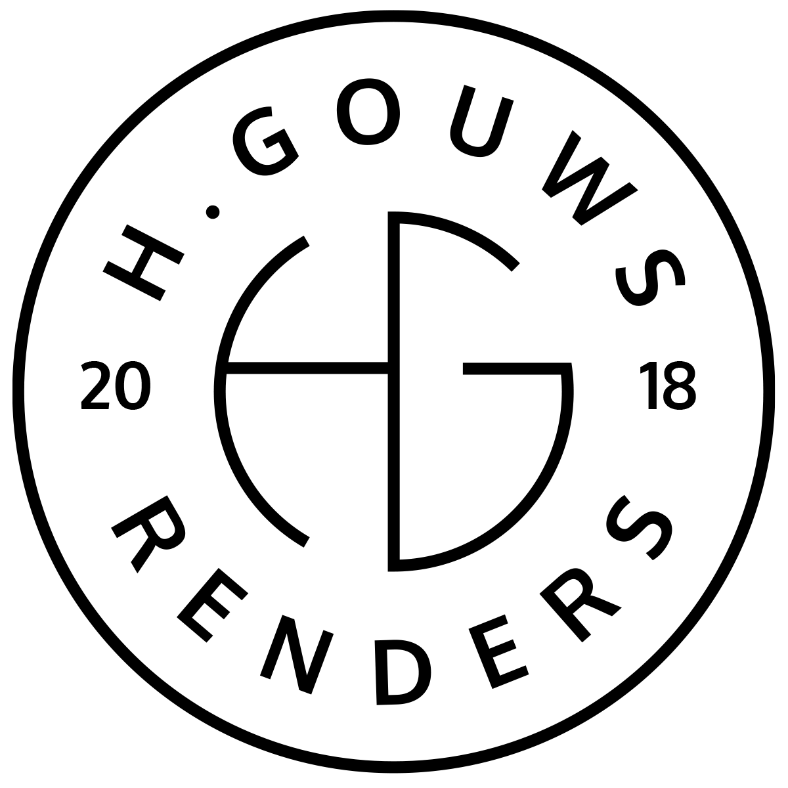H. Gouws Renders PTY LTD:
2020/784683/07
T/A: H. Gouws Renders and Designs

Unit 10 – The Network
19 Cactus Street
Fairview
Port Elizabeth (Gqeberha)
Eastern Cape
6075

Client:
BASEMARK INVESTMENTS (Pty) Ltd
11 Meyer Street
Claremont
Cape Town
7708

INVOICE:
000432022BASE

Date: 07 APRIL 2022

Item: | Description: | Quantity: | Price: | Total:
-------------------------------------------------------------------------------------------------------
1 | House Swire-Griffiths – Construction Drawing Revisions:
| 8hrs | R850.00 | R6 800.00

-----------------------------------------------------------------------------------------------------------------------------------
TOTAL:
VAT Not Applicable R6 800.00 ex VAT

Banking details:
Nedbank
Account Number: 1212774191
Branch Code: 12681700
Cheque account

KINDLY USE THE INVOICE NUMBER AS YOUR PAYMENT REFERENCE

