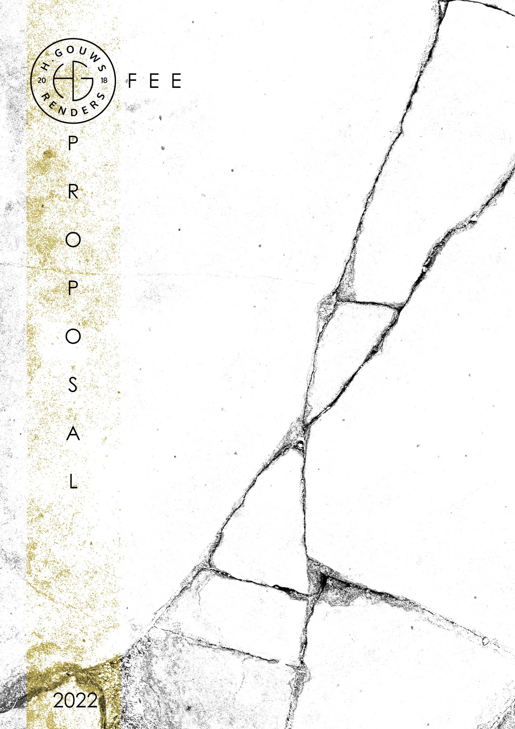

H. Gouws Renders PTY LTD: Trading as:
2020/784683/07 H. Gouws Renders and Designs

19 Cactus Road
Fairview
Port Elizabeth (Gqeberha)
Eastern Cape
2075

Client:
RIAAN ESTERHUIZEN
071 891 1160
riaan@rusticnova.co.za

Date: 02 MARCH 2022
|SCOPE OF WORKS:
Design a new Single storey house of +- 150m², on ERF 1224, Bushmans Creek Estate, Bushmans, Port Alfred.
Project Requirements:
- Ground Floor:

  - 2 x Bedrooms.
  - 1 x En-Suite Bathroom, (Shower, basin, toilet.)
  - 1 x General Bathroom, (Shower, basin, toilet, bath.)
  - Open plan living, dining and kitchen.
  - Covered Patio Entertainment with Braai.
  - House must be designed to allow for future additions and alterations.
Information required for the project:
- As per regulation, I would need a survey of the erf indicating:
  - The Boundary and beacons,
  - Building line,
  - Contours indicating the slope of the erf.
  - I would also need the survey to indicate any existing trees and/or vegetation.
This is also required to by the municipality for submissions.

|HOUSE ESTERHUIZEN_BUSHMANS QUOTE.
Design and do Municipal Drawings and Documentation:
Excluded from the fees:
- Submission fees and hard copy prints, if required. (e.g. Council and municipal related fees/Estate/NHBRC)
- Other Professional consultancy fees that may be required (e.g. Structural Engineer, Quantity and Site Surveyors, Health & Safety, etc.)
- Execution of the works and testing of materials to ensure compliance with drawings and specifications remains the responsibility of the contractor.
- Occupation and As-Built drawings, should the building not be built as per the approved plans.
- Printing of drawings for site.

Professional fees calculation: (Standard cost-based fee, as per SACAP Government Gazette 2020)
Estimated Value of Works: = R 1 200 000.00 (building cost.)

Project Cost | R1 200 000.00
Professional Fees: (ex. VAT)
Primary Fee | R107 779.60
Secondary fee | R66 659.88
 | R174 439.48
Additions and alterations Extra| N.A. | 0
Stages 1 - 6 | R174 439.48

Work Stages |  | % of Fee | Fee ex VAT | % Discount | Final Fees ex VAT
Design | Stages 1-3 | 40% | R69 775.79 | 25% | R52 331.84
Municipal/Technical Drawings | Stage 4.1 | 20% | R34 887.90 | 0% | R34 887.90
Construction drawings and Tender | Stage 4.2 | 10% | R17 443.95 | 0% | N/A
Construction | Stages 5-6 | 30% | R52 331.84 | 0% | N/A
Total ex. Discount |  |  | R174 439.48
Total incl. Discount |  |  |  | Ex. VAT | R87 219.74

H. Gouws Renders High Resolution Rendering: Optional Service
This can be tailored to your needs. (Renders added or removed.)
As a starting point we can do:
- 1 x Render of each space:
  - Showing finishes and materials in high resolution and Interior Designing for the spaces.
- 2 x External Renders:
  - Showing external finishes and how the house fit within the environment.
6 x Interior Renders @ R3500 per render and Interior Design.
R21 000.00
2 x External Renders @ R3000 per render.
R6 000.00

Total Quote: Work Stages 1 – 4.1 and site visits: R92 319.74 excl. VAT
3 x Site visits at a reduced rate of R1700 per site visit included with this proposal, with to be paid with the final invoice of the municipal / technical drawings Stage.
VAT Not Applicable.

Optional Additional Service:
High Resolution Rendering and Interior Design R27 000.00

*Should our scope of work increase, our fees will be adjusted to accommodate the extra scope. This will be discussed before the work commences.
*Included with my fees are conceptual 3d modelling and images to resolve design details. Examples of this can be shown should you want to see.
*This quote is only valid for 30 Days after the date of issue.

|PAYMENT TERMS:
- 50% Design Deposit payable at inception.

- Balance of Design fees payable at Design approval with 50% Municipal Drawings Deposit to commence with Municipal Drawings.

- Balance of Municipal drawings fees payable at Municipal Submission together with 100% of the 3 x Site visit fees included in the fee proposal.

|ACCEPTANCE:
The Terms and Conditions presented here may be modified or amended as necessary only by written instrument signed by both parties.
By submitting the deposit payment, you are agreeing to the terms and conditions detailed in this document. This proposal is agreed upon in full, signed and dated.
By signing this document, I indicate that I understand, agree to, and accept the terms and conditions as contained herein, dated this 02 MARCH 2022.

I, __________________________________________ hereby agree to the Terms and Conditions laid out in this document.

Email: hgouws.renders@gmail.com
Phone: 072 799 9597

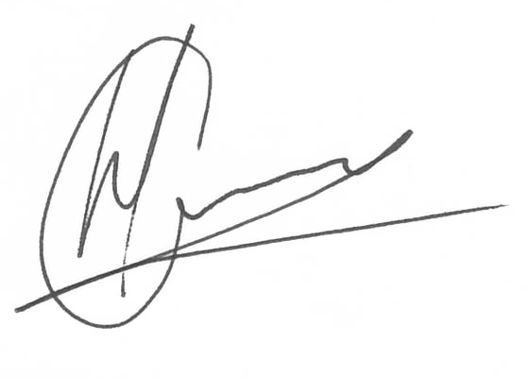

----------------------------------------------- -------------------------------------
Hannes Gouws Name:
Director | PSAT 32449887 Date:

|TERMS AND CONDITIONS:
H. Gouws Renders will be employed for Work stages 1 to 4.1: to Design and create municipal drawings, assist with the municipal submission process until the design has been approved by the local authorities.
(Kindly see the end of the document for descriptions of the Architectural work stages.)
If H. Gouws Renders are not appointed for work stages 5 and 6, only Work stages 1 – 4.1 fees will be applicable and additional fees will be charged to provide a Form 4 at the completion of the project, which is required to certify that the project has been completed in accordance with the National Building regulations and Standards Act. (As legally required and outlined in SANS 10400-A:2010)
  - SITE VISITS:
If H. Gouws Renders are employed for Work stages 1 to 6, fortnightly site visits will be included in the overall quote. (Please see the work stages breakdown at the end of the document)
Further to the fees, should additional Site Visits be requested, a Travel expense of R3 850.00 per Site Visit will be charged to cover the travel distance, and time. This will be invoiced at the end of each month for the duration of the project or when Site visits are requested.
  - DETAILS AND TECHNICAL DRAWINGS:
If H. Gouws Renders is not appointed for Stage 4.2 to 6:
The municipal drawings will be drawn to a level of detail to build from. I will be available on my cell or email should the builder/contractor require insight or spot details.
Please note: Should you require technical detail drawings to be issued for site, a rate of R2500 per detail drawing will be applicable.
  - PRINTS:
Revision drawings will be emailed to the site management team. Hard copy revision drawings will be the responsibility of the site manager.
If I must make hard copy prints for site, it will be added to a monthly invoice of:
R65 per A1 print
R85 per A0 print.
  - EXTENDED CONSTRUCTION PERIOD: Only applicable to work stage 5 and 6
If the building construction period is exceeded by more than 10% due to no fault of the architect, he/she is to be remunerated for his/her services for all additional work under work stage 5 at the hourly rate of R1 450.00 ex VAT provided that such services are note covered by any other additional fees.
|ARCHITECTURAL WORK STAGES:
Stage 1: Inception
a) Receive, appraise and report on the client's requirements with regard to the client's brief;
b) Determine the site and rights and constraints;
c) Determine budgetary constraints;
d) Determine the need for consultants;
e) Determine indicative project timelines;
f) Determine methods of contracting; and
g) Whether other statutory authority applications are required or desirable.

Stage 2: Concept Design
- Prepare an initial design concept and advise on:
i the intended space provisions and planning relationships;
ii proposed materials and intended building services; and
iii the technical and functional characteristics of the design.
b) Check for conformity of the concept with the rights to the use of the land.
c) Consult with local and statutory authorities.
d) Review the anticipated costs of the project. e) Review the project programme.

Stage 3: Design Documentation
a) Develop all aspects of the design from concept to full development including, but not limited to, construction systems, materials, fittings, and finishes selections;
b) Review the programme and budget with the client, principal consultant or other consultants;
c) Coordinate other consultants’ designs into building design;
d) Prepare design development drawings including drafting technical details and material specifications;
e) Discuss and agree on the building plan application and approval requirements with the local authority;

Stage 4: Documentation and Procurement (municipal submission stage)
Stage 4.1:
a) Prepare documentation required for local authority building plan application submission;
b) Co-ordinate technical documentation with the consultants and complete primary co-ordination sufficient to support building plan submission;
c) Review the costing and programme with the consultants;
d) Obtain the client's authority, and submit documents for approval at the local authority.
Stage 4.2:
a) Prepare specifications for the works;
b) Complete technical documentation sufficient for tender;
c) Obtain offers for the execution of the works;
d) Evaluate offers, and recommend a successful tenderer for appointment;
e) Prepare the contract documentation and arrange the signing of the building contract by the client and the successful tenderer;
f) Complete all remaining technical and construction documentation and coordinate same with the consultants;

Stage 5: Construction
a) Administer the building contract;
b) Give possession of the site to the contractor;
c) Issue construction documentation;
d) Review sub-contractor designs, shop drawings and documentation for conformity of design intent;
e) Inspect the works for conformity with the contract documentation and acceptable quality in terms of industry standards;
f) Administer and perform the duties and obligations assigned to the principal agent in the building contract; g) Manage the completion process of the project;
h) Assist the client to obtain the required documentation necessary for the client to obtain the occupation certificate.

Stage 6: Close out
a) Facilitate the project close-out including the collation of the necessary documentation to effect completion, handover and operational manual of the project.
b) When the contractor's obligations with respect to the building contract have been fulfilled, the architectural professional shall issue the certificates related to the contract completion.
c) Provide the client with construction record documentation and the relevant technical and contractual undertakings by the contractor and subcontractors.

